Modified Wave Spectrum
Swell
Fully developed wind waves are a result of long wind fetch. We believe that exist the fully developed wind waves (dimensionless wind fetch 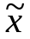 >= 20170 – in our model). If wind reduces or changes the direction, the process of swell formation is beginning.
Fully developed wind waves are a result of long wind fetch. We believe that exist the fully developed wind waves (dimensionless wind fetch >= 20170). If wind speed has decreased or changed the direction, the process of swell formation is beginning.
The simple spectrum model of swell is given by following formula:
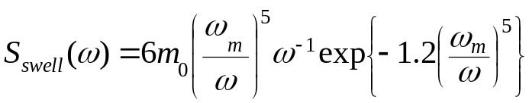 ,
where 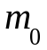 is the first moment of wave spectrum, i.e. significant wave height SWH = 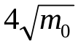 .
The significant wave height of swell is reducing during propagation. There is a maximal value of for every 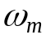 (dominant wavelength 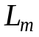). The simplest formula to estimate this value is following:
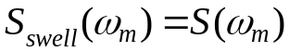
where 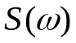 - spectrum of wind waves.

In result we have the following formula for :
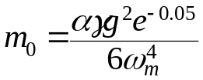
and maximal value of SWH of swell for this dominant wavelength is equal to
SWH = 4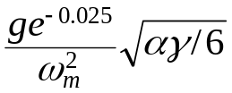
We may introduce the SWH and determine the «age» of swell.
Combining the wind waves and swell we may simulate the most of sea states in our calculations. We introduced the notion of a mixed sea (swell + wind waves).

Our determination of swell is enough general. We may easy transfer from wind waves (fully developed of developing wind waves) to swell. Let’s consider.

During simulation we know 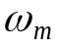 or 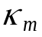 of wind waves and SWH. Swell has same as an initial wind waves. Therefore, changing of SWH in interval from SWH of wind waves (initial stage) to 0 (final stage) we obtain the swell of required intensity. It is convenient for simulation of mixed sea (swell + wind waves).

For example. We have the fully developed wind waves (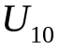 = 14.75 m/s, 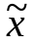 = 20170) and we know 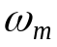. Let the initial wind speed was 14.75 m/s and then wind speed reduced to 10 m/s. After some transfer period we will have swell, corresponding to previous wind speed ( = 14.75 m/s, , 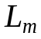 = 200 m) and wind waves corresponding to 10 m/s. We obtain the mixed sea: wind waves and swell.

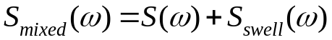

Let’s consider some figures.

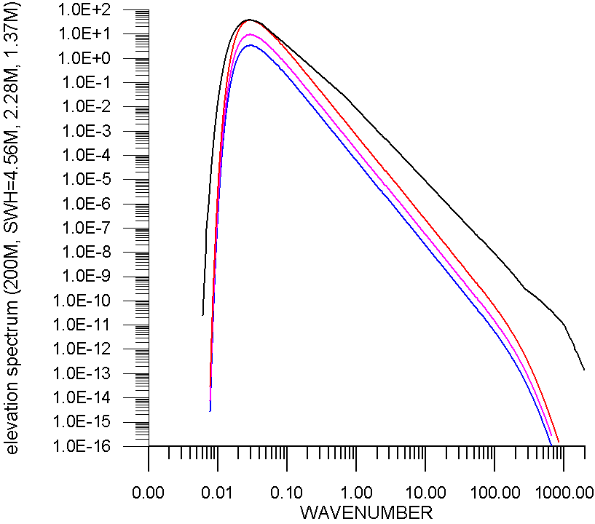

figure 7. Omnidirectional elevation spectrum for swell (200 m, SWH=1.37m, 2.28m, 4.56 m) and wind speed 14,75 m/s (Lm = 200m). Blue – swh = 1.37 m, Red – 4.56m), Black – wind waves .

File with data contains 4 columns: 1) wavenumber 2) swell 3) wind waves 4) mixed sea (swell + wind waves)

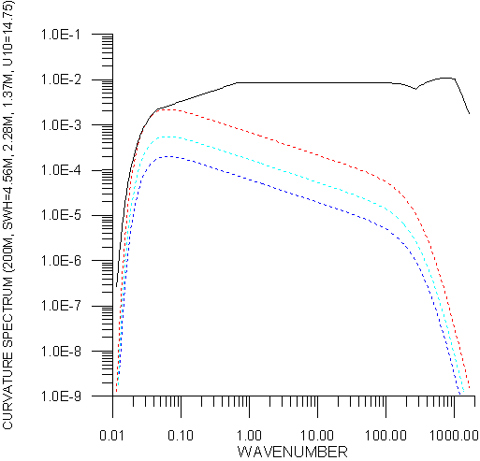

figure 8. curvature spectrum of swell (Lm SWELL = 200m, SWH=1.37m, 2.28m, 4.56m). Blue line – 1.37m, red line – 4.56m. Black line – fully developed wind waves U10=14.75 m/s, Lm=200m).

Data files for height: SWL20_13.dat (swh=1.37 m), SWL20_22.dat (swh = 2.28 m), SWL20_45.dat (swh = 4.56 m). = 200 m.

Data files for curvature spectrum: SSL20_13.dat, SSL20_22.dat, SSL20_45.dat

Mixed sea (slopes): SML20_10.dat (U10 = 10 m/s) + swell (= 200 m, swh = 1.37 m)

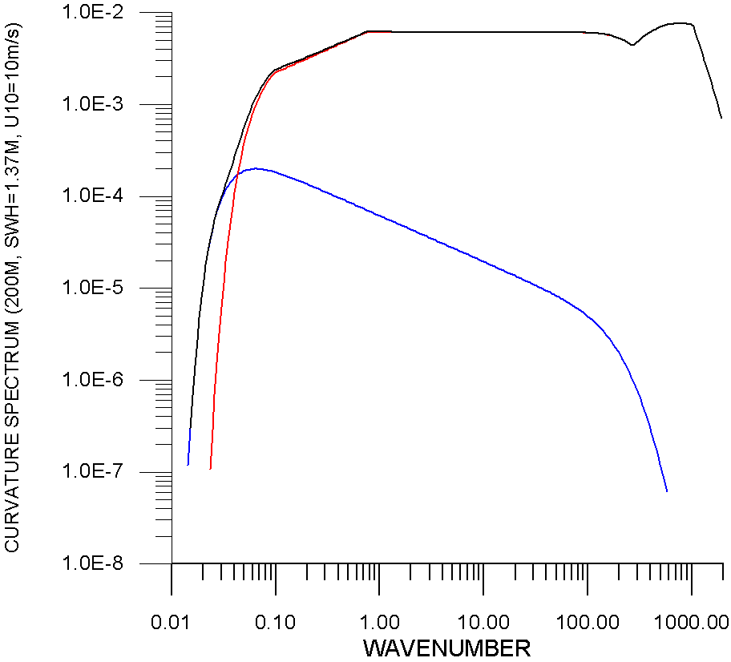

figure 9. curvature spectrum of mixed sea (swell Lm = 200m, SWH=1.37m and wind waves U10= 10m/s). Blue line – swell, red line – wind waves. Black line – mixed sea.

Instruction for program

SEAWVS_2.EXE

E X A M P L E
1) Calculation of SWELL (Y) or Mixed sea (N) ? N
2) Input wind fetch (1430-20170) : 10000 , ENTER
3) long calculations? (Y/N): Y
long calculations KT = KT + HK*KT (changing step)
calculations: KT = KT + HK (permanent step)
4) Slopes (Y) or Height (N) : Y
5) Input wavelength of swell 200
6) Input SWH of swell 2
7) Input U10, m/s : 10 , ENTER
8) Input K0 : 0.006
9) Input KK : 2000
10) Input HK : 0.05
11) File is rewritten? : Y
12) Continue ? : N

data file is SEAWVS_2.dat

Appendix

- DISPERSION EQUATION

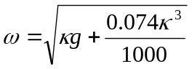

2) HEIGHT PROFILE OF WIND SPEED

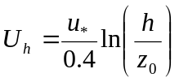 (CM/S)

– HEIGHT, CM
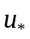 - FRICTION VELOCITY, CM/S
