AWS – Task 2

1. Creating a VPC

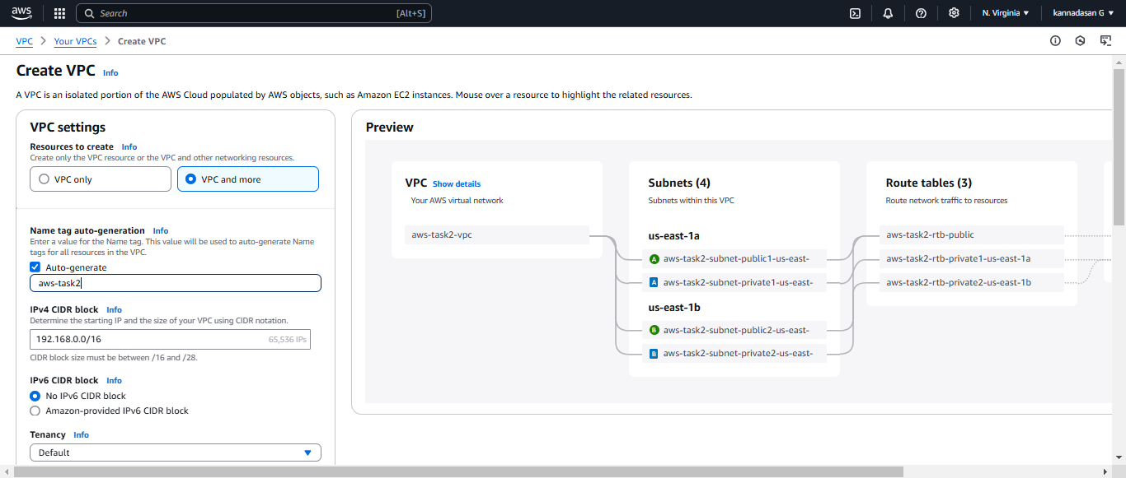

1. VPC workflow generated

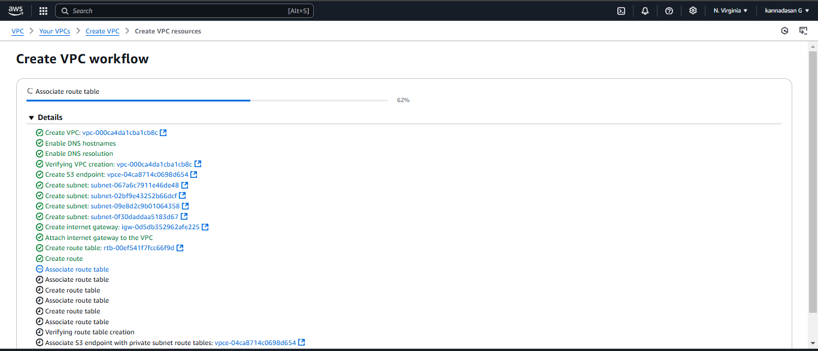

3.Create Linux Instance

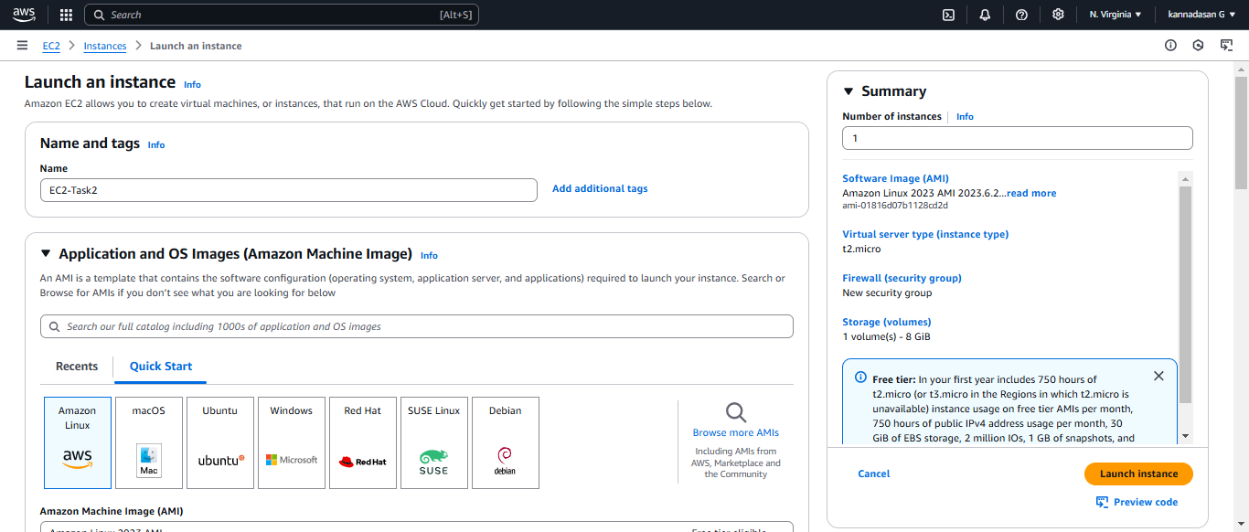

4.Updating VPC in EC2 Instance and updating public subnet in network section.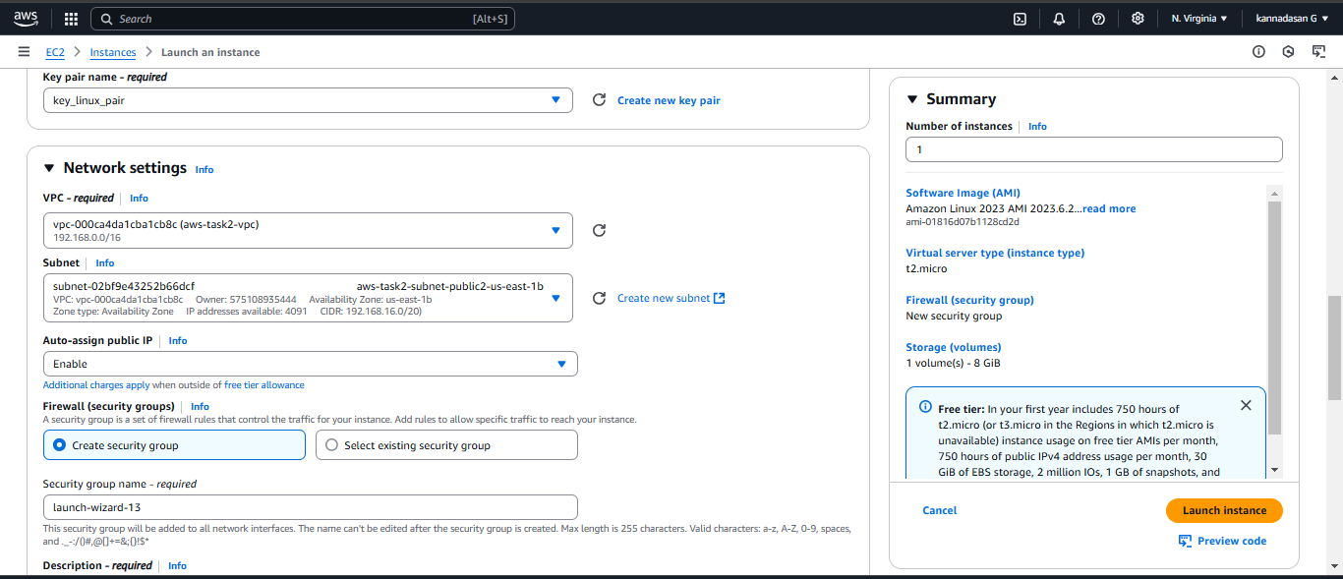

5. Connecting Ec2 linux server

