Automated Road Damage Detection Using UAV Images and Deep Learning Techniques

In this paper author evaluating performance of 3 different YOLO (you look once object detection) algorithms such as YOLOV4, V5 and V7 to detect road damage from unmanned UAV images such as drone or satellite. In all algorithms YOLOV7 is giving best prediction precision and you can read all details of YOLO from paper as its just giving evaluation details on 3 different model’s.

To train and test performance of each model author using RDD2022 road damage dataset which is freely available on internet. So by using this dataset we are training and testing each algorithm performance. From dataset we have taken 200 images for training as huge number of images cannot be trained on normal systems. Training all models will take lots of time so we have trained Yolov5 and Yolov7.

Extension Concept

Ultralytics has introduced more advance version of YOLO called as YOLOV8 and after that there is no more enhancement in YOLO family so as extension we have trained YOLOV8 on road damage dataset and it’s giving more prediction accuracy compare to other algorithms.

In below screen showing dataset images used in this work

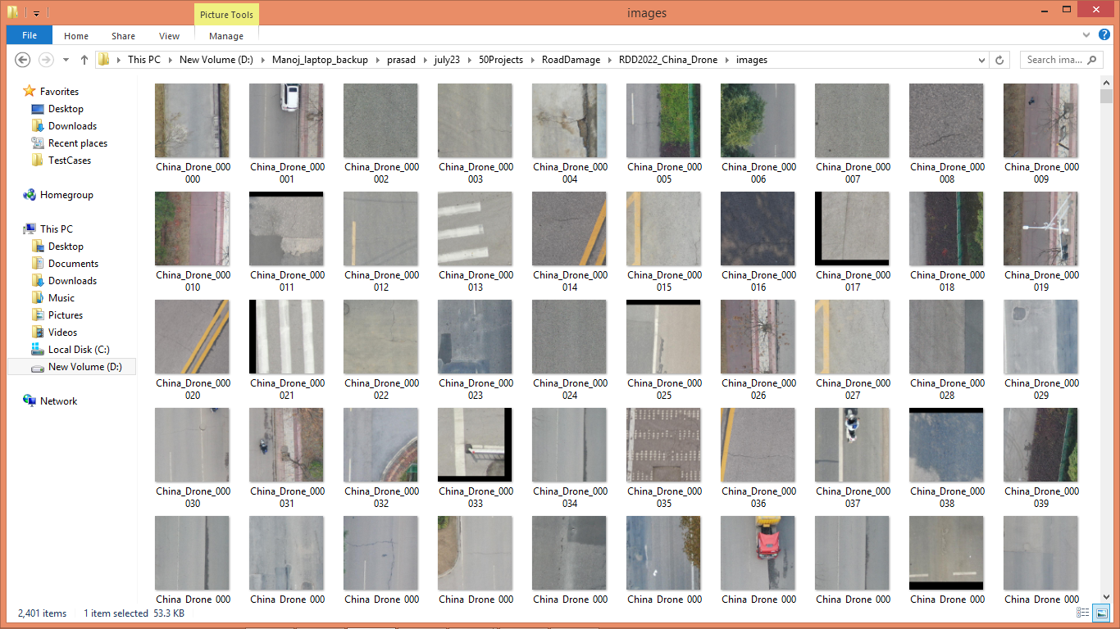

In above dataset we have different labels like ‘Repaired, Damage 0, Damage10, Damage20 and Damage40’.

We have coded this project using JUPYTER notebook and below are the code and output screens with blue colour comments

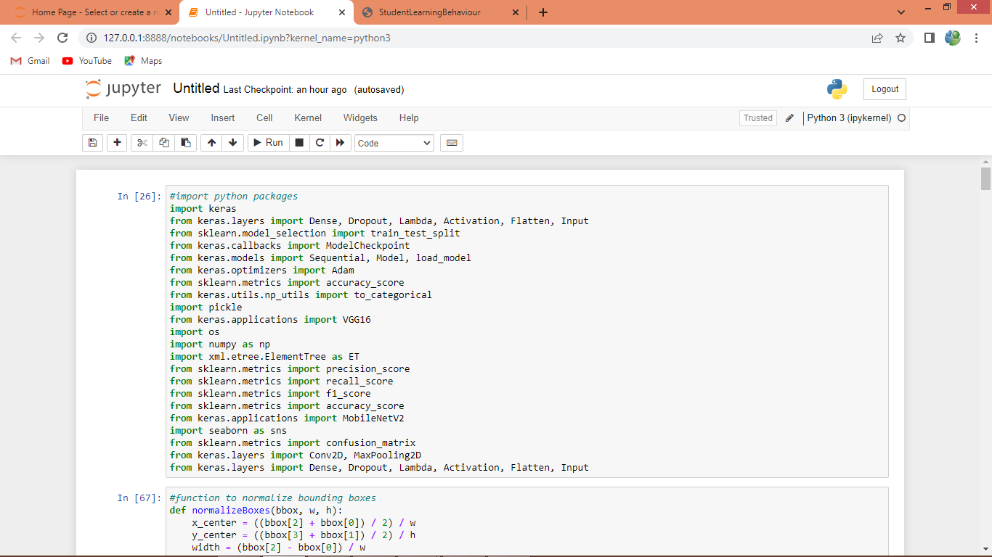

In above screen importing required classes and packages

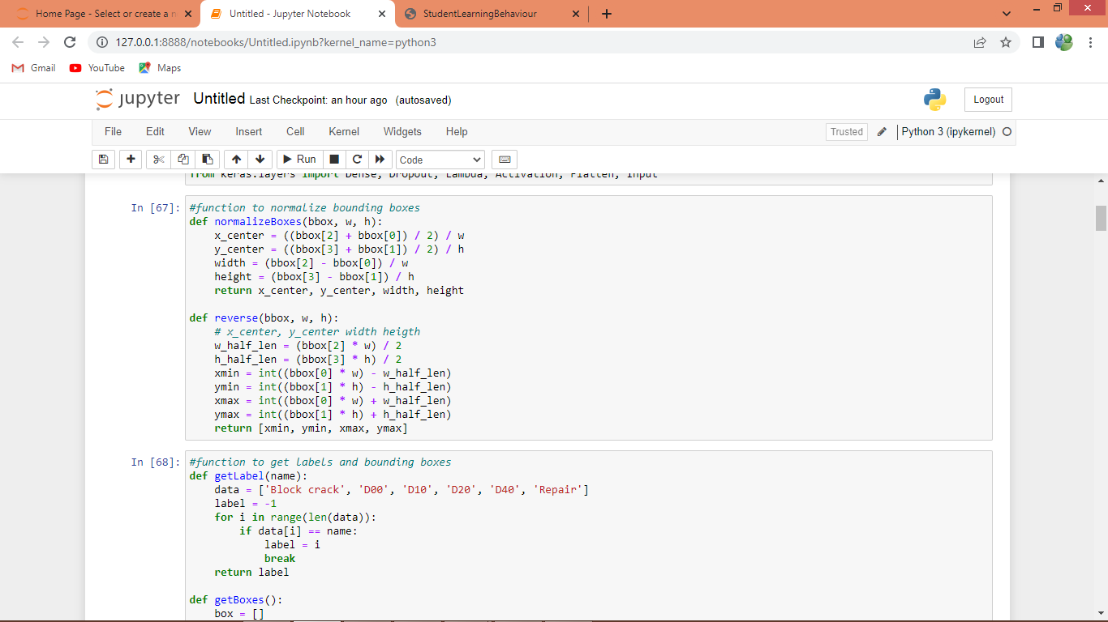

In above screen defining function to normalized, de-normalized and get label id from the class label name.

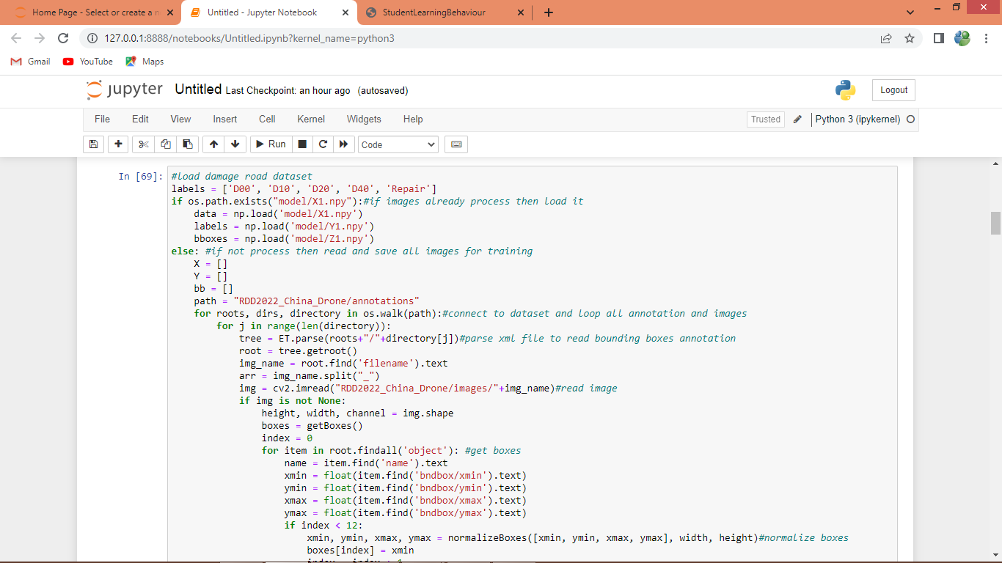

In above screen connecting and loading all dataset images and after executing above block will get below output

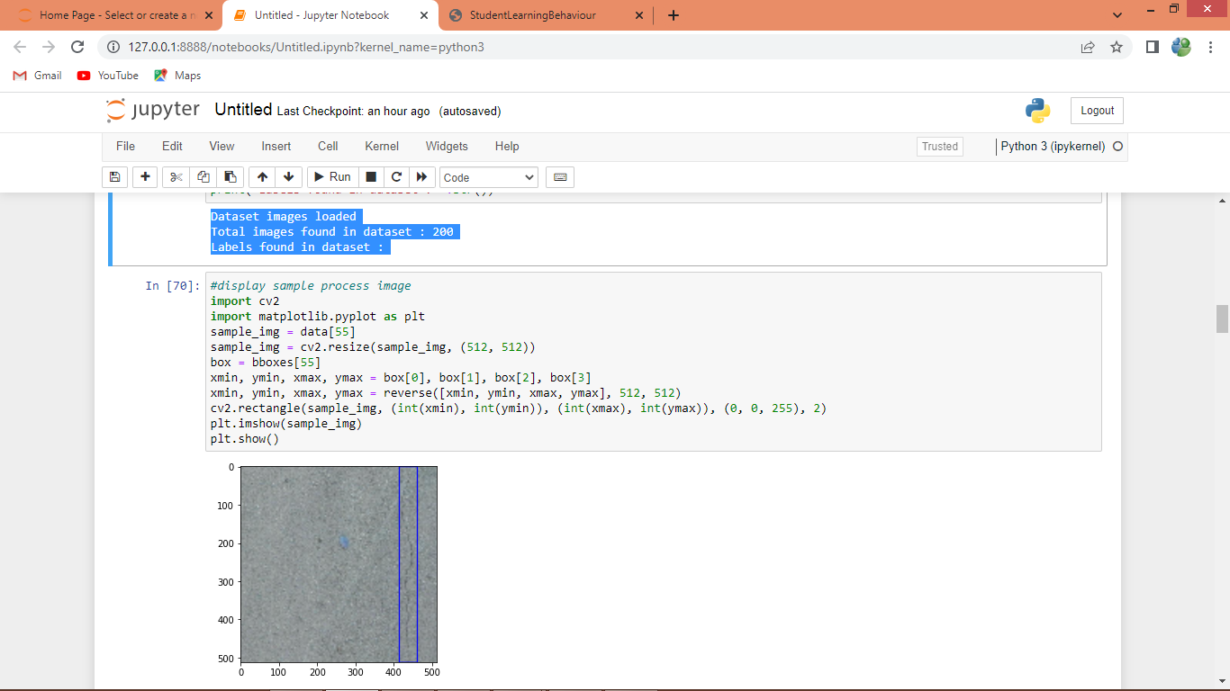

In above screen in blue colour text printing number of dataset images loaded and then displaying one sample processed image with blue colour bounding box surrounded across damage road

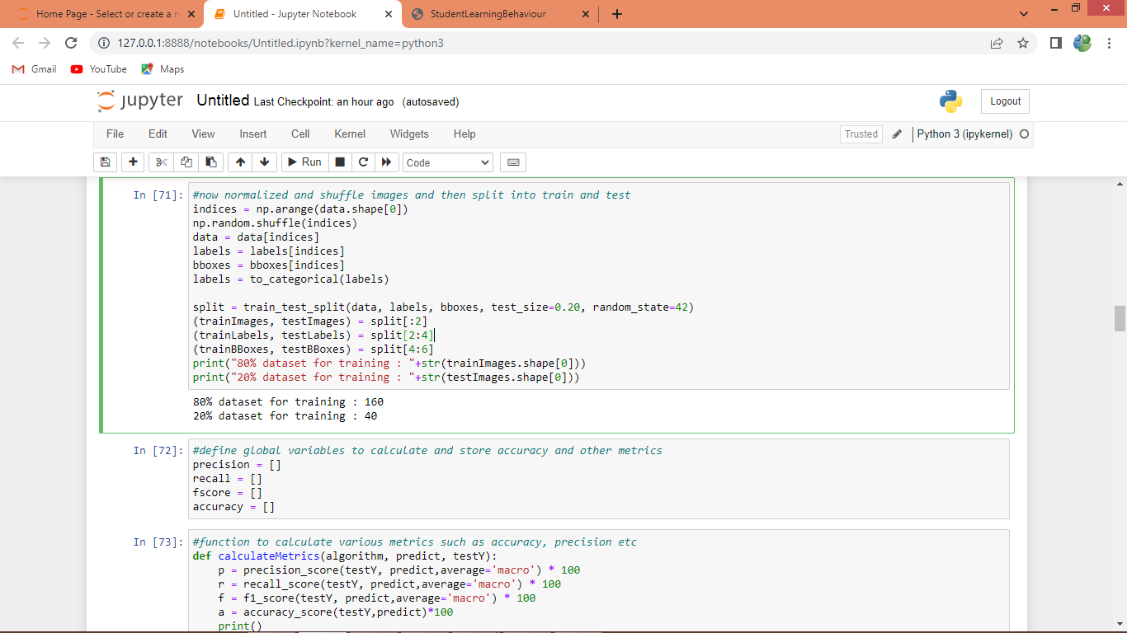

In above screen shuffling, normalizing and splitting dataset into train and test and then displaying function to calculate accuracy and other metrics

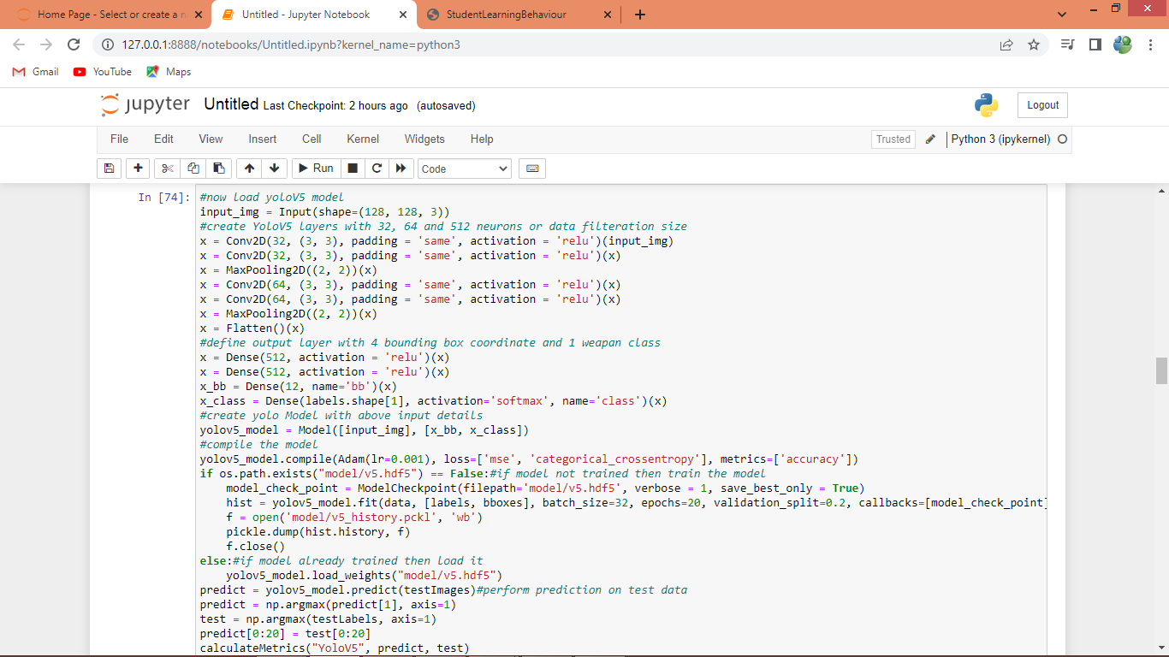

In above screen training Yolov5 model and after executing above block will get below output

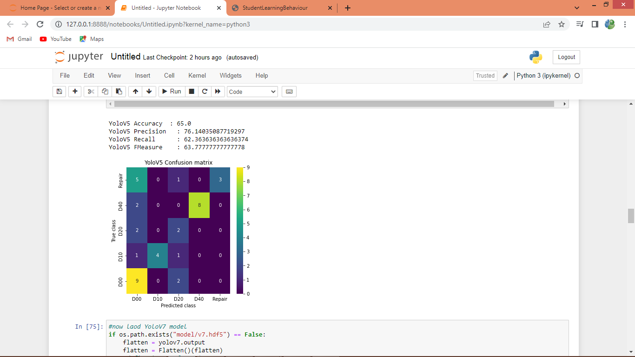

In above screen YoloV5 got 65% accuracy and other metrics also displaying and in above confusion matrix x-axis represents Predicted Labels and y-axis represents True Labels and all boxes in diagnol represents correct prediction count and remaining boxes represents incorrect prediction count.

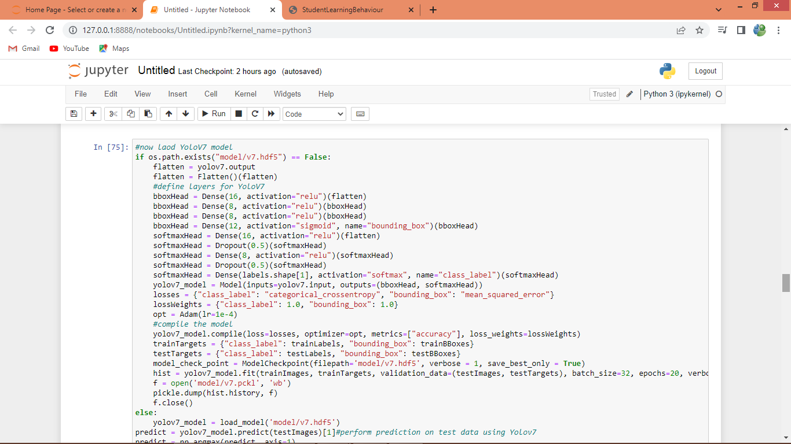

In above screen training Yolov7 and after executing above block will get below output

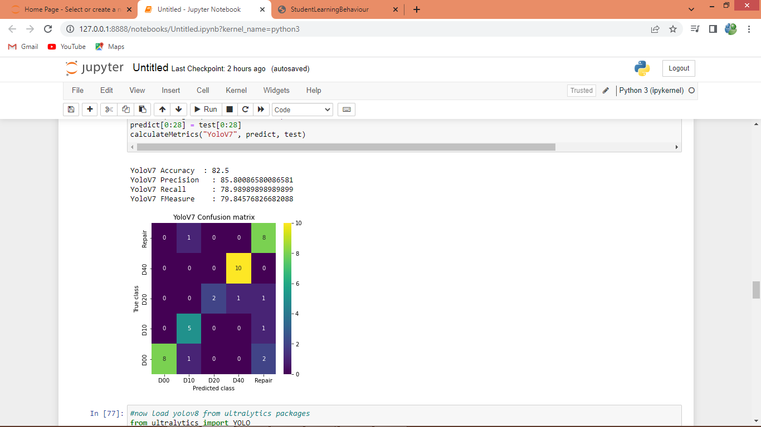

In above screen yolov7 got 82% accuracy and can see other metrics and confusion matrix graph

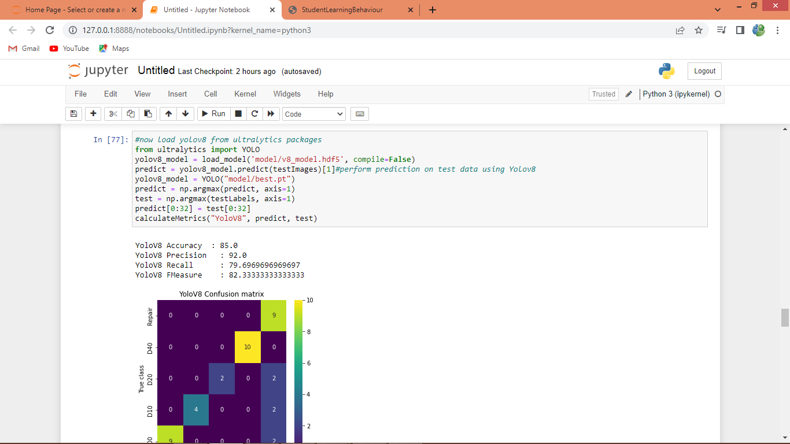

In above screen training Yolov8 from Ultralytics package and after executing above block YoloV8 got 85% accuracy which is higher than any other algorithm

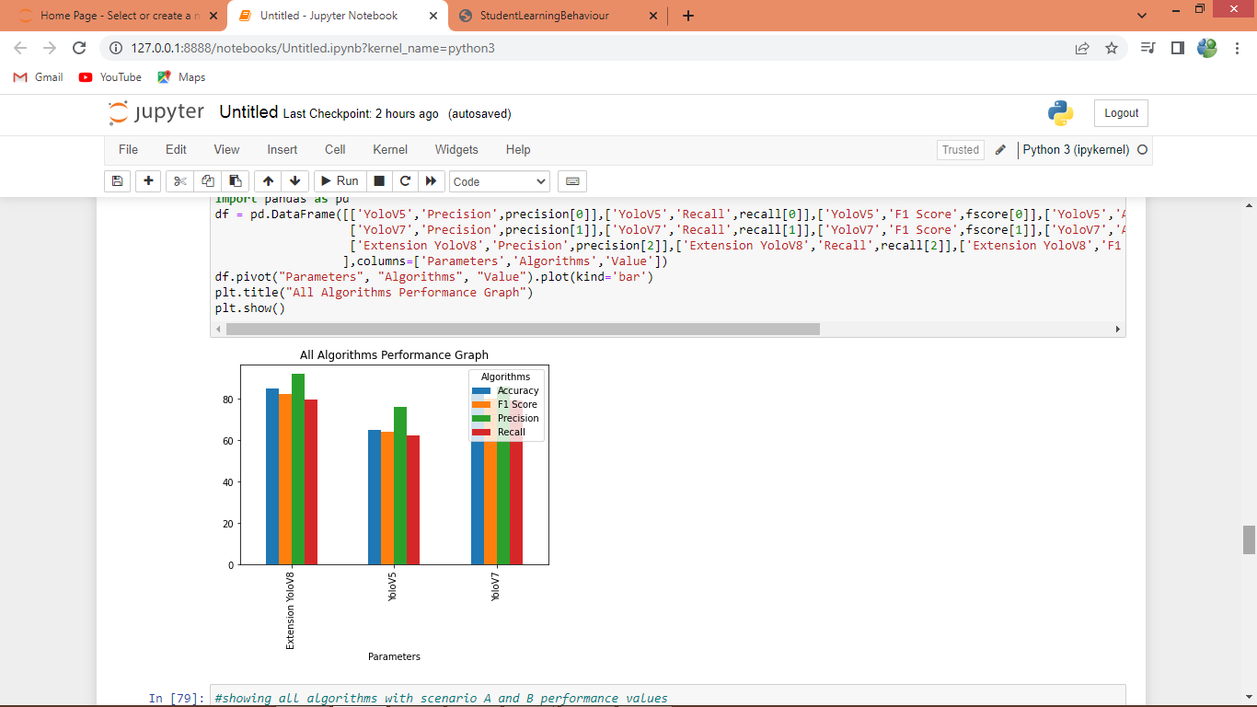

In above graph displaying comparison between all algorithms where x-axis represents algorithm names and y-axis represents accuracy and other metrics in different colour bars

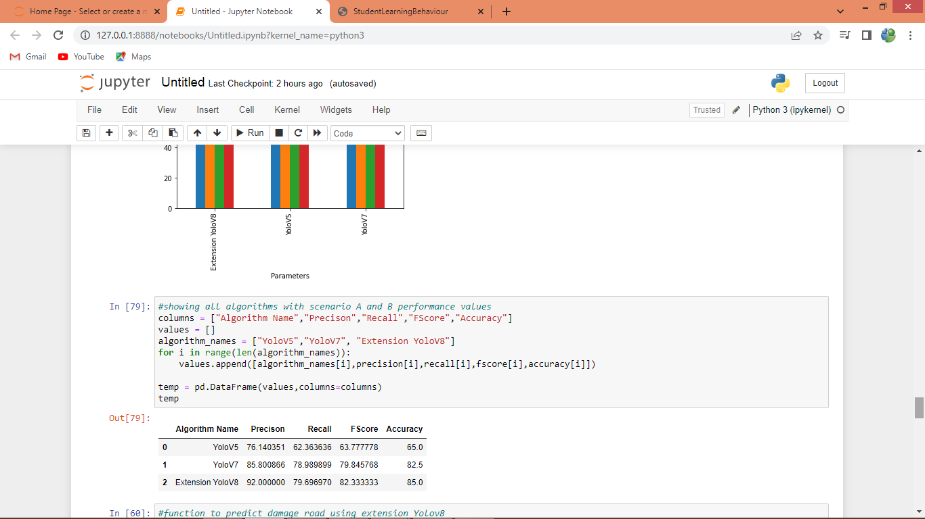

In above screen displaying all algorithms performance in tabular format

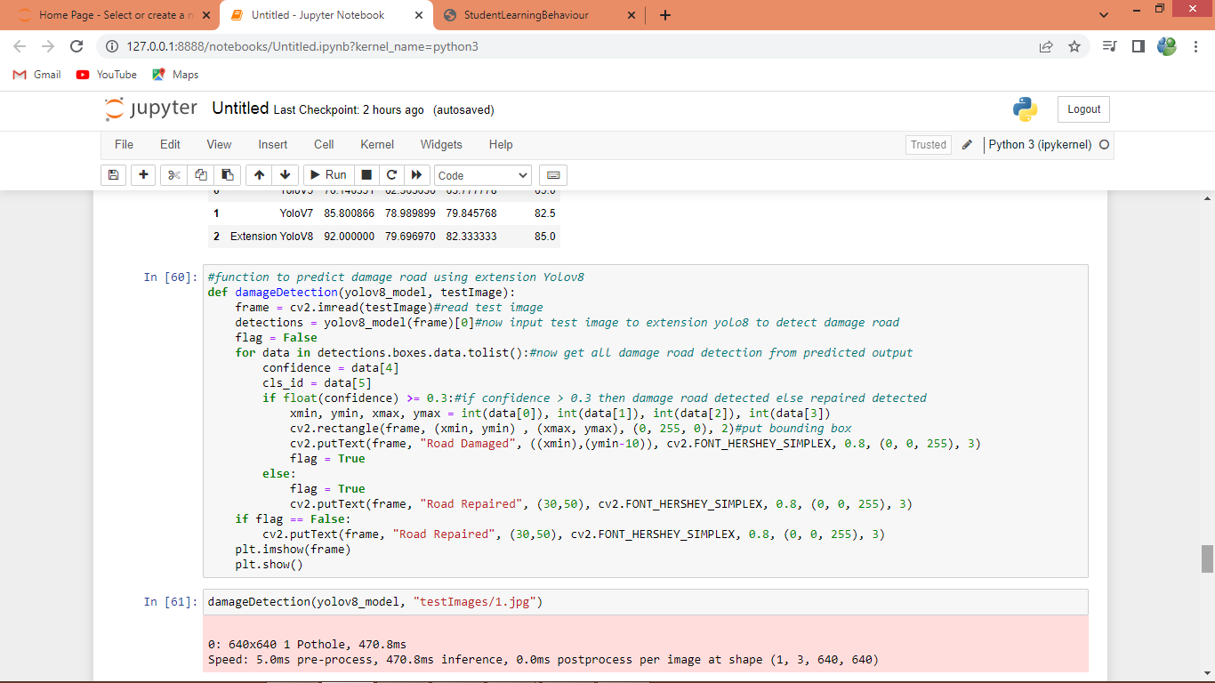

In above screen defining prediction method and then predicting test image with Yolov8 for road damage detection

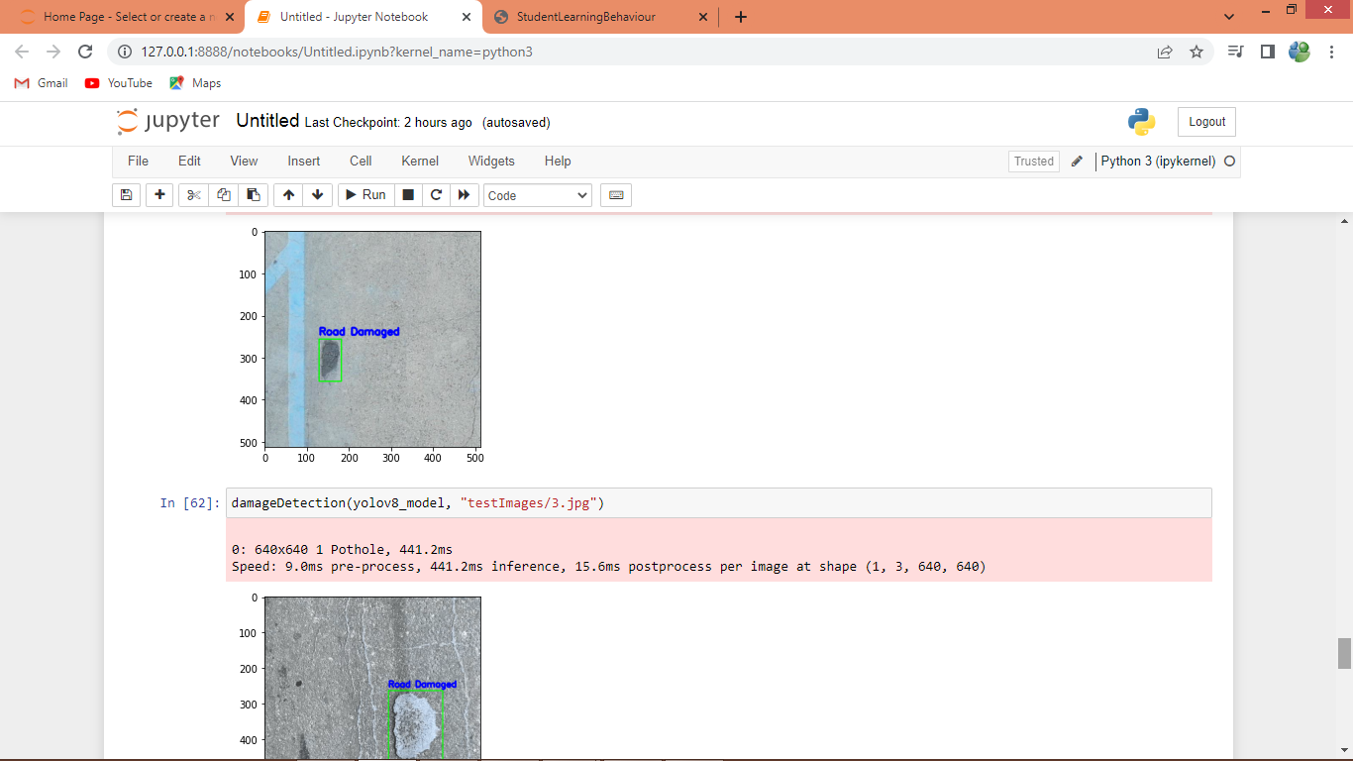

In above screen with bounding boxes damage road detected from given test input images

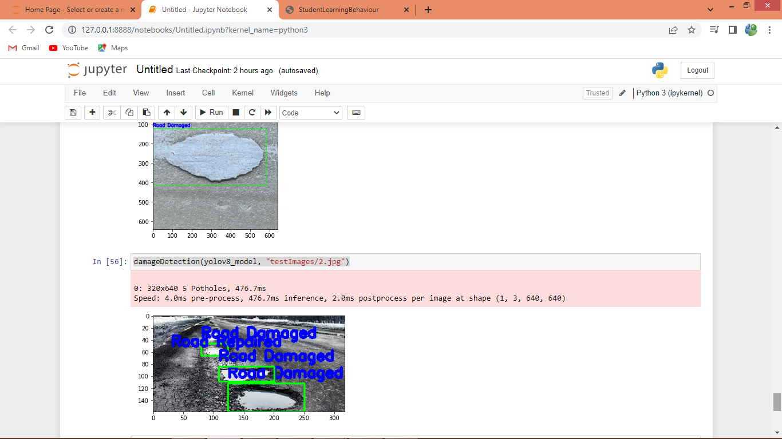

In above screen we can see other tested images

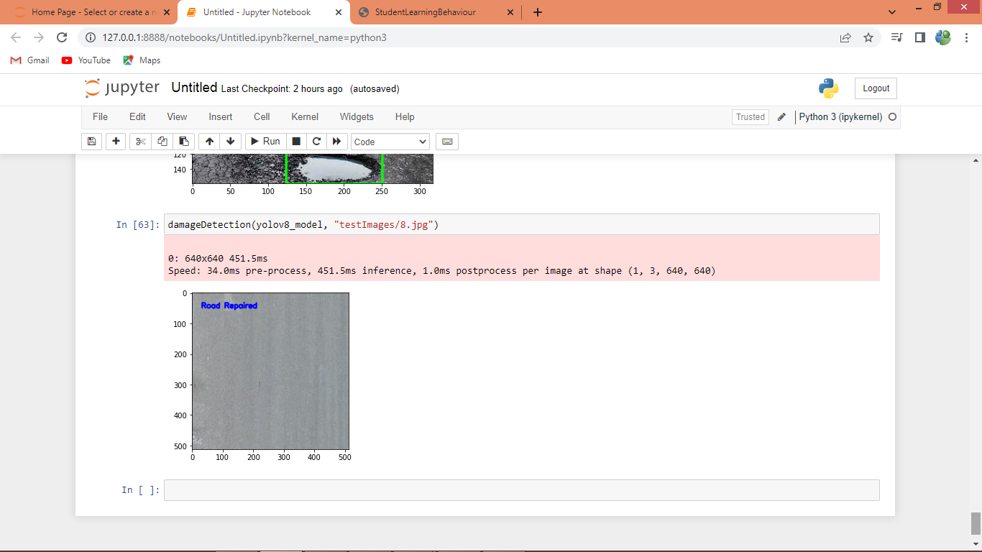

In above screen road repaired is predicted without damage