# 1. WORKING OF CNN ARCHITECTURE TO CLASSIFY IMAGES

|  |  |
| --- | --- |
| **EX.N0 : 1** | **WORKING OF CNN ARCHITECTURE TO CLASSIFY IMAGES** |
| **DATE : 21/01/2025** |

**AIM:**

To implement and demonstrate a Convolutional Neural Network (CNN) for image classification using the CIFAR-10 dataset in TensorFlow and Keras.

# ALGORITHM:

Step 1: Import necessary libraries.

Step 2: Load and pre-process the CIFAR-10 dataset.

Step 3: Build the CNN model using Keras Sequential API.

Step 4: Compile the model with appropriate loss function and optimizer. Step 5: Train the model on the training dataset.

Step 6: Evaluate the model on the test dataset.

Step 7: Visualize a few predictions to validate performance.

# PROGRAM:

import tensorflow as tf

from tensorflow.keras import layers, models import matplotlib.pyplot as plt

from tensorflow.keras.datasets import cifar10 import numpy as np

(x_train, y_train), (x_test, y_test) = cifar10.load_data() x_train = x_train.astype('float32') / 255.0

x_test = x_test.astype('float32') / 255.0 model = models.Sequential([

layers.Conv2D(32, (3, 3), activation='relu', input_shape=(32, 32, 3)),

layers.MaxPooling2D((2, 2)),

layers.Conv2D(64, (3, 3), activation='relu'),

layers.MaxPooling2D((2, 2)),

layers.Conv2D(64, (3, 3), activation='relu'), layers.Flatten(),

layers.Dense(64, activation='relu'), layers.Dense(10, activation='softmax')

])

model.compile(optimizer='adam', loss='sparse_categorical_crossentropy', metrics=['accuracy'])

history = model.fit(x_train, y_train, epochs=10, batch_size=64, validation_data=(x_test, y_test))

test_loss, test_acc = model.evaluate(x_test, y_test, verbose=2) print(f'\nTest accuracy: {test_acc:.4f}')

class_names = ['airplane','automobile','bird','cat','deer', 'dog','frog','horse','ship','truck']

predictions = model.predict(x_test) plt.figure(figsize=(10,5))

for i in range(5):

plt.subplot(1, 5, i+1) plt.xticks([])

plt.yticks([]) plt.grid(False) plt.imshow(x_test[i])

pred_label = class_names[np.argmax(predictions[i])] true_label = class_names[y_test[i][0]] plt.xlabel(f"Pred: {pred_label}\nTrue: {true_label}") plt.tight_layout()

plt.show()

# OUTPUT:

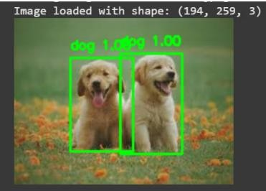

**RESULT:**

Thus, to implement and demonstrate a Convolutional Neural Network (CNN) for image classification using the CIFAR-10 dataset in TensorFlow and Keras.