**Chapter 1**

**Market Segmentation**

**1.1 Strategic and Tactical Marketing**

Strategic and tactical marketing play important roles in market segmentation. Let's first understand what market segmentation is, Market segmentation is the process of dividing a broad market into smaller, more manageable segments based on similar characteristics, needs, or behaviours of potential customers. By segmenting the market, businesses can better understand their customers, tailor their marketing efforts, and achieve higher levels of customer satisfaction and profitability.

Now, let's delve into the concepts of strategic and tactical marketing in the context of market segmentation:

**Strategic Marketing:**

Strategic marketing involves long-term planning and decision-making that sets the overall direction for a company's marketing activities. In the context of market segmentation, strategic marketing focuses on the following aspects:

* Target Market Selection: Strategic marketing involves selecting the most attractive market segments that align with the company's overall objectives, resources, and competitive advantages. This includes analyzing various segments based on factors such as size, growth potential, profitability, and compatibility with the company's capabilities.
* Positioning: Once the target segments are identified, strategic marketing determines how the company wants to position its products or services within each segment. Positioning involves creating a unique and favorable perception of the company's offerings compared to competitors, emphasizing the value proposition and key benefits that resonate with the specific needs and preferences of the target segment.
* 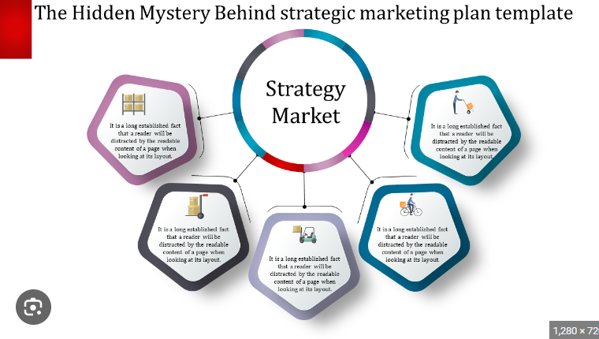Resource Allocation: Strategic marketing also involves allocating resources effectively to reach and serve the chosen market segments. This includes decisions related to budget allocation, marketing channels, and resource allocation across different segments based on their strategic importance.

**Tactical Marketing:**

Tactical marketing focuses on the implementation of specific marketing initiatives to reach and engage with the target market segments. It involves executing the strategies formulated during the strategic planning process. In the context of market segmentation, tactical marketing entails:

* Message Customization: Each market segment has unique characteristics and needs. Tactical marketing involves tailoring marketing messages, content, and communication channels to effectively resonate with the specific segment. This customization ensures that the marketing efforts are relevant, compelling, and targeted to the segment's preferences and interests.
* Channel Selection: Tactical marketing involves selecting the appropriate marketing channels to reach the target segments. This could include traditional advertising, digital marketing, social media, direct mail, or a combination of multiple channels. The choice of channels should consider the segment's media consumption habits, preferred communication channels, and overall marketing objectives.
* Campaign Execution: Tactical marketing focuses on executing marketing campaigns, which include activities such as advertising, promotions, content creation, events, and public relations. These campaigns are designed to engage with the target segments, generate leads, drive sales, and build brand awareness and loyalty.
* 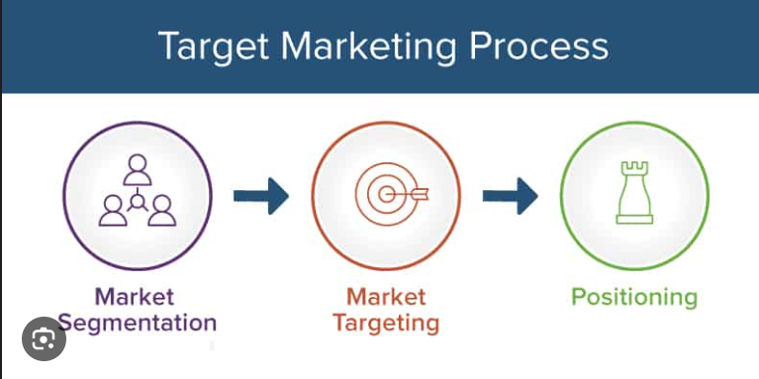Performance Measurement: Tactical marketing also involves monitoring and measuring the performance of marketing initiatives to evaluate their effectiveness and make data-driven adjustments. Key performance indicators (KPIs) such as customer acquisition, conversion rates, customer satisfaction, and ROI are tracked to assess the success of the tactics and optimize future marketing efforts.

**1.2 Definitions of Market Segmentation**

Market segmentation is the process of dividing a broad and heterogeneous market into distinct groups or segments that share similar characteristics, needs, or behaviours. These segments are typically based on various factors such as demographics, psychographics, geographic location, behaviour patterns, or customer preferences. By dividing the market into smaller, more homogeneous segments, businesses can better understand their customers and tailor their marketing strategies and tactics to effectively target and serve each segment.

Market segmentation is a crucial strategy used by businesses to better understand and cater to the diverse needs and preferences of their customers. It involves dividing a broad market into smaller, more manageable segments based on shared characteristics, needs, or behaviours. This process allows companies to tailor their marketing efforts to each segment, resulting in more effective and personalized marketing campaigns.

Segmentation is typically based on various factors such as demographics, psychographics, geographic location, behaviour patterns, or customer preferences. Demographic segmentation involves categorizing customers based on age, gender, income, education, or other demographic variables. Psychographic segmentation focuses on customers' lifestyles, values, attitudes, or personality traits. Geographic segmentation divides customers based on their geographic location, such as country, region, or city. Behavioural segmentation considers customers' buying habits, product usage, loyalty, or other behavioural patterns.

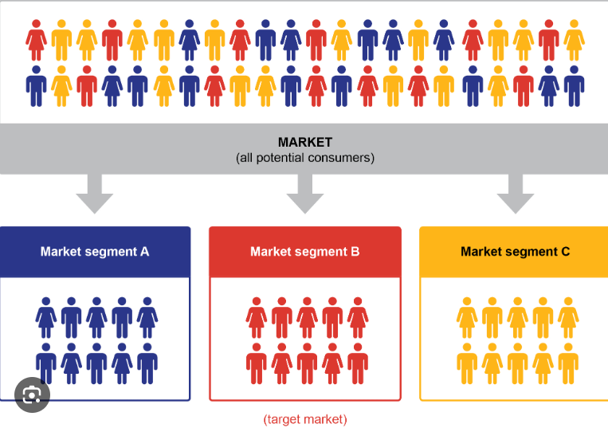

Each segment represents a distinct group of customers who exhibit similar characteristics and needs. These segments are internally consistent, meaning that individuals within the same segment are more similar to each other compared to individuals in other segments. By understanding the unique characteristics of each segment, businesses can develop targeted marketing strategies that resonate with the specific needs, preferences, and behaviors of each segment.

Targeting a specific market segment allows businesses to allocate their resources more efficiently. They can focus their marketing efforts on the most attractive and profitable segments that align with their capabilities and objectives. This approach ensures that resources are not wasted on irrelevant or less profitable segments, leading to a more cost-effective and impactful marketing strategy.

Once the segments are identified, businesses can customize their marketing messages, content, and communication channels to effectively reach and engage with each segment. This customization ensures that the marketing efforts are relevant, compelling, and resonate with the specific segment. By speaking directly to the unique needs and preferences of each segment, businesses can build stronger connections with their target customers and increase the chances of conversion and loyalty.

Furthermore, market segmentation allows businesses to differentiate themselves from competitors. By understanding the distinct characteristics of each segment, companies can position their products or services in a way that emphasizes the value proposition and key benefits that are most relevant to the target segment. This differentiation helps businesses stand out in the market and attract customers who resonate with their unique offerings.

**1.3 The Benefits of Market Segmentation**

* Better Understanding of Customers: Market segmentation provides businesses with a deeper understanding of their customers. By dividing the market into smaller segments, companies can identify and analyze specific customer groups with shared characteristics, needs, or behaviours. This understanding helps businesses gain insights into customers' preferences, motivations, buying habits, and pain points, enabling them to develop products, services, and marketing strategies that are tailored to each segment's unique requirements.
* Improved Customer Satisfaction: When businesses understand their customers' needs and preferences through market segmentation, they can provide more relevant and personalized products, services, and experiences. By meeting the specific requirements of each segment, companies can enhance customer satisfaction levels. Satisfied customers are more likely to become repeat buyers, refer others to the business, and contribute to positive word-of-mouth, fostering long-term customer loyalty.
* Increased Sales and Profitability: Targeted marketing through market segmentation can lead to increased sales and profitability. By focusing on the most receptive segments, businesses can generate higher conversion rates and customer acquisition. Customized marketing efforts also tend to result in higher customer loyalty and repeat purchases, driving revenue growth. Additionally, by optimizing resource allocation and reducing wasteful spending, businesses can improve their profitability.

**Step 1:**  **Deciding (not) to Segment**

Deciding whether or not to segment in market segmentation involves a careful assessment of various factors. One key consideration is the level of heterogeneity within the target market. If the market consists of diverse customer groups with distinct needs, preferences, and behaviours, segmentation can help tailor marketing efforts and enhance customer satisfaction. Additionally, evaluating the market size and growth potential is important as segmentation allows for a more focused approach to address specific segments, potentially increasing market share and revenue.

It is important to align the decision with overall marketing objectives. If goals include understanding customers deeply, improving satisfaction, increasing market share, or maximizing profitability, segmentation can provide a framework for achieving these objectives. Feasibility and implementation should also be evaluated, including data availability, analysis capabilities, and marketing infrastructure.

Conducting a cost-benefit analysis is crucial. Weigh the potential gains in customer satisfaction, market share, and profitability against the costs of research, implementation, and ongoing maintenance. By considering these factors, a well-informed decision can be made on whether to segment or not, taking into account the unique characteristics and dynamics of the market, product, and organizational capabilities.

**Step 2: Specifying the Ideal Target Segment**

Specifying the ideal target segment is a crucial step in market segmentation. It involves identifying the specific customer group or segment that aligns most closely with the business's objectives and value proposition.

Here are some key considerations in specifying the ideal target segment:

**Market Research:**

Conduct comprehensive market research to gather data and insights on different customer segments. This includes demographic, psychographic, behavioural, and geographic information. Analyze customer needs, preferences, behaviours, and purchase patterns to identify segments with the highest potential for success.

**Alignment with Business Objectives:**

Evaluate how well each segment aligns with the business's objectives, mission, and values. Consider the segment's fit with the company's core competencies, capabilities, and competitive advantage. The ideal target segment should have a genuine need for the product or service being offered and should align with the company's strategic direction.

**Profitability and Revenue Potential:**

Analyze the profitability and revenue potential of each segment. Evaluate factors such as purchasing power, willingness to pay, and customer lifetime value. The ideal target segment should have a high potential for generating sustainable profits and long-term customer relationships.

**Competitive Advantage:**

Assess the level of competition within each segment. Identify segments where the business has a competitive advantage or can differentiate itself effectively. The ideal target segment should provide opportunities for the business to stand out and create a unique value proposition.

**Step 3: Collecting Data**

Data collection is a critical process in market segmentation that involves gathering relevant information about potential customers and the market. It serves as the foundation for identifying distinct customer segments and understanding their unique characteristics. The data collection process typically involves multiple methods and sources to ensure comprehensive and accurate information.

One common approach to data collection is primary research, which involves collecting data directly from the target market through surveys, interviews, focus groups, or observations. This allows businesses to obtain specific and tailored information about customer preferences, needs, behaviours, and demographics. Primary research provides firsthand insights and can be customized to address specific research objectives.

Secondary research is another important data collection method. It involves gathering existing data from various sources such as industry reports, government publications, market studies, and academic research. Secondary research provides a broader perspective on the market, industry trends, and customer segments. It helps to validate and supplement the findings from primary research and provides a benchmark for comparison.

To ensure data quality and reliability, it is crucial to establish proper data collection protocols and methodologies. This includes developing clear research objectives, designing well-structured questionnaires or interview guides, employing appropriate sampling techniques, and ensuring data privacy and ethical considerations.

**Step 4: Exploring Data**

**1. A First Glimpse at the Data**

After data collection, exploratory data analysis cleans and – if necessary – pre-processes the data. This exploration stage also offers guidance on the most suitable algorithm for extracting meaningful market segments. At a more technical level, data exploration helps to

* identify the measurement levels of the variables;
* investigate the univariate distributions of each of the variables; and
* assess dependency structures between variables.

Results from the data exploration stage provide insights into the suitability of different segmentation methods for extracting market segments.

The Data Exploration is key technique to understand the data in a better way.

The Data can be visualised by using the pie charts, bar charts, scatter plots, line graphs etc.

**2. Data Cleaning**

The first step before commencing data analysis is to clean the data. This includes checking if all values have been recorded correctly, and if consistent labels for the levels of categorical variables have been used.

The Data Cleaning may includes the several steps:

* Identify Data Quality Issues: The first step in data cleaning is to identify potential data quality issues. This includes examining the dataset for missing values, duplicate records, incorrect or inconsistent values, outliers, formatting errors, and other anomalies that may affect the integrity and reliability of the data.
* Handle Missing Data: Missing data refers to the absence of values for certain variables or records in the dataset. Depending on the nature and extent of missing data, various techniques can be applied, such as imputation (estimating missing values based on existing data), deletion of records with missing values, or creating separate categories for missing data.
* Remove Duplicates: Duplicate records occur when multiple entries with identical or highly similar data exist in the dataset. These duplicates can skew analysis results and lead to incorrect conclusions. Identifying and removing duplicates ensures that each record is unique and avoids bias in subsequent data analysis.
* Standardize and Correct Inconsistent Values: Inconsistencies in data occur when different representations or formats are used for the same variable. For example, variations in date formats, spelling errors, or different units of measurement. Standardizing and correcting these inconsistencies involves transforming the data to a consistent format, resolving misspellings or abbreviations, and converting units of measurement to a common standard.
* Handle Outliers: Outliers are data points that deviate significantly from the majority of the data. These extreme values can affect statistical analyses or modelling outcomes. Determining the source and nature of outliers is important to decide whether to remove them or treat them separately based on the context of the data and the analysis objectives.

**3. Descriptive Analysis**

Descriptive analysis in machine learning refers to the exploration and summarization of data to gain insights and understand the characteristics and patterns within the dataset. It involves using statistical and visualization techniques to describe the data's key features, distributions, relationships, and summary statistics. Descriptive analysis plays a crucial role in the initial stages of machine learning projects as it helps researchers and practitioners develop a deeper understanding of the data they are working with.

Some of the basic methods involving the Descriptive Analysis are:

* Summary Statistics: Summary statistics provide a concise overview of the dataset, including measures such as mean, median, mode, standard deviation, range, and quartiles. These statistics help understand the central tendency, variability, and distribution of the data.
* Data Distribution: Descriptive analysis allows examining the distribution of variables in the dataset. This involves analyzing the shape of distributions (e.g., normal, skewed), identifying any skewness or kurtosis, and checking for multimodality or presence of multiple peaks. Understanding the data distribution helps in selecting appropriate modelling techniques and identifying potential issues that may affect model performance.
* Correlation Analysis: Correlation analysis measures the strength and direction of relationships between variables. It helps identify whether variables are positively, negatively, or not correlated. Techniques such as correlation matrices or scatter plots can be used to visualize and quantify the relationships. Correlation analysis assists in understanding the dependencies and interactions between variables, which can guide feature selection or inform the modelling process.
* Missing Data Analysis: Descriptive analysis allows understanding the extent and patterns of missing data within the dataset. It involves analyzing missing data mechanisms (e.g., missing completely at random, missing at random, or missing not at random) and identifying potential patterns or biases associated with missing values. This analysis helps determine appropriate strategies for handling missing data, such as imputation or exclusion.

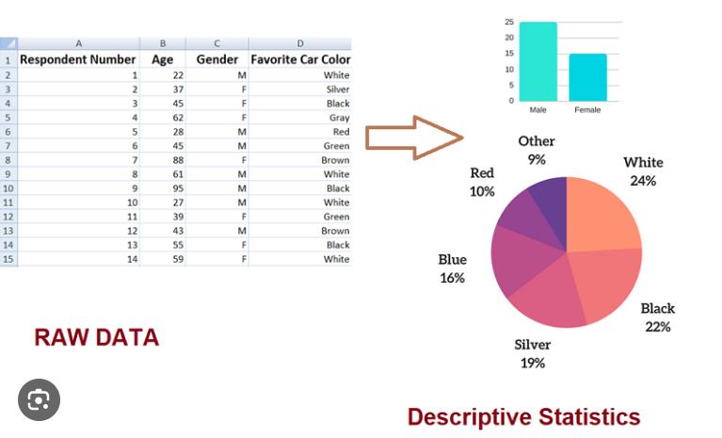

**4. Pre-Processing**

**4.1 Categorical Variables**

Preprocessing categorical variables is an important step in preparing data for machine learning algorithms. Categorical variables represent qualitative or non-numeric data, such as categories, labels, or groupings. Preprocessing these variables involves transforming them into a numerical format that can be easily understood and processed by machine learning algorithms.

Here are some common techniques for preprocessing categorical variables:

* Label Encoding: Label encoding assigns a unique numeric label to each category in a variable. Each category is mapped to a corresponding integer value. This technique is suitable for ordinal variables where the categories have a specific order or rank. However, label encoding may introduce unintended ordinality where none exists in the data.
* One-Hot Encoding: One-hot encoding, also known as dummy encoding, creates binary variables for each category in a categorical variable. Each category is transformed into a separate binary column, where a value of 1 indicates the presence of the category, and 0 indicates its absence. One-hot encoding is suitable for nominal variables without any inherent order or hierarchy.
* Ordinal Encoding: Ordinal encoding assigns numeric values to categories based on their relative order or rank. This technique is appropriate when the categories have an inherent order or if the variable is a combination of both nominal and ordinal values. Each category is assigned a unique numeric value based on its order or importance.
* Target Encoding: Target encoding, also known as mean encoding, replaces each category with the mean of the target variable for that category. It is particularly useful for classification problems, as it captures the relationship between the categorical variable and the target variable. However, target encoding may be prone to overfitting if not properly regularized.

**4.2. Numeric Variables**

Preprocessing numerical variables is an important step in preparing data for machine learning algorithms. While numerical variables are already in a numeric format, preprocessing helps to standardize or transform them to ensure they are suitable for the chosen machine learning algorithm.

Most popular techniques are discussed below:

* Standardization: Standardization, also known as Z-score normalization, scales numerical variables to have a mean of 0 and a standard deviation of 1. It involves subtracting the mean of the variable from each data point and then dividing by the standard deviation. Standardization ensures that variables with different scales and units have a comparable range, which can be important for algorithms that are sensitive to scale.
* Min-Max Scaling: Min-Max scaling transforms numerical variables to a specific range, typically between 0 and 1. It involves subtracting the minimum value from each data point and then dividing by the difference between the maximum and minimum values. Min-Max scaling preserves the relative relationships between data points and is useful when you want to constrain variables to a specific range.
* Feature Scaling: Feature scaling ensures that all numerical variables are on a similar scale. It involves scaling variables to a specific range or unit magnitude. Feature scaling can be beneficial for algorithms that use distance-based calculations, such as clustering or k-nearest neighbors.
* Log Transformation: Log transformation applies the natural logarithm to numerical variables. It is useful when the variable has a skewed distribution, and a log transformation can help make the data more symmetric. Log transformation can also help stabilize the variance of variables that exhibit heteroscedasticity.