The construction of both the machines I,e the motor and the generator is almost similar. In DC, there is no constructional difference between the generating and the utilizing machine. Similarly, in AC, both the utilizing and the generating machines have the same constructional features. But, the construction of these two machines differs at a point I,e while using AC and DC. In this article, we shall discuss the basics of what is utilizing and generating machine, and the major differences between a motor and a generator.

**What is Motor?**

It is a device that transforms the form of the input electrical energy to an output mechanical energy. It is mainly used in household and industrial applications. Depending upon the type of input applied, these are categorized into AC and DC type. If the [rotor](https://en.wikipedia.org/wiki/Rotor_(electric)) winding is given a supply of DC, then it acts as a DC type. If it is supplied alternating current, then it acts as an AC type.

**What is a** [**Generator**](https://www.watelectrical.com/electrical-generator-working-types-and-applications/)**?**

It is a device that transforms the form of the input mechanical energy to an output electrical energy. It is mainly used in power stations for the generation of electricity. Depending on the devices used in the armature core it acts as AC and DC type machine. If the armature uses commutator, it acts as a DC type and if it uses slip rings, then it acts as an AC type.

**Difference Between Motor and Generator**

The working of both these machines will be different. The input given to these machines will be electrical input for the former and mechanical input for the latter. The working of these machines is explained in detail by considering the following figures.

The construction of these machines is similar in DC type and in AC type. In DC machines, the commutator is used whereas in AC type slip rings are used. The commutator is used for changing the current direction from alternating to unidirectional in the case of a DC generating machine. The same commutator is used to alter the current direction in the coil in the case of a DC utilizing the machine.

In AC machines, instead of a commutator, slip rings are used. These rings are used to maintain the current alternating in the case of an AC generating machine whereas these are used to deliver the continuous alternating current in the case of an AC utilizing machine.

The working of the DC generating machine is shown in the figure below.

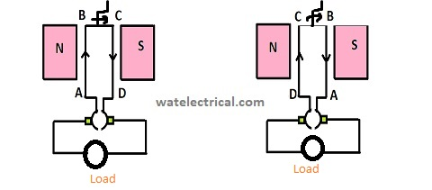

DC Generator Working

As the coil is rotated with the help of a handle, it cuts the magnetic lines of flux and induces an emf. The emf induced will be maximum when the coil is parallel to the magnetic field and no emf is induced when it is perpendicular. This induced emf develops armature flux in the air gap and develops torque to rotate the rotor.  The current in the coil is made unidirectional with the help of a commutator that collects the current from the armature. The generated voltage will be unidirectional and is fed to the load to be utilized.

The working of the DC motor is shown in the figure below.

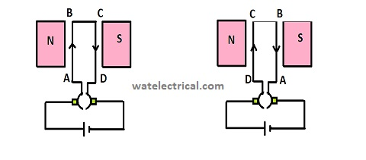

DC Motor Working

The input dc supply is given to the armature winding placed on the rotor bars. Now, the coil experiences a force, due to the principle of Lorentz force equation I,e a current-carrying conductor under the influence of a magnetic field experiences a force. The direction of this force is found by Fleming's Left-hand rule. The commutator is used to alter the current in the coil placed under the magnetic field. Otherwise, no force will be generated upon the coil. So, commutator plays a crucial role in the generation of torque in this type of machine.

The working of the AC generating machine is shown in the figure below.

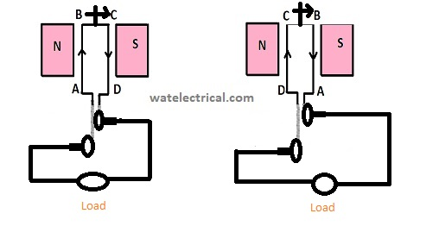

AC Generating Machine Working

When the coil is rotated with the help of a prime mover inside the magnetic field, some emf will be induced. This induced emf generates armature current and this, when interacted with flux, produces armature flux. This flux is responsible for the generation of torque in the machine. Here, in this machine, the alternating current generated flows through the slip rings and is further carried to brushes and then to the load.

The working of the AC motor is shown in the figure below.

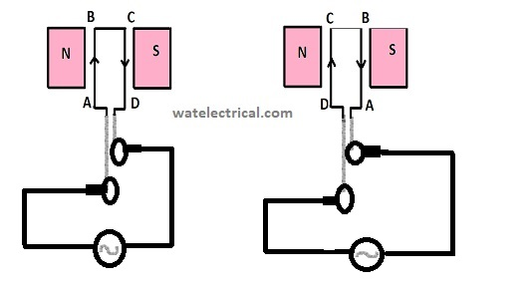

AC Utilizing Machine Working

In this type of machine, the alternating current is supplied to the coil through the slip rings. The current-carrying conductors as under the influence of the magnetic field experienced some force that develops torque which in turn rotates the rotor.

Thus, in this article, we had an overview of what are the basic rotating machines, and also we had studied the difference between their operations. Here is a question for the readers, what is the role of the commutator in any machine?

**Picture Credit**

[ResearchGate](https://www.researchgate.net/figure/Wind-turbine-emulation-through-computational-interface-using-motor-and-generator_fig1_322565584)