**Question1**: Install Power BI Desktop and share the final screenshot of the report view page which appears when power desktop starts.

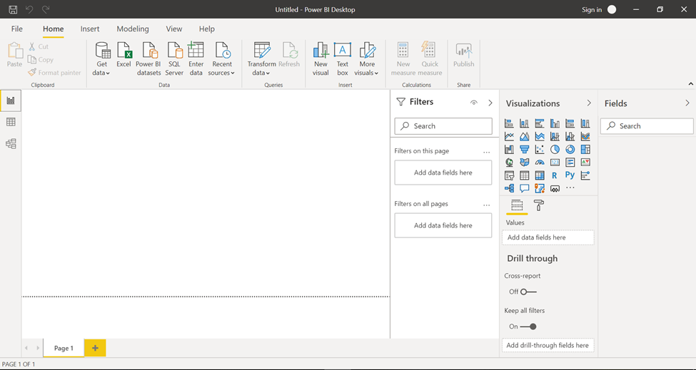

**Question2:** Prepare a document and with the following screenshot **– Report View**



**− Data View**

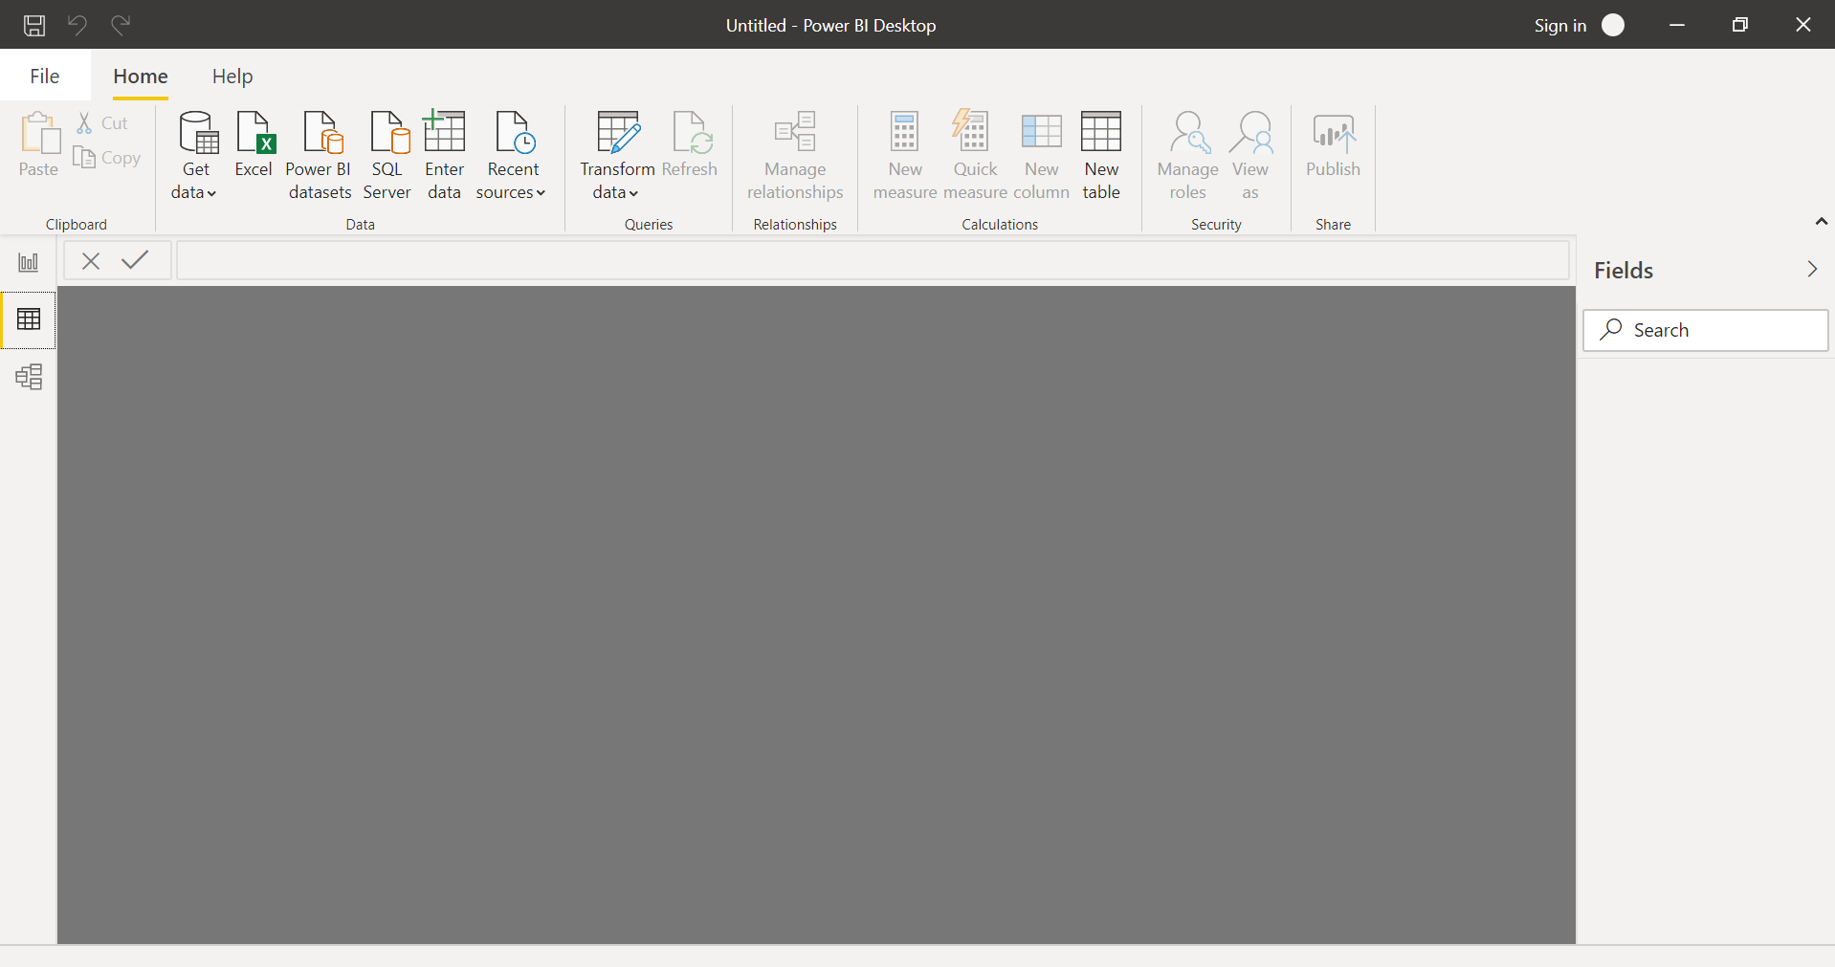

**− Model View**

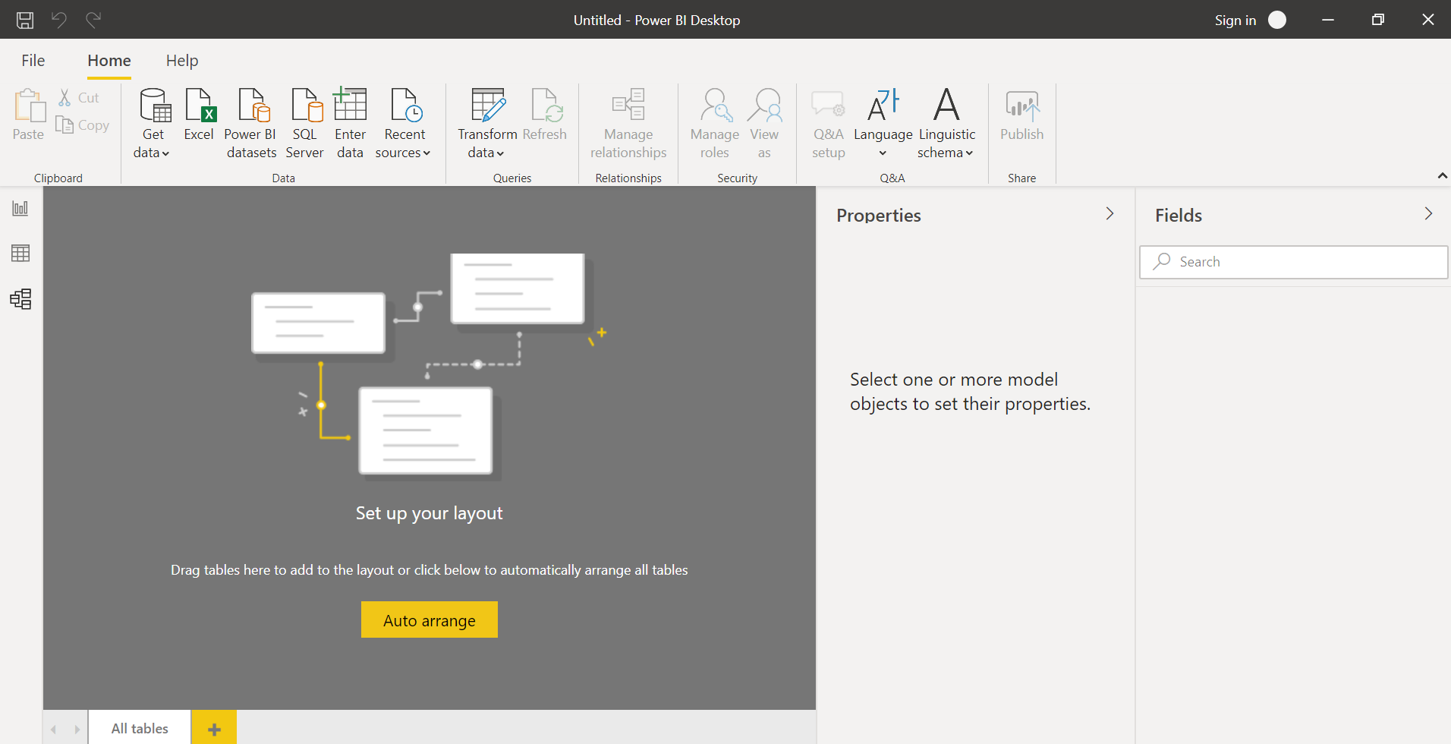

**− Power Query Editor**

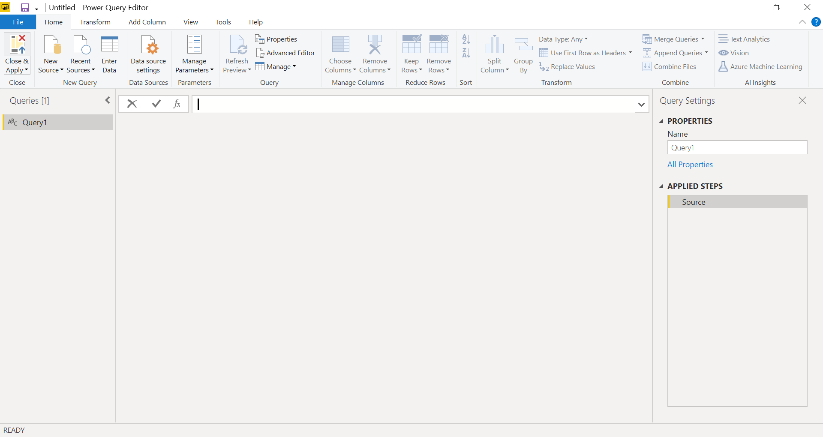

**− Advance Editor**

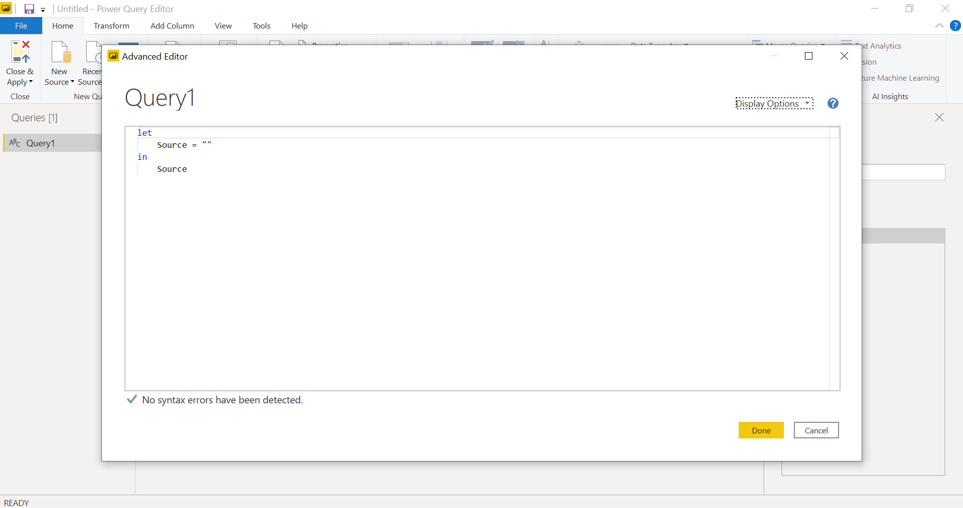

Prepare a document with details of the following along with their price − Power BI Desktop − Power BI Pro − Power BI Premium

**Power BI Desktop:-** -

Free version of Power BI

Can connect and import data from cloud-based and on-premises sources.

Auto-detect that finds and creates data relationships between tables and formats.

Has certain limitations like no API embedding, no application workspaces.

Free

**Power BI Pro:-** -

Power BI Pro is the full version of Power BI. –

Pro users are licensed individually and participate fully in the use of Power BI – both the creation of content and the consumption. –

All Pro users can connect to hundreds of data sources on-premises and in the cloud, create interactive reports

Share that content with other Pro users, and consume content shared by others.

Price:- $9.99 per month

**Power BI Premium:-** - It gives licensing capacity for your content rather than licensing all users of that content.

- Content (datasets, dashboards, and reports) is stored in Premium and can then be viewed by as many users as you want, without additional per-user costs.

- These users can only view content, not create it. Viewing includes looking at dashboards and reports on the web, in our mobile apps, or embedded in your organization’s portals or apps. The creators of content in Premium still need their own Pro licenses.

- It comes with Increased data capacity limits and maximum performance. –

Price:- $4995 per month