ROAD SAFETY DATA ANALYSIS

# **Visualisation Context**

* **Question 1:**

How does the cities score on the three categories – Caution, Compassion and Compliance?

* **Question 2:**

How does the cities compare on the various sub questions under the above mentioned categories

* **Question 3:**

What are the critical observations on the driving habits?

Approach:

* We will analyse the driving habits of Indian drivers based on the data collected from the survey participants from the 10 cities across the five zones – East, West, North, South and Central.
* We will visualize the highlights of the data
* We will compare the driving habits across metros and non-metros

# **Visualisations Used**

## **Map - Locations where the survey was conducted**

We have used Indian map to display the location of the cities where the survey was conducted.

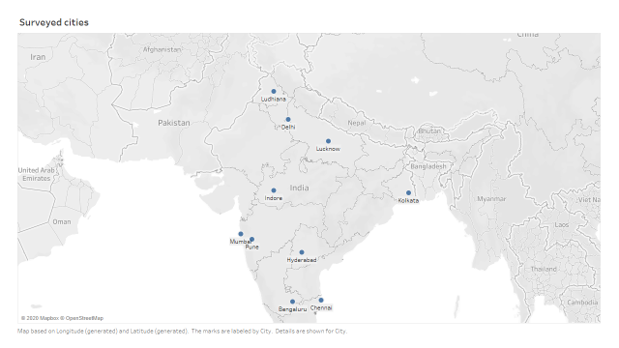

## **Text boxes – Highlights (Question 3)**

We have used text to display the numbers/percentages for the critical questions in the survey across the three categories – Caution, Compliance and compassion

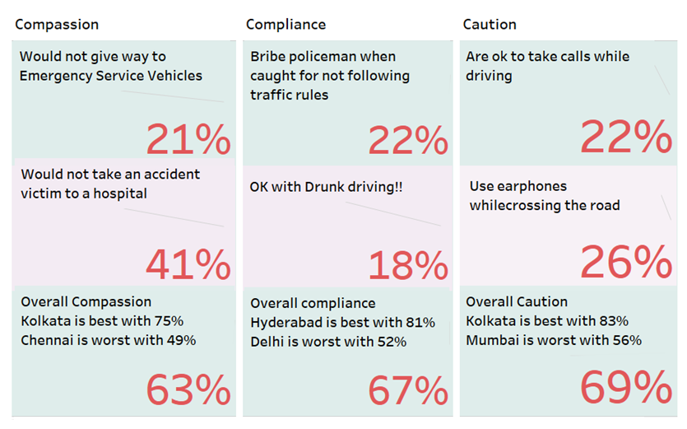

## **Donut chart – Ranking of the cities overall**

We have used donut charts to show the ranking of the cities along with their scores, grouped by metros and non-metros

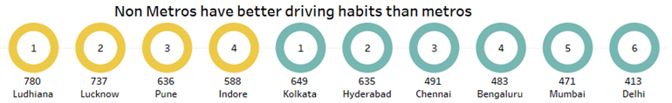

## **Horizontal bar chart – Ranking of the cities overall**

We have used horizontal bar chart show the ranking of the cities with icons for winners and worst performers, grouped by metros and non-metros

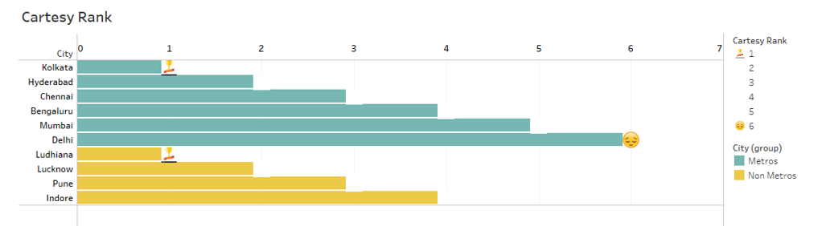

## **Lollipop chart – Ranking of the cities detailed (Question 1)**

We have used lollipop chart to show the ranking of the cities on the three categories – caution, compassion and compliance

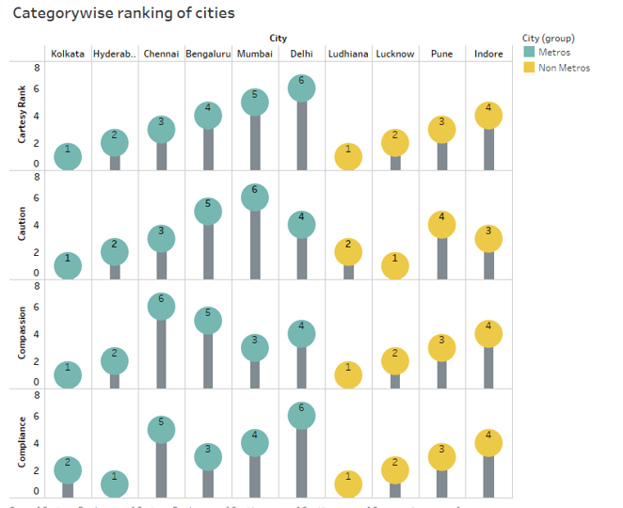

## **Vertical chart – Scores on various parameters (Question 2)**

We have used vertical bar chart to display the scores of the cities on the various sub questions under the three categories – caution, compassion and compliance

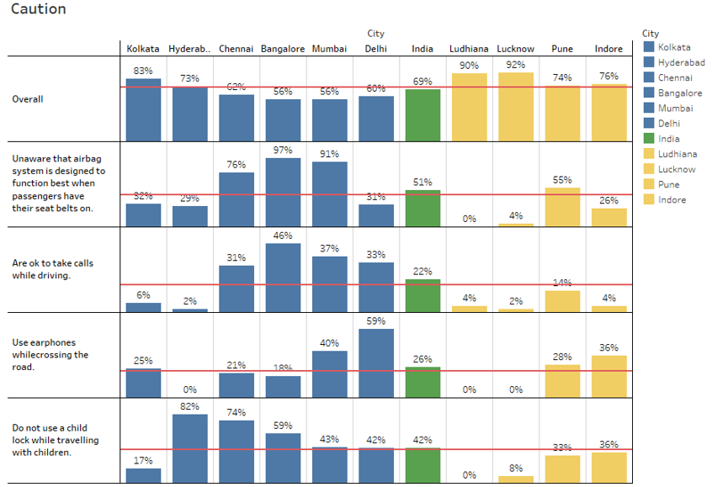

## **Pie chart – Survey participants type**

We have used pie chart to display the proportion of the type of the survey participants

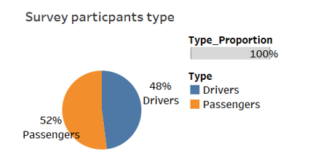

## **Dashboard – Ranking of cities**

We have created a dashboard to display the ranking and the score information – overall, detailed and also the survey participants type

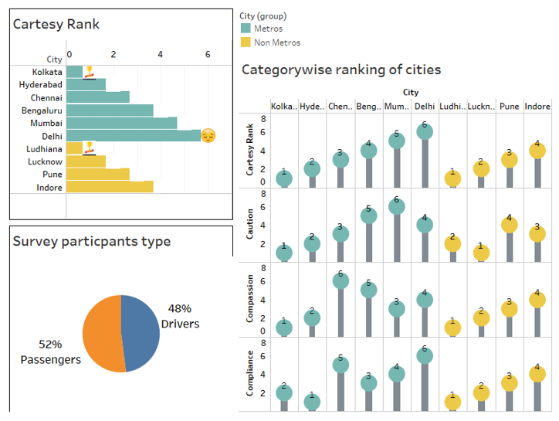

## **Dashboard – Highlights**

We have created another dashboard to display the highlights of the survey data

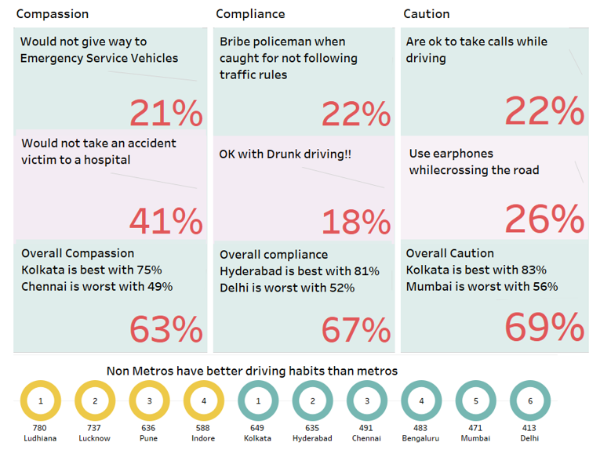

## **Story – Indian driving habits**

We have created a story with the above visualisations and the dashboard to tell a story on the Indian driving habits

