Data Analytics on New York City Current Job Posting data

# **Business Problem Understanding**

Focus on applying the data analytics concepts and share findings on following aspects:

1. What are the highest paid Skills in the US market?
2. What are the job categories, which involve above mentioned niche skills?
3. Applying clustering concepts, depict visually what are the different salary ranges based on job category and years of experience.

# **What are the highest paid Skills in the US market?**

Required skills for the job are mentioned in the following columns. Column ‘Job category’ provides the required details. We shall use that column for selecting the top 10 skills.

|  |  |  |
| --- | --- | --- |
| **Order Number** | **Column Name** | **Column Description (including the unit of measure, acronyms and range of possible values)** |
| 9 | Job Category | The occupational group in which the posted job belongs, such as: - Administration & Human Resources - Communications & Intergovernmental Affairs - Constituent Services & Community Programs - Engineering, Architecture, & Planning - Finance, Accounting, & Procurement - Health - Technology, Data & Innovation - Legal Affairs - Building Operations & Maintenance - Policy, Research & Analysis - Public Safety, Inspections, & Enforcement - Social Services |
| 16 | Job Description | The description of the job responsibilities for the position listed in the job posting. |
| 17 | Minimum Qual Requirements | Minimum qualifications (“minimum qual”) required for the position listed in the job posting. |
| 18 | Preferred Skills | Additional, preferred skills desired by the hiring agency for a given position. |
| 19 | Additional Information | Additional information provided by the hiring agency. |

Below columns provide the salary details.

|  |  |  |
| --- | --- | --- |
| **Order Number** | **Column Name** | **Column Description (including the unit of measure, acronyms and range of possible values)** |
| 11 | Salary Range From | The lowest salary on a job posting for a position within the salary band for the related civil service title. |
| 12 | Salary Range To | The highest salary on a job posting for a position within the salary band for the related civil service title. |
| 13 | Salary Frequency | The frequency of proposed salary. Possible salary frequency values include “hourly”, “daily”, and “annual”. |

We take the average of the ‘Salary Range From’ and ‘Salary Range To’ to get a single salary value for the job category.

We also convert the Hourly and Daily salaries to Annual so that the salaries can be compared.

**Following are the skills that are most sought after:**

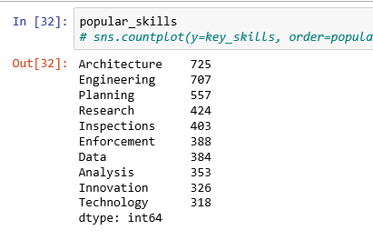

**Following are the skills that are highly paid:**

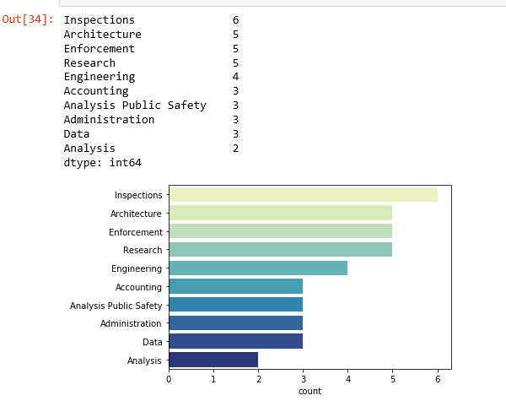

# **What are the job categories, which involve above mentioned niche skills?**

Following are the job categories that contain the above mentioned skills

|  |  |
| --- | --- |
| **job category** | **average salary** |
| Administration & Human Resources Finance, Accounting, & Procurement Building Operations & Maintenance | 218587 |
| Engineering, Architecture, & Planning Maintenance & Operations | 198518 |
| Engineering, Architecture, & Planning Finance, Accounting, & Procurement Building Operations & Maintenance Public Safety, Inspections, & Enforcement | 196043 |
| Health Policy, Research & Analysis Public Safety, Inspections, & Enforcement | 128695 |
| Engineering, Architecture, & Planning Policy, Research & Analysis Public Safety, Inspections, & Enforcement | 128248 |
| Engineering, Architecture, & Planning Technology, Data & Innovation Public Safety, Inspections, & Enforcement | 128248 |
| Communications & Intergovernmental Affairs Engineering, Architecture, & Planning Technology, Data & Innovation Policy, Research & Analysis | 125000 |
| Administration & Human Resources Finance, Accounting, & Procurement Technology, Data & Innovation Building Operations & Maintenance Policy, Research & Analysis Public Safety, Inspections, & Enforcement | 118287 |
| Constituent Services & Community Programs Communications & Intergovernmental Affairs Policy, Research & Analysis | 116900 |
| Administration & Human Resources Constituent Services & Community Programs Health Legal Affairs Public Safety, Inspections, & Enforcement Social Services | 104552 |

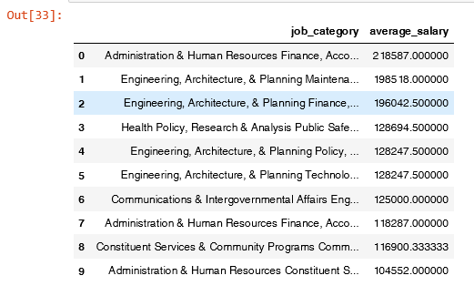

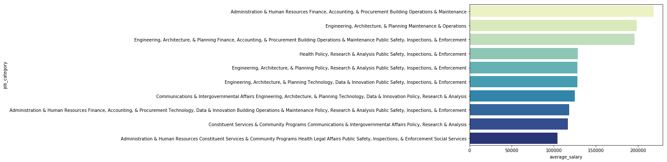

# **Applying clustering concepts, please depict visually what are the different salary ranges based on job category and years of experience.**

We drew a histogram with salary ranges in 20 bins, against the number of job categories. We can see that most of the job categories are in the range of 50000 to 100000 which the salary at 60000 having around 500 job categories

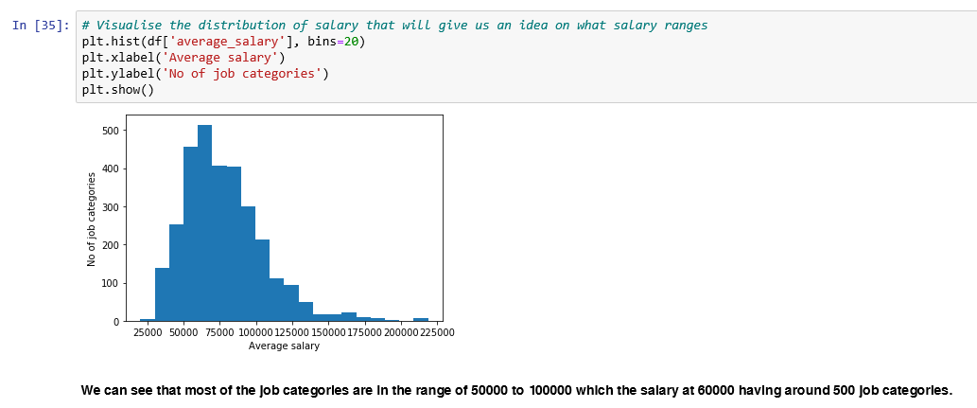

Let us try to draw the scatter plot between the average salary and the job category. We have hidden the job categories in the x axis as that will clutter the chart. From the scatter plot, we can see that, the salaries for the different job categories are in the range of 50000 to 100000, with some outliers in the range of 220000.

