**Online Reality Show**

The images given below describes how the website appears for those who haven't logged in and for the guest users.

**Home Page**

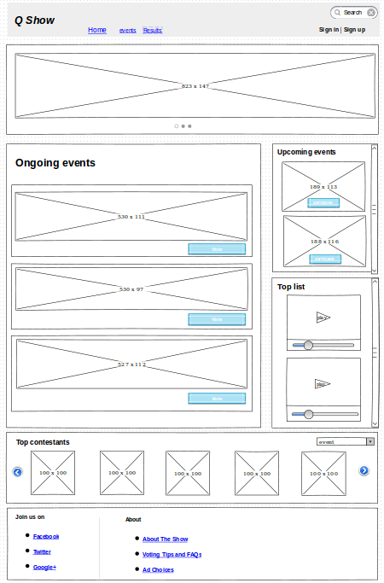

**Fig. 1 Home page**

The above one is the image of home page. Its header consists of a search option to find the user requirements as fast as possible. Then there is option for sign up and sign in for user registration and login purposes respectively. The home page lists the ongoing events, upcoming events and list of top contestants. Ongoing events shows the current event that’s going on. And on clicking the vote button, the web page is redirected to the corresponding event page and from there, user can vote for contestants. User registration and login is must for voting. On clicking the image redirects to that event page. On clicking the “ On going events “ redirects to a page showing more details of current running events. Upcoming events list the events that are going to happen and on clicking it, the web page showing more details of the upcoming events is shown. On clicking participate in that event, the webpage of that particular event is shown and in order to participate logging in is must. Top rated videos shows the most liked and rated performances of the contestants. “ Top contestants “ lists the toppers in each event. On clicking on results in the menu will take us to result page.

**Ongoing event page**

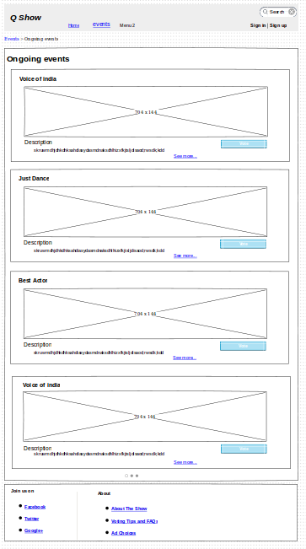

**fig. 2 on going events page**

* Shows the current running events.
* On clicking the image or the event name or vote button leads to the corresponding event page.

**Each Ongoing Event page**

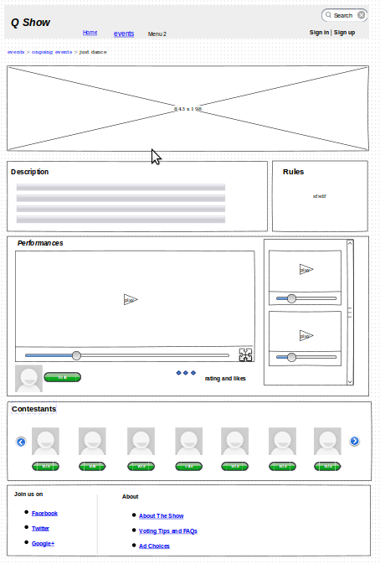

**fig.3 each on going event**

* Shows details of the event.
* Includes description and rules.
* Shows the performances of that event.
* Has options for rating the video.
* Click on vote button to cast vote(only if you are signed in)

**Upcoming Events Page**

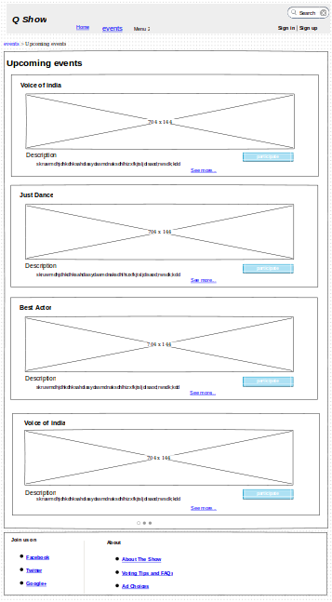

**fig. 4 upcoming events page**

* Shows the upcoming events.
* On clicking the image or the event name or participate button leads to the corresponding event page.

**Each Upcoming Event page**

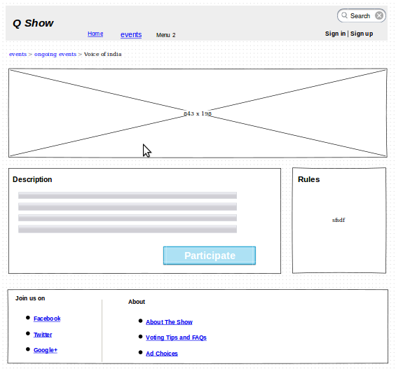

**fig 5. each upcoming event page**

* Shows details of the event.
* Includes description and rules.
* Clicking on participate button leads the user account if they are logged in else to the login/registration page.

**Sign in / Sign up**

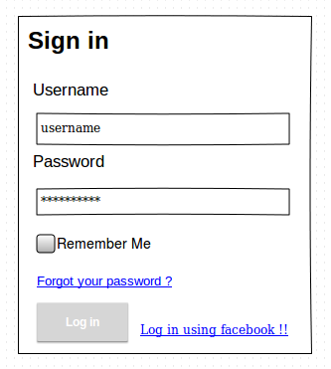

**fig 6. sign in**

The above image is user sign in. It contains

* Fields to enter Username and Password.
* Option to log in using facebook.

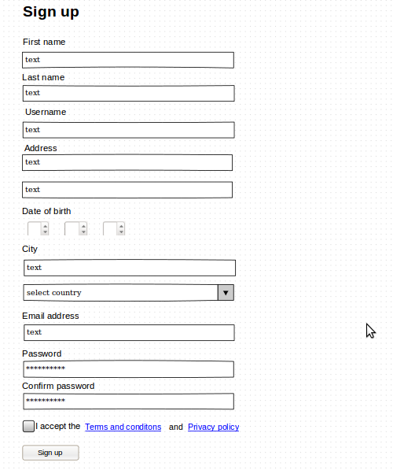

**fig. 7 sign up**

The above image is of sign up.

* It asks user for certain details and provides a user account on clicking sign up button.
* Also contains options to know the terms and conditions and the privacy policy of the site.

**Result page**

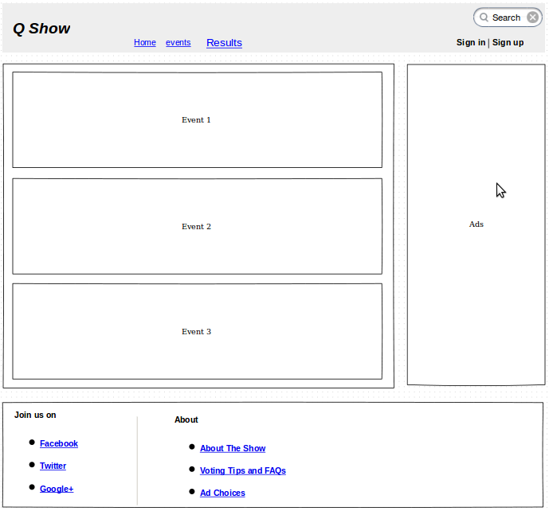

**fig. 8 Results**

* Shows the completed events.
* Click on each event to obtain their corresponding results.

**User Account Details**

**User Account** :

The following set of images will describe the administrator user’s basic layout and basic functionalities that will be developed in MVP.

1. User Profile :

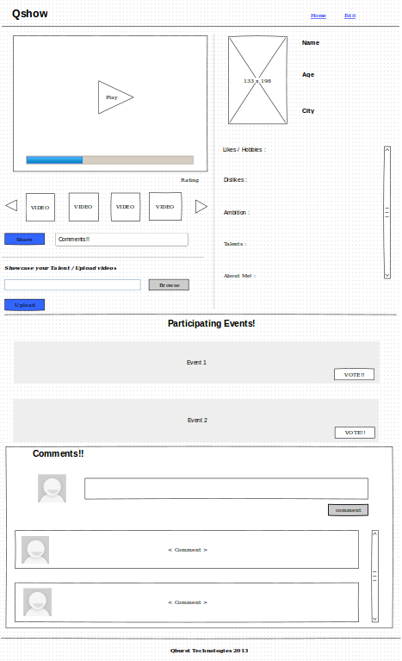

Fig 1 : User Profile Page

The page above shows the Profile page of the User. It consists of functionalities such as

* Share Videos

Users can share videos to social media sites such as Facebook, Twitter etc.

* Upload Videos

Users can upload his/her videos to his profile to showcase his/her talents.

Other users can view all the uploaded videos.

* Participating Events

Users participating event list is shown.

* Comments

Users can comment on the profile or on his/her performance. All comments are public.

2. User Profile Edit :

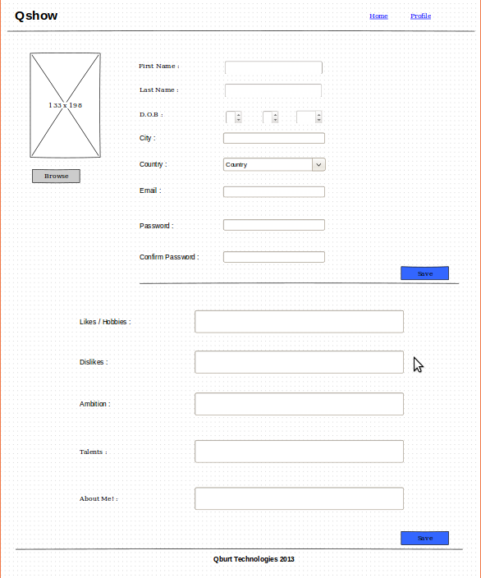

Fig 2 : User Profile Edit

In this page, User can edit his/her basic informations, password and display picture.

3. User Public Profile :

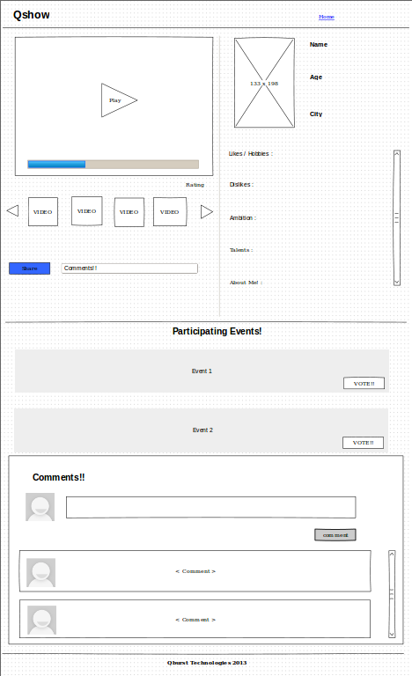

Fig 3 : User Public Profile

This is the public profile page of a user which can be seen by all other users and guest users. The video upload functionality is removed from this page. Other functionalities remains same.

* Share Videos

All users can share videos to social media sites such as Facebook, Twitter etc.

* Participating Events

Users participating event list is shown. Vote option is also provided.

* Comments

Anyone can comment on the profile or on his/her performance. All comments are public.

**Administrator Account Details**

The following set of images will describe the administrator account’s basic layout and basic functionalities that will be developed in MVP.

1. Administrator Home : 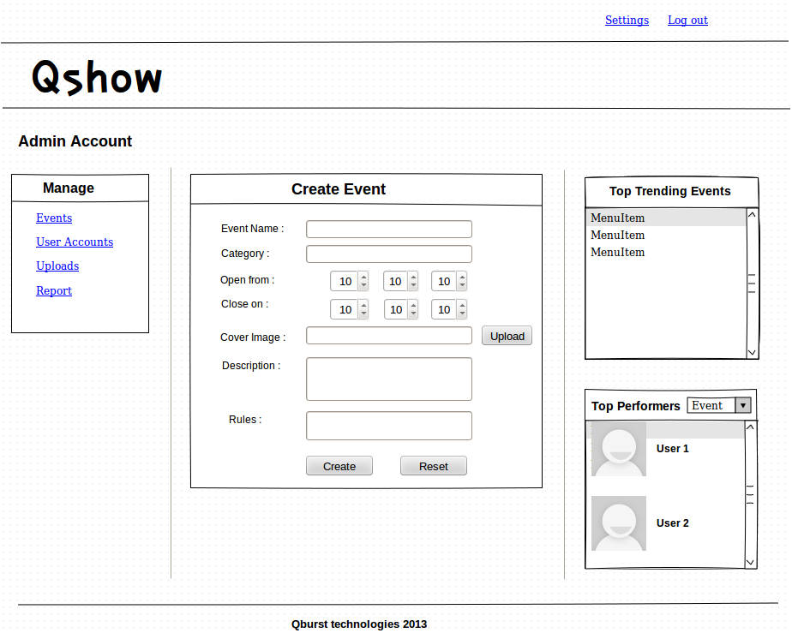

Fig 1 : Administrator Home Page

The page above shows the homepage of Administrator. It consists of functionalities such as

* Manage

It consists of resources that should be managed by the Administrator. By using these functionalities the Admin will be able to edit, delete,block any of the resources such as Events, User accounts etc.

* Create Event

Events can only be created by the Admin. So by using this functionality

the Admin will be able to create event. And set it out to public.

2. Event Management :

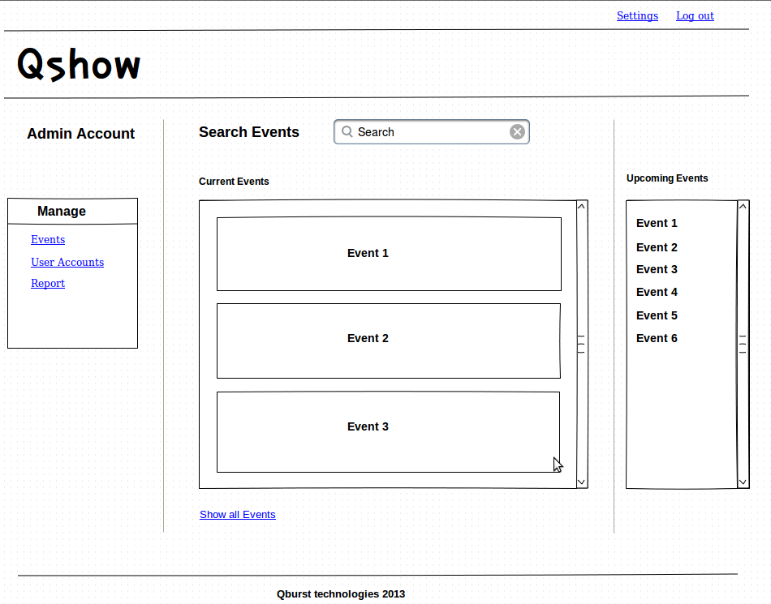

Fig 2 : Event Management Page.

On clicking ‘Events’ under ‘Manage’ the Event management page is obtained. Here the admin will be provided with entire list of ongoing events and upcoming events. On clicking any of the event that is shown, Admin can edit that particular event as shown in the following figure

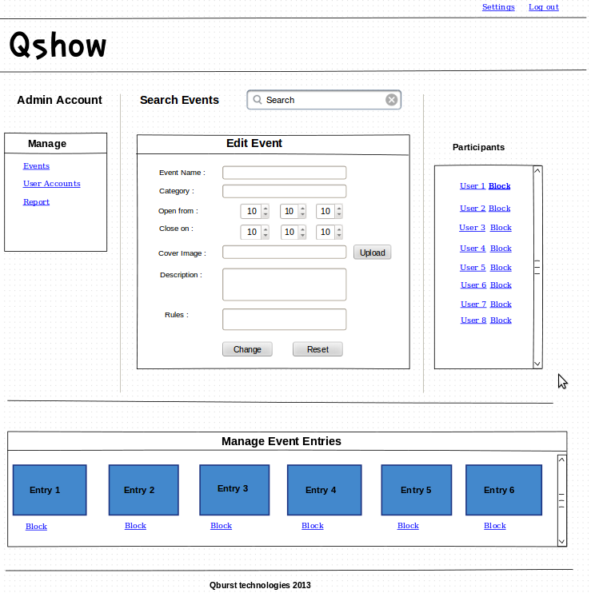

Fig 3 : Edit Event Page

The admin is also provided with the option of blocking participants from the event as well as can block any of the event entries.

3. Managing User account

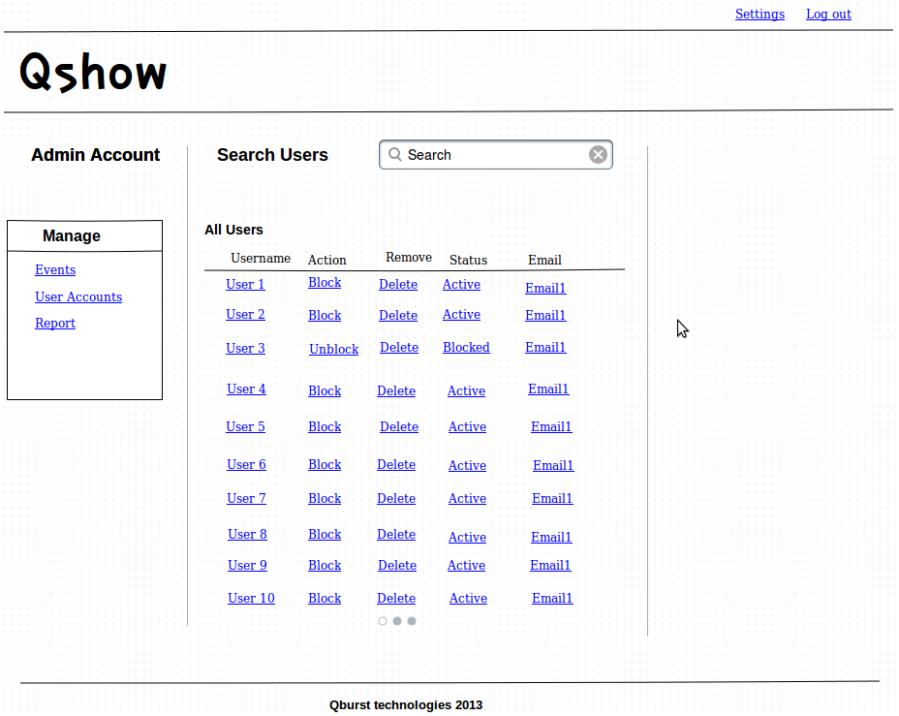

Fig 4 : User Account Management Page

The above page provides the Admin with the ability to manage user accounts, the admin can block, delete. Admin can also have control over the user’s data and his uploads by clicking on the user name on this page.

4. User data Edit Page :

Here the Admin can edit the user data and even remove the contents uploaded by the user. 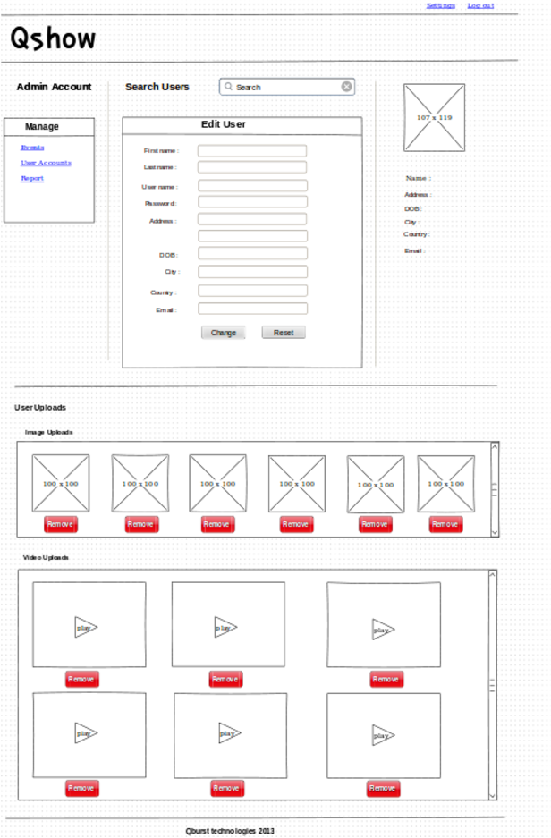

Fig 5: User Date Edit Page