Question:

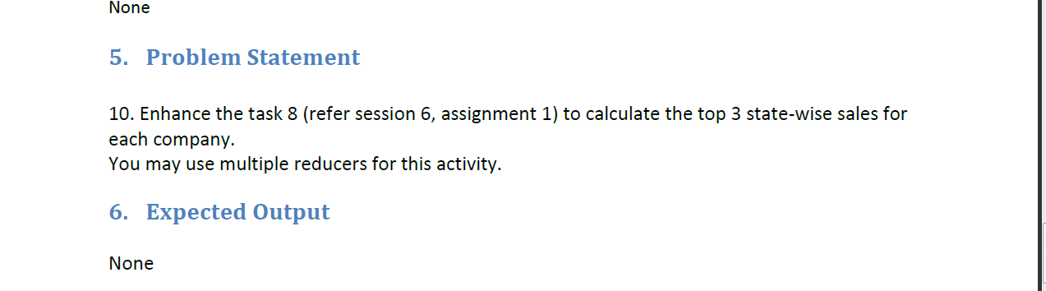

Input:

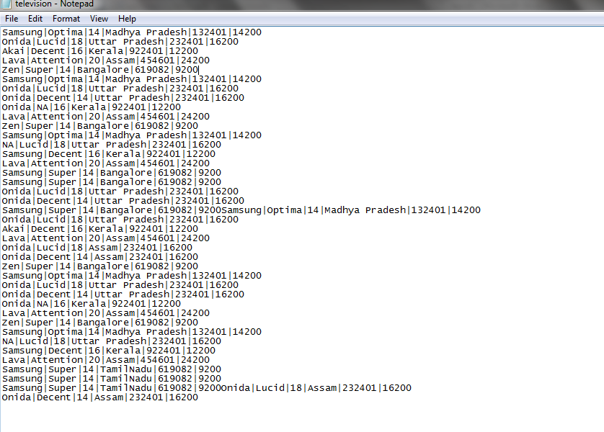

Command:

hadoop jar /home/acadgild/Desktop/Test.jar /user/acadgild/television.txt /user/acadgild/out_sold_company

Output:

