SMART NON-INVASIVE GLUCOSE MONITORING USING NIR AND AI INTEGRATION
Coimbatore Institute of Technology, Coimbatore - 14

Chapter 1: Abstract and Inroduction
Diabetes is a major global health concern affecting more than 830 million people, caused by the body’s inability to produce or effectively use insulin. Continuous glucose monitoring is essential for managing the condition, but existing methods like finger-prick tests are invasive, painful, and inconvenient, often leading to irregular monitoring and poor control of blood sugar levels. These limitations highlight the urgent need for a more comfortable, accurate, and user-friendly alternative for regular glucose tracking.
This project presents a non-invasive, AI-driven glucose monitoring system that utilizes Near-Infrared (NIR) spectroscopy to measure glucose concentration through the skin. In addition, Heart Rate Variability (HRV) and Galvanic Skin Response (GSR) are analyzed to detect psychological stress, a key factor influencing glucose fluctuations. The system processes data using a microcontroller integrated with AI algorithms for real-time glucose estimation and stress analysis. By providing a compact, wearable, and stress-aware solution, this project aims to enhance accuracy, reduce discomfort, and support effective long-term diabetes management.

Chapter 2: Review of Related Studies
Recent studies have focused on developing non-invasive glucose monitoring systems by integrating optical sensors, physiological data, and artificial intelligence. These advancements aim to improve accuracy, comfort, and real-time health monitoring for diabetic patients.
- Integration of Optical Sensors and AI:
Modern glucose monitoring systems benefit from combining optical sensing with artificial intelligence (AI), improving both precision and ease of use for continuous glucose tracking.
- NIR Spectroscopy-Based Models:
Studies by Santoso et al. (2025) and Priyadarshini et al. (2024) demonstrated that Near-Infrared (NIR) spectroscopy, coupled with deep learning and linear regression models, can estimate glucose levels through the skin without requiring blood samples, offering a painless alternative to traditional methods.
- Stress and Activity-Aware Glucose Prediction:
Sevil et al. (2021) emphasized that physical activity and psychological stress significantly affect glucose variation. Their models incorporate these behavioral and physiological parameters to enhance prediction accuracy in real-world scenarios.
- Tiny Machine Learning for Wearables:
Diab and Rodriguez-Villegas (2022) introduced the use of Tiny Machine Learning (TinyML), allowing AI models to run directly on microcontrollers. This reduces power consumption, minimizes latency, and eliminates the need for cloud connectivity—crucial for portable, continuous monitoring.

Chapter 3: Proposed System Architecture
The proposed AI-based Non-Invasive Glucose Monitoring System integrates optical, electronic, and computational modules for real-time glucose prediction.
System Workflow
- Signal Acquisition
The NIR module emits infrared light (940–1550 nm) through the skin using high-intensity LEDs. A photodiode captures the reflected light intensity, which varies with glucose concentration.
- Signal Conditioning and Processing
The captured signal is amplified and filtered through a transimpedance amplifier (TIA) to reduce noise and convert the photodiode’s current into voltage. The system ensures stable operation under different lighting and temperature conditions.
- Microcontroller Unit (ESP32)
The ESP32 microcontroller digitizes the conditioned signal using its built-in 12-bit ADC and communicates with cloud or mobile platforms using Wi-Fi/Bluetooth connectivity. For enhanced accuracy, an external ADS1115 16-bit ADC is used to detect fine variations in signal amplitude.
- Machine Learning and AI Integration
The system employs a CNN-based model to analyze optical intensity variations. The attention mechanism identifies features strongly correlated with glucose concentration and filters out noise.
- Mobile Application
The application displays real-time glucose data, trends, and stress levels. Built-in AI algorithms provide personalized health insights and alerts to improve daily glucose management.

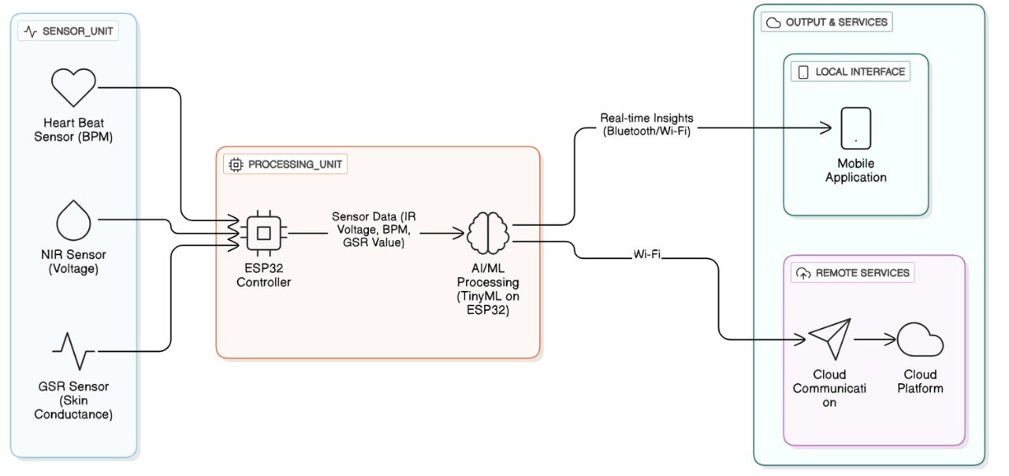

Chapter 4: Algorithm And Data Processing
The Convolutional Neural Network–Attention Hybrid Model (CNN-AHM) analyzes optical signal variations to estimate glucose levels. It combines feature extraction, attention weighting, and regression prediction to improve accuracy.
The underlying mechanism follows the Beer–Lambert Law, which relates light absorption to glucose concentration:
$$A=εcl$$
Where:
- $A$= absorbance
- $ε$= molar absorptivity
- $c$= concentration of glucose
- $l$= optical path length
The voltage output from the photodiode is modeled as:
$$V=k×I_{LED}×T(c)$$
where $T(c)$represents the transmitted light, inversely related to glucose concentration.
The ADC samples these voltage signals at high resolution, and machine learning algorithms map them to estimated glucose values in mg/dL. The attention mechanism improves robustness against noise caused by movement or skin variations.

Chapter 5: Validation and Experimental Results
The technical feasibility of the proposed non-invasive glucose monitoring system was validated through a series of controlled experiments. The prototype setup included an NIR sensor, GSR sensor, and heart rate sensor, interfaced with an ESP32 microcontroller for signal acquisition and AI-based analysis. The collected sensor data was processed to estimate glucose concentration using regression-based modeling.
Validation Tests Conducted:
- Optical Signal Calibration: The NIR sensor was calibrated using reference glucose solutions to determine the relationship between voltage output and glucose concentration.
- Glucose Variation Analysis: Voltage readings from the optical sensor were recorded for different glucose levels, and a linear regression model was used to derive a predictive equation.
Observation:
The experimental results (as shown in Figure 5.1) revealed a negative correlation between glucose concentration and voltage output, described by the equation:
$$V=-0.0001C+2.6746$$
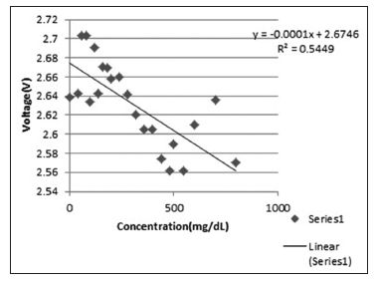
where V is the sensor voltage (V) and C is the glucose concentration (mg/dL).
The coefficient of determination ($R^{2}=0.5449$) indicates a moderately strong linear relationship between the measured variables.

Figure 5.1: Glucose Concentration vs. Voltage Relationship

Discussion: Advantages and Challenges
Key Advantages:
- Non-Invasive Sensing: Eliminates the need for blood extraction, ensuring painless monitoring.
- Cost-Effective Hardware: Uses easily available components such as ESP32 and NIR sensors.
- Real-Time Monitoring: Enables continuous glucose tracking and wireless data transmission to mobile/cloud platforms.
Challenges Identified:
- Calibration Sensitivity: Accuracy depends on proper sensor alignment and skin reflectivity.
- Environmental Effects: Variations in ambient light and temperature can affect optical readings.
- Model Optimization: Further tuning of regression and AI models is needed to enhance prediction accuracy.

Chapter 6: Conclusion and Future Trajectory
The project successfully presents an innovative approach to non-invasive glucose monitoring through NIR optical sensing integrated with AI-based data analysis. By combining NIR, heart rate, and GSR sensors with ESP32-based processing, the system provides continuous and painless glucose tracking while also assessing stress levels. The use of TinyML enables on-device analysis, ensuring low latency, privacy, and real-time performance suitable for wearable applications.
Future developments for the system aim to enhance its reliability, accuracy, and usability:
• Advanced AI Models: Incorporating deep learning techniques for adaptive calibration and personalized glucose prediction.
• Miniaturization: Designing a compact, wrist-worn prototype optimized for comfort and continuous wearability.
• Cloud Integration: Enabling secure health data storage, trend visualization, and medical analytics via IoT platforms.
• Extended Physiological Monitoring: Adding temperature and SpO₂ sensors to improve metabolic and stress correlation accuracy.
• Clinical Validation: Conducting large-scale testing to ensure accuracy across diverse populations and real-world conditions.
This project thus represents a step toward developing a reliable, affordable, and intelligent health monitoring system that empowers users to manage diabetes and stress effectively.

References

- H. A. Santoso, N. S. Dewi, Susilo, A. D. Pambudi, H. P. Suhito and I. Dehzangi, "Non-Invasive Glucose Monitoring Using Optical Sensors and Machine Learning: A Predictive Model for Nutritional and Health Assessment," in IEEE Access, vol. 13, pp. 132804-132821, 2025, doi: 10.1109/ACCESS.2025.3591505.

- J. Lee et al., "Analysis of Acute Stress Reactivity and Recovery in Autonomic Nervous System Considering Individual Characteristics of Stress Using HRV and EDA," in IEEE Access, vol. 12, pp. 115400-115410, 2024, doi: 10.1109/ACCESS.2024.3437671.

- S. Alhaddad et al., “AI-Based Noninvasive Blood Glucose Monitoring: Scoping Review,” Journal of Medical Internet Research (JMIR), 2024 scoping review focusing on AI/ML methods used in NIBGM research.

- G. Taskasaplidis, D. A. Fotiadis and P. D. Bamidis, "Review of Stress Detection Methods Using Wearable Sensors," in IEEE Access, vol. 12, pp. 38219-38246, 2024, doi: 10.1109/ACCESS.2024.3373010.

- C. Cenerini, A. Sabatini, L. Vollero and D. Pau, "Optimizing Glucose Sensor Calibration With Lightweight Neural Networks: A Comparative Study," in IEEE Sensors Letters, vol. 8, no. 9, pp. 1-4, Sept. 2024, Art no. 6010904, doi: 10.1109/LSENS.2024.3436630.

