**Application: E-Commerce Application**

1. **Introduction**
2. **Purpose**

*Define the goals and scope of the DDD documentation for the e-commerce application*

Goals:

Scope:

Objective

1. **Domain Overview:**

*Briefly describe the Online-Retail domains, including their core functionalities/tasks*

Online Order Fulfillment System

1. **Context**

*Explain the boundaries of the particular domain with can specific to their models and sub-domains*

1. **Strategic Design**
2. **Bounded Contexts**

*Define the core bounded contents for each domain created for this application*

**Bounded Context – 1 (Order)**

**Bounded Context – 2(Customer)**

**Bounded Context – 3 (Marketing**

1. **Sub-Domains and their Category**

*Identify the sub-domain for each bounded contexts*

*Identify the core, generic and supporting sub-domains*

*Prioritize the development efforts and determine the appropriate strategies for each sub-domains*

*Describe the specific responsibilities and boundaries*

**Bounded-Context (Order)**

Product Service (core)

Order Service (core)

Payment Service (Generic)

Shipping Service (core)

**Bounded Context 2 (Customer)**

.

.

**Bounder Context 3 (Marketing)**

.

1. **Context Map**

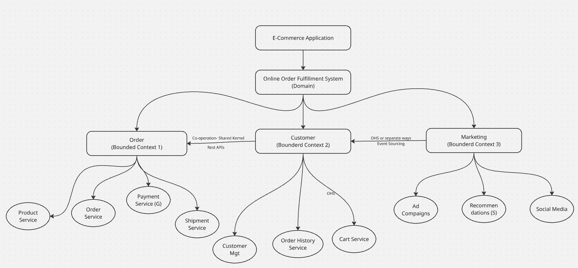

*Diagrammatic representation of context and its relationships*

*Specify the relationships (C-S, Conformists, Shared kernel, ACL, OHS)*

*Document the interactions and data flow between the contexts*

1. **Tactical Design**

*Add all the sub-domains with the attributes of Tactical design*

*Define each by giving some lines of summary*

1. **Product Service**

**Entities:**

Product

**Value Objects:**

Measurements

**Aggregates**

Product (Product + Measurements)

**Domain Events**

ProductAdded

ProductPriceChanged

ProductOutofStock

**Domain Service**

ProductCatalogService

ProductSearchingService

**Application Services**

CreateProduct

UpdateProdct

ChooseProduct

**Repository**

ProductRepository

**Factory**

ProductFactory

1. **Customer**

**.**

**.**

**.**

1. **Marketing**
2. **Illustrative Diagram**

*Complete diagram on Domain, Sub-domains, attributes and its relationships are clearly represented here*

1. **Implementation Considerations**
2. **Technology Choices**

*Discuss technologies and frameworks that align with the DDD design (ORM, JPA, Hibernate, Messagin, JMX, JMS)*

1. **Architectural Patterns**

*Describe the patterns wants to be considered for application development*

*(CQRS, Event Sourcing, Cicuit Breaker, SAGA, Canary, A/B Testing, Kafka RabbitMQ)*

1. **Testing Strategies:**

*Outline the testing strategies: Unit Testing, Integration Testing, Slice Testing and Method Testing*

1. **Security Considerations**

AuthN and AuthZ (LDPA, OAuth 2.0, JWT)

Encryption (Data in Rest and Data in Transit)

**Code Snippets (Illustrative)**

class Product{  
adas

Asda

Asdad

}

**Glossary (Ubiquitous Language)**

Bold – Titles

Normal- Values

Italic – Instructions or Content to be