**Application: E Commerce Application**

1. **Introduction**
2. **Purpose:**

*Define the goals and scope of the DDD documentation for the e-commerce application*

Goals:

Scope:

1. **Domain Overview:**

*Briefly describe the e-commerce domains, including their core functionalities / tasks*

*Ex: Online Order Fulfillment system / Customer Management / Product Inventory Management*

1. **Context:**

*Explain the boundaries of the particular domain with can specific to their models and sub-domains*

1. **Strategic Design**
2. **Bounded Contexts**

* *Define the core bounded contexts for each domain created for this application*

**Bounded Context 1 (Order)**

Summary/Functionalities

**Bounded Context 2 (Customer)**

Summary/Functionalities

**Bounded Context 3 (Marketing)**

Summary/Functionalities

1. **Sub-Domains with their Category**

* *Identify the sub-domains for each bounded contexts*
* *Identify the core, generic and supporting sub-domains*
* *Prioritize the development efforts and determine the appropriate strategies for each sub-domains*
* *Describe the specific responsibilities and boundaries*

**Bounded Context 1 (Order)**

Product Service (core)

Order Service (core)

Payment Service (Generic)

Shipping Service (core)

…

…

1. **Context Map**

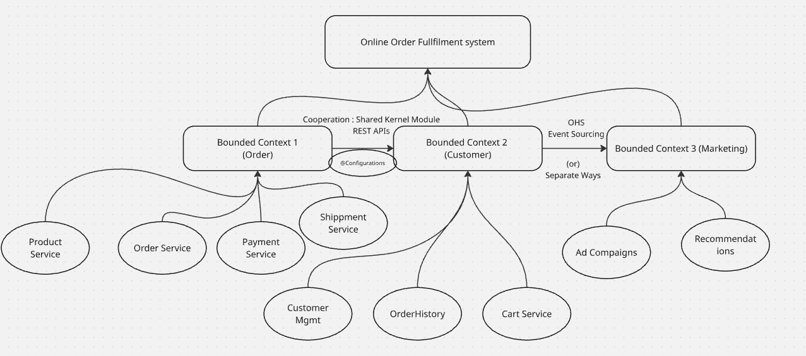

* *Diagrammatic representation of context and its relationships*
* *Specify the relationships (C-S, Conformist, ACL, OHS)*
* *Document the interations and data flow between the contexts*

**Ex: Customer depends on the Products for Product Information in Cooperation: Partnership relationship**

1. **Tactical Design**

* *Add all the sub-domains with the attributes of Tactical design*
* *Define each by giving some lines of summary*

1. **Product Service**

Entities:

Product

Category

Value Objects:

Price

Measurements

Aggregates:

Product

Category as child, Price and Measurements as value objects

Domain Event:

ProductAdded

ProductPriceChanged

ProductOutofStock

ProductRemoved

Domain Services:

ProductCatalogService

ProductSearchService

Application Services:

CreateProduct

UpdateProduct

GetProduct

Repository:

ProductRepository

Factory:

ProductFactory

1. **Order Service**
2. **Payment Service**
3. **…**
4. **…**
5. **Illustrative Diagram**

***Complete diagram with all the tactical design elements and attributes added to the domain models***

1. **Implementation Considerations**
2. **Technology Choices**

*Discuss technologies and frameworks that align with the DDD design (ORM, Hibernate, Messaging, JMS, JMX)*

1. **Architectural Patterns**

*Describe the patterns wants to be considered for application development*

*(CQRS, Event Sourcing, Circuit Breaker, SAGA, Canary, A/B Testing, Kafka, RabbitMQ)*

1. **Testing Strategies**

*Outline the testing strategies: Unit Testing, Integration Testing, Slice Testing, Web and Method testing*

1. **Security Considerations**

AuthN and AuthZ (LDAP, OAuth2.0, JWT)

Encryption( Data-in-Rest and Data-in-transit) : SHA256

**Code Snippets (illustrative)**

**Glossary (Ubiquitous Language)**

* *Define all the terminologies we used in this language across the bounded context*