Domain-Driven Design (DDD) Document for Digital Payment System

1. Introduction
The Digital Payment System (DPS) enables users to send and receive money through various payment methods including wallets, cards, and banks. It handles:
- Identity verification
- Fund availability
- Transaction processing
- Fraud checks
- Notifications

2. Core Subdomains
Subdomain | Type | Description
User Management | Core | Handles user registration, identity, KYC, and authentication
Wallet/Account | Core | Manages funds, balances, and internal transfers
Payment Processing | Core | Orchestrates transactions, debits, credits, and settlements
Transaction Logging | Supporting | Stores transaction history and status tracking
Fraud Detection | Supporting | Monitors unusual behavior and flags high-risk transactions
Notification | Supporting | Sends transaction alerts, OTPs, and confirmations
External Integrations | Generic | Integrates with banks, gateways (e.g., Stripe, PayPal)

3. Bounded Contexts
Each subdomain maps to a bounded context to keep models isolated and cohesive.
+---------------------+ +------------------------+
| User Context | <----> | Wallet Context |
+---------------------+ +------------------------+
| |
v v
+---------------------+ +------------------------+
| Payment Context | <----> | Transaction Context |
+---------------------+ +------------------------+
|
v
+---------------------+ +------------------------+
| Fraud Detection | | External Gateway ACL |
+---------------------+ +------------------------+

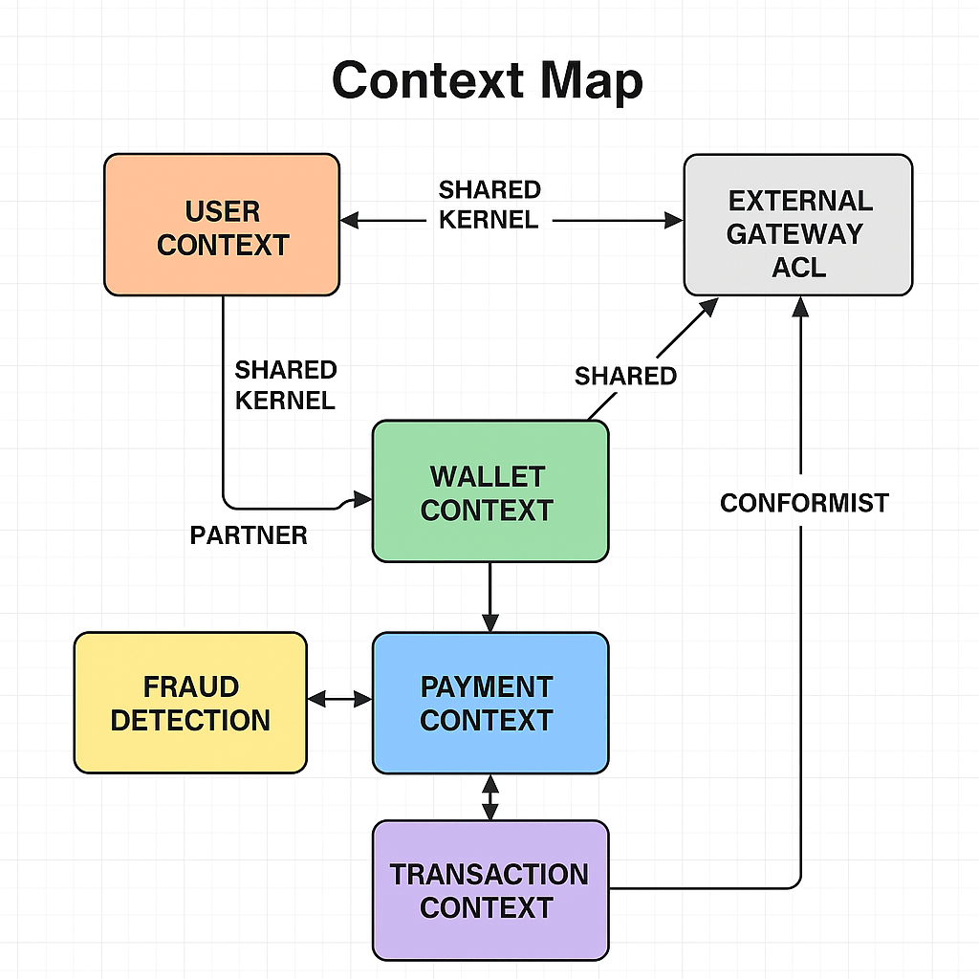

4. Entities, Aggregates, Value Objects

User Entity
- Attributes: UserId, Email, Phone, KYCStatus, AuthMethod
- Aggregate Root: User

Wallet Entity
- Attributes: WalletId, UserId, Currency, Balance, IsFrozen
- Aggregate Root: Wallet

Payment Entity
- Attributes: PaymentId, SourceWalletId, TargetWalletId/Bank/Card, Amount, Status
- Aggregate Root: Payment

Transaction Entity
- Attributes: TransactionId, PaymentId, Event, Timestamp, Status
- Aggregate Root: TransactionLog

Value Objects
- Money: Amount, Currency
- PaymentMethod: Type (Card/Wallet/Bank), Details
- PaymentStatus: Enum (Pending, Completed, Failed, Cancelled)
- KYCStatus: Enum (NotVerified, Verified, Rejected)

5. Domain Services

Service | Responsibility
PaymentService | Validates and initiates payments
WalletService | Deducts and credits wallet balances
FraudDetectionService | Analyzes transaction risk
NotificationService | Sends alerts to users
KYCService | Verifies user identity

6. Repositories

Repository | Methods
UserRepository | findById(), save()
WalletRepository | findByUserId(), save(), updateBalance()
PaymentRepository | findById(), save()
TransactionRepository | logEvent(), findByPaymentId()

7. Domain Events
- PaymentInitiatedEvent
- PaymentCompletedEvent
- WalletDebitedEvent
- FraudDetectedEvent
- KYCVerifiedEvent
These events can be published to message queues (e.g., Kafka, RabbitMQ) for asynchronous processing.

8. Anti-Corruption Layer (ACL)
PaymentGatewayFacade translates domain requests into external API calls/responses for:
- Stripe
- PayPal
- UPI/Bank Transfer APIs
This prevents external models from leaking into the domain logic.

9. Security Considerations
- Two-Factor Authentication (2FA) and device binding
- Fraud behavior engine (IP tracking, velocity checks, geolocation)
- PCI-DSS-compliant card storage
- KYC required for large transfers

