Domain-Driven Design (DDD) Document

Application: Digital Payment System

I. Introduction

A. Purpose

Goals:
- Establish a domain-driven architecture for the Digital Payment System.
- Improve maintainability, security, and scalability of payment-related functionalities.
- Align technical implementation with business requirements for financial transactions.

Scope:
- Covers payment initiation, processing, verification, and transaction lifecycle management.

B. Domain Overview
- Transaction Management: Handle the lifecycle of financial transactions.
- Payment Gateway Integration: Interface with third-party services (NEFT, UPI, cards).
- User Wallets and Accounts: Maintain balances, transaction history.
- Fraud Detection: Analyze and mitigate fraudulent activities.
- Reporting and Reconciliation: Provide transaction records and audits.

C. Context
- Bounded contexts will be clearly defined to isolate services such as processing, user accounts, and gateways.
- Models and logic encapsulated within specific domains to ensure data integrity and secure operations.

II. Strategic Design

A. Bounded Contexts

Payment Processing Context
- Summary: Handles creation, execution, and status tracking of payments.

User Account Context
- Summary: Manages user credentials, wallets, limits, and transaction history.

Gateway Integration Context
- Summary: Interfaces with NEFT, IMPS, UPI, and card service providers.

Fraud Detection Context
- Summary: Monitors transaction anomalies, user behavior and raises alerts.

Reporting & Audit Context
- Summary: Logs and aggregates transaction data for reporting, dashboards, and audits.

B. Sub-Domains with Their Category
Payment Processing (Core)
- Transaction Service
- Payment Lifecycle Manager
User Account (Core)
- Wallet Management
- User Limit Validation
Gateway Integration (Generic)
- NEFT Adapter
- UPI Connector
- Card Service
Fraud Detection (Supporting)
- Risk Analysis Engine
- Alert Management
Reporting & Audit (Supporting)
- Ledger Service
- Dashboard Reporting Service

C. Context Map
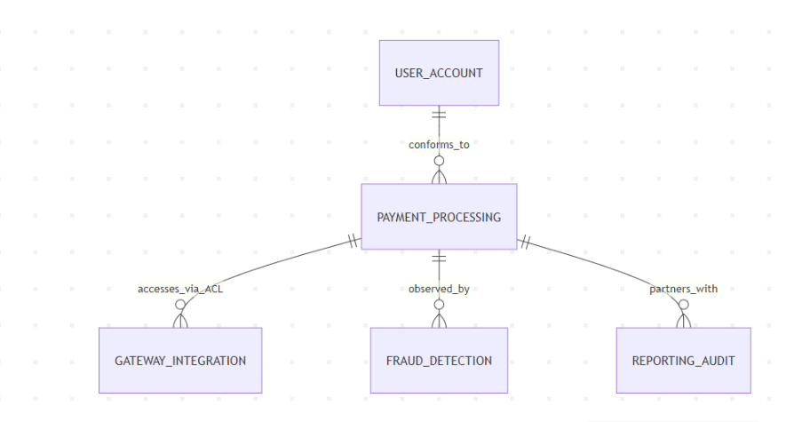

III. Tactical Design

1. Payment Processing Service

2. User Account Service

3. Gateway Integration Service

4. Fraud Detection Service

5. Reporting & Audit Service

IV. Illustrative Diagram
Include architecture diagram showcasing interactions between tactical components, aggregates, events, and repositories.

V. Implementation Considerations

A. Technology Choices
- Backend: Spring Boot + Java
- Database: PostgreSQL (Transactional), MongoDB (Reporting)
- Messaging: Apache Kafka, RabbitMQ
- Monitoring: Prometheus + Grafana

B. Architectural Patterns
CQRS, Event Sourcing, SAGA Pattern for gateway/payment reconciliation, Circuit Breaker with Resilience4j

C. Testing Strategies
Unit Testing: JUnit + Mockito, Integration Testing: Spring Test + Testcontainers, Load Testing: JMeter, Slice Testing and E2E Scenarios

D. Security Considerations
Authentication: OAuth2.0, JWT
Authorization: RBAC
Encryption: TLS, SHA-256 for sensitive data
Audit Trails and Monitoring

Glossary (Ubiquitous Language)
Transaction: Atomic unit of payment activity
Wallet: Virtual account representing user funds
Gateway: External financial interface
RiskProfile: User’s fraud risk level
Ledger: Record of financial activity for auditing
Event: Significant occurrence in the domain (e.g., PaymentSuccess)
Aggregate: Consistency boundary in domain modeling
Service: Performs domain-specific operations
Factory: Responsible for complex object creation
Repository: Abstraction for database interaction

