Application: E Commerce Application
- Introduction
- Purpose:
Define the goals and scope of the DDD documentation for the e-commerce application
Goals:
Scope:
- Domain Overview:
Briefly describe the e-commerce domains, including their core functionalities / tasks
Ex: Online Order Fulfillment system / Customer Management / Product Inventory Management
- Context:
Explain the boundaries of the particular domain with can specific to their models and sub-domains
- Strategic Design
- Bounded Contexts
- Define the core bounded contexts for each domain created for this application
Bounded Context 1 (Order)
Summary/Functionalities
Bounded Context 2 (Customer)
Summary/Functionalities
Bounded Context 3 (Marketing)
Summary/Functionalities
- Sub-Domains with their Category
- Identify the sub-domains for each bounded contexts
- Identify the core, generic and supporting sub-domains
- Prioritize the development efforts and determine the appropriate strategies for each sub-domains
- Describe the specific responsibilities and boundaries
Bounded Context 1 (Order)
Product Service (core)
Order Service (core)
Payment Service (Generic)
Shipping Service (core)
Bounded Context 2 (Customer)
CustomerService(Generic)
CartService(core)
OrderHistoryService(Core)
Bounded Context 3 (Marketing)
RecommendationService(supporting)
AdCampaignsService(supporting)

- Context Map
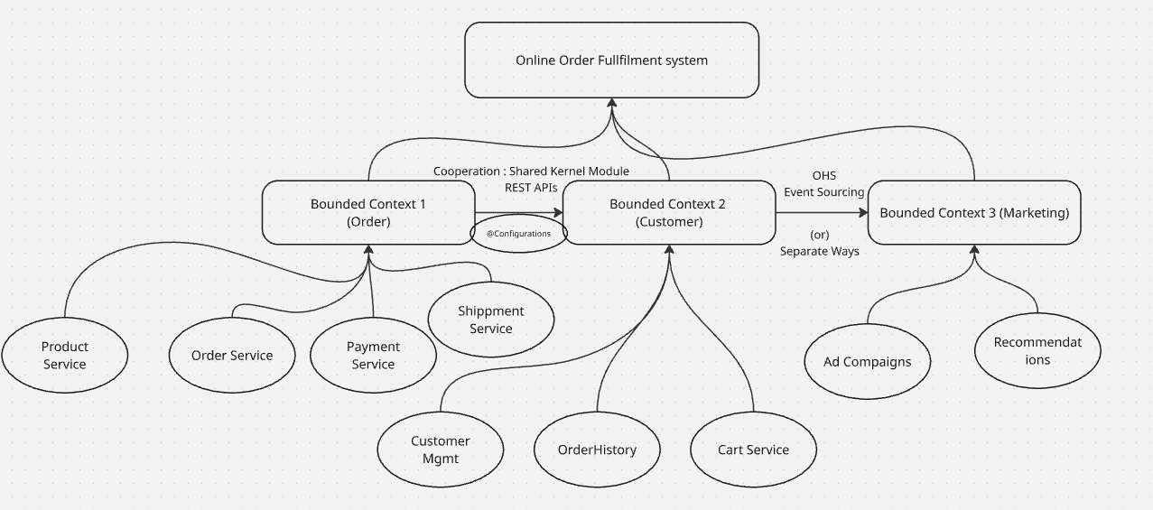

- Diagrammatic representation of context and its relationships
- Specify the relationships (C-S, Conformist, ACL, OHS)
- Document the interations and data flow between the contexts
Ex: Customer depends on the Products for Product Information in Cooperation: Partnership relationship

- Tactical Design
- Add all the sub-domains with the attributes of Tactical design
- Define each by giving some lines of summary
- Product Service
Entities:
Product
Category
Value Objects:
Price
Measurements
Aggregates:
Product
Category as child, Price and Measurements as value objects
Domain Event:
ProductAdded
ProductPriceChanged
ProductOutofStock
ProductRemoved
Domain Services:
ProductCatalogService
ProductSearchService
Application Services:
CreateProduct
UpdateProduct
GetProduct
Repository:
ProductRepository
Factory:
ProductFactory
- Order Service
Entities:
Order
Value Objects:
Total Amount
No of items

Aggregates:
Order
Product as child, Total Amount and No of items as value objects
Domain Event:
OrderPlaced
OrderCancelled
Domain Services:

Application Services:
CreateOrder
UpdateOrder
GetOrder
Repository:
OrderRepository
Factory:
OrderFactory
- Payment Service
Entities:

Value Objects:
Total Amount
No of items

Aggregates:
Order
Product as child, Total Amount and No of items as value objects
Domain Event:
OrderPlaced
OrderCancelled
Domain Services:

Application Services:
CreateOrder
UpdateOrder
GetOrder
Repository:
OrderRepository
Factory:
OrderFactory
- …
- …

- Illustrative Diagram
Complete diagram with all the tactical design elements and attributes added to the domain models
- Implementation Considerations
- Technology Choices
Discuss technologies and frameworks that align with the DDD design (ORM, Hibernate, Messaging, JMS, JMX)

- Architectural Patterns
Describe the patterns wants to be considered for application development
(CQRS, Event Sourcing, Circuit Breaker, SAGA, Canary, A/B Testing, Kafka, RabbitMQ)
- Testing Strategies
Outline the testing strategies: Unit Testing, Integration Testing, Slice Testing, Web and Method testing
- Security Considerations
AuthN and AuthZ (LDAP, OAuth2.0, JWT)
Encryption( Data-in-Rest and Data-in-transit) : SHA256
Code Snippets (illustrative)
Glossary (Ubiquitous Language)
- Define all the terminologies we used in this language across the bounded context

