**LABCYCLE**

**Submitted By**

**KANNAN R R**

**MCA S1**

**Roll No :124**

**LABCYCLE 1 QUESTION 1**

**AIM** :

Model a simple HTML file to demonstrate the use of different tags

**DESIGN** :

**Step 1 :** Create html page containing basic tags

**Step 2 :** include style if needed

**PROGRAM CODE** :

Program1CO1

<html>

<head>

<title>My college</title>

<meta name="viewport" content="width=device-width,initial-scale=1.0">

</head>

<body>

<header style="background-color: #37487a;color:white;">

<center>

<div>

<h1>TKM College of Engineering</h1>

<h2>Department of MCA</h2>

<h3>2021-22 Batch</h3>

</div>

</center>

</header><br>

<div>

<div style="border:1px solid black;width: 30%;height:320px;float: left;"></div>

<div style="border:1px solid black;width: 60%;float: right;height:320px;">

<ul>

<div style="background-color: rgb(89, 207, 89);width:70%;border-radius: 10px;;margin-bottom:20px">

<center>

<li><u>Advanced Software Engineering</u> [ <abbr title="ASE">ASE</abbr> ]</li>

<p><i>Classes contains details about ASE</i></p>

</center>

</div>

<div style="background-color: rgb(218, 100, 100);width:70%;border-radius: 10px;margin-bottom:20px">

<center>

<li><u>Advanced Data Structures</u> [ <abbr>ADC</abbr> ]</li>

<p><i>Classes contains details about ADC</i></p>

</center>

</div>

<div style="background-color: rgb(61, 222, 228);width:70%;border-radius: 10px;margin-bottom:20px">

<center>

<li><u>Python</u> [ <abbr>Py</abbr> ]</li>

<p><i>Classes contains details about Python</i></p>

</center>

</div>

<div style="background-color: rgb(75, 105, 240);width:70%;border-radius: 10px;margin-bottom:20px">

<center>

<li><u>Mathematics</u> [ <abbr>Py</abbr> ]</li>

<p><i>Classes contains details about Mathematics</i></p>

</center>

</div>

</ul>

</div>

</div>

<div style="width: 100%;float: left;margin-top:20px">

<footer style="border:1px solid black;background-color: black;color: white;height:100px;">

<center>

<p style="padding: 20px;">TKMCE, © 2020. All rights reserved.</p>

</center>

</footer>

</div>

</body>

</html>

**RESULT :**

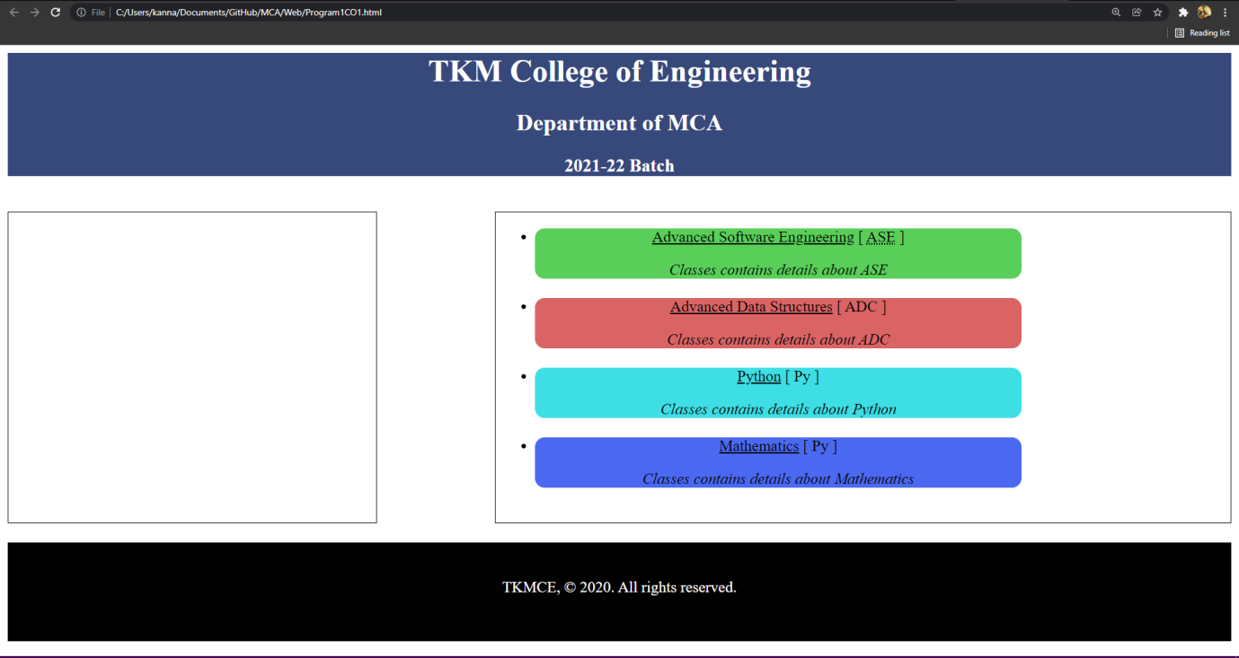

**LABCYCLE 1 QUESTION 2**

**AIM** :

Create a HTML file to link to different HTML page which contains images, tables, and also link within a page

**DESIGN** :

**Step 1 :** Create main html page which shows general information

**Step 2 :** include links for contact details and Accademic details

**Step 3 :** Create pages for contact details and accademic details

**PROGRAM CODE** :

Program2CO1.html

<html>

<style>

.col{

border: 1px solid rgb(142, 174, 235);

background-color: rgb(142, 174, 235);

border-right: 1px solid darkgreen;}

.inner{

text-align: center;}

.col3{

background-color: rgb(172, 161, 99);}

.col4{

background-color: rgb(224, 211, 135);}

</style>

<head>

<title>My college</title>

<meta name="viewport" content="width=device-width,initial-scale=1.0">

</head>

<body>

<table width="70%" align="center" style="background-color: rgb(142, 174, 235)">

<tr>

<td class="col"><a href="Program2CO1.html">General Information</a></td>

<td class="col"><a href="AccDetails.html">Accademic Information</a></td>

<td class="col"><a href="Contact.html">Contact

Details</a></td>

</tr>

</table>

<table width="70%" align="center" cellpadding="10px">

<tr>

<td class="col3"><b>Picture : </b></td>

<td colspan="2" class="col4"><center><img src="user.png" width="20%"></center></td>

</tr>

<tr>

<td class="col3"><b>Graduation : </b></td>

<td colspan="2" class="col4"> Bsc Computer Science</td>

</tr>

<tr>

<td class="col3"><b>Post Graduation : </b></td>

<td colspan="2" class="col4">MCA</td>

</tr>

<tr>

<td class="col3"><b>Hobbies : </b></td>

<td colspan="2" class="col4">Animie</td>

</tr>

<tr>

<td class="col3"><b>Aspiration : </b></td>

<td colspan="2" class="col4">Peace</td>

</tr>

</table>

</body>

</html>

Contact.html

<html>

<style>

.col{

border: 1px solid rgb(142, 174, 235);

background-color: rgb(142, 174, 235);

border-right: 1px solid darkgreen;}

.col2{

border: 1px solid rgb(142, 174, 235);}

</style>

<head>

<title>My college</title>

<meta name="viewport" content="width=device-width,initial-scale=1.0">

<tr>

</head>

<body>

<table width="70%" align="center" style="border: 1px solid black;">

<td class="col"><a href="Program2CO1.html">General Information</a></td>

<td class="col"><a href="AccDetails.html">Accademic Information</a></td>

<td class="col"><a href="Contact.html">Contact Details</a></td>

</tr>

</table>

<center>

<div style="width:70%;">

<h2 style="float:left;">Contact details</h2>

</div>

</center>

<br><br><br><br>

<hr>

<table width="70%" align="center" cellpadding="10px">

<tr>

<td class="col2">Mobile No :</td>

<td class="col2" colspan="2">9495758577</td>

</tr>

<tr>

<td class="col2">Address :</td>

<td class="col2" colspan="2">Chirayinkeezhu ,Trivandrum</td>

</tr>

</table>

</body>

</html>

AccDetails.html

<html>

<style>

.col{

border: 1px solid rgb(142, 174, 235);

background-color: rgb(142, 174, 235);

border-right: 1px solid darkgreen;}

.col1{

background-color: rgb(61, 126, 72);}

.col2{

border: 1px solid rgb(142, 174, 235);}

</style>

<head>

<title>My college</title>

<meta name="viewport" content="width=device-width,initial-scale=1.0">

</head>

<body>

<table width="70%" align="center" style="border: 1px solid black;">

<tr>

<td class="col"><a href="Program2CO1.html">General Information</a></td>

<td class="col"><a href="AccDetails.html">Accademic Information</a></td>

<td class="col"><a href="Contact.html">Contact Details</a></td>

</tr>

</table>

<center>

<div style="width:70%;">

<h2 style="float:left;">Accademic details</h2>

</div>

</center>

<br><br><br><br>

<hr>

<table width="70%" align="center" cellpadding="10px">

<tr>

<td class="col1">Stream</td>

<td class="col1" colspan="2">College</td>

</tr>

<tr>

<td class="col2">MCA</td>

<td class="col2" colspan="2">TKM College Of Engineering</td>

</tr>

</table>

</body>

</html>

**RESULTS** :

**Program2CO1.html**

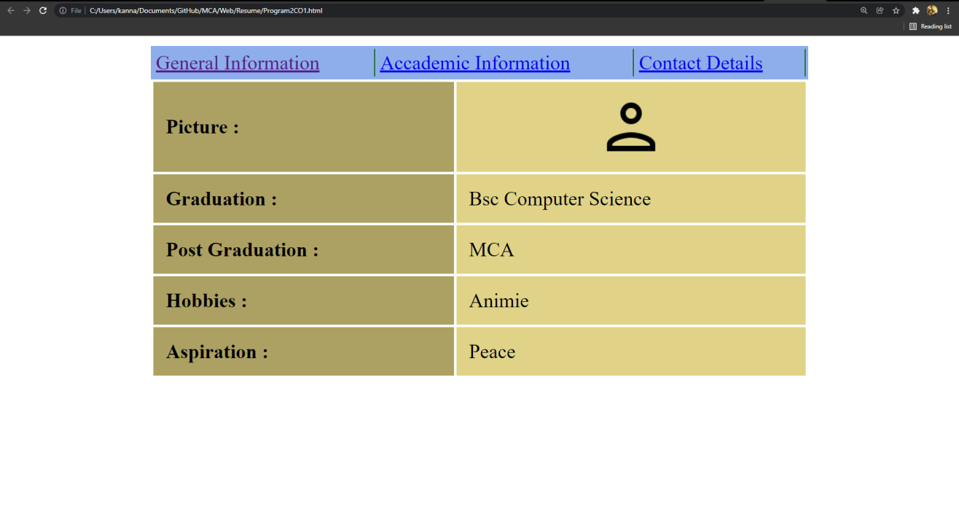

**AccDetails.html**

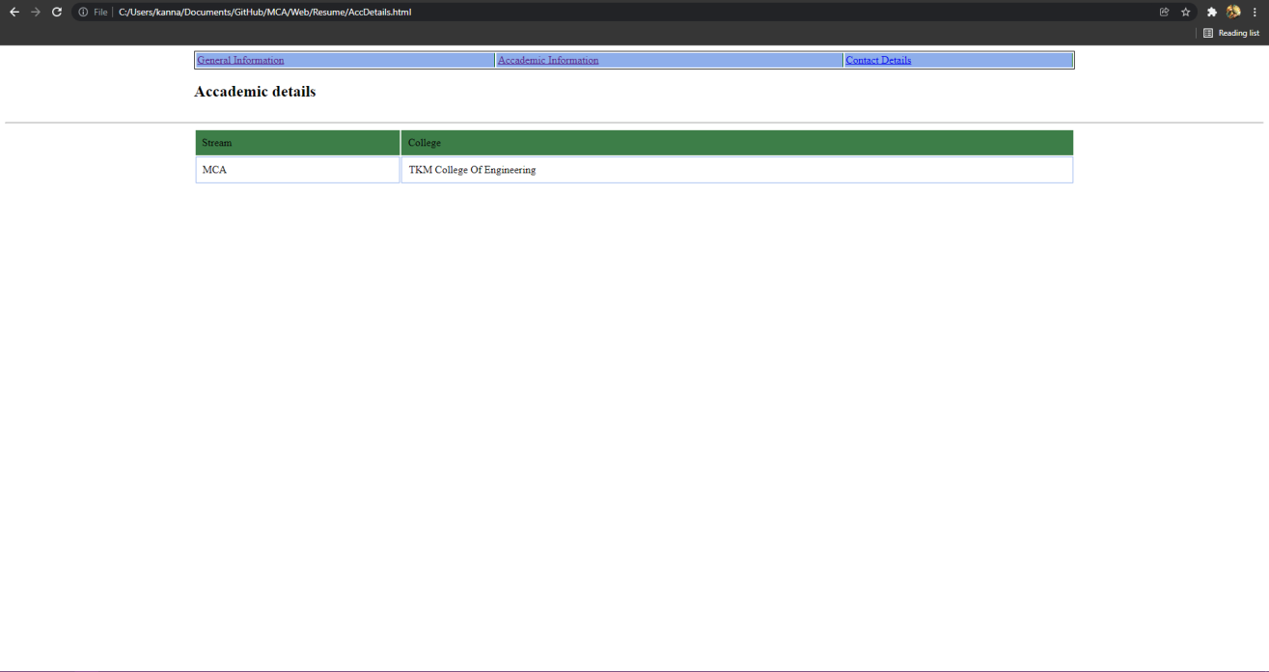

**Contact.html**

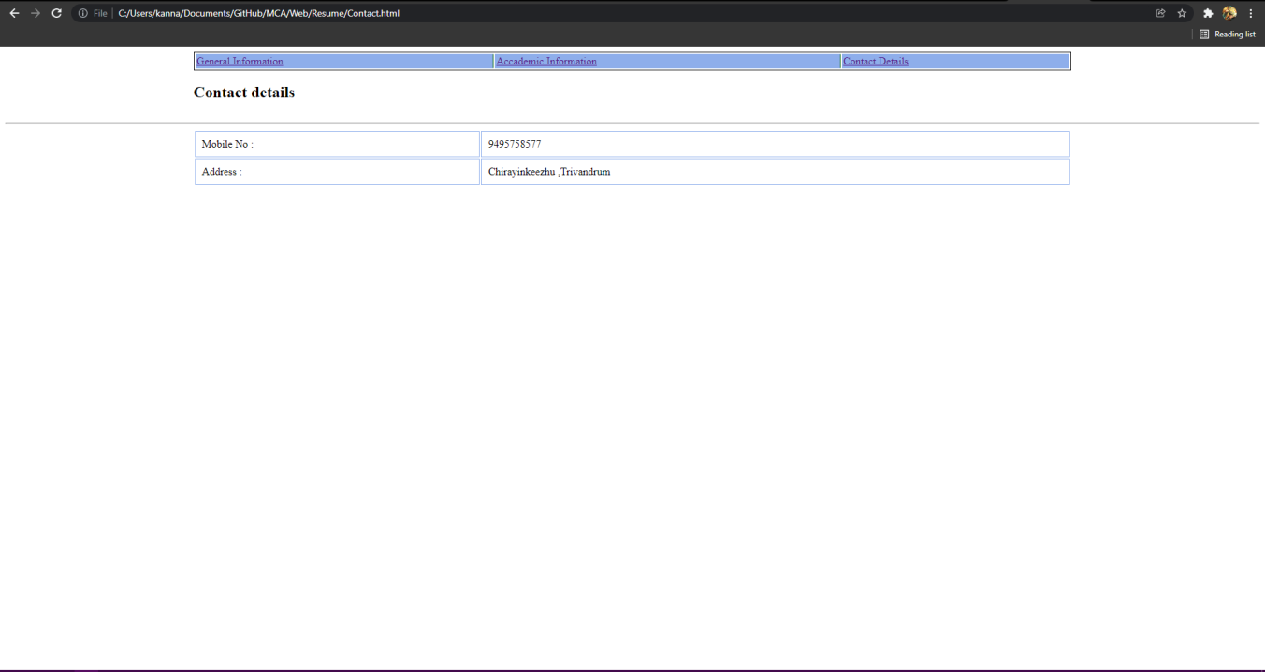

**LABCYCLE 1 QUESTION 3**

**AIM** :

Create a HTML page with different types of frames such as floating frame, navigation frame & mixed frame.

**DESIGN :**

**Step 1 :** Create main html page which has links to other pages containing other types of frames

**Step 2 :** Create one page implementing Floating frames

**Step 3 :** Create one page implementing Mixed frames

**Step 3 :** Create one page implementing Navigation frames

**PROGRAM CODE** :

Frames.html

<html>

<head>

<title>My college</title>

<meta name="viewport" content="width=device-width,initial-scale=1.0">

</head>

<frameset cols="20%,50%">

<frame name="a" src="Navi.html" ></frame>

<frame name="b" ></frame>

</frameset>

</html>

Navi.html

<html>

<style>

.nav{

background-color: #f9f2ac;}

</style>

<head>

<title>My college</title>

<meta name="viewport" content="width=device-width,initial-scale=1.0">

</head>

<body>

<a href="floating.html" target="b"><div class="nav">Floating</div></a>

<a href="Mixed.html" target="b"><div class="nav">Mixed</div></a>

</body>

</html>

Mixed.html

<html>

<head>

<title>My college</title>

<meta name="viewport" content="width=device-width,initial-scale=1.0">

</head>

<frameset cols="50%,50%">

<frameset rows="50%,50%">

<frame name="a" src="contact.html" ></frame>

<frame name="c" src="contact.html"></frame>

</frameset>

<frameset rows="50%,50%">

<frame name="a" src="contact.html" ></frame>

<frame name="c" src="contact.html"></frame>

</frameset>

</frameset>

</html>

Floating.html

<html>

<head>

<title>My college</title>

<meta name="viewport" content="width=device-width,initial-scale=1.0">

</head>

<body style="background-color: rgb(197, 129, 177);">

<center><iframe width="60%" src="contact.html">

</iframe></center>

</body>

</html>

Contact.html

<html>

<head>

<title>My college</title>

<meta name="viewport" content="width=device-width,initial-scale=1.0">

</head>

<body style="background-color: rgb(94, 104, 194);">

<center><h1>Test</h1></center>

</body>

</html>

NavigationFrame.html

<html>

<style>

.nav

{background-color: #f9f2ac;

margin-bottom: 10px ;

padding: 20px;}

</style>

<head>

<title>My college</title>

<meta name="viewport" content="width=device-width,initial-scale=1.0">

</head>

<frameset cols="20%,80%">

<frame src="Navigate.html"></frame>

<frame name="navi"></frame>

</frameset>

</html>

Navigate.html

<html>

<style>

.nav{

background-color: #f9f2ac;

margin-bottom: 10px ;

padding: 20px;}

</style>

<head>

<title>My college</title>

<meta name="viewport" content="width=device-width,initial-scale=1.0">

</head>

<body>

<a href="https://tkmce.ac.in/" target="navi"><div class="nav">TKM</div></a>

<a href="https://www.cet.ac.in/" target="navi"><div class="nav">CET</div></a>

</body>

</html>

**RESULT** **:**

**Frames.html**

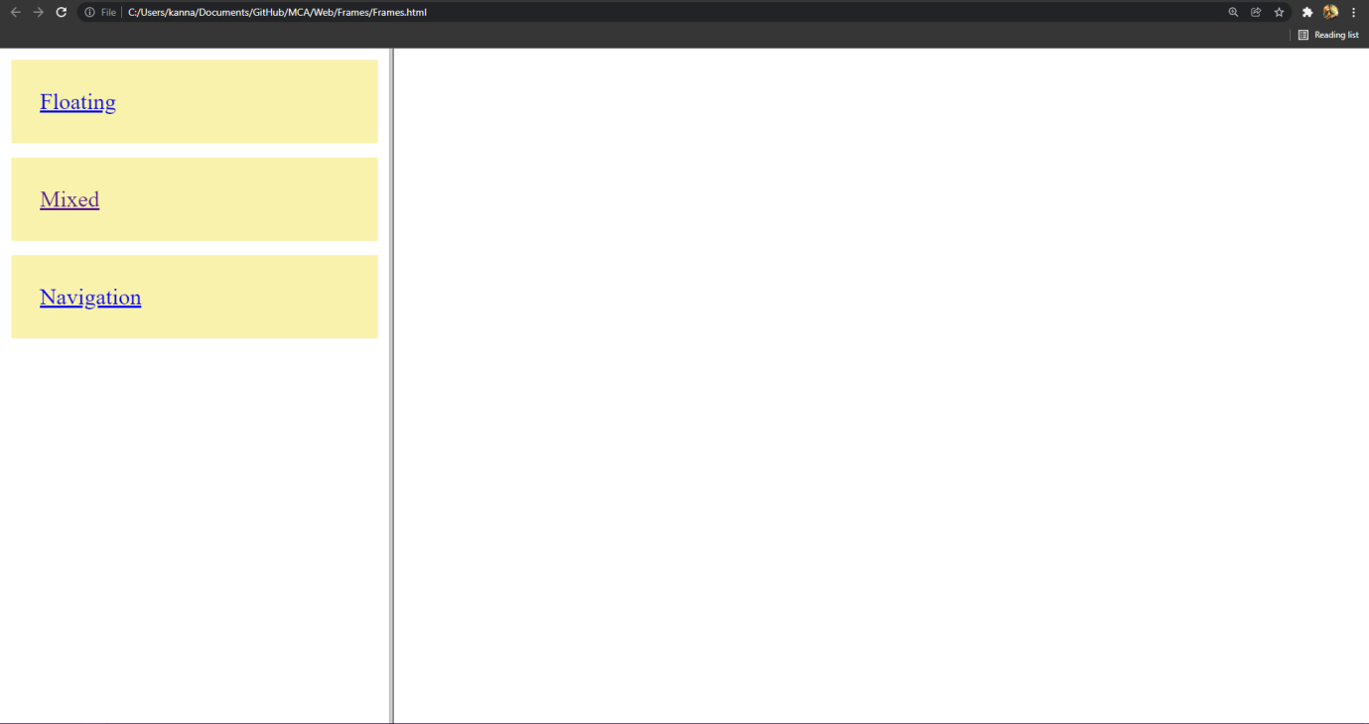

**Floating.html**

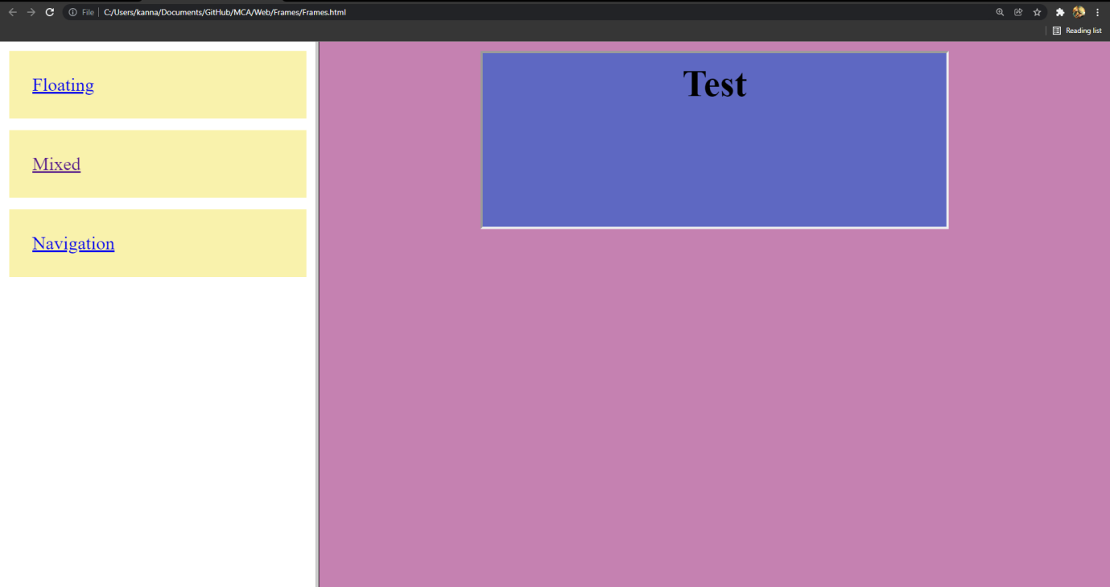

**Mixed.html**

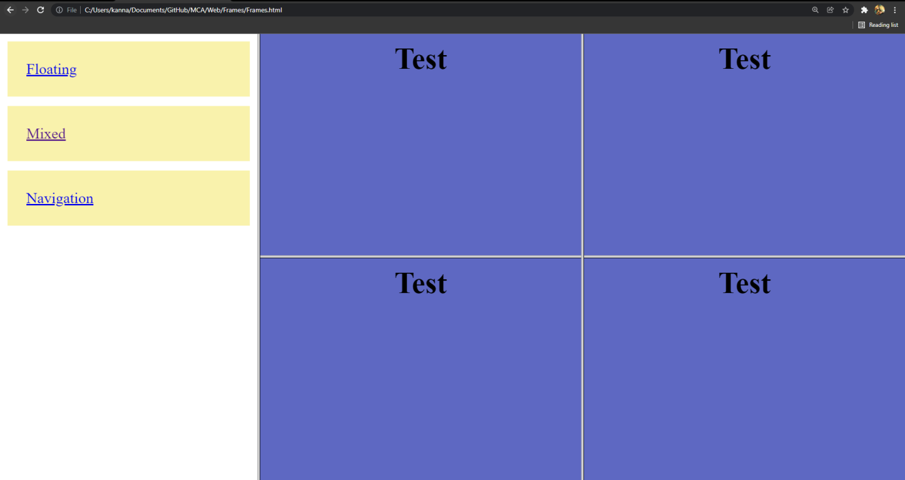

**NavigationFrame.html**

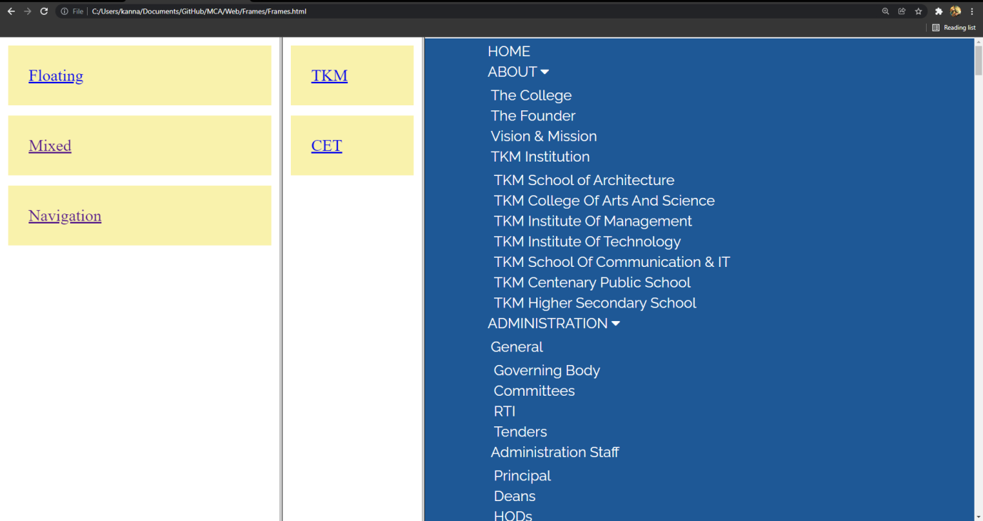

**LABCYCLE 1 QUESTION 4**

**AIM** :

Analyze CSS by applying the different styles using inline, external & internal style sheets in a HTML file.

**DESIGN :**

**Step 1 :** Create main html page which has some common tags

**Step 2 :** Add some internal Styles

**Step 3 :** Add some inline styles

**Step 3 :** Create one external style sheet file and add link to the html file

**PROGRAM CODE** :

RegForm.html

<html>

<head>

<title>My college</title>

<meta name="viewport" content="width=device-width,initial-scale=1.0">

<link rel="stylesheet" href="Reg.css">

<style>

.input{

border-radius: 5px;

border:0px solid #df9c70;

padding:10px;

float: left;

width: 100%;}

.button{

padding: 10px;

width: 75%;

border-radius: 20px;

border:1px solid rgb(94, 155, 94);

background-color: rgb(94, 155, 94);

color: white;}

p{

font-family:Sans-serif;

font-weight: bold;}

.button,.input:hover{

border:1px solid green;}

</style>

</head>

<body><br><br><br><br>

<center>

<div class="outer">

<h2><p>Registration form</p></h2>

<form>

<table>

<tr>

<td><input type="text" placeholder="First Name" class="input"/></td>

<td><input type="text" placeholder="Last Name" class="input"/></td>

</tr>

<tr>

<td><p>Mobile Number :</p></td>

<td><input type="number" placeholder="Number" class="input"/></td>

</tr>

<tr>

<td><p>Date Of Birth :</p></td>

<td><input type="date" class="input"></td>

</tr>

<tr>

<td><p>Gender :</p></td>

<td><input type="radio" value="Male" id="male" checked="true">

<label for="male">Male</label><br>

<input type="radio" value="Female" id="male">

<label for="male">Female</label><br></td>

</tr>

<tr>

<td><p>Languages Known :</p></td>

<td><input type="checkbox" value="c" id="c" checked="true">

<label for="c">C</label><br>

<input type="checkbox" value="c++" id="c++">

<label for="c++">C++</label><br>

<input type="checkbox" value="p" id="p">

<label for="p">Python</label><br></td></td>

</tr>

<tr>

<td colspan="2"><textarea cols="50" rows="3" placeholder="Address" class="input"></textarea></td>

</tr>

<tr>

<td><p>Select Country : </p></td>

<td><select class="input">

<option value="" ></option>

<option value="India" >India</option>

</select></td> </tr>

<tr>

<td><p>Select State : <p></td>

<td><select class="input">

<option value="" ></option>

<option value="Kerala" >Kerala</option>

</select></td>

</tr>

<tr>

<td><p>Upload Photo : </p></td>

<td><input type="file" placeholder="Number" class="input"/></td>

</tr>

<tr>

<td><input type="reset" value="Reset" class="button"/></td>

<td><input type="submit" value="Submit" class="button" style="float:right;"/></td>

</tr>

</table>

</div>

</form>

</center>

</body>

</html>

Reg.css

td

{

padding:10px;

margin:10px;

width:50%;

}

.outer{

width:28%;

padding:20px;

border-radius:20px;

background-color:#f29455;

}

body

{

background-color:#CCCCCC;

}

**RESULT :**

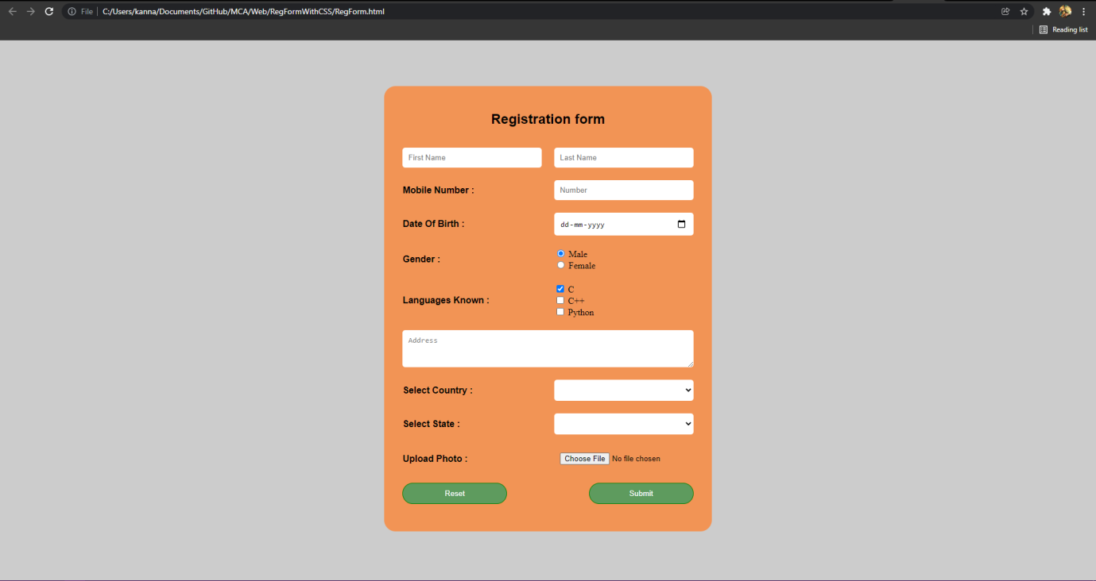

**LABCYCLE 1 QUESTION 5**

**AIM** :

Demonstrate a registration form using HTML.

**DESIGN :**

**Step 1 :** Create main html page which has various types of form elements

**Step 2 :** Add some test boxes,text area etc

**Step 3 :** Add some checkboxes,radio buttons and apply some styles id needed

**Step 3 :** Create a submit button and reset button

**PROGRAM CODE** :

RegForm.html

<html>

<head>

<title>My college</title>

<meta name="viewport" content="width=device-width,initial-scale=1.0">

<link rel="stylesheet" href="Reg.css">

<style>

.input{

border-radius: 5px;

border:0px solid #df9c70;

padding:10px;

float: left;

width: 100%;}

.button{

padding: 10px;

width: 75%;

border-radius: 20px;

border:1px solid rgb(94, 155, 94);

background-color: rgb(94, 155, 94);

color: white;}

p{

font-family:Sans-serif;

font-weight: bold;}

.button,.input:hover{

border:1px solid green;}

</style>

</head>

<body><br><br><br><br>

<center>

<div class="outer">

<h2><p>Registration form</p></h2>

<form>

<table>

<tr>

<td><input type="text" placeholder="First Name" class="input"/></td>

<td><input type="text" placeholder="Last Name" class="input"/></td>

</tr>

<tr>

<td><p>Mobile Number :</p></td>

<td><input type="number" placeholder="Number" class="input"/></td>

</tr>

<tr>

<td><p>Date Of Birth :</p></td>

<td><input type="date" class="input"></td>

</tr>

<tr>

<td><p>Gender :</p></td>

<td><input type="radio" value="Male" id="male" checked="true">

<label for="male">Male</label><br>

<input type="radio" value="Female" id="male">

<label for="male">Female</label><br></td>

</tr>

<tr>

<td><p>Languages Known :</p></td>

<td><input type="checkbox" value="c" id="c" checked="true">

<label for="c">C</label><br>

<input type="checkbox" value="c++" id="c++">

<label for="c++">C++</label><br>

<input type="checkbox" value="p" id="p">

<label for="p">Python</label><br></td></td>

</tr>

<tr>

<td colspan="2"><textarea cols="50" rows="3" placeholder="Address" class="input"></textarea></td>

</tr>

<tr>

<td><p>Select Country : </p></td>

<td><select class="input">

<option value="" ></option>

<option value="India" >India</option>

</select></td> </tr>

<tr>

<td><p>Select State : <p></td>

<td><select class="input">

<option value="" ></option>

<option value="Kerala" >Kerala</option>

</select></td>

</tr>

<tr>

<td><p>Upload Photo : </p></td>

<td><input type="file" placeholder="Number" class="input"/></td>

</tr>

<tr>

<td><input type="reset" value="Reset" class="button"/></td>

<td><input type="submit" value="Submit" class="button" style="float:right;"/></td>

</tr>

</table>

</div>

</form>

</center>

</body>

</html>

Reg.css

td

{

padding:10px;

margin:10px;

width:50%;

}

.outer{

width:28%;

padding:20px;

border-radius:20px;

background-color:#f29455;

}

body

{

background-color:#CCCCCC;

}

**RESULT :**

