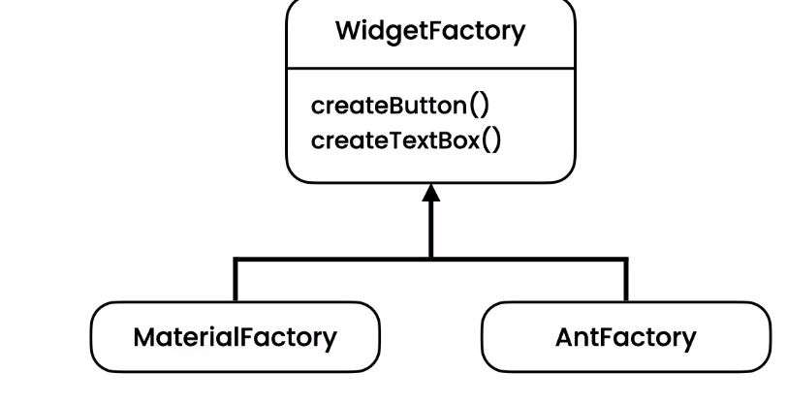

public interface Widget {

  void render();

}

public interface TextBox extends Widget {

}

public interface Button extends Widget {

}

public interface WidgetFactory {

  Button createButton();

  TextBox createTextBox();

}

public class MaterialButton implements Button {

  @Override

  public void render() {

    System.out.println("Material Button");

  }

}

public class MaterialTextBox implements TextBox {

  @Override

  public void render() {

    System.out.println("Material TextBox");

  }

}

public class MaterialWidgetFactory implements WidgetFactory {

  @Override

  public Button createButton() {

    return new MaterialButton();

  }

  @Override

  public TextBox createTextBox() {

    return new MaterialTextBox();

  }

}

public class AntButton implements Button {

  @Override

  public void render() {

    System.out.println("Ant Button");

  }

}

public class AntTextBox implements TextBox {

  @Override

  public void render() {

    System.out.println("Ant TextBox");

  }

}

public class AntWidgetFactory implements WidgetFactory {

  @Override

  public Button createButton() {

    return new AntButton();

  }

  @Override

  public TextBox createTextBox() {

    return new AntTextBox();

  }

}

//IN application Layer (Console App)

public class ContactForm {

  public void render(WidgetFactory factory) {

    factory.createTextBox().render();

    factory.createButton().render();

  }

}

Main

