A simple terminal based banking application, where customer can login with their account no and password, view their transaction summary, update their profile information. The application allows admin user to create new customers and to do transaction on their behalf , search and view other customers details .

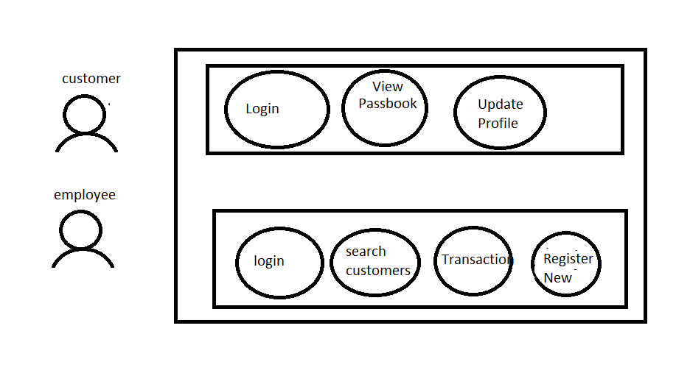

Database Table Structure

