Table of Contents

MLOps Assignment 01 — End-to-End Heart Disease Risk API
Course: AIMLCZG523 · Machine Learning Operations Author: Kanna TJ (2024ad05219@wilp.bits-pilani.ac.in) Repository: https://github.com/kannatj/MLOPS_HeartDiseaseRiskPrediction Deployed API: Local only — Docker Compose (:8000) or local Kubernetes; run/access instructions in §2, §8, §9 Video walkthrough: <link to short recording>

1. Project overview
A production-ready pipeline that predicts the risk of heart disease for a patient using the UCI Heart Disease dataset (920 patients, 14 clinical features). The solution covers every stage of the MLOps lifecycle:
- Data & EDA — reproducible dataset download, missing-value handling, feature analysis.
- Modelling — Logistic Regression, Random Forest and XGBoost tuned with GridSearchCV (5-fold stratified CV, ROC-AUC as selection metric).
- Experiment tracking — MLflow file store logging params, metrics, model artefacts, confusion matrix and ROC plots for every run.
- Packaging — one sklearn.Pipeline containing preprocessing + estimator, saved as heart_model.joblib and referenced by the API.
- CI/CD — GitHub Actions runs lint → pytest (+coverage) → smoke training → Docker build + /health + /predict probe.
- Containerisation — multi-stage Dockerfile, non-root runtime.
- Deployment — Kubernetes Deployment (2 replicas), Service, Ingress, HPA, plus an equivalent Helm chart.
- Monitoring — structured request logs, Prometheus metrics (/metrics) and a Grafana dashboard bundled via docker-compose.

2. Setup & install instructions
git clone https://github.com/kannatj/MLOPS_HeartDiseaseRiskPrediction.git
cd MLOPS_HeartDiseaseRiskPrediction
python -m venv .venv && source .venv/bin/activate
pip install -r requirements-dev.txt
python data/download_data.py # verifies data/raw/heart_disease_uci.csv
Common tasks:
Task | Command
Lint | make lint (ruff check src tests)
Test | make test (pytest --cov=src)
Train | make train (writes MLflow runs + models/heart_model.joblib)
Serve locally | make serve (Swagger UI at http://127.0.0.1:8000/docs)
CLI inference | python -m src.predict --json '{"age": 63, "sex": "Male", "cp": "typical angina"}'
Docker build/run | make docker-build && make docker-run
Local monitoring stack | make compose-up (Grafana :3000, Prometheus :9090)
Kubernetes | kubectl apply -f k8s/

3. EDA findings
See notebooks/01_eda.ipynb and reports/figures/.
Key observations:
- Shape: 920 rows, 16 raw columns from four hospitals (Cleveland, Hungary, Switzerland, VA Long Beach).
- Class balance: the engineered binary target target = (num >= 1) is mildly imbalanced (~55% disease, ~45% no-disease). Stratified splits and stratified k-fold CV keep the class ratio stable across folds.
- Missingness: substantial in ca, thal, slope, and moderate in chol, trestbps, thalch. This drives the choice of imputers inside the pipeline.
- Strongest signal: oldpeak, thalch, ca, age, and categorical cp (chest-pain type), exang, thal.
- Hospital effect: disease prevalence differs across dataset; retained as a one-hot feature.
The full set of EDA visualisations (missing-value matrix, class-balance bar chart, numeric-feature histograms, categorical-vs-target plots and the correlation heatmap) is produced and displayed inline in notebooks/01_eda.ipynb. The per-model diagnostic plots that feed the modelling discussion are exported to reports/figures/ (confusion matrices and ROC curves for all three models).

4. Modelling choices
Preprocessing (src/data_preprocessing.py) — a ColumnTransformer inside a single Pipeline:
- Numeric features (age, trestbps, chol, thalch, oldpeak, ca): median-impute → StandardScaler.
- Categorical features (sex, dataset, cp, fbs, restecg, exang, slope, thal): most-frequent impute → OneHotEncoder(handle_unknown="ignore").
Models & hyperparameter grids (src/train.py):
Model | Grid
Logistic Regression | C ∈ {0.01, 0.1, 1, 10}, penalty ∈ {l1, l2} (liblinear)
Random Forest | n_estimators ∈ {200, 400}, max_depth ∈ {None, 6, 10, 16}, min_samples_split ∈ {2, 4, 8}
XGBoost | n_estimators ∈ {200, 400, 600}, max_depth ∈ {3, 4, 6, 8}, lr ∈ {0.03, 0.1, 0.2}, subsample ∈ {0.7, 0.9, 1.0}
Selection metric: stratified 5-fold roc_auc. All models are refit on the full training set and evaluated on a held-out 20% test split for accuracy, precision, recall, F1, ROC-AUC and average precision.
Model comparison (from models/metrics.json, held-out 20% test split):
Model | CV ROC-AUC | Test ROC-AUC | Test F1 | Test Accuracy
Logistic Regression | 0.8921 | 0.9175 | 0.8692 | 0.8478
Random Forest (best) | 0.8874 | 0.9287 | 0.8704 | 0.8478
XGBoost | 0.8595 | 0.9026 | 0.8612 | 0.8424
The best-performing model (Random Forest, test ROC-AUC 0.9287) is persisted at models/heart_model.joblib and consumed by the API at startup.
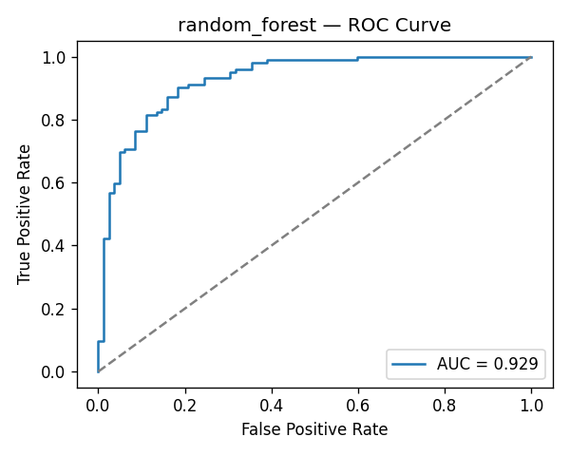
Random Forest ROC curve
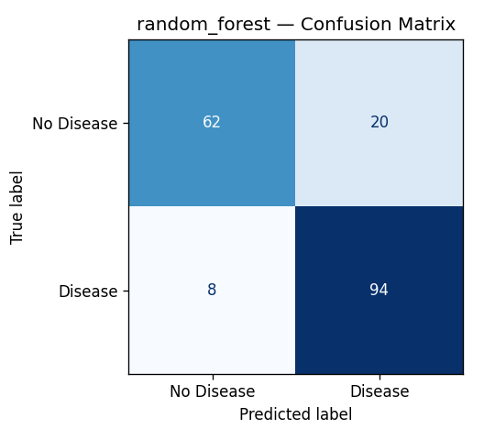
Random Forest confusion matrix

5. Experiment tracking summary (MLflow)
- Tracking URI: local file store at ./mlruns.
- Experiment: heart-disease-classification.
- Logged per run: best hyperparameters, all six evaluation metrics, confusion matrix PNG, ROC curve PNG, joblib model, sklearn flavour model.
- Additional “best_model” run: convenience run that duplicates the top model with the tag role=best_model.
Screenshots (captured from the live MLflow UI, screenshots/evidence/ui/):
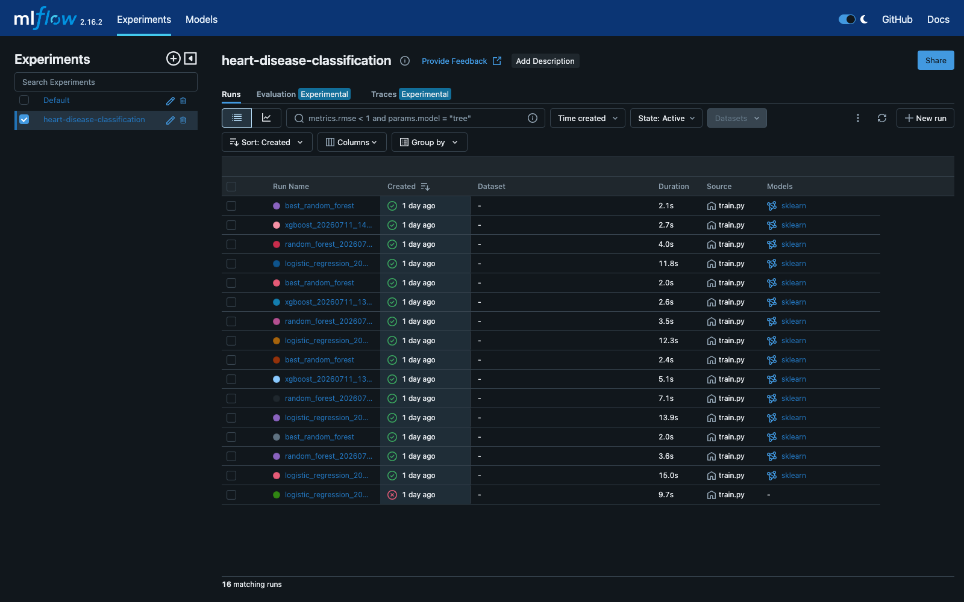
MLflow experiment runs list
Figure: 16 tracked runs across Logistic Regression, Random Forest and XGBoost.
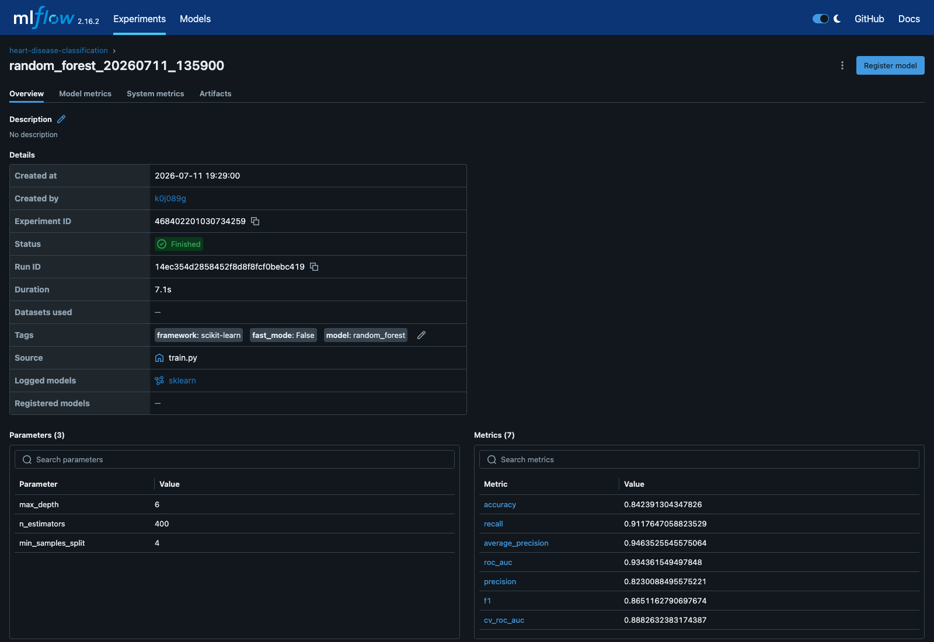
MLflow run detail
Figure: parameters and the seven logged metrics for the best Random Forest run.

6. Reproducibility
- requirements.txt pins every runtime dependency (major versions frozen).
- requirements-dev.txt adds test + lint + notebook tooling.
- sklearn.Pipeline ensures the exact same preprocessing runs at training and inference time — no drift between notebook and API.
- Random seeds are centralised in src/config.py::RANDOM_STATE = 42.
- Dataset SHA-256 is printed by data/download_data.py.

7. CI/CD workflow
.github/workflows/ci.yml runs on every push / PR to main:
- lint-test-train — set up Python 3.11, install deps, run ruff, run pytest --cov, execute python -m src.train --fast to prove the training pipeline still works end-to-end, upload the trained model + coverage as build artefacts.
- docker-build (needs job #1) — downloads the trained model, builds heart-api:ci via docker/build-push-action with a GitHub Actions cache, starts the container, probes /health and posts a sample payload to /predict.
The pipeline fails hard on lint errors, test failures, training errors, or a non-200 response from the containerised API. The GitHub Actions run screenshot (screenshots/evidence/ui/github_actions_pipeline.png) is captured after the first push to GitHub, once a workflow run is available.

8. Containerisation
docker/Dockerfile uses a two-stage build:
- Builder (python:3.11-slim) — installs build toolchain, then pip install --prefix=/install -r requirements.txt.
- Runtime — copies only the site-packages, source code, and trained model into a non-root user’s home. Adds a HEALTHCHECK against /health.
Local usage:
docker build -f docker/Dockerfile -t heart-api:latest .
docker run --rm -p 8000:8000 heart-api:latest
Proof of a working isolated build/run is captured in screenshots/evidence/06_docker_build.txt, 07_docker_run.txt and 08_docker_logs.txt. The interactive Swagger UI served by the container:
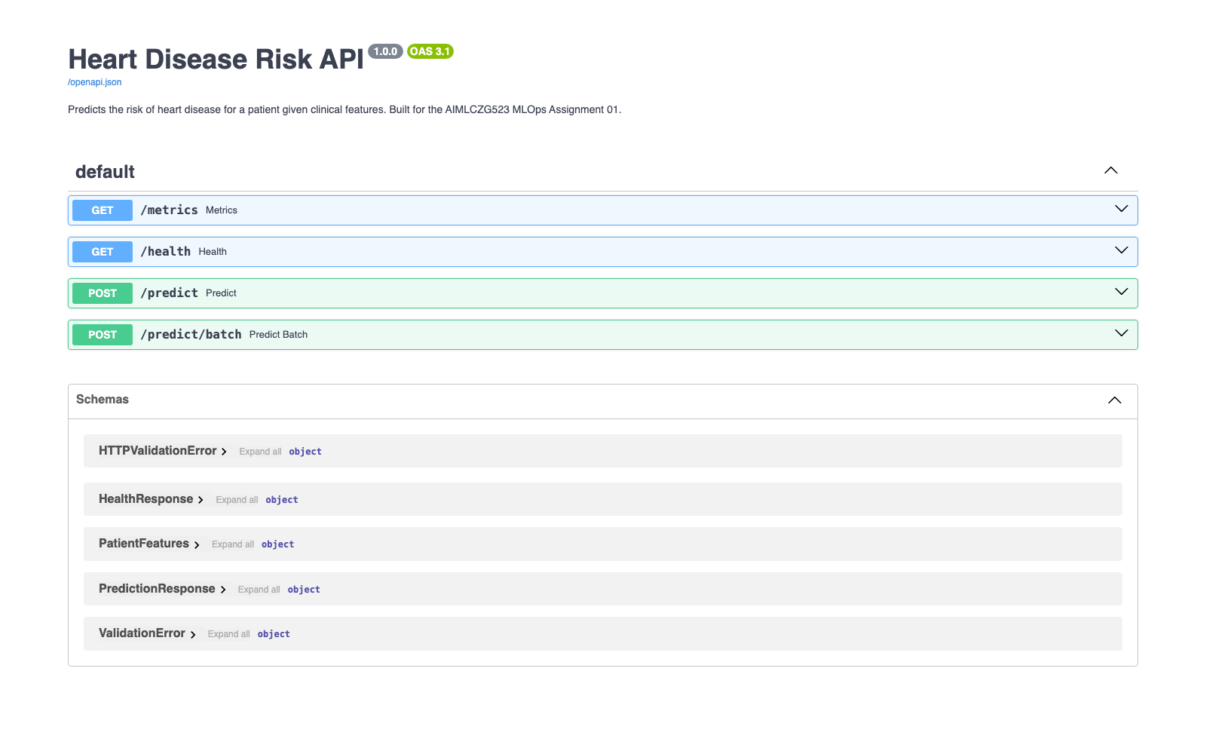
Swagger UI served by the container

9. Kubernetes deployment (Docker Desktop)
Manifests in k8s/:
- namespace.yaml — heart-disease namespace
- deployment.yaml — 2 replicas, readiness/liveness probes on /health, resource requests/limits, Prometheus scrape annotations
- service.yaml — ClusterIP on port 80 → container 8000
- ingress.yaml — nginx ingress at heart-api.localhost
- hpa.yaml — HPA scaling 2→5 pods at 70% CPU
docker build -f docker/Dockerfile -t heart-api:latest .
kubectl apply -f k8s/
kubectl -n heart-disease rollout status deploy/heart-api
kubectl -n heart-disease port-forward svc/heart-api 8000:80
# → http://127.0.0.1:8000/docs
Screenshots / evidence:
- screenshots/evidence/11_k8s_deploy.txt — kubectl get deploy,pods,svc,hpa with 2/2 pods Running, ClusterIP Service and the HPA (2→5 replicas)
- screenshots/evidence/12_k8s_predict.txt — live /health and /predict responses served through the Kubernetes Service

10. Monitoring & logging
- Structured request logs — every HTTP call is logged with method, path, status code, duration and client IP.
- /metrics (Prometheus) — exposes standard http_requests_total, http_request_duration_seconds, plus two custom metrics:
  - heart_predictions_total{label} — counter of predictions grouped by outcome
  - heart_prediction_latency_seconds — histogram of /predict latency
- Grafana — a provisioned dashboard (monitoring/grafana/provisioning/dashboards/heart-api.json) visualises predictions, latency percentiles and HTTP status codes.
- Kubernetes — pod annotations enable prometheus.io/scrape=true for any Prometheus operator installed in the cluster.
Screenshots / evidence:
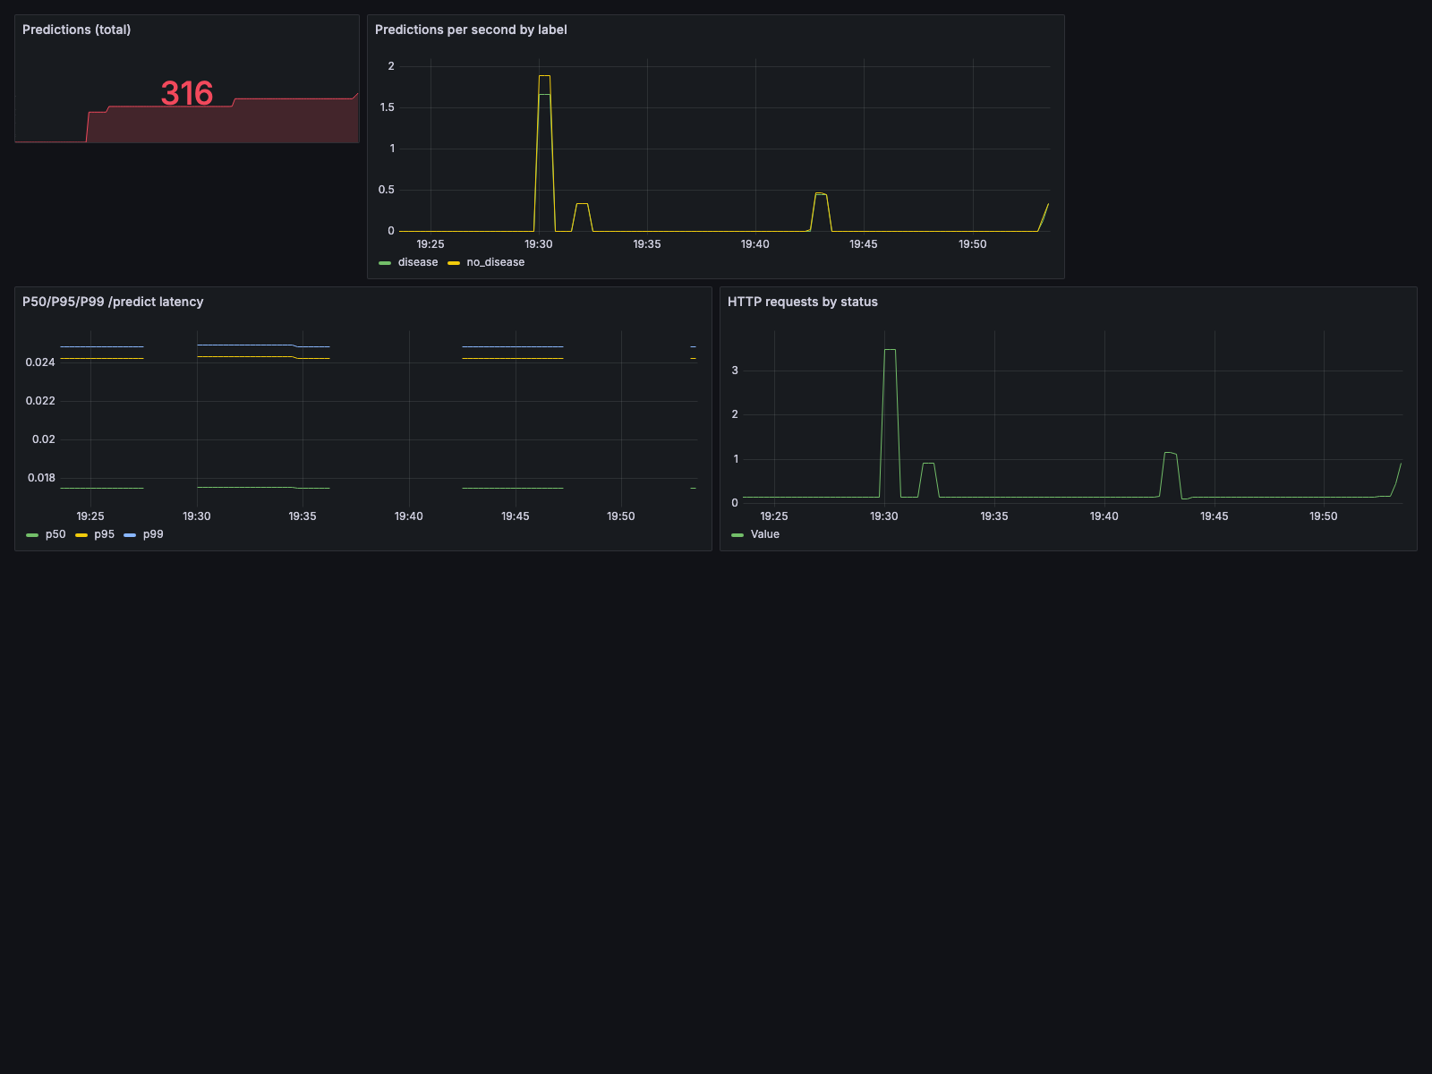
Grafana dashboard
Figure: live Grafana dashboard — total predictions, per-label rate, P50/P95/P99 latency and HTTP status codes.
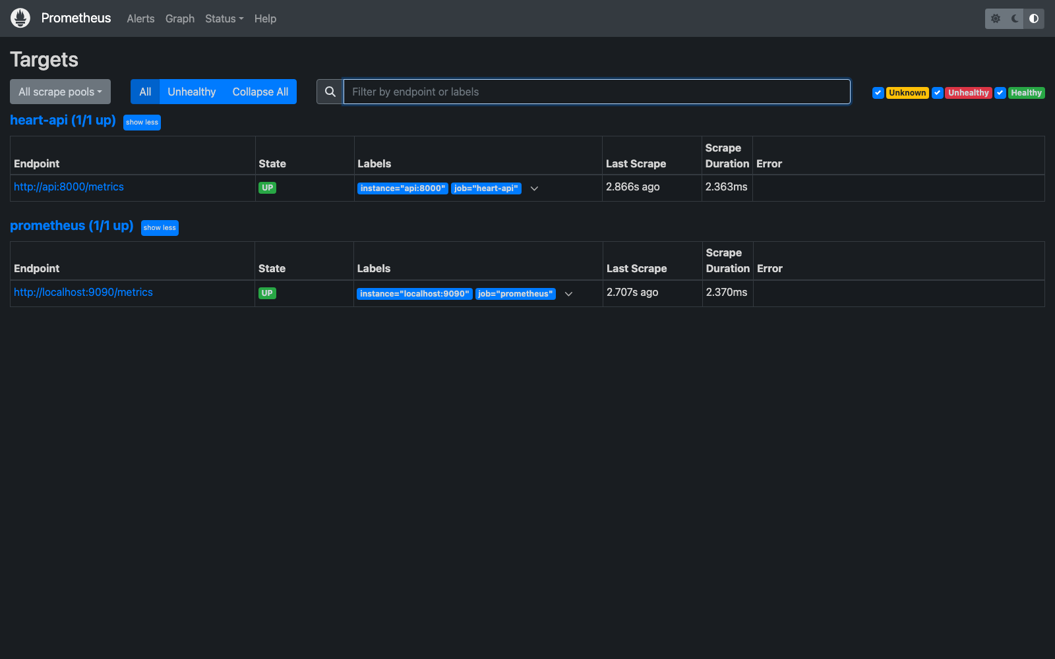
Prometheus targets
Figure: Prometheus scraping the API /metrics endpoint (target UP).
Raw metric/logging evidence: screenshots/evidence/13_monitoring.txt (PromQL query results) and screenshots/evidence/14_request_logging.txt (structured request logs).

11. Architecture diagram
The end-to-end architecture is defined as code in docs/architecture.mmd (Mermaid flowchart) covering: local development → experiment tracking (MLflow) → CI/CD (GitHub Actions) → packaging (model + image) → Kubernetes runtime (Deployment, Service, Ingress, HPA) → observability (Prometheus + Grafana). Render it to SVG/PNG with any Mermaid renderer (e.g. npx @mermaid-js/mermaid-cli -i docs/architecture.mmd -o docs/architecture.png) or paste it into https://mermaid.live.

12. Deliverables checklist
- GitHub repository with code, Dockerfile(s), requirements.txt
- Cleaned dataset (data/raw/heart_disease_uci.csv) + data/download_data.py
- Jupyter notebooks + scripts (notebooks/01_eda.ipynb, notebooks/02_model_dev.ipynb, src/train.py, src/predict.py)
- tests/ folder with pytest suite (16 tests)
- GitHub Actions workflow YAML (.github/workflows/ci.yml)
- Kubernetes manifests + Helm chart
- screenshots/evidence/ folder (Swagger, MLflow, Prometheus, Grafana + text logs)
- Final written report (this document, exported to DOCX/PDF)
- API access instructions (local — §2, §8, §9)
- Short video recording of the pipeline

13. Academic integrity statement
This submission was authored independently by Kanna TJ (2024ad05219@wilp.bits-pilani.ac.in). All feature engineering choices, model grids, CI/CD steps, container layout, Kubernetes manifests, monitoring configuration and documentation reflect original work. External libraries used are cited via requirements.txt and are standard MLOps tooling.

