ATT-1: Blackbucks Mini Project (Mern Stack Project)
Title: Internship Monitoring and Evaluation System
PROJECT ARCHITECTURE

- Architecture Overview
The Internship Monitoring and Evaluation System is designed to manage and track student internships efficiently. It connects students, mentors, and administrators through a centralized system.
The architecture follows a 3-tier structure:
1.Frontend (User Interface)
2.Backend (Server & Logic)
3.Database (Storage)

2. Internship Monitoring and Evaluation System Architecture
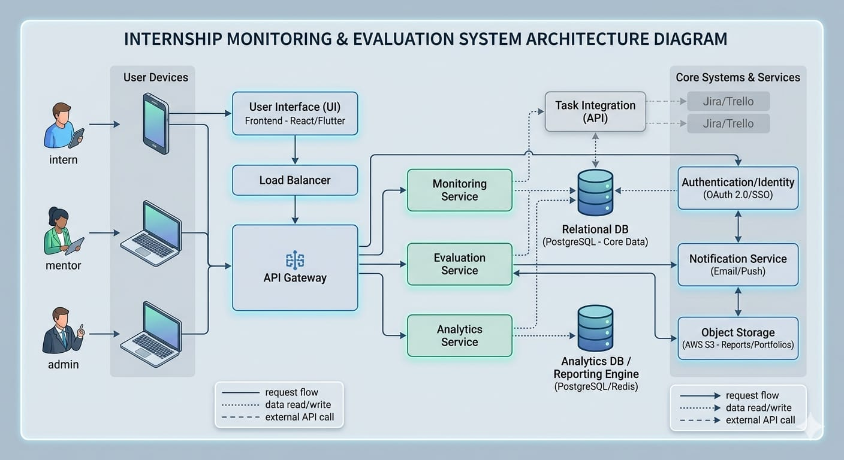

3 . Components Explanation
3.1 Frontend (User Interface)
- Used by students, mentors, and admin
- Provides features like:
- Login/Register
- Upload reports
- View progress
- Built using HTML, CSS, JavaScript (or React)

  - Backend (Server)
- Acts as the brain of the system
- Handles:
- User authentication
- Data processing
- API requests
- Developed using Node.js and Express
3.3 Database
- Stores all system data:
- Student details
- Internship reports
- Evaluation marks
- Using MongoDB

4.Modules Description
4.1. User Management Module
  - Handles registration and login
  - Provides role-based access (student, mentor, admin)
4. 2. Internship Monitoring Module
- Tracks student activities
- Monitors attendance and task completion

4.3 Report Submission Module
- Students upload internship reports
- Maintains submission history
4.4 Evaluation Module
- Mentors assign marks and feedback
- Calculates performance
4. 5 Admin Module
- Manages users and system data
- Generates reports and analytics

4.DataFlow
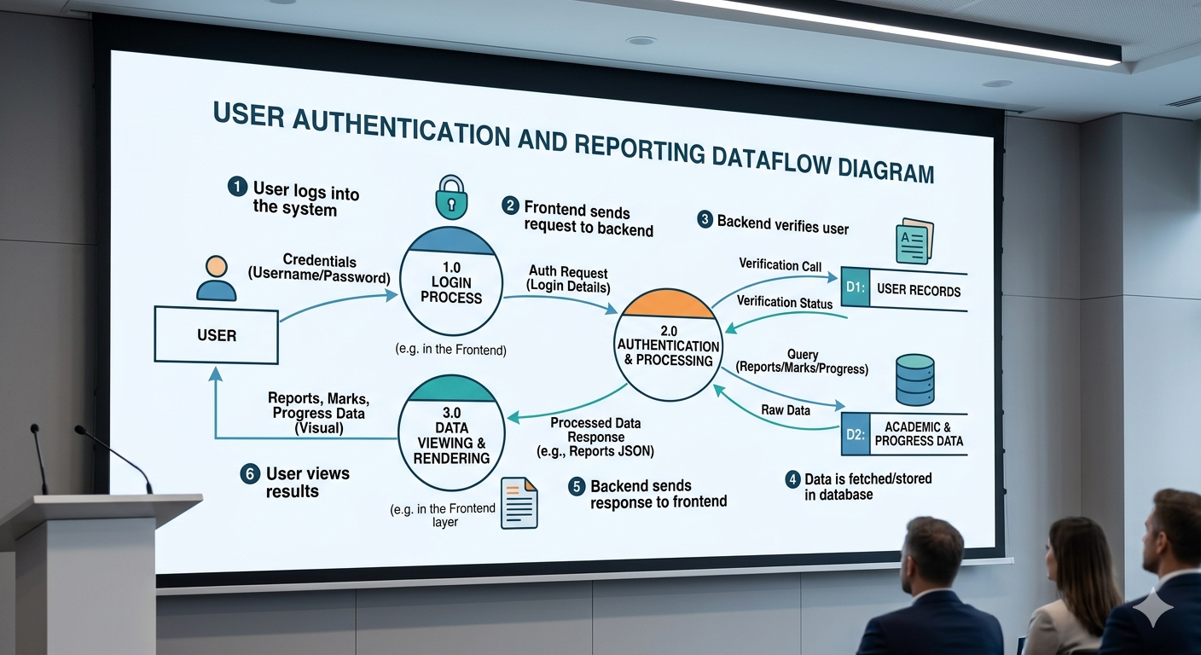
- User logs into the system
- Frontend sends request to backend
- Backend verifies user (authentication)
- Data is fetched/stored in database
- Backend sends response to frontend
- User views results (reports, marks, progress)

5. Technologies Used
- Frontend: HTML, CSS, JavaScript / React
- Backend: Node.js, Express
- Database: MongoDB / MySQL
- Tools: VS Code, GitHub

6. Conclusion
The Internship Monitoring and Evaluation System provides an efficient solution for managing student internships. It simplifies the process of tracking student progress and performance. The system enables easy communication between students, mentors, and administrators. It reduces manual work and minimizes errors in evaluation. Real-time monitoring helps in identifying student performance effectively. The report submission feature ensures proper documentation of internship activities. The evaluation module provides accurate and transparent assessment. The centralized database helps in secure data storage and easy access. Overall, the system improves productivity and organization. Thus, it is a reliable and effective tool for internship management.

Training and Placement ATT-1 Batch (T48)
Bushra Marva (B23AI075)
Kanne Asritha(B23IT023)
Shanigarapu Amulya(B23IN061)

