Report of Software Architecture

Experiment 4: Façade pattern-Student Information System

Basic information
Team name： _______________________________
Class number: ___________________________________________________
Department/school：
Team members with student numbers：

_______________________

Instructor’s comments and score
Comments：

Score：
Signature of the Instructor：

Year Month Date

Now we have some student information documents classes:

StudentBasicInfo,

StudentBasicInfoModel,

AcademicRecord,

StudentAcademicModel,

Award and

StudentAwardModel.

现在我们有一些学生信息文档类：

学生基本信息，

学生基础信息模型，

学术记录，

学生学术模型，

奖项和

StudentWardModel。

The StudentBasicInfo class is responsible for reading student's basic information from a file containing student basic information. The StudentBasicInfoModel class provides the format of the student basic information that is stored in the text file. The returns data type is the ArrayList<StudentBasicInfoModel> type. In class StudentBasicInfo, class StudentBasicInfoModel is called.

Similarly, AcademicRecord is responsible for reading student's academic information, including the course title and the scores, with return data structure type as ArrayList<StudentAcademicModel>. Therefore, in class AcademicRecord, class StudentAcademicModel is called.

Class Award is responsible for reading the award information from a text file, including what kind of awards and the date to get them. The return type is ArrayList<StudentAwardModel>.

We use the façade pattern to design a student comprehensive information system, which will extract all the information including student basic information, student academic information, and student award information. The design is as below.

StudentInfoFacade
+extractStudentInfo(): String
+extractAcademicRecord(): String
+extractAllAwards(): String
+getStudentInfo(): String
- firstName: String;
- lastName: String;
- studNum: String;
StudentBasicInfo
+isExistingStudentName(String name)
+getStudentBasicInfo(): ArrayList
- name: String;
- birthDate: String;
- serialNum: String;
AcademicRecord
+getAllScores(String file): ArrayList
- firstName: String;
- lastName: String;
- studNum: String;
EllipseDrawerGUI
Award
+getAllAwards(String file): ArrayList
- firstName: String;
- lastName: String;
- studNum: String;
StudentAwardModel
+getAllAwards(String file): ArrayList
- studFirstName: String;
- studLastName: String;
- studSerialNum: String;
- awardName: String;
- awardDate: String
StudentAcademicModel
+getAllAwards(String file): ArrayList
- studFirstName: String;
- studLastName: String;
- studSerialNum: String;
- courseTitle: String;
- courseNum: String;
- score: String;
StudentBasicInfoModel
+getAllAwards(String file): ArrayList
- name: String;
- birthDate: String;
- serialNumber: String;
- ssNumber: String;
- major: String;
- degree: String;
+getStudFirstName(): String
+getStudLastName(): String
+getStudSerialNum(): String
+getAwardName(): String
+ getAwardDate(): String
+getStudFirstName(): String
+getStudLastName(): String
+getStudSerialNum(): String
+getCourseTitle(): String
+getCourseNum(): String
+getScore(): String
+getName(): String
+getBirthDate(): String
+getSerialNum(): String
+getSocialSecurityNum(): String
+getMajor(): String
+getDegree(): String

Figure 1 Student information system designed by using the façade pattern

The graphical user interface is as below.

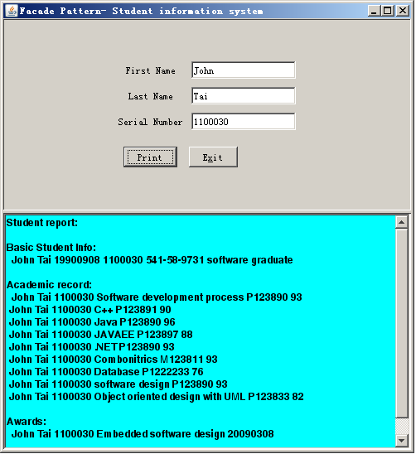

Figure 2 Graphical user interface for the student information system

Requirement: In the design above, add a class named Tuition, which has already been included in this file directory. You need to implement the method extractTuitionInfo() in the class StudentInfoFacade correctly. Then you also need to modify other part of the class StudentInfoFacade in order to extract the student tuition information in addition to the already existing functionalities.

- Describe your finished homework, including
    - What classes have been added to the existing class hierarchy?
    - The relationship between the existing classes and the newly added classes.
    - What code has been added to what class?
etc.

- Original class diagram, and new class diagram

- Your new key code, and your new key parameters in order to finish the required new functionalities

- Typical input and output from running your finished program

