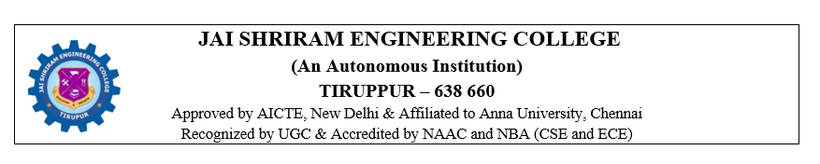
DEPARTMENT OF ARTIFICIAL INTELLIGENCE AND DATA SCIENCE
REPORT ON INTERNSHIP TRAINING

Name of the Student/reg.no: | Saranya M - 711223243047
Year/Sem: | III/V
Date of Training: | 22.12.2025 - 05.01.2026
Name of the Organization: | BRAINERY SPOT TECHNOLOGY
Address of the Organization: | 3rd floor, 76, Ansari St, near Elite Furniture Mart Building, Ram Nagar, Coimbatore, Tamil Nadu 641009.
Contact Person Name: | Jeevarathinam
Details of the Contact Person: | +91 98944 50083

About the Organization:
1.Company Profile:
Brainery Spot Technology, located in Coimbatore, Tamil Nadu, is a growing technology-driven organization specializing in IT training, software development, and digital solutions. The company focuses on delivering industry-relevant technical education and practical skill development to students and aspiring professionals.
Brainery Spot Technology offers training programs in various domains such as full stack development, software programming, and emerging technologies. The organization emphasizes hands-on learning, real-time project exposure, and the use of modern development tools to bridge the gap between academic knowledge and industry requirements.The company follows structured training methodologies that include conceptual learning, practical implementation, testing, and project-based evaluation. Its professional learning environment encourages innovation, problem-solving, teamwork, and continuous skill enhancement.

Brainery Spot Technology actively supports student development by providing internship and training programs that focus on practical experience, industry standards, and career readiness. These initiatives help students gain confidence and technical competence for future opportunities in the IT sector.
2. Overview of the Training:
a) Introduction:
The internship training conducted at Brainery Spot Technology, Coimbatore was focused on Full Stack Development. The main objective of the training was to provide practical knowledge of designing, developing, and deploying complete web applications involving both frontend and backend technologies. The training program was structured to combine theoretical concepts with hands-on practice to enhance technical skills.
The training covered both client-side and server-side development, enabling an understanding of how complete applications are built, connected, and maintained. Emphasis was given to responsive design, user experience, database integration, and industry-standard coding practices followed in real-time projects.
b) Summary of the Training and Experiences Gained:
The training began with an introduction to HTML, where the fundamentals of web page structure, elements, forms, links, tables, and semantic tags were explained. This helped in understanding the basic structure of frontend interfaces. Next, CSS was introduced to design and style web pages effectively. Concepts such as layouts, colours, fonts, box model, positioning, and responsive design were practiced to create visually appealing and user-friendly user interfaces.
JavaScript was used to add interactivity and dynamic behaviour to web pages. Topics such as variables, functions, conditions, loops, event handling, DOM manipulation, and basic form validation were covered. These concepts improved understanding of client-side scripting and enhanced user interaction within applications. An overview of backend development concepts was also provided to explain how server-side logic works in full stack applications. Topics such as request–response cycle, data handling, authentication, and basic API concepts were introduced. The importance of validation, security, and smooth data flow between frontend and backend was discussed. The training also introduced development tools and coding practices followed in the industry, which improved logical thinking, debugging skills, and confidence in full stack development.

c) Exploration for Project Development:
The internship provided exposure to the complete full stack application development life cycle. Initially, project requirements were analyzed to understand user needs, system functionality, and technical specifications. Simple user interface designs and application layouts were planned before implementing the frontend code. Frontend development was carried out using HTML, CSS, and JavaScript to create responsive and interactive user interfaces. Backend integration concepts were explored to understand server-side operations, database connectivity, and data processing.
Testing procedures were performed to identify errors and improve functionality, security, and performance. The training concluded with an introduction to deployment concepts, providing insight into how full stack applications are hosted, managed, and accessed online. This project exploration provided practical experience and a clear understanding of real-world full stack development practices.
3. Tools and Technologies Used:
- HTML5
- CSS3
- JavaScript
- Backend Technologies (Basics)
- Database Concepts
- Visual Studio Code
- Web Browsers for Testing

4.Photographs:
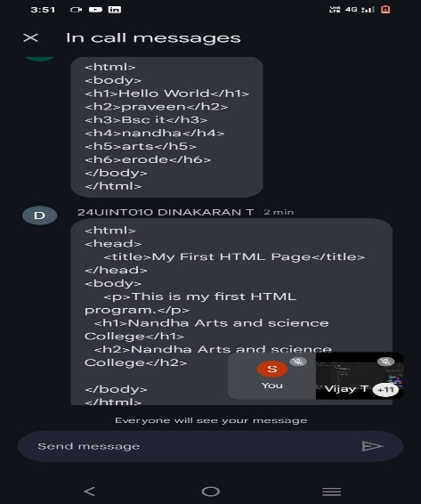
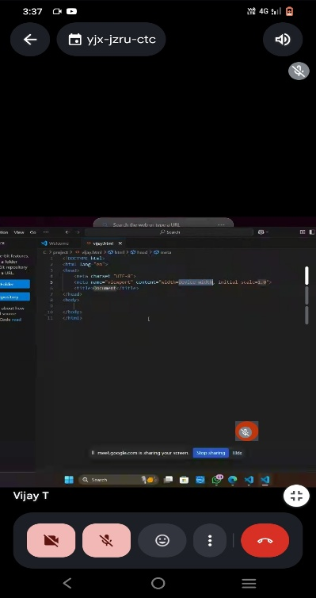

5.Outcome of the Internship:
The internship training in Full Stack Development at Brainery Spot Technology, Coimbatore was highly informative and beneficial. The training provided a strong foundation in both frontend and backend technologies, along with a clear understanding of complete application development processes.

Practical exposure to HTML, CSS, JavaScript, backend concepts, and database integration enhanced the ability to develop responsive, interactive, and data-driven applications. The training also improved understanding of application architecture, server-side processing, and full stack workflows.

Problem-solving skills, logical thinking, and debugging abilities were significantly improved through hands-on practice and real-time examples. Additionally, the internship offered valuable insight into professional work culture, teamwork, and industry-level development practices. Overall, this internship strengthened technical skills, boosted confidence, and prepared students to work on future academic projects and pursue a career in full stack development.

IIPC COORDINATOR

