DESIGN AND IMPLEMENTATION OF TRAFFIC OFFENCE TICKETING SYSTEM, KANO ROAD TRAFFIC AGENCY(KAROTA) AS A CASE STUDY.

BY

# DECLARATION

I, hereby declare that this project titled “DESIGN AND IMPLEMENTATION OF TRAFFIC OFFENCE TICKETING SYSTEM” has been carried out by me under the supervision of SUPERVISOR NAME. It has not been presented for award of any degree in any institution. All sources of information are specifically acknowledged by means of reference.

______________________________ _____________________

Signature Date

# CERTIFICATION

This project entitled “DESIGN AND IMPLEMENTATION OF TRAFFIC OFFENCE TICKETING SYSTEM” by with matriculation number meets the requirements governing the award of the Bachelor of Science in COMPUTER SCIENCE and is approved for its contribution to knowledge and literary presentation.

_______________________________ _________________

Name Date

Supervisor

_______________________________ _________________

Name Date

Head of Department

________________________________ __________________

Name Date

External Examiner

# DEDICATION

This Project Report is dedicated to my parents for their love, care and support. I am indeed grateful. May Almighty ALLAH reward them abundantly. Ameen!

# ACKNOWLEDGEMENT

# ABSTRACT

In recent years, the quantity of motor vehicles in Kano State is increasing rapidly and the burden of the management of the road traffic offences are increasingly heavy and tedious for the Kano Road Traffic Agency (KAROTA) hence the reason for developing this system. The system provides access to the Agency’s Marshalls to log in offenders and generate fine ticket instantly. The system will effectively improve the traffic police’s regulatory capacity and efficiency in dealing with violations against traffic control and realized the management of this information. In the running process, the system is stable in performance, with good sharing of data and simple operation.

# CHAPTER ONE

# INTRODUCTION

## Background of Study

Traffic offence is any violation of a traffic regulation of a town, city, municipal or quasi municipal corporation. A violation of traffic regulations, such as breaking the speed limit, illegal parking etc. attract a penalty punishable by pre-stated rules of the state. Traffic offence ticketing is the act of registering traffic offenders by officers of the law with the perpetrator’s details and offence committed to a single traffic ticketing management system. This is to minimize monetary loss due to corruption by officers and address absence of a centralized offender’s database. Appropriate road safety policy one of the essential elements of a well-balanced overall transport and public health policy (Michael Ray, 1995). Also, State Federal Road Safety Corps in their 2014 report stated that one third of all dangerous traffic conditions on Nigerian roads are created by traffic offenders who behaves disorderly while driving and drives very risky. Risky driving is still one of the most important factors in determining the road accidents all over the world. World Health Organization states that the total number of road traffic deaths remains unacceptably high at 1.24 million per year (WHO, 2013). A number of solutions have been proposed to address the issue of offence monitoring and management. However, none of the existing solution fully automate the process of traffic offence ticketing. Therefore, in this project, I design and implement a Traffic Offence Ticketing System for Kano Road Traffic Agency (KAROTA) to help them automate offence ticketing. The designed system will be a system is a web-based application that enables traffic Marshalls to register offenders with the offence committed instantly.

## Problem Statement

Kano Road Traffic Agency(KAROTA) and the Kano State Government at large loose a significant amount of revenue money generated from fines and penalties due to negligence of duty, improper documentation and corruption by traffic officers. Existing systems cannot keep track and records of offences committed, automatically generate ticket and manage staff information. The existing system is not a fully automated system. It lacks the capability to checkmate offences, time and place committed and the officer or Marshall that reported the offence. Furthermore, the existing system does not have a single centralized database. Thus, traffic offenders and officers regard the system with less importance. In an attempt to address the aforementioned problems, I proposed the use of a computerized, centralized and web based traffic offence ticketing system that documents offences committed, automatically generate fine invoice and keep records of traffic Marshalls.

## Motivation

With current speedy advancements in technology, almost all manual processes of record keeping and ticketing is being computerized to ease work management and facilitate accessibility. The bid to automate, increase fairness, reduce money loss due to corruption and curb biasness in traffic offence ticket is the reason for developing the electronic means of Traffic Offence Ticketing System. The web-based Traffic Offence Ticket System makes it easier and faster to register offenders and manage the process.

## Aim and Objectives

The aim of this project is to design and implement an automate a web based traffic offence ticketing system. The following are the objectives that the project seeks to achieve;

1. To provide and interface for system administrators to view all offences committed
2. To provide and interface for system administrators to add new offence, its degree and associated fines and penalties.
3. To provide and interface for system administrators to add new Marshall to the system
4. To provide and interface for system administrators to view, edit and delete existing Marshalls.
5. To provide an interface for system administrator to suspend and activate user accounts.
6. To use username and passwords to authenticate the Marshall.
7. To provide an interface for Marshalls to register/view traffic offenders and offence committed.
8. To provide an interface for the Marshall to change his password and edit profile details.
9. To curb corruption, reduce biasness, increase fairness, improve job satisfaction, reduce administrative work and centralized traffic offence ticketing.
10. To function in a simple and intuitive manner.

## 1.5 Significance of Study

The ability to register offender instantly with committed offence, generate ticket for the offender and achieving a centralized repository will ease work, increase fairness and draw the trust of people in the Traffic Agency.

## 1.6 Scope of Study

The scope of this study is to design and implement a Traffic Offence Ticketing System. The system covers the operations of the Kano Road Traffic Agency(KAROTA). Computers or handheld devices with internet access are recommended for this system.

## 1.7 Limitations of The Study

The proposed project has the following limitations:

1. The system’s operation is only limited to Kano Road Traffic Agency(KAROTA).
2. Ticket Payment cannot be done on the system unless taken to a bank.
3. Limited only to computers or handheld devices with internet access.

## 1.8 Project Organization

In this project research chapter two sheds light on the literature review which creates intellectual masturbation in a domain principle in other to generate an added value to the topic at hand. Chapter three covers system analysis and design. Chapter four presents the system implementation, documentation and testing. It demonstrates the functionality of the system with screen shots of the interfaces of the proposed system in order to give a visual display of its appearance as the user navigates through different stages of the system. Chapter five summarizes and concludes the research findings.

# CHAPTER TWO

# LITERATURE REVIEW

## 2.1 Introduction

This chapter reviews the related literature of this study. Summarized history of Kano Road Traffic Agency (KAROTA) was stated. The chapter defines traffic offence, traffic ticket and traffic violation. Traffic offence ticketing and related works were also discussed. Finally, the chapter reviews the essence of automating traffic offence ticketing.

## 2.2 Overview of Kano Road Traffic Agency(KAROTA)

KAROTA is a government agency that was established in 2012 by His Excellency Dr. Rabiu Musa Kwankwaso, the then executive governor of Kano State, Federal Republic of Nigeria and Muhammad Diggol was appointed the GM by the governor. The agency is established in line with international best practices in traffic and environmental management. No modern metropolis can function effectively without well-articulated traffic and environmental laws. KAROTA is established to help articulate these laws, communicate them effectively to the citizenry, and ultimately ensure compliance. KAROTA is not meant primarily, to be a revenue generating agency but in all civilized societies fines are an acceptable means of ensuring compliance to rules and regulations.  So fines are only instituted to discourage people from violating the laws of the State.

## 2.3 Traffic Offence/Logging, Traffic Ticket and Traffic Violation

Traffic offence is any violation of a traffic regulation of a town, city, municipal or quasi-municipal corporation.

Traffic ticket is a simplified traffic police investigation report that specifies the identity of the offender, the type of offense, the location of the offense, the evidence requested, the time of trial and the data of the law enforcer along with the signature.

A violation of traffic regulations, such as breaking the speed limit, illegal parking etc. attract a penalty punishable by pre-stated rules of the state. (ncibi, 2012) .

## 2.4 Traffic Offence Ticketing and Related Studies

Globalization and advances in science and technology have significant impacts on people’s lives. A closer look at the impacts would indicate that a very practical and modern way of life almost occurs in all aspects of people’s lives, no exception the legal aspect. The technological developments also have impacts on levels of crime and offences committed by people. Law and society are two inseparable things since they are interrelated. Law enforcement on Road Traffic and Transportation covers the prosecution of violations and handling of Traffic Accidents. Prosecution of violations is carried out by on-road checks of motor vehicles. In the case of violations during the checks, prosecution may be taken by fast procedure and immediate imposition of fines.

Despite these technological advancements and improved environment including good conditions, the rate of road traffic accidents continues to increase. According to David (1999), the second African Road Safety congress in Addis- Ababa, Ethiopia in 1989 revealed that the road safety situation in a developing Economic (especially Africa) still poses a great concern as shown in the following cooperative statistics: At the global level: 500,000 persons die and 10, 12 to 15million persons are injured every year in road accidents throughout the world and approximately 30% of these fatalities and injuries are experimented in developing countries. A recent analysis of Global Burden of Disease, in assessing changes in ranking order of disease burden for 15 leading causes in the world, shows that road traffic accidents ranked No. 9 in 1990 and will probably be No. 3 in the year 2020, if not properly checked and controlled. At the regional level: Research shows that road accidents are the second highest cause of death for the 5 to 44 years’ age group in Africa. The major challenge facing the Federal Road Safety Commission and other coordinating bodies is act of competent support staff and experts to assess the relevance of existing road safety.

Program implementation and continuity, funding and follow-up of the actions undertaken, are additional challenges. There is need for increased funding, the initiation of the in-depth studies and actions plan to improve Road Safety situation at the national, sub-regional and regional levels. The essence is exchange of experiences and results in order to gradually increase available relevant knowledge.

Road Traffic injuries have escalated to serious health, social and economic hazard, in developing countries. According to Yar’Adua (2008), Road Traffic Accidents cost US$ 18 billion globally in low income and middle income countries; and that road related injuries will rise to third position ahead of such diseases as Tuberculosis and even HIV/AIDS. He submits that a total of 55, 195 Road Traffic Accident were reported in Nigeria from 2003-2007, out of which 25,939 persons were killed and 85,976 others injured. Yar’Adua posted that the situation of Road Traffic Accidents in contemporary world and local perspectives has given an insight into the significance of the existence of the Federal Road Safety Commission.

An analysis of the causes of death in a number of countries throughout the developing countries has shown that deaths and fatalities from road traffic accident in Nigeria rank among the highest in the world and second behind those by hunger and gastroenteritis Adebisi (1988) cited in Balogun (2006). A number of experts have suggested several causes of road traffic accident to broadly include the following: According to Oyeyemi (2003:4), human factors constitute about 80% of the cause of road traffic accidents recorded in the country. This includes dangerous overtaking at bends, crest of a hill, over speeding, driving under the influence of alcohol/drugs and the use of mobile phone while driving among others. Oyeyemi continues that this is a situation where drivers operate mechanically deficient vehicles on the roads on the roads carrying passengers and property without safety consideration. Such vehicles are not road worthy and they do not meet minimum safety standards. Bad weather condition leading to mist, haze, harmattan and sometimes heavy rainfall resulting in poor visibility and accidents. Oyeyemi (2003) concludes that Road Traffic Accidents constitute a major cause of death and loss of property in the country, depleting the workforce of the nation and rendering victims and their relatives to suffer severe psychological trauma. Billions of naira worth of property including human beings, most of them belonging to the productive age group are consumed through automobile fire incidents on the roads due to accidents. Different accident statistics have been presented by a number of stakeholders to underscore the adverse effect of road traffic accidents on the economy.

There are several ways to make travelling safe and one is through the Traffic Policing. Responsibility of the traffic officer regarding traffic management includes enforcing traffic rules and regulations and penalizing the driver in case of violating traffic rules. In today's information-rich society, everything is becoming smart. Traffic offence management is a major concern in cities around the world.

## 2.5 Essence of Automating Traffic Offence Ticketing

With the development of transportation in our country, the number of motor vehicle drivers and vehicles is growing. Accordingly, with increasingly complex situation of road traffic, and the constantly updated vehicle performances and vehicle types, the traditional ticketing method actually has been far from enough to satisfy the need of modern traffic management. To resolve a variety of existing issues effectively, present network resources should be taken full advantage of, which will be convenient for Traffic Police Department to successfully automate the process of offence ticketing. This reduces the amount of manual repetitive tasks, and it enables the processing of more offences with fewer staff. Automation increase accuracy and ensures that each offence is dealt with swiftly and fairly. Also overall government expenditure is reduced.

Poor quality of information generated by a Traffic Ticket Data Processing Information Systems is inseparable from the handling and management of information systems, since the outputs of this system is information useful to stakeholders and decision makers in the Traffic Police Department. Information systems that do not produce output but always receive input would put the input into a deep hole (Hevner A., and Chatterjee S., (2010). Results also indicated that user’s satisfaction with the Traffic Ticket Data Processing Information Systems was not significant. Satisfaction with the use of information technology can be measured from the aspect of behavior since behavior is one of the important aspects that relate directly to the user. Furthermore, interaction between user and computer devices is heavily influenced by perception, attitudes and affections inherent in human beings as users (Cheung C. M., and Lee M. K., 2008).

(Grispos G., et. al 2014) suggest that user behavior and a personal system are needed in the system development. This relates to the understanding and perspective of the system user since the perception of the personnel involved in the implementation of the system will take effect at the end of a system, whether the system is successful or not, acceptable or not, useful or not, if implemented. Furthermore, (Gil D.N., 2009) argues that the use of information technology by an individual, group, or organization is an important variable in the information system since its acceptance or rejection should be confirmed beforehand.

In today’s rapid technological developments, information systems support to a network constitutes a necessity to speed up acquisition of accurate and timely information fast. Information systems supported by an intranet network will have an impact on the high rate of data communication and provide advantages in a variety of transactions from a variety of different places that can cut the cost of the preparation and delivery of reports due to capability of online acquisition.

Understanding and awareness of the functions and benefits of the information system will determine the quality of information produced by a system since the computer system has taken over human works in data processing; however, man has an important role as a user (Au N., and Cheng, T.C.E., 2012). (Al-Debei M.M., 2013) argue that the success of an information system is influenced by the perceived information quality and the perceived quality system which is a significant predictor for user satisfaction, while user satisfaction is also a significant predictor for the intended use and perceived individual impact.

Utilization of information technology within an information system provide an accelerated access and timeliness as well as the reduction of bureaucracy since it is capable of fast information generation with high accuracy (Iivari J., 2007), which has a positive impact on decision making.

To assist traffic police and people with regard to improving the settlement of traffic tickets, a WEB-based traffic offence ticketing information system is required, which can generate traffic ticket information quickly, at any time round the clock. This information system is aimed at reducing traffic violations committed by people as well as increasing public awareness of safe, orderly and proper driving. The purposes of the present study were to improve efficiency and effectiveness of ticketed motor vehicle data management, to assist the traffic police in addressing and reducing traffic offenses and to improve the order in driving.

Web based architecture means that the system runs quickly over a broadband connection. Its intuitive interface ensures fast processing of tickets and also the inbuilt reporting tool allows for flexible reporting from a management perspective. Reports are easy to create and customize on the go, which enables users to locate the information they need. The automated system is more efficient than a paper based system as data can be accessed from various sources and users for a single solution for all enforcement processing. It’s Full document management capability to realize the paperless office.

The proposed system helps traffic police keep adequate information of all traffic offences that has been committed by road users and also maintain the databases of the driver and vehicle details for which a ticket was issued. We have many existing applications that helps the offender or driver to check his penalty status and he can pay the penalty online without the intervention of traffic police, but my application focuses on traffic police as user to register offender and generate ticket, penalize the one who commits the traffic offence and manage information for the traffic department. With the information stored in the database the higher authorities can take appropriate measures. Another way of enforcing traffic discipline is frequent conduction of awareness program, from the department of Traffic Police, based on the offence data collected. The existing system do not have centralized repository for storing the penalized data.

# CHAPTER THREE

# SYSTEM ANALYSIS AND DESIGN

## 3.1 Introduction

This chapter covers the analysis of the proposed system which discusses the specification of what the system intends to meet. It also covers requirement determination thereby discussing the functional and non-functional requirements of the proposed system. The chapter presents the methodology which is an approach followed in implementing the proposed system. The system architecture and the Data Flow Diagram(DFD), Entity Relation(ER) model and database tables are also presented in this chapter.

## 3.2 System Analysis

This is the process of studying a procedure or business in order to identify its goals and purposes and create systems and procedures that will achieve them in an efficient way. The principal objective of the systems-analysis phase is the specification of what the system needs to do to meet the requirements of end users.

### 3.2.1 Analysis of The Existing System

The existing systems for traffic offence ticketing is the manual method. The existing system is analyzed and the following features are identified;

1. Traffic Marshalls have to manually issue traffic ticket.
2. Fine invoice is generated manually.
3. The system lacks centralized repository.
4. Offender ticketing is only done at the Agencies’ head office.

### 3.2.2 Analysis of The Proposed System

The Traffic Offence Ticketing System is a web application that automate the manual methods traffic police use to register and fine traffic rules violators and manage its staff. The system was designed as a web-based system to allow traffic police and decision makers access to information where ever they are. The system is very important because, it achieves the following objectives;

1. It replaces the existing technique of offence ticketing to a fully computerized and automated process.
2. Only traffic Marshalls with activated account can access the system.
3. Marshall’s information can be registered, edited, activated, suspended or deleted from the system.
4. Only Administrators have super rights to the system.
5. The system automatically generates ticket for each traffic offender logged which can then be printed.

## 3.3 Requirement Determination

A requirement is simply a statement of what the system must do or what characteristic it must have. The requirements for a system are the descriptions of what the system should do the services that it provides and the constraints on its operation (Sommerville, 2011).

### 3.3.1 Functional Requirements

Functional Requirements are statements of services the system should provide, how the system should react to particular inputs, and how the system. should behave in particular situations (Sommerville, 2011). In some cases, the functional requirements may also explicitly state what the system should not do. The following are the analyzed functional requirements of the proposed system

1. Administrator should access the system using a username and password known to the admin.
2. Each employee should be uniquely identified by his or her staff I.D.

### 3.3.2 Non-Functional Requirements

Nonfunctional requirements refer to behavioral properties that the system must have, such as performance and usability (Denis A, 2009). Nonfunctional requirements describe a variety of characteristics regarding the system: operational, performance, security, dependability, regulatory, efficiency, environmental and safety requirements. The following are the analyzed non-functional requirements of the proposed system.

***Operational Requirement***

The application has to allow administrator to view and modify its data concurrently, while preserving the accuracy of the data. Invalid inputs to the system will throw error, then hints will be displayed to guide the user to enter correct data format.

***Security Requirements***

The system should be secure and accessed only by a username and password. Suspended traffic Marshalls cannot access the system unless their account is activated by the Administrator.

***Environmental Requirements***

The application should reside on any web server that support PHP version 7 or higher with a MySQL database. The system can then be accessed through any device’s web browser with internet access. The System can run on computers with either a Windows, Mac or Linux operating systems.

***Performance Requirements***

The system is expected to operate smoothly on any system with a processor of at least 1.2GHz speed and a minimum of 512MB Random Access Memory (R.A.M).

## 3.4 Methods of Data Collection

Having achieved the software requirements, the next step was to source for information relative to the subject. This process of information gathering was achieved through so many sources including:

1. File downloads from the internet.
2. Textbooks in the library.
3. Journals and articles.

## 3.5 Design Methodology

A methodology is a formalized approach to implementing the Software Development Life Cycle (SDLC). It is a list of steps and deliverables. (Denis A, 2009). The key activity in this design methodology is finding the best solution for each design situation, whether it be in industrial design, architecture or technology. This study makes use of the software engineering concept and method to critically analyze the existing employee tracking and attendance system then build an online application that will perform better and faster. The model adopted for this project is the waterfall model using plan-driven approach.

***3.5.1 The Waterfall System Design Model***

It is a software design process model that involves discrete development stages: specification, design, implementation, testing, and maintenance. In principle, one stage must be complete before progress to the next stage is possible. In practice, there is significant iteration between stages. Although it is possible to go backward in the SDLC (e.g., from design back to analysis), it is extremely difficult. It’s like a salmon trying to swim upstream against a waterfall. Figure 3.1 shows the diagrammatic representation of different phases of the waterfall model.



Fig 3.1: The sequential phases in Waterfall model.

From figure 3.1 we can conclude that in this model all the phases are in a sequence and are dependent with one another, therefore a phase cannot be started until the previous phase is completed and fully documented. This approach is most appropriate for my project, because all the requirements and goals of my project are very clear. Secondly, this model is very economical .and risk free due to its sequential approach.

## 3.6 System Design

Systems design is the process of defining the architecture, components, modules, interfaces, and data for a system to satisfy specified requirements. Systems design could be seen as the application of systems theory to product development. There are basically two steps involved in producing system design; the first step is the analysis which involves system specifications in terms of what is expected of the system and the second is design of the information database system proposed for the new system.

The system specifications have been analyzed in terms of:

1. The data required for input.
2. The operation and procedures involved in producing the output.

## 3.7 System Architectural Design

“System architectural design is concerned with understanding how a system should be organized in terms of overall structure of that system.” (Denis A, 2009). In the model of the software development process, architectural design is the first stage in the software design process. It is the critical link between design and requirements engineering, as it identifies the main structural components in a system and the relationships between them. The output of the architectural design process describes how the system is organized as a set of communicating components as presented in figure 3.2.

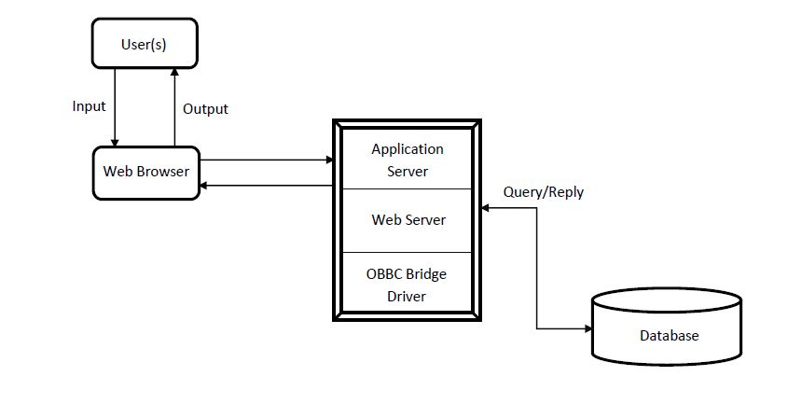

Fig 3.2 System Architecture

As illustrated in figure 3.2, The user provides input to a web browser which sends a Html request to the web server/application server which translates the Html request. If there is a data to be fetched from the database, the application server queries the database which in return replies the application with the needed data. Thereafter, the command is executed and Html response is send to the browser which in return give the user the processed output.

## 3.8 System Use Case Diagram

A use case diagram is a dynamic or behavior diagram in UML. Use case diagrams model the functionality of a system using actors and use cases. Use cases are a set of actions, services, and functions that the system needs to perform. From the use case diagram below, two actors are involved that is the admin and the traffic marshal. The use case diagram of the proposed system is shown in figure 3.3.



Fig 3.3 Use Case Diagram

As illustrated in Figure 3.3, the Admin’s function includes login, registering offender, viewing/issuing invoice of all registered offenders, adding/deleting offences, registering new marshals, editing/viewing/suspending existing marshals, adding new administrator and editing own profile. The Marshal’s function includes login, registering offender, viewing/issuing invoice of offenders he registered, viewing offences information and editing own profile.

## 3.9 System Data Flow Diagram (DFDs)

Data-flow diagrams (DFDs) are system models that show a functional perspective where each transformation represents a single function or process. DFDs are used to show how data flows through a sequence of processing steps. The data-flow-diagram for the proposed system is presented in Figure 3.4.



Fig 3.4 Data Flow Diagram

As illustrated in figure 3.4, starting from “Start” stage the user provides his username and password to access the system, the username and password is compared against stored usernames and passwords in the database. If it matches the user get access to the system and perform tasks available for his user group else the system returns to “Start stage.

## 3.10 Database Design

Database designis the process of producing a detailed data model of a database. This show the data entities, their associated attributes, and the relations between these entities. This logical model contains all the needed logical and physical storage parameters needed to generate a design definition in a Data Definition Language(DDL), which can then be used to create the database. In this project the database is designed using MYSQL and 5 tables were created. Figure 3.5 presents the E.R diagram while the relational tables are presented in table 3.1 through to 3.5.

### 3.9.1 Entity Relation Model

Figure 3.5 illustrates the entity relational model of the database, entities with their entire attributes and how they are related to one another in the database.



Fig 3.5 Entity-Relationship Diagram

### 3.9.2 Database Tables

Table 3.1 through table 3.5 presents the database relation and their descriptions;

Table 3.1 Admin Table

|  |  |  |  |
| --- | --- | --- | --- |
| FIELD | TYPE | LENGTH | NULL |
| Id | Integer | 10 | Auto_Increment |
| Name | Varchar | 50 | No |
| Username | Varchar | 50 | No |
| Staff_id | Varchar | 50 | No |
| Password | Varchar | 50 | No |
| Rank | Varchar | 50 | No |

Table 3.2 Offences Table

|  |  |  |  |
| --- | --- | --- | --- |
| FIELD | TYPE | LENGTH | NULL |
| ID | Integer | 20 | Auto_Increment |
| Offence | Varchar | 100 | No |
| Code | Varchar | 5 | No |
| Degree | Integer | 20 | No |
| Penalty | Integer | 20 | No |
| Point | Integer | 20 | No |

Table 3.3 Offender’s Table

|  |  |  |  |
| --- | --- | --- | --- |
| FIELD | TYPE | LENGTH | NULL |
| ID | Integer | 11 | Auto_Increment |
| Name | Varchar | 100 | No |
| Chasis_no | Varchar | 100 | No |
| Vehicle_type | Varchar | 100 | No |
| Plate_no | Varchar | 50 | No |
| Offence | Varchar | 100 | No |
| Degree | Integer | 5 | No |
| Confiscated_item | Varchar | 100 | No |
| Reporting_officer | Varchar | 100 | No |
| Commited-location | Varchar | 100 | No |
| Commited-Date | Date | Undefined | Current_timestamp |
| Phone | Integer | 11 | No |
| Remark | Varchar | 200 | Yes |

Table 3.4 Officer’s Table

|  |  |  |  |
| --- | --- | --- | --- |
| FIELD | TYPE | LENGTH | NULL |
| ID | Integer | 5 | Auto_increment |
| Name | Varchar | 100 | No |
| Username | Varchar | 100 | No |
| Password | Varchar | 100 | No |
| Rank | Varchar | 100 | No |
| Address | Varchar | 200 | No |
| Email | Varchar | 50 | No |
| Phone | Integer | 11 | No |
| Staff_id | Varchar | 100 | No |
| Status | Varchar | 5 | Active(1) |

# CHAPTER FOUR

# SYSTEM IMPLEMENTATION AND TESTING

## 4.1 Introduction

This chapter discusses after implementation of the proposed system. Its gives the overview of the programming tools used in implementing the system. It highlights the system modules which is a part of a program that contains one or more routines.

## 4.1 Software Implementation

This is the actualization of the proposed system specification by converting the specification into executable files. Tools used in implementing the system were thoroughly analyzed. The software is designed to collect and store offenders tickets and marshal’s information. It is also designed generate tickets, therefore simple user interfaces are designed. In other to prevent unauthorized access to the system secure login parameters are required before a user can access the system.

## 4.2 Choice of Programming Tools

A programming tool or software development tool is a program or application that system software developers use in creating, maintaining or otherwise supporting other programs and applications. The programming tools used to achieve the implementation of the designed system in this project are discussed below;

***4.2.1 PHP (Hypertext Preprocessor)***

PHP is a server-side script language designed for web development. It runs on a webserver and generally cannot run on its own unless invoked. It is designed to work with HTML. When invoked it returns HTML response to the browser. It is flatform independent, powerful, robust and scalable. It has a large active developer community.

***4.2.2 HTML (Hyper-Text Markup Language)***

HTML is a markup language that is used in creating views for web-pages and other information that can be displayed on web browsers. HTML was used in designing views for the designed system.

***4.2.3 CSS (Cascading Style Sheet)***

CSS is a stylesheet language that describes the presentation of a HTML (or XML) document. CSS describes how elements should be displayed on screen or other media. CSS was used to style the view of my system.

***4.2.4 JavaScript***

JavaScript is a full-fledged [dynamic programming language](https://developer.mozilla.org/en-US/docs/Glossary/Dynamic_programming_language) that, when applied to an [HTML](https://developer.mozilla.org/en-US/docs/Glossary/HTML) document, can provide dynamic interactivity on websites. JavaScript is incredibly versatile. JavaScript was used to add features to our system to make it more interactive.

***4.2.5 Visual Studio Code (VS Code)***

[VS Code](https://code.visualstudio.com/) is a new type of tool that combines the simplicity of a code editor with what developers need for their core edit-build-debug cycle. VS Code provides comprehensive editing and debugging support, an extensibility model, and lightweight integration with existing tools. It is free, open-source, and provides support for syntax highlights, snippets, and so on. VSCode was used as the text editor.

## 4.3 System Modules

A module is a software component or part of a program that contains one or more routines. One or more independently developed module makes up a program. A single module can contain one or more several routines. The following are the core modules for the proposed system.

***4.3.1 The Login Page***

The login page serves as the entrance through which authorized users only can access the system and its contents. A user can either login as an administrator or a traffic marshal officer. If a user provides invalid parameters, the user will not be allowed access to the system and an error will be issued. The screen snapshot for the login is shown in figure 4.1;

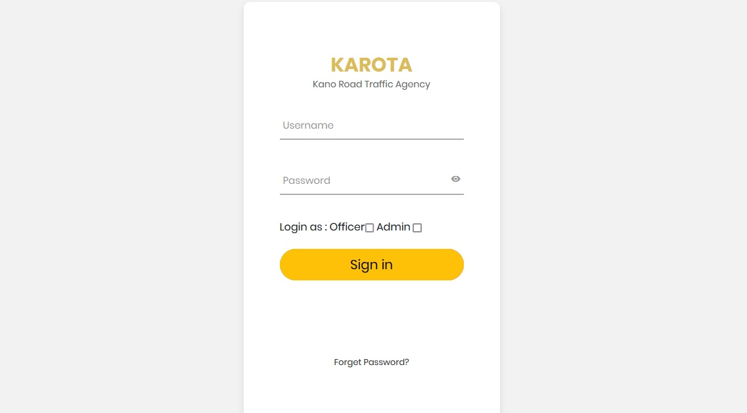

Fig 4.1 Login Page

***4.3.2 Admin Home Page***

When an admin successfully login into system by providing the right login credentials, the admin is taken to the administrator’s home page as illustrated in figure 4.2;

## 

Fig 4.2 Admin Homepage

***4.3.3 Register Offender Module***

On this page and admin or officer can register a new offender with his details and offence committed to the system as illustrated in figure 4.3.

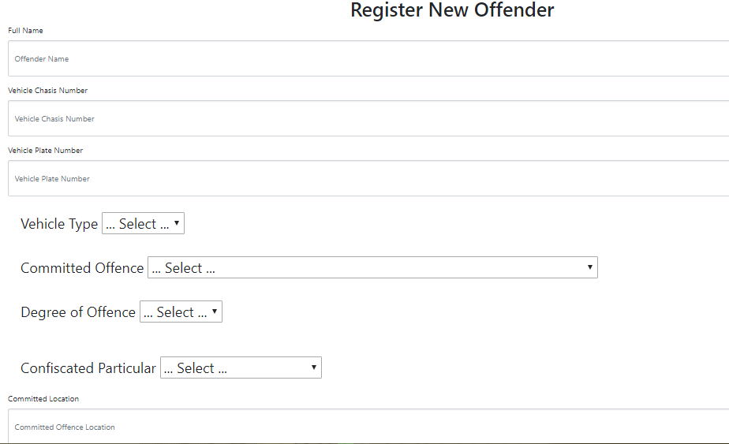

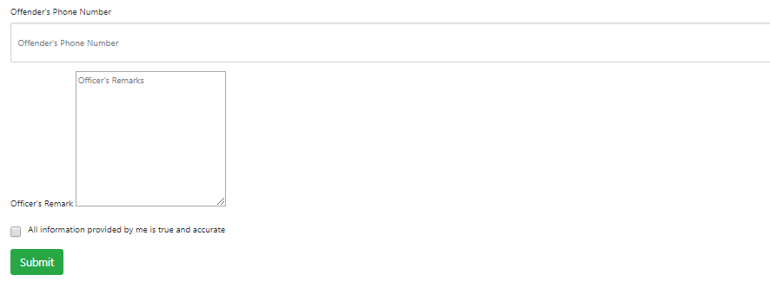

Fig 4.3 Register Offender Page

***4.3.4 View All Committed Offences***

From Figure 4.4 an admin can view all reported offences while an officer can only view offences he reported. Both can view and generate payment invoice;

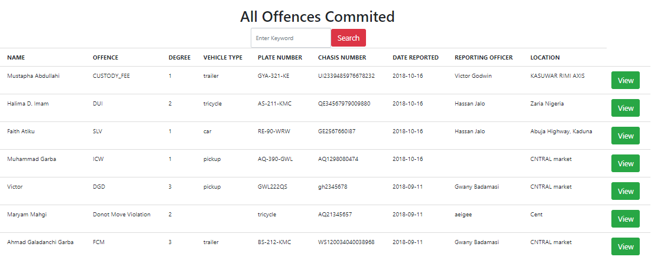

Fig 4.4 View All Offences Committed

***4.3.5 View and Generate Payment Invoice***

When the user clicks view in figure 4.4 the user is taken to a page where the system automatically generates payment invoice to the offender base on the offence committed and the specified fine for that offence. Thereafter the user can click print to print the invoice and the offender heads to the bank to pay the specified fine. As illustrated in figure 4.5.

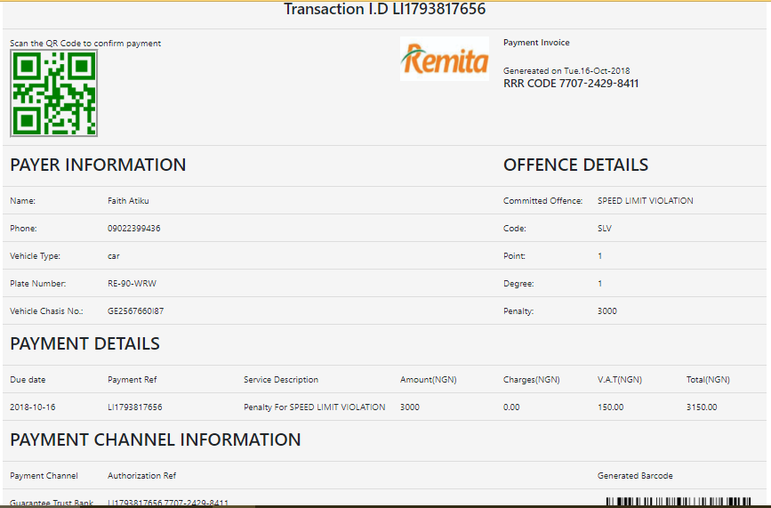

Fig 4.5 Payment Invoice

***4.3.6 Add New Offence Module***

An administrator can also add new offence to the system, as illustrated in figure 4.6

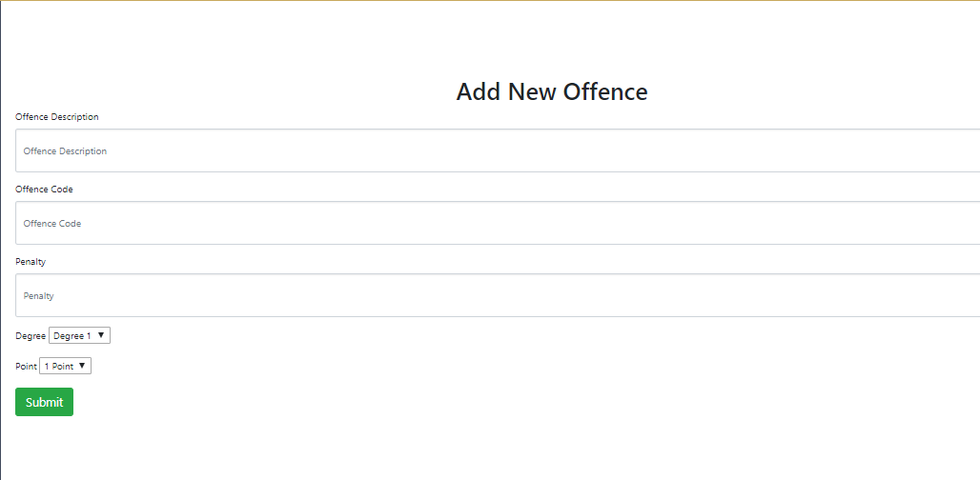

Fig 4.6 Add New Offence Module

***4.3.7 All Offences Information***

In this module the admin can view all offences registered on the system. An admin can also edit and delete an offence. Officers can only view the offence information. This is illustrated in figure 4.8

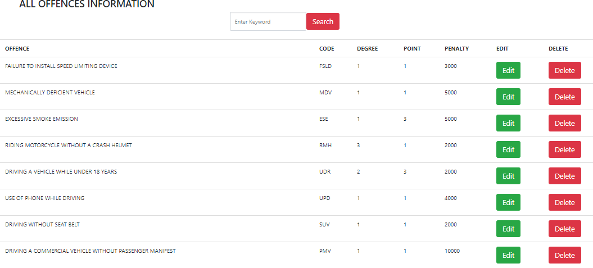

Fig 4.8 All Offence Management

***4.3.9 View All Marshals***

In this module, an admin can view all Marshal’s/Officer’s information. The admin can view and edit the officer’s information. An admin can also activate and suspend a marshall’s account. Suspended marshal’s cannot login into the system. This is illustrated in figure 4.9 below;

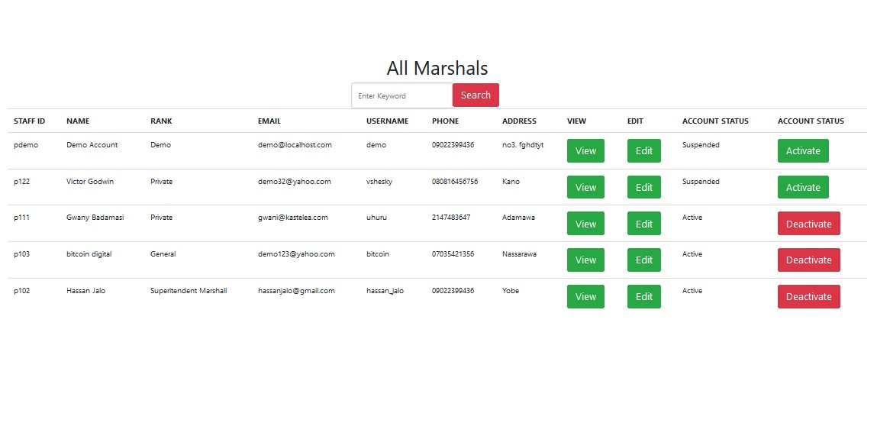

Fig 4.9 View All Marshal

***4.3.10 Add New Admin***

In this module, an administrator can add new admin to help with other administrative tasks. As illustrated in figure 4.10.

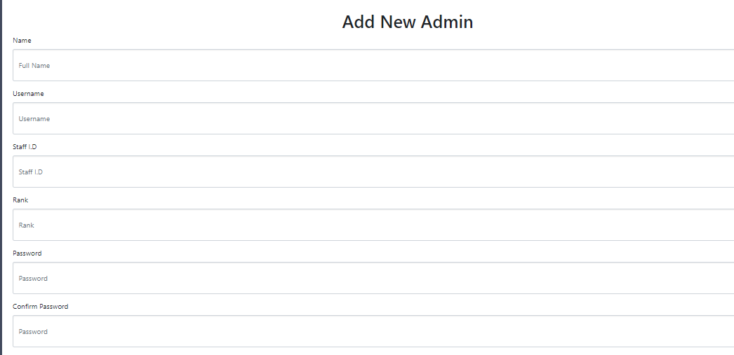

Fig 4.10 Add new admin

***4.3.11 Add New Marshal***

As illustrated in figure 4.11 an admin can add new marshal. The admin can select new password for the new marshal. The new marshal can later login and change his password.

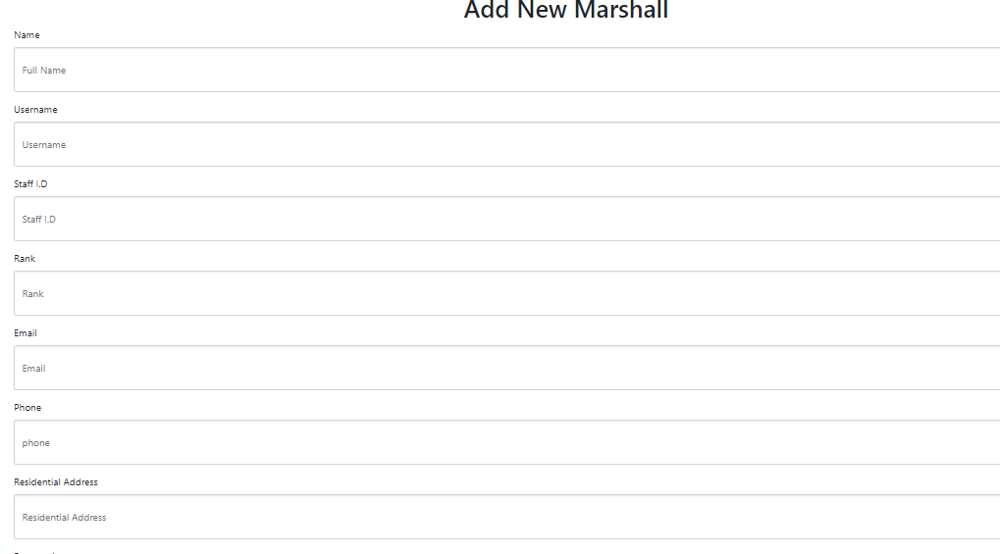

Fig 4.11 Add new Marshall

***4.3.12 Edit Admin Profile***

In this module an admin can edit his own profile. As illustrated in figure 4.12.

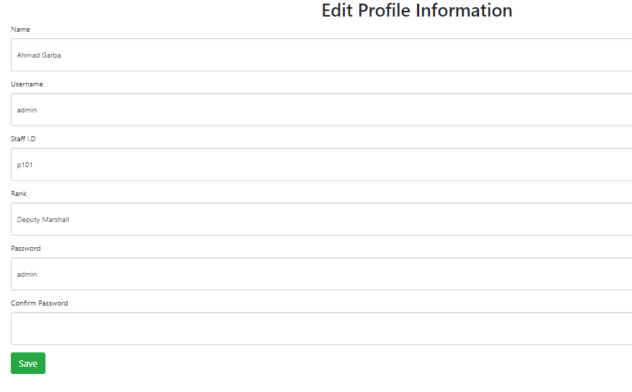

Fig 4.12 Edit Admin Information

***4.3.13 Officer Home Page***

When an officer Marshall successfully logged in. He/She is taken to Officer HomePage. As illustrated in figure 4.13

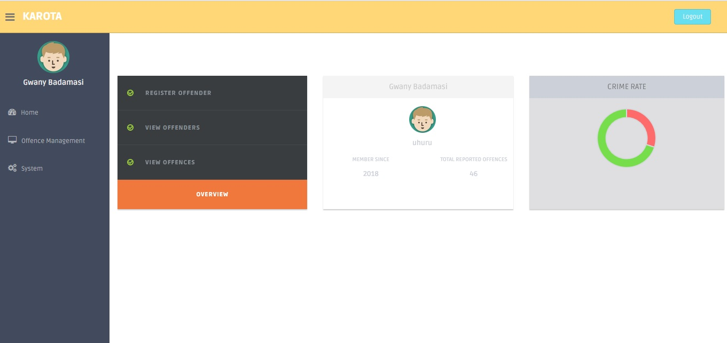

***4.3.14 All Offences Information***

In this module the officer can view all offences information. As illustrated in figure 4.14.

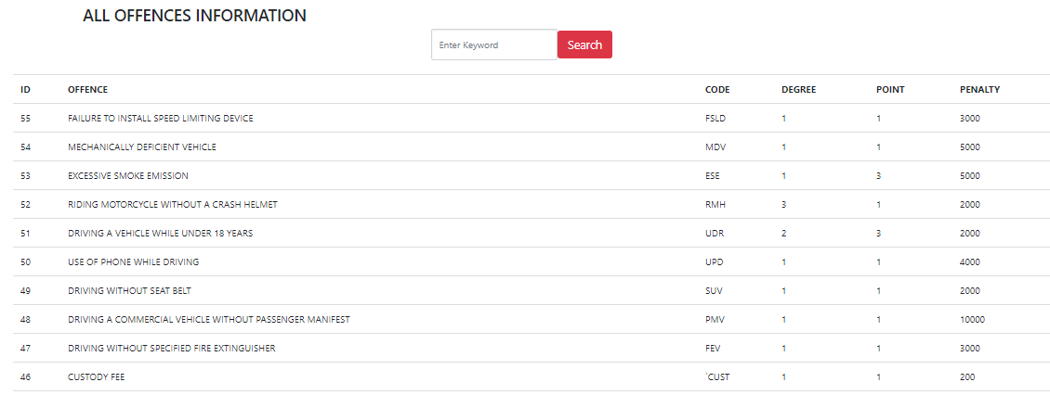

Fig 4.14 All Offences Information

***4.3.15 Edit Office Profile***

In this module, the officer can edit his profile information. The officer cannot change his Name, Rank and Staff I.D as illustrated in figure 4.15

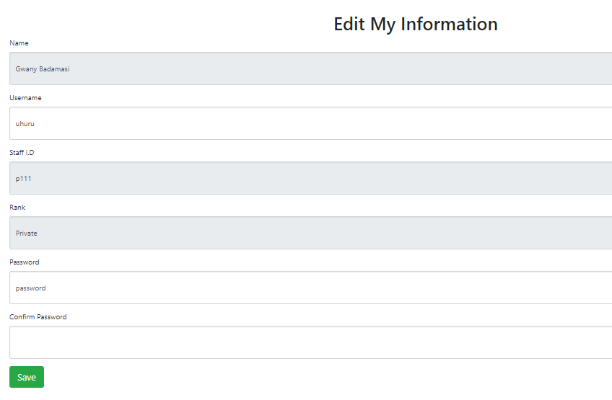

Fig 4.15 Edit Profile Information

## 4.4 System Testing

System testing is conducted on a complete integrated system to evaluate the system’s compliance with its specified requirements. System testing falls within the scope of black box testing and as such should require no knowledge of the inner design of the code or logic. During system testing, the focus is on the software design, behavior and even the believed expectations of the intended user. So, we can also refer to the system testing phase as investigatory testing phase of the software development life cycle. The system testing strategies used in this system include the unit test and integration test.

### 4.1.1 Unit Testing

In this phase, individual units or single components of the system are tested independently to ensure that individual phases are working effectively without errors. The primary goal of unit testing is to take the smallest piece of testable software in the application, isolate it from the remainder of the code and determine whether it behaves exactly as it is expected to behave. Each unit is tested separately before integrating them into modules Each unit is tested separately before integrating them into modules to test the interfaces between modules.

### 4.1.2 Integration Testing

After testing the individual components, integration testing was carried out to ensure that all the individual components are linked in the correct flow and tested all together for bugs. The units that have already been tested are combined into a component and the interface between them is tested. The idea is to test combination of pieces and eventually expand the process to test your modules with those of other groups.

# CHAPTER FIVE

# SUMMARY, CONCLUSION AND RECOMMENDATIONS

## 5.1 Summary

This project is intended to automate and improve the manual method of traffic offence ticketing for the Kano Road Traffic Agency. The project covered all the processes involved in designing and developing a traffic offence ticketing system. The system is aimed to address the problems associated with the current manual means traffic offence ticketing, as well as provide a better interface that will automate the process.

## 5.2 Conclusion

The proposed system was successfully implemented. The aim of the research was achieved. The system has overcome many limitations incorporated in the manual process of a traffic offence ticketing. This system saves a great amount of time in coming back to the head office to log an offender and generating a ticket.

## 5.3 Recommendations

Based on this research the following recommendations are to be considered:

1. It is strongly recommended that the Kano Road Traffic Agency embrace the implementation of the software package for traffic offence ticketing as the benefit of the software implementation cannot be over emphasized.
2. Training is also recommended for traffic marshals for maximum utility of the application, despite the fact that the software development is highly efficient.
3. Further research should be carryout on this project research to integrate the system with National Identity Management Commission to integrate all the country’s citizen’s data
4. Other researchers and developers should employ different technologies to design this system for performance analysis.

# 1.8 References

A. Denis, B. W. (2009). *System Analysis Design UML Version 2.0 An Object-Oriented Approach.* Massacheusets: John Wiley & Sons, Inc.

cps.gov.uk. (2004, March 20). *Legal Guidance on Road Traffc Offence*. Retrieved from cps.gov.uk: https://www.cps.gov.uk/legal-guidance/road-traffic-offences

ncibi. (2012, Febuary 13). *Traffic offence*. Retrieved from ncib.nlm.nih.gov: https://www.ncbi.nlm.nih.gov/pmc/articles/PMC3566732/

police.sa.gov.au. (2017, October 4th). *Frequently Asked Question*. Retrieved from Police.sa.gov.au: https://www.police.sa.gov.au/services-and-events/expiations/frequently-asked-questions

Wikipedia.org:(2012). *Kano Road Traffic Agency.* Retrieved from wikipedia.org

https://en.wikipedia.org/wiki/Kano_Road_Traffic_Agency