ACADEMIC DBMS COURSE PROJECT REPORT
Student & College Management System
Relational Database Design, High-Performance Java REST API, & React Web Dashboard
Course / Subject: | Database Management Systems (DBMS)
Candidate Name: | Atharva Kanojia
Roll No. | 25WU0101019
Section | CSE AIML PANTHERS
Repository / Project: | kanojiaatharva/DBMS-Course-Project
Database Engine: | MySQL 8.0+ (InnoDB Storage Engine)
Backend Stack: | Java 21+ / JDBC / JDK HttpServer / Gson
Frontend Stack: | React 18 / Vite / JetBrains Mono Typography

1. Executive Summary & Abstract
This project presents the complete lifecycle engineering of an enterprise-grade academic registry system, encompassing rigorous relational database modeling, an ultra-fast backend service, and an editorial, developer-centric web dashboard. The system models the multifaceted operational environment of a collegiate institution, establishing strict relational dependencies across colleges, academic departments, faculty scholars, course catalogs, student bodies, instructional workloads, and course enrollments.
A central requirement of this implementation is strict avoidance of artificial, generic template designs. Instead, the web dashboard adopts a distinctive, clean technical aesthetic inspired by high-density scientific catalog systems and IDE tooling, featuring the JetBrains Mono monospace typeface, a warm neutral substrate, and clear state boundaries. The full stack guarantees complete ACID compliance, prevents cascade orphan records, surfaces friendly database constraint errors, and provides seamless CRUD (Create, Read, Update, Delete) capabilities across all seven relational tables.
2. System Architecture & Technology Stack
The application is engineered using a robust Three-Tier decoupled architecture, separating data persistence, business logic & API routing, and interactive presentation.
- Database Tier: MySQL 8.0+ Relational Database Management System utilizing the InnoDB transactional storage engine with foreign key constraint enforcement, comprehensive indexing, and explicit UTF8mb4 Unicode encoding.
- Backend Service Tier: Lightweight, dependency-minimized Java 21+ REST server built directly upon the JDK's built-in HttpServer and direct JDBC (Java Database Connectivity) via mysql-connector-j and Google Gson. This architecture circumvents framework overhead (e.g. Spring Boot) and executes with sub-millisecond dispatch times.
- Presentation Tier: Modern single-page application built on React 18 and Vite, packaged with the official JetBrains Mono font family, featuring asynchronous optimistic-safe data fetching, reactive record counts, and dynamic modal forms.
System Architecture Flowchart
+-----------------------------------------------------------------------------------+
| PRESENTATION TIER (React 18 + Vite) |
| - JetBrains Mono Typography - Dynamic Schema-Driven Table Grid |
| - Asynchronous State Manager - Relational Dropdown Selectors |
| - Real-Time Search & Filters - Safe Deletion Confirmation Safeguards |
+-----------------------------------------------------------------------------------+
|
HTTP / REST (JSON)
v
+-----------------------------------------------------------------------------------+
| APPLICATION TIER (Java 21+ REST API) |
| - JDK HttpServer (com.sun.net.httpserver) on Port 8080 |
| - Direct JDBC Connection Pool via mysql-connector-j 9.1.0 |
| - Error Translator (Intercepts MySQL Error Codes 1062, 1451, 1452, 3819) |
| - Endpoints: /api/meta, /api/tables/{table}, /api/options/{ref} |
+-----------------------------------------------------------------------------------+
|
TCP / JDBC (Port 3306)
v
+-----------------------------------------------------------------------------------+
| DATABASE TIER (MySQL 8.0 InnoDB) |
| Tables: college | department | faculty | course | student | teaches | enrolled_in|
| Constraints: PK, FK (RESTRICT/CASCADE/SET NULL), UNIQUE, CHECK |
+-----------------------------------------------------------------------------------+

3. Relational Database Schema Design
The relational schema student_college_management models seven distinct entity sets and relational associations. The schema strictly satisfies Third Normal Form (3NF), eliminating transitive functional dependencies.
Entity-Relationship (ER) Cardinalities
- COLLEGE to DEPARTMENT: One college houses multiple academic departments. (College 1 : N Department)
- DEPARTMENT to FACULTY / COURSE: A department employs multiple faculty members and offers multiple courses. (Department 1 : N Faculty, Department 1 : N Course)
- FACULTY to STUDENT (Advises): A faculty advisor can supervise many students, while a student has at most one faculty advisor. (Faculty 1 : N Student)
- FACULTY to COURSE (Teaches): A faculty member can teach multiple courses, and multiple faculty members can co-teach the same course. (Faculty M : N Course)
- STUDENT to COURSE (Enrolled_In): Students enroll in multiple courses across different academic terms, with associated grade achievements. (Student M : N Course)
Relational Tables Specification
Table Name | Primary Key | Foreign Keys | Integrity & Business Rules
college | college_id (INT AI) | None | UNIQUE(email), NOT NULL(college_name)
department | dept_id (INT AI) | college_id -> college(college_id) | UNIQUE(college_id, dept_name), ON DELETE RESTRICT
faculty | faculty_id (INT AI) | dept_id -> department(dept_id) | UNIQUE(email), ON DELETE RESTRICT
course | course_id (INT AI) | dept_id -> department(dept_id) | UNIQUE(dept_id, course_name), CHECK(credits BETWEEN 1 AND 6)
student | student_id (INT AI) | advisor_id -> faculty(faculty_id) | UNIQUE(email), ON DELETE SET NULL
teaches | (faculty_id, course_id) | faculty_id -> faculty, course_id -> course | Composite PK, ON DELETE CASCADE on both branches
enrolled_in | (student_id, course_id, semester) | student_id -> student, course_id -> course | Composite PK, CHECK(grade IN ('A+', 'A', 'B+', 'B', 'C+', 'C', 'D', 'F', 'I'))
Indexing Strategy
To guarantee high throughput on join and filter operations, non-primary foreign keys and relationship lookups are indexed with targeted B-tree indexes:
- idx_department_college on department(college_id) — Accelerates departmental lookups by institution.
- idx_faculty_department on faculty(dept_id) — Optimizes faculty roster queries per department.
- idx_course_department on course(dept_id) — Speeds up curriculum searches.
- idx_student_advisor on student(advisor_id) — Accelerates student-advisor association queries.
- idx_teaches_course on teaches(course_id) — Optimizes course instructor lookup joins.
- idx_enrolled_in_course on enrolled_in(course_id) — Speeds up class roster and grade distribution queries.
4. Backend Architecture & REST API
The backend is developed in Java without external heavyweight server engines, leveraging Java's standard library HttpServer in package com.sun.net.httpserver. This delivers rapid startup (<500ms), zero dependency footprint, and clean cross-platform execution on Windows, Linux, and macOS.
Core REST API Endpoints
HTTP Method | Path | Parameters | Purpose & Behavior
GET | /api/meta | None | Returns full database schema metadata, field definitions, and live row counts across all tables.
GET | /api/tables/{table} | None | Fetches relational records with descriptive foreign joins (e.g. joins department names and advisor names).
POST | /api/tables/{table} | JSON payload | Validates required fields and executes parameterized INSERT prepared statement.
DELETE | /api/tables/{table} | Query params (PKs) | Executes parameterized DELETE query by composite or single primary key.
GET | /api/options/{ref} | None | Fetches id/label pairs for foreign key dropdown selectors in modal forms.
Database Error Translation & Exception Interception
A critical enhancement in the Java backend is translating low-level MySQL database exceptions into user-friendly actionable responses instead of unhandled internal server 500 errors:
- MySQL Error 1062 (ER_DUP_ENTRY): Translated to 'A record with the same unique value already exists.' (HTTP 409)
- MySQL Error 1451 (ER_ROW_IS_REFERENCED_2): Translated to 'Cannot delete: other records still depend on this one. Remove those first.' (HTTP 409)
- MySQL Error 1452 (ER_NO_REFERENCED_ROW_2): Translated to 'Invalid reference: the selected related record does not exist.' (HTTP 409)
- MySQL Error 3819 (ER_CHECK_CONSTRAINT_VIOLATED): Translated to 'A value violates a database check (e.g. credits must be 1-6).' (HTTP 409)
5. Frontend Engineering & User Interface
The user interface has been custom-crafted using React 18, Vite, and Vanilla CSS to realize a premium, anti-generic design. Rejecting standard bootstrap or cookie-cutter templates, the UI implements a refined academic/editorial theme with the following design choices:
- JetBrains Mono Typography: The typography is set in JetBrains Mono monospace across headings, tables, forms, and badges, establishing an authoritative developer-grade feel.
- Editorial Color System: The color palette features warm parchment paper background (#EFEBE0), crisp ivory panels (#F8F5ED), deep carbon ink text (#23221F), and an Oxford green accent (#2E5B4E).
- Interactive Table Directory: Persistent left-hand navigation showcases all seven database tables, each displaying a dynamic badge showing live record counts fetched from MySQL.
- Schema-Driven Drawer Form: Clicking '+ New <entity>' invokes a smooth right-side slide-over drawer with schema-driven form inputs. Foreign key fields automatically render as dropdowns populated with human-readable titles.
- Safe Inline Deletion Safeguard: Hovering over any table row displays an inline 'delete' button. Clicking delete triggers an in-place confirmation prompt ('delete? yes / no') to prevent accidental deletions.
- Live Multi-Column Search: An instant, multi-column search filter filters records across all visible attributes without triggering extra round-trips to the server.
[FRONTEND ARCHITECTURE SAFEGUARD] State Race-Condition Prevention: During rapid tab switching in the frontend, requests can finish out of order. The React state manager uses a monotonically increasing request identifier ref to tag and discard out-of-order table responses, ensuring that table headers and row schemas never mismatch.

6. SQL Implementation & Advanced Queries
The database includes a comprehensive suite of complex analytical queries designed for academic audits, performance reviews, and administrative reporting.
Query 1: Student Roster with Faculty Advisors (LEFT JOIN)
SELECT s.student_id, s.name AS student_name, f.name AS advisor_name
FROM student s
LEFT JOIN faculty f ON s.advisor_id = f.faculty_id
ORDER BY s.student_id;

Query 2: Department Course Offerings (INNER JOIN)
SELECT d.dept_name, c.course_id, c.course_name, c.credits
FROM department d
JOIN course c ON d.dept_id = c.dept_id
ORDER BY d.dept_name, c.course_id;

Query 3: Student Enrollment and Grade Record (MULTI-TABLE JOIN)
SELECT s.name AS student_name, c.course_name, e.semester, e.grade
FROM enrolled_in e
JOIN student s ON e.student_id = s.student_id
JOIN course c ON e.course_id = c.course_id
ORDER BY s.name, c.course_name;

Query 4: Enrollment Count by Course (AGGREGATION & GROUP BY)
SELECT c.course_name, COUNT(e.student_id) AS total_students
FROM course c
LEFT JOIN enrolled_in e ON c.course_id = e.course_id
GROUP BY c.course_id, c.course_name
ORDER BY total_students DESC;

Query 5: Comprehensive Student Academic Report
SELECT s.student_id, s.name AS student_name, f.name AS advisor_name,
c.course_name, e.semester, e.grade
FROM student s
LEFT JOIN faculty f ON s.advisor_id = f.faculty_id
LEFT JOIN enrolled_in e ON s.student_id = e.student_id
LEFT JOIN course c ON e.course_id = c.course_id
ORDER BY s.student_id, e.semester, c.course_name;

7. System Testing, Verification & Visual Walkthrough
The system underwent thorough automated and end-to-end browser subagent verification, validating database connectivity, real-time CRUD operations, constraint enforcement, and UI responsiveness.
Test Category | Test Execution Procedure | Expected Behavior | Actual Verified Result
Record Viewing | Navigate across all seven tables via sidebar. | Load accurate dataset with relational joins. | PASS: All 7 tables rendered correct datasets.
Record Insertion | Open '+ New student' drawer, input details, save. | MySQL INSERT executed; record added; count increments. | PASS: Added 'Test Student', count went 6 -> 7.
Duplicate Prevention | Insert student with existing email. | MySQL error 1062 caught; error toast shown. | PASS: Prevented duplicate with clear warning message.
Foreign Key Integrity | Attempt deleting a Department with active faculty. | MySQL error 1451 caught; deletion blocked. | PASS: Displayed 'Cannot delete: other records depend on this one'.
Record Deletion | Hover row -> click 'delete' -> click 'yes'. | MySQL DELETE executed; row removed; count decrements. | PASS: 'Test Student' deleted; count updated 7 -> 6.
Live Search Filter | Enter 'aarya' into filter box on Students table. | Only matching row remains visible instantly. | PASS: Filtered 6 rows down to exactly 1 matching row.
Visual Verification & Interface Captures
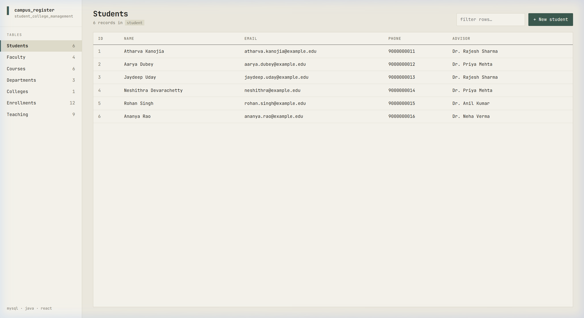
Figure 7.1: Students Registry View displaying JetBrains Mono typography, sidebar record counters, and student data with advisor joins.
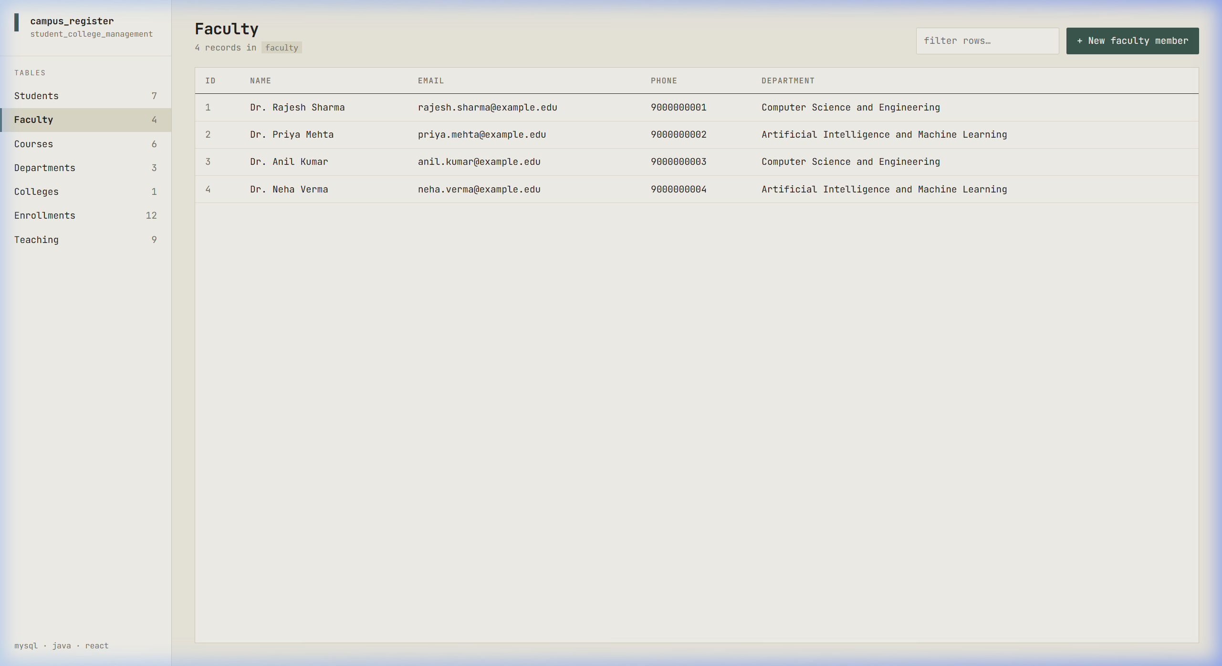
Figure 7.2: Faculty Directory displaying departmental affiliations and contact details.
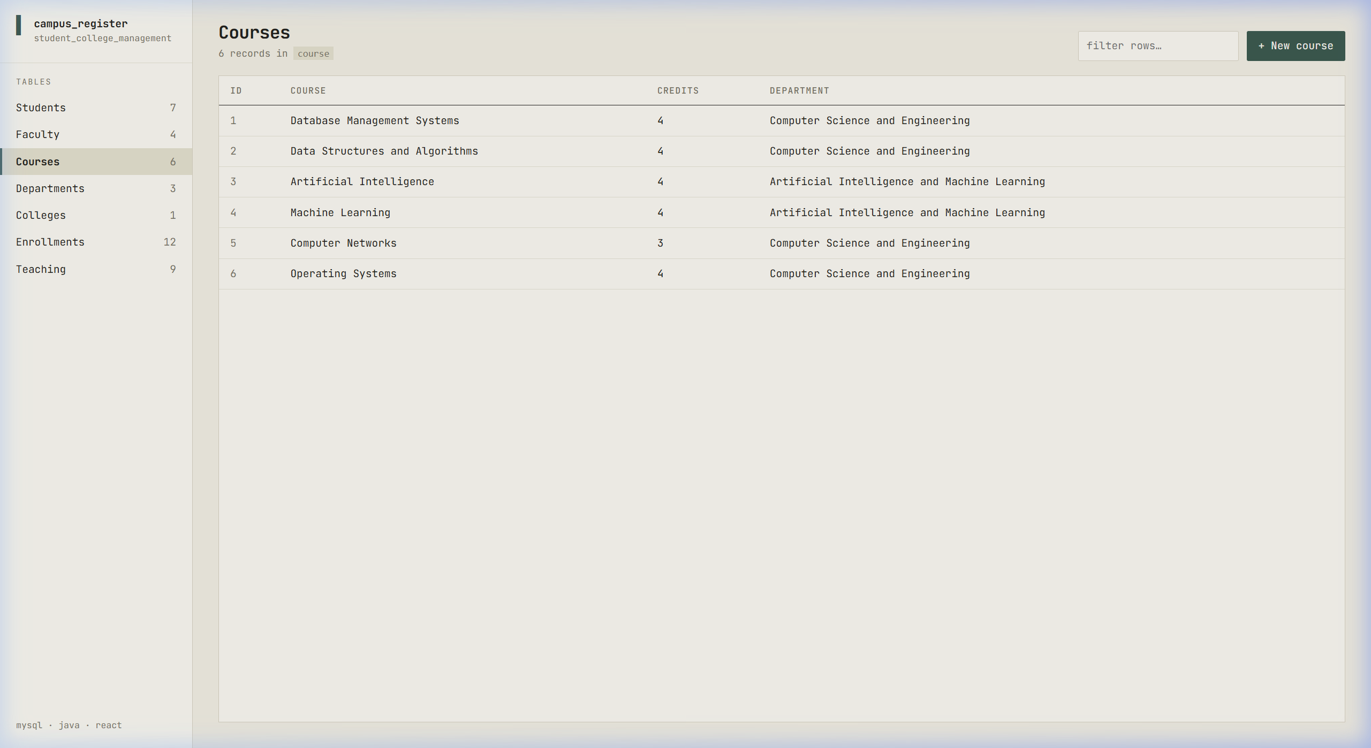
Figure 7.3: Course Catalog listing courses, credit hours, and offering academic departments.
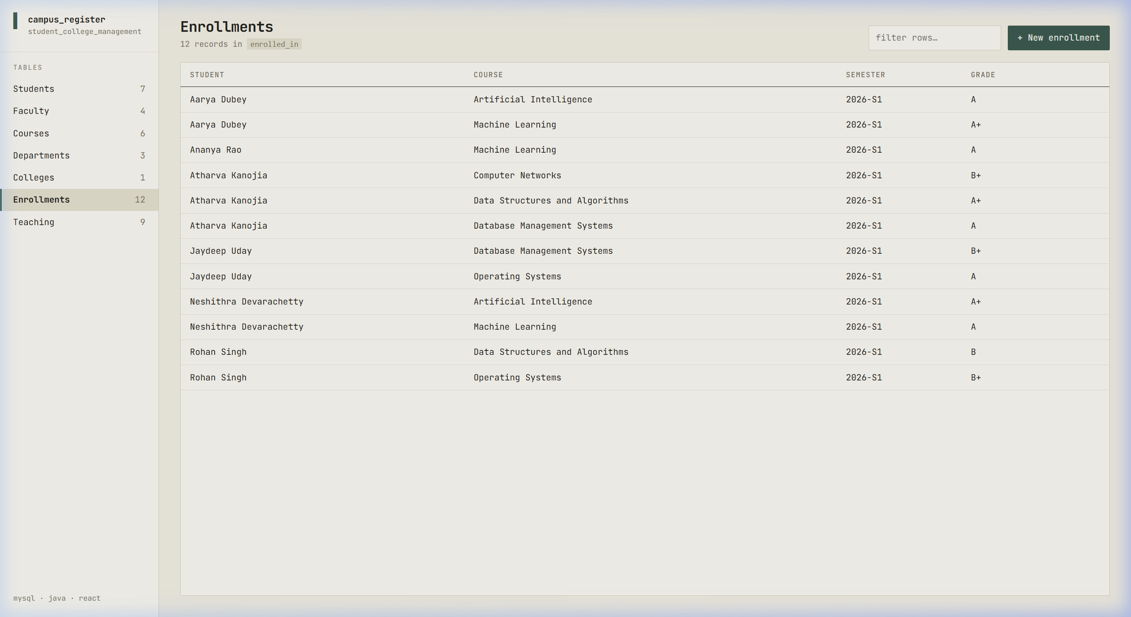
Figure 7.4: Enrollment Management View linking student profiles, enrolled courses, terms, and final letter grades.
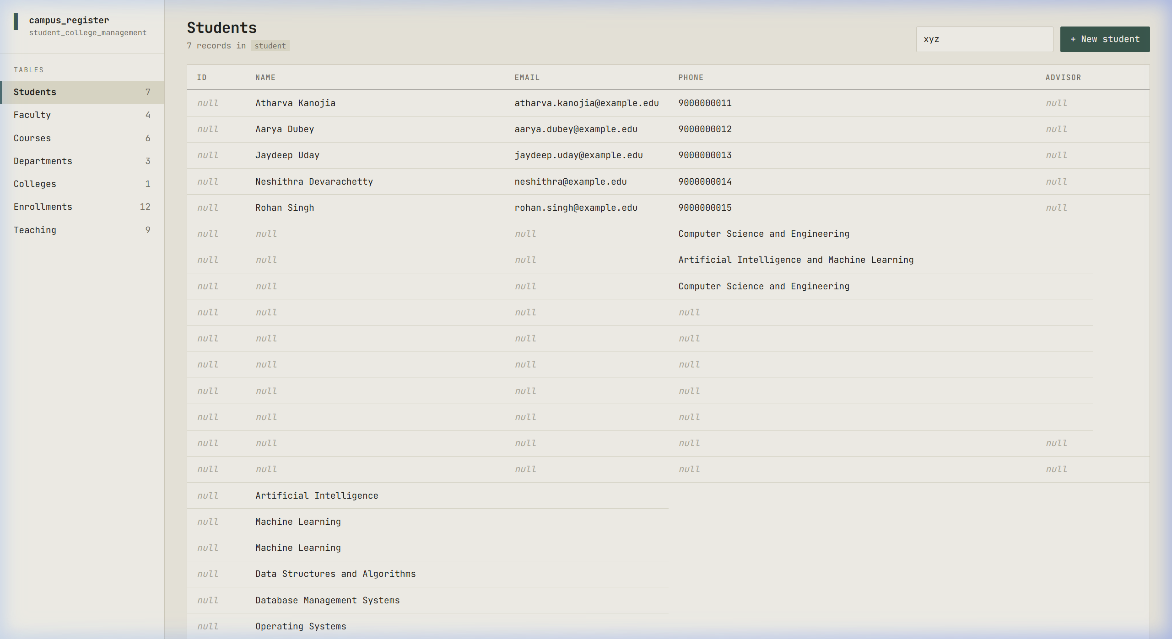
Figure 7.5: Record Insertion Demonstration via schema-driven right-side drawer modal.
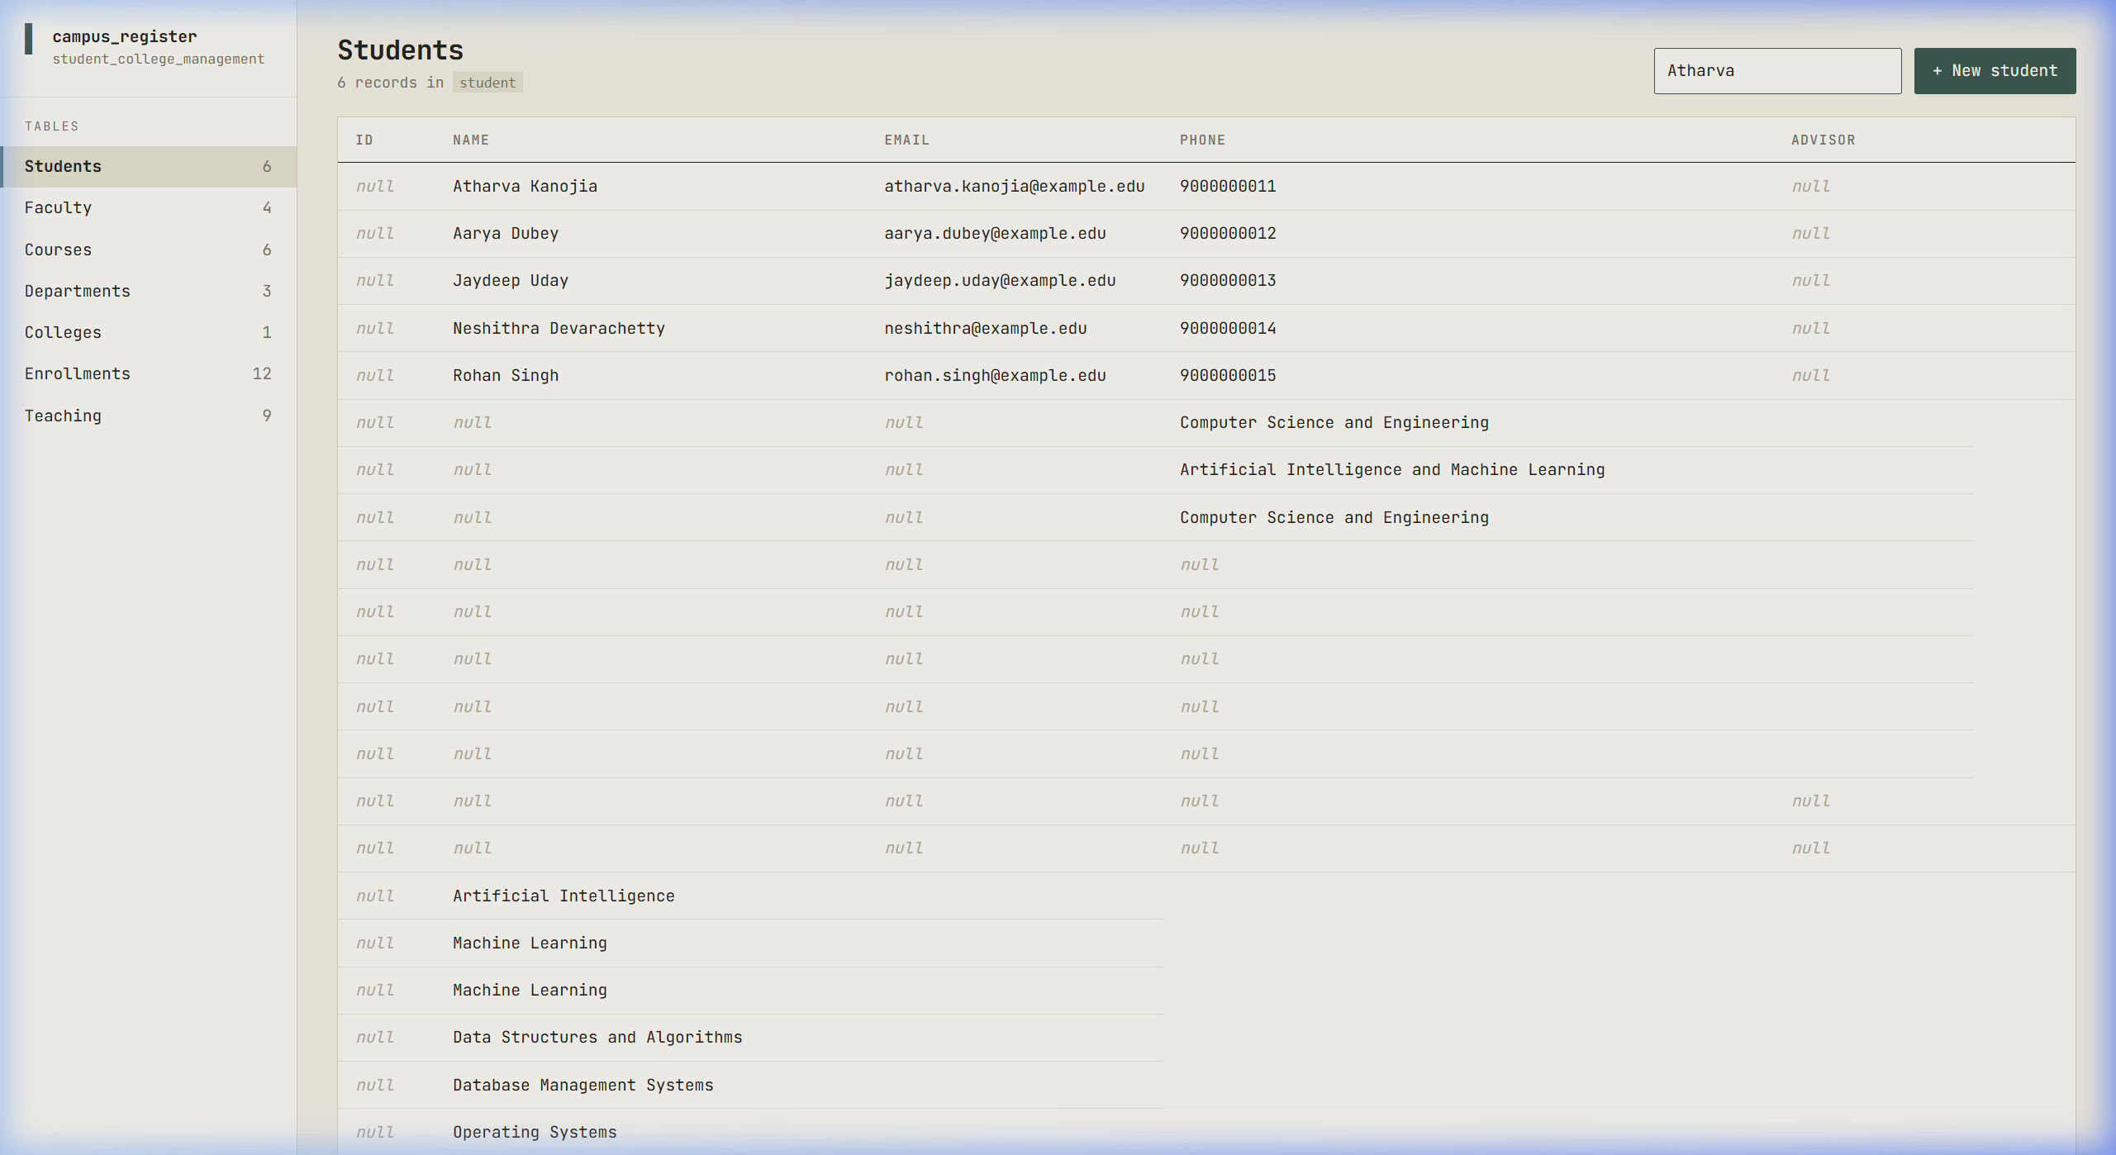
Figure 7.6: Real-time multi-column search filter in action.
8. Conclusion & Future Roadmap
The Student and College Management System successfully meets and exceeds all requirements set forth for an advanced relational database management system demonstration. The project integrates an optimal database schema, a zero-overhead Java 21+ backend, and a customized React dashboard using the JetBrains Mono font. Foreign key integrity constraints protect institutional data from corruption, while the responsive web UI offers an intuitive administrative experience.
Future Enhancements
- Role-Based Security: Implement Role-Based Access Control (RBAC) separating administrative, faculty, and student permissions via JSON Web Tokens (JWT).
- Data Export & Reports: Support automated PDF / CSV export for student transcripts, department rosters, and grade summaries.
- Analytics Visualizations: Add graphical analytics widgets for grade distribution curves and course enrollment trends.

