**IoT Application for Smart Refrigerator System**

Project Proposal

**By**

Ms. Pariyathida Watcharawontanont 572115039

Mr. Rungroj Sonsubanan 572115047

Department of Software Engineering

College of Arts, Media, and Technology

Chiang Mai University

**Project Advisor**

________________________

**Dr. Noppon Choosri**

**Document History**

|  |  |  |  |  |  |  |
| --- | --- | --- | --- | --- | --- | --- |
| Document Name | Version | Status | Date | Viewable | Editable | Responsible |
| IoT Application for the Smart Refrigerator System | V.0.1.docx  Add Chapter1  -Background | Draft | May 23rd 2017 | PW, RS, NC | PW, RS | PW, RS |
| IoT Application for the Smart Refrigerator System | V.0.2.docx  Add Chapter2  -Technology Review  Add Chapter3  -ISO 29110  -Project Management Process  -Software Implementation Process  Add Chapter4  -Motivation  -Aim and Objectives  -Deliverables and limits  -Future Work  -Software Process  -Schedule & Milestones | Draft | May 29th 2017 | PW, RS, NC | PW, RS | PW, RS |

*PW = Pariyathida Watcharawontanont, *RS = Rungroj Sonsubanan, *NC = Noppon Choosri

**Topic** IoT Application for Smart Refrigerator System

**Author** Ms. Pariyathida Watcharawontanont

Mr. Rungroj Sonsubanan

**Degree** Bachelor of Science

Software Engineering Program

**Project Advisor** Dr. Noppon Choosri

**ABSTRACT**

The Internet of Things (IoT) is a computer concept that the device can communicate each other over the internet without needing human to human interaction. In this application, we purpose a System that applies to create a Smart Refrigerator System which can track the consumption of products and can monitor the product’s expiration in real time. Furthermore, retailer can reach their customer’s behavior to offer the sale.

The “IoT Application for Smart Refrigerator System” will provide the convenience to track the product which is out of stock or expired. It will also help to notify to the customer in case the product is expired, the customer will be notified so that their products won’t be spoiled or rotten in the refrigerator.

We would like to present the "IoT Application for Smart Refrigerator System" to give customer happiness, deliver the comfortable life, and to support the improving of business.

Table of Contents

Chapter One | Introduction and Background 5

Chapter Two | Literature Review 6

2.1 Business Review 6

2.2 Business Tools and Software Review …………………………………………………………..

2.3 Technology Review 8

2.4 Development Tool Review 15

Chapter Three | Quality Standard 16

3.1 ISO 29110 for Very Small Entity (VSE) 16

3.1.1 Project management process 16

3.1.2 Software implementation process 16

Chapter Four | Project Plan 17

4.1 Motivation 17

4.1.1 Aims 17

4.1.2 Objectives 17

4.2 Deliverables and Limits 18

4.2.1 Deliverables 18

4.3.2 Limits 19

4.2.3 Future Work 19

4.3 Software Process 20

4.4 Schedule & Milestone 21

Chapter Five | References 27

# Chapter One | Introduction and Background

The internet of things (IoT) is a computing concept that describes the idea of everyday physical objects being connected to the internet and being able to identify themselves to other devices. IoT Smart fridge system is a new business model that retailer can track the consumption of the customer. Meanwhile, the customers receive the notification when the product is the expired in such case that they forget to read the label of the product or elderly who has poor sight.

IoT Smart fridge system is an application to help manage the products in a refrigerator. The system will provide the features that can handle problems mentioned above. The Smart Fridge system is designed to give an elderly convenience. Moreover, This IoT Smart fridge system is very useful for customer and retailer. For the retailer, the Smart fridge system can track the customer’s behavior and can analyze the marketing very well.

In short, this application system can be very useful for everyone who interested in a comfortable life. The application system will help to track the expiry date of the product, send a notification to the customer, help the Retailer to get more loyalty customer to increase the sale volumes. Also, track the customer’s behavior for future marketing.

# Chapter Two | Literature Review

## 2.1 Business Review

**Overview**

The internet of things (IoT) is a computing concept that describes the idea of everyday physical objects being connected to the internet and being able to identify themselves to other devices. The "IoT Application for Smart Refrigerator System" is an application that run on the web browser. It is developed to an elderly people with poor sight help to avoid the expiry date of the product and add a new channel that will help retailer increase the sales volume by new business model. The new business model is a retailer can know the customer's product are out of stock or need some product. The retailer can improve marketing efficiency and can collect the customer's behaviors such as the most popular product for a customer or in each month when the customer goes to shopping. The new business model meets the needs of customers and retailer very well.

**Target**

The target of this project is the customer can know which product are out of stock or expiry date and can view the reported expense in each year. This application will also help the retailer increase their sales volumes. The customer and retailer will have a benefit and happy for using this application.

**Benefits**

* The customer will be able to know their product are out of stock or expiry date.
* The customer can get the notification when the product is expiry date.
* The customer no need to go supermarket for expense their money when they need a product.
* The retailer can improve their sales volume for using the new business model.
* The retailer can reach their customer's behavior and can marketing in the right way.
* The retailer will get more the loyalty customer.
* It is very good to improve the product replenishment system for the branch of the retailer.

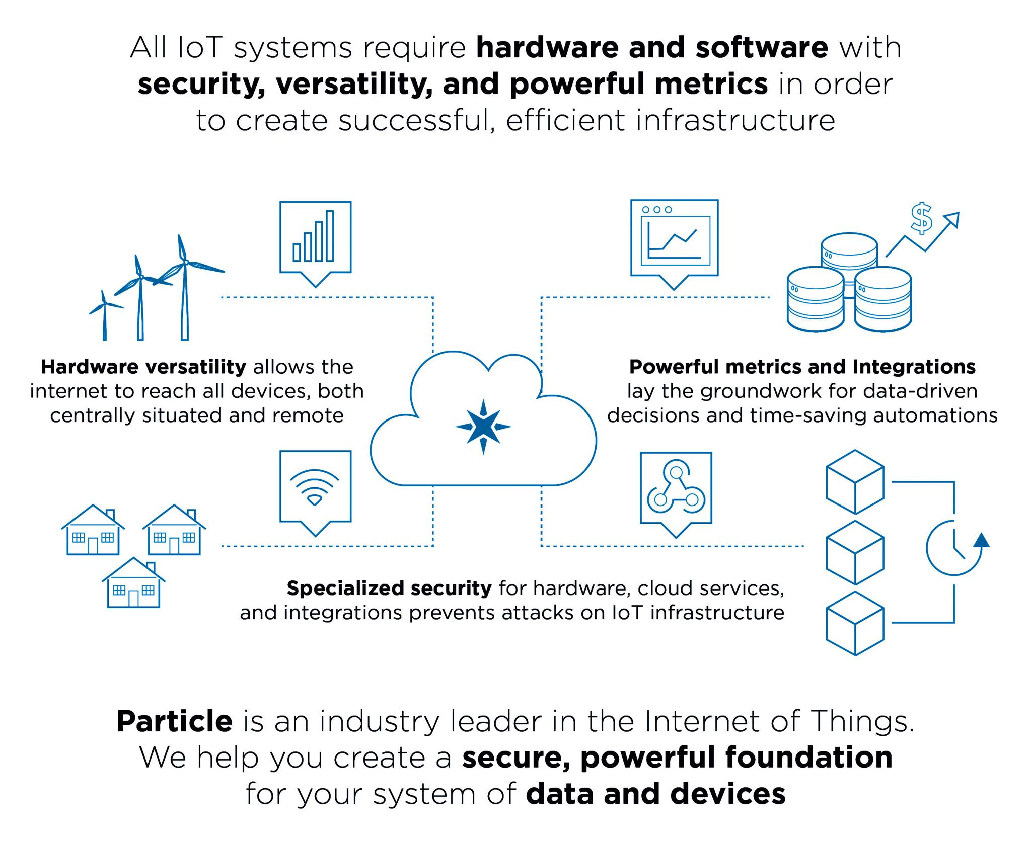

***Figure 1****: IoT Concept*

## 2.2 Technology Review

**2.2.1 Angular 2**

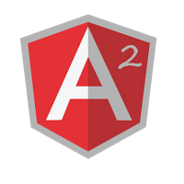

***Figure 2****: Angular 2*

**Angular 2**  is a JavaScript-based [open-source](https://en.wikipedia.org/wiki/Open-source_software) front-end [web application framework](https://en.wikipedia.org/wiki/Web_application_framework) mainly maintained by [Google](https://en.wikipedia.org/wiki/Google) and by a community of individuals and corporations to address many of the challenges encountered in developing [single-page applications](https://en.wikipedia.org/wiki/Single-page_application). The AngularJS framework works by first reading the [HTML](https://en.wikipedia.org/wiki/HTML) page, which has embedded into it additional custom [tag attributes](https://en.wikipedia.org/wiki/HTML_attribute). Angular interprets those attributes as [directives](https://en.wikipedia.org/wiki/Directive_(programming)) to bind input or output parts of the page to a model that is represented by standard [JavaScript](https://en.wikipedia.org/wiki/JavaScript) [variables](https://en.wikipedia.org/wiki/Variable_(computer_science)). The values of those JavaScript variables can be manually set within the code, or retrieved from static or dynamic [JSON](https://en.wikipedia.org/wiki/JSON) resources. [2].

**Alternative technology**

* C#

**Reason we choose this Technology**

* We are familiar with using Angular2 to develop the web application.

**2.2.2 Python**



***Figure 3****: python*

**Python** is a widely used high-level, general-purpose, interpreted, dynamic programming language. Its design philosophy emphasizes code readability, and its syntax allows programmers to express concepts in fewer lines of code than would be possible in languages such as C++ or Java. The language provides constructs intended to enable clear programs on both a small and large scale [3].

**Alternative technology**

* C

**Reason we choose this Technology**

* Python is easy to use for the Raspberry PI to communicate with Arduino.
* Python is easy to learn and adapt in the future.

**2.2.3 JSON**



***Figure 4****: JSON*

**JSON** is a text format that is completely language independent but uses conventions that are familiar to programmers of the C-family of languages, including C, C++, C#, Java, JavaScript, Perl, Python, and many others. These properties make JSON an ideal data-interchange language [4].

**Alternative Technology**

* XML

**Reason we choose this Technology**

* JSON is a lightweight data-interchange format. It is easy for humans to read and write. It is easy for machines to parse and generate.

**2.2.4 Cascading Style Sheets 3 (CSS3)**



***Figure 5****: Cascading Style Sheets 3 (CSS3)*

**CSS** stands for Cascading Style Sheets. It is defined how to display HTML elements that presentation of web pages, including colors, layout, and fonts [5].

**Alternative Technology**

* + None
* CSS2

**Reason we choose this Technology**

* Using CSS to make web application look better than only HTML does. It helps us design the web flexibility because we don't need to define the style each tag. Then, redesign (i.e. colors, size, fonts) with not has effect to HTML code by create a separate CSS file for each page and only edit one single file.

**2.2.5 HTML 5**

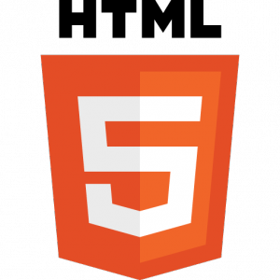

***Figure 6****: HTML5*

**HTML5** is the fifth revision of the HTML. It is a markup language to create a web page and present contents that can be displayed in a web browser [6].

**Alternative Technology**

* + Adobe Flash

**Reason we choose this Technology**

* + Using HTML5 to make creating accessible sites easier that allow other can access content easily than the older version. Then, HTML5 code is clean and simple.

**2.2.6 MySQL**

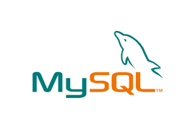

***Figure 7****: MySQL*

**MySQL** is the world's most popular open source database. With its proven performance, reliability and ease-of-use, MySQL has become the leading database choice for web-based applications, used by high-profile web properties including Facebook, Twitter, YouTube, Yahoo!, and many more. Oracle drives MySQL innovation, delivering new capabilities to power next generation web, cloud, mobile, and embedded applications [7].

**Alternative Technology**

* HyperSQL
* phpMyAdmin

**Reason we choose this Technology**

* + Open source
* Comfortable for accessing information

**2.2.7 QR Code**

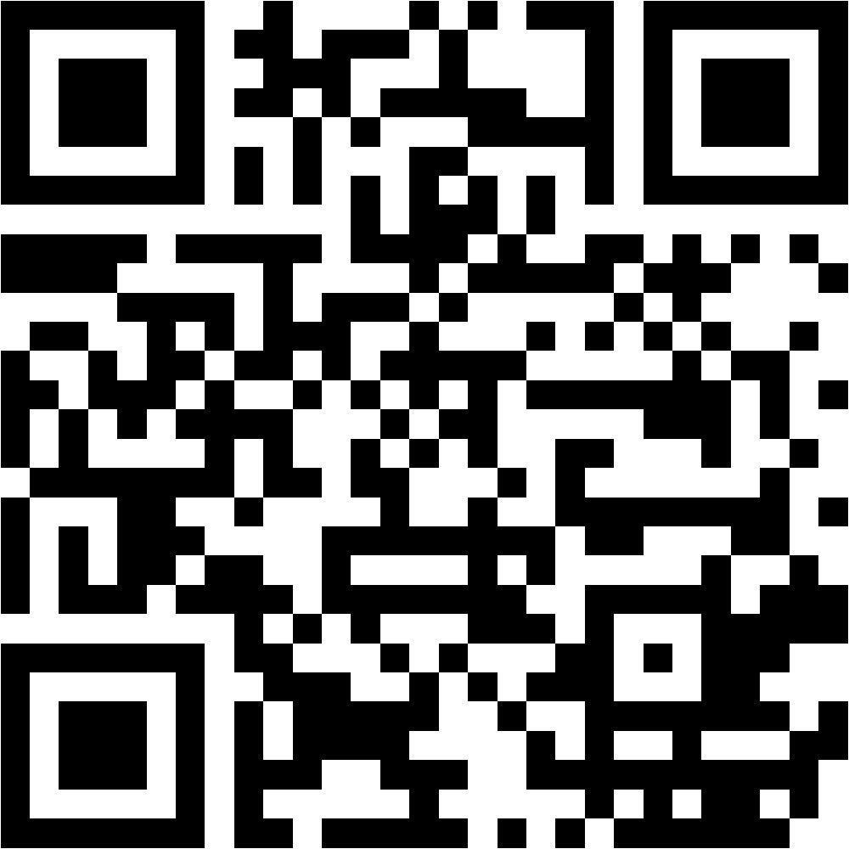

***Figure 8****: QR code*

**QR code** (quick response code) is a machine-readable optical label that contains information about the item to which is attached. A QR code uses four standardized encoding modes (numeric, alphanumeric, byte/binary, and [kanji](http://en.wikipedia.org/wiki/Kanji)) to store data efficiently; extensions may also use [8].

**Alternative Technology**

* Barcode
* AR code

**Reason we choose this Technology**

* It can store much more data, including URL links, geo coordinates, and text. QR code is also more popular than the standard barcode.

**2.2.8 Raspberry PI**

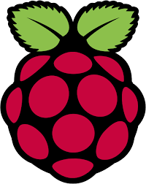

***Figure 9****: Raspberry PI*

**The Raspberry Pi** is a series of credit card-sized single-board computers developed in the United Kingdom by the Raspberry Pi Foundation with the intent to promote the teaching of basic computer science in schools and developing countries. The original Raspberry Pi and Raspberry Pi 2 are manufactured in several board configurations through licensed manufacturing agreements with Newark element14 (Premier Farnell), RS components and Egoman. The hardware is the same across all manufacturers. The firmware is closed-source [9].

**Alternative Technology**

* Banana PI

**Reason we choose this Technology**

* Raspberry PI is easy to find and also it is well known all over the world.

**2.2.9 NETPIE**



***Figure 10****: USB Camera for the Raspberry Pi*

**NETPIE** platform is a cloud-based platform-as-a-service that facilitates interconnecting IoT devices (“things”) together in a most seamless and transparent manner possible by pushing the complexity of connecting IoT devices form the hands of application developers or device manufacturers to the cloud[10].

**2.2.10 USB Camera for the Raspberry Pi**

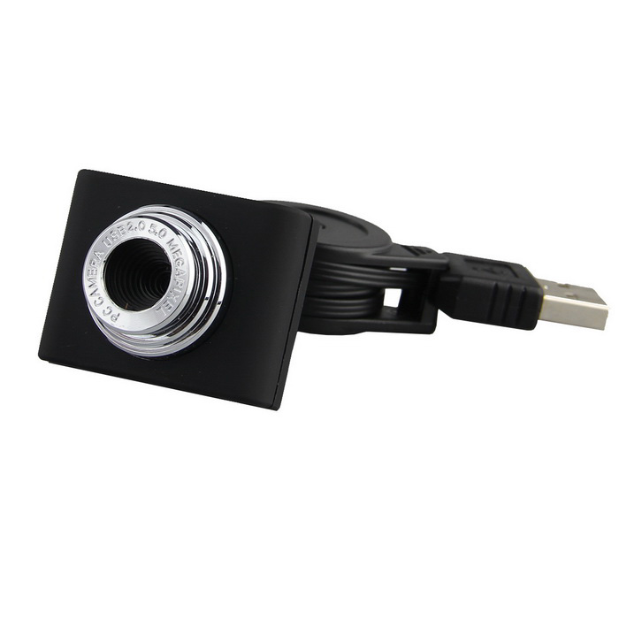 ***Figure 11****: USB Camera for the Raspberry Pi*

**USB Cameras** are imaging cameras that use USB 2.0 or USB 3.0 technology to transfer image data. USB Cameras are designed to easily interface with dedicated computer systems by using the same USB technology that is found on most computers. The accessibility of USB technology in computer systems as well as the 480 Mb/s transfer rate of USB 2.0 makes USB Cameras ideal for many imaging applications. An increasing selection of USB 3.0 Cameras is also available with data transfer rates of up to 5 Gb/s. Edmund Optics offers a variety of USB Cameras suited to meet many imaging needs. EO USB Cameras are available in both CMOS as well as CCD sensor types making them suitable across a larger range of applications. USB Cameras contain out-of-the-box functionality for quick setup. USB Cameras using low power USB ports, such as on a laptop, may require a separate power supply for opreration [11].

**Alternative Technology**

* None

**Reason we choose this Technology**

* It is very cheap for using in a small project.

**2.2.11 3.5 Inch TFT Display for Raspberry Pi**

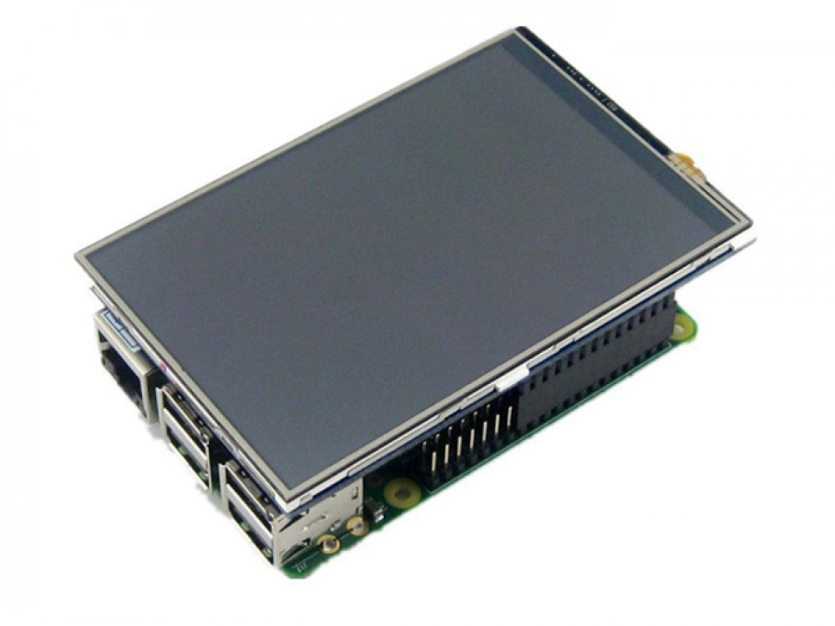

***Figure 12****: 3.5 Inch TFT Display for Raspberry Pi*

**3.5 Inch TFT Display for Raspberry Pi** has features a 3.5" display with 480x320 16-bit color pixels and a resistive touch overlay so is slightly larger. Uses the hardware SPI pins (SCK, MOSI, MISO, CE0, CE1) as well as GPIO #25 and #24. GPIO #18 can be used to PWM dim the backlight [12].

**Alternative Technology**

* 3.5 Inch TFT Display with touch panel for Raspberry Pi

**Reason we choose this Technology**

* It is very cheap for using in a small project.

## 

## 2.3 Business Tools and Software Review

**2.3.1 Samsung Family Hub 2.0 Refrigerator**

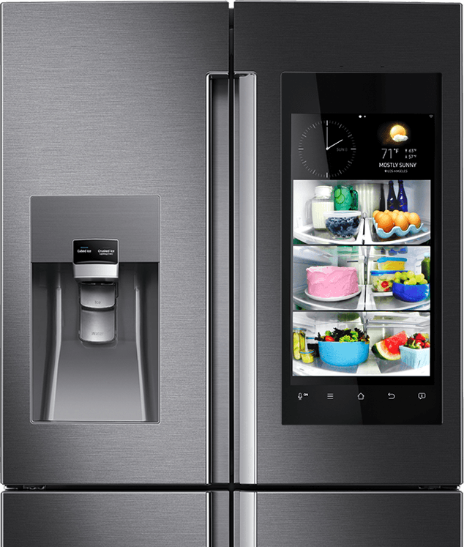

***Figure*** 13: Samsung Family Hub 2.0 Refrigerator

**Description**

The [Family Hub 2.0](https://news.samsung.com/global/samsung-electronics-unveils-family-hub-2-0-and-smart-built-in-appliances-at-ces-2017), which builds on the original model released last year, includes a 21.5-inch LED touchscreen. And have a camera inside to watch food expire in real time.

The touchscreen allows family members to post messages and notes to others, share photos, and look at shared calendars. Included in the latest update to the Family Hub is the ability to create profiles for different people: avatars or personal pictures can be used.

**Pros:**

* + Post message.
  + Users can issue voice commands to learn the weather and time.
  + Easy to use.
  + 21.5-inch LED touchscreen.

**Cons:**

* Expensive.
* The camera only takes pictures of a small portion of the fridge. It appears to show the entire inside but it only shows the middle of the main section.

## 2.4 Development Tool Review

**2.4.1 IntelliJ IDEA**



***Figure 14****: IntelliJ IDEA*

**IntelliJ IDEA** is a special programming environment or integrated development environment (IDE) largely meant for Java. This environment is used especially for the development of programs. It is developed by a company called Jet Brains, which was formally called IntelliJ. It is available in two editions: the Community Edition which is licensed by Apache 2.0, and a commercial edition known as the Ultimate Edition. Both of them can be used for creating software which can be sold. What makes IntelliJ IDEA so different from its counterparts is its ease of use, flexibility and its solid design [14].

**Alternative Technology**

* Eclipse

**Reason we choose this Technology**

* + IntelliJ IDEA Code completion and renaming suggestions are so clever

**2.4.2 Nano Text Editor**

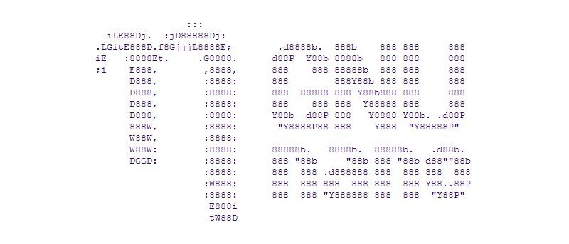 ***Figure 15****: Nano Text Editor*

**GNU nano** is a text editor for Unix-like computing systems or operating environments using a command line interface. It emulates the Pico text editor, part of the Pine email client, and provides additional functionality. Unlike Pico, nano is licensed under the GNU General Public License(GPL) [15].

**Alternative Technology**

* Notepad++

**Reason we choose this Technology**

* GNU Nano is a text editor for Unix-like computing systems

# Chapter Three | Quality Standard

## 3.1 ISO 29110 for Very Small Entity (VSE)

ISO 29110 is a guide applying to a very small entity, enterprise, organization, department or project up to 25 people dedicated to software development. The guide provides project management and software implementation process which integrate practice based on the selection of ISO/IEC 12207 systems and software engineering software life cycle process and ISO/IEC 15289 software engineering software life cycle process guideline for the content of software life cycle process information product (documentation) standards elements

### 3.1.1 Project management process

The purpose of the software management process is to establish and carry out in a systematic way the task of the software implementation project that allows complying with the project's objectives in the expected quality. Time and cost

**Selected process**

3.1.1.1 Project planning process

3.1.1.2 Project plan execution process

3.1.1.3 Project assessment and control process

3.1.1.4 Project close process

### 3.1.2 Software implementation process

The purpose of the software implementation process is the systematic performance of the analysis, design, construction, integration and test actives for new or modified software products, according to the specified requirements.

**Selected process**

3.1.2.1 Software implementation process

3.1.2.2 Software requirement analysis process

3.1.2.3 Software architectural design process

3.1.2.4 Software construction process

3.1.2.5 Software integration process and test process

3.1.2.6 Software delivery process

# Chapter Four | Project Plan

## 4.1 Motivation

We have the impulsion to develop the Smart fridge system for improving the quality life and step closer to our dream Smart Life that everyone has a high quality of life. This Smart fridge system will help people avoid eating the expiry date of product that will cause illness. Furthermore, will increase the sales volume of retailer and customer loyalty.

### 4.1.1 Aims

We aim at the three important aspects

* Develop electronic tools, which will store the product in a fridge and check the product are expired.
* Develop the web application, which will help the customer to see the consumption in each month. And will help the retailer to get information about their customer's behavior.
* Create a new business model that can improve the customer relationship management.

### 4.1.2 Objectives

* To improve the quality life for everyone especially an elderly.
* To develop the web application for customer to manage their consumption.
* To develop the web application for the retailer to collecting their customer’s behavior to meet the needs.

## 4.2 Deliverables and Limits

### 4.2.1 Deliverables

**Overview architecture**

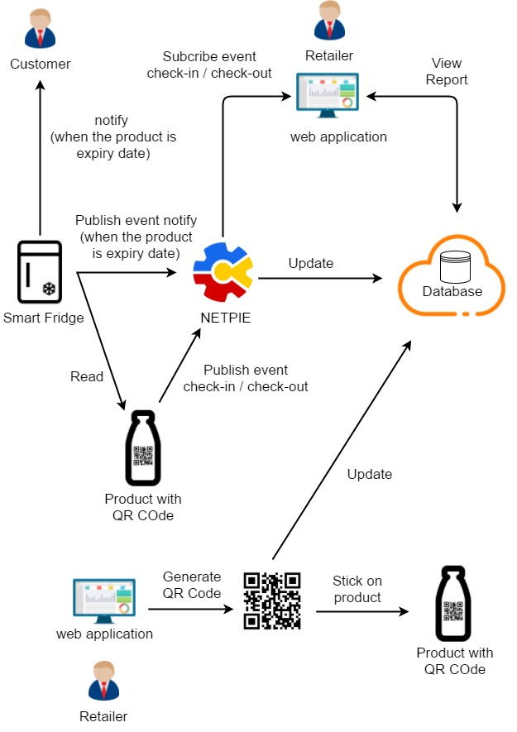

***Figure 16****: System architecture*

The architecture of IoT application for Smart Fridge system shown in the figure above consists of two parts.

First part is the QR Code generator. The unique QR Code is generated for this system particularly. The flow starts from retailer input the product’s information into the web application. Then, the generated QR Code will be saved into the database.

The second part is about displaying which has two sub-systems. First sub-system begins with Smart fridge system reading QR Code from the product (one time for check-in and one time for check-out). The reading result is sent via NETPIE server to update the data in database. Another sub-system is the notification system. When the product is expired or empty, the customer will get notification from LED panel and the retailer will get notification from web application. For retailer, the system sent the publish event notify to the web application via NETPIE server.

**Document**

* Proposal
* Project plan
* Software requirement specification
* Software design document
* Testing document
* Traceability record
* Software quality assurance document
* Certification client and server system
* Video clips for demo program
* Poster A1 for presentation

### 4.3.2 Limits

* Internet connection is required for using this system.
* The system supports only English language.
* User must show the QR Code to the camera.
* The product must be from only one place.

### 4.2.3 Future Work

In the future, we would like to improve the application, so that the customer can shop at home with the real-time video. We would like to increase the customer experience and customer satisfaction with the new business model.

## 4.3 Software Process

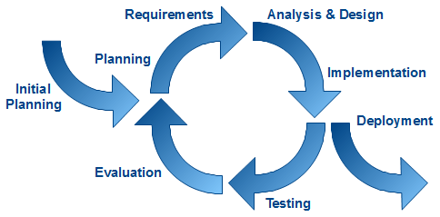  
***Figure 17****: Iterative Software Development Model*

**Iterative model** is one of Software Development Model which evolves from waterfall model. By changing process flow from step to step into iterative step. This iteration will repeat until all processes planned are complete then out from the loop and go to next main phase. The advantages of this model are support dividing and flexible. It can divide the system into subsystem or feature and then iterative create each feature. With this, chance of project failure will be reduced because it can delete problem early before integrating into the system.

**Proposal phase:** This phase is about creating a proposal for “IoT Application for Smart Refrigerator System”. This proposal contains about project introduction, technologies and tool involved, quality standard and project plan.

**Document plan phase:** This phaseis about document for planning and designs the overall system from requirement given by the user. These documents are Project Management Plan, Software requirement Specification and Software Design Document.

**Iterative all feature:** This phase is about separate system into many features and then iterative create all feature from the first feature till final feature. For this phase, it will be divided into 4 phases.

These are

* **Plan:** Planning the method for creating and test each feature.
* **Implement:** Implement and coding each feature.
* **Test:** Test and debug each feature.
* **Review:** Review and maintain each feature to meet the feature plan.

**System test phase**: This phase will integrate all features together into one system and then create test document from system testing.

**Deploy phase:** This phase is about deploy the whole system to serve and use as a regular mobile application.

## 4.4 Schedule & Milestone

According to the architecture of our project and the time schedule of senior project, we separated the whole project to four processes. The description is shown below:

There are two types of users:

* Retailer
* Customer

**Process 1**: Proposal and Project plan

**Process 2** [Progress I]

**Feature#1** Generate QR Code

**Description:** The feature#1 supports the retailer to generate QR Code.

**User:** Retailer  
**Detail:**

* + 1-1 Retailer: Retailer can input product name, product expiration for generating QR Code
  + 1-2 Retailer: Retailer can view the QR Code
  + 1-3 Retailer: Retailer can print the QR Code

**Feature#2** Database system

**Description:** The feature#2 provides CRUD operation of all data using in this system.

**User:** System  
**Detail:**

* 2-1 System: System can use CRUD operation to access the product information.
* 2-2 System: System can use CRUD operation to access the customer information.

**Process 3** [Progress II]

**Feature#3** QR code scanner

**Description:** The feature#3 supports the customer to scan QR code to check in and check out the product via the camera.

**User:** Customer

**Detail:**

* 3-1 Customer: The customer can scan QR code to check in.
* 3-2 Customer: The customer can scan QR code to check out.

**Process 4** [Final Progress]

**Feature#4** View report

**Description:** The feature#4 supports the retailer to get the customer’s expired product history.

**User:** Retailer

**Detail:**

* 4-1 Retailer: The retailer can get the customer’s expired product history from Web Application.

**Feature#5** Notification.

**Description:** The feature#5 supports the retailer and the customer to alert notification product expiration via web application and LED panel

**User:** Retailer and Customer

**Details:**

* 5-1 Retailer: The retailer can get product expiration notification from Web Application
* 5-2 Customer: The customer can get product expiration notification from LED Panel

**Relation between Feature and Users**

|  |  |  |  |
| --- | --- | --- | --- |
| **Feature** | **System** | **Retailer** | **Consumer** |
| Feature#1 |  | X |  |
| Feature#2 | X |  |  |
| Feature#3 |  |  | X |
| Feature#4 |  | X |  |
| Feature#5 |  | X | X |

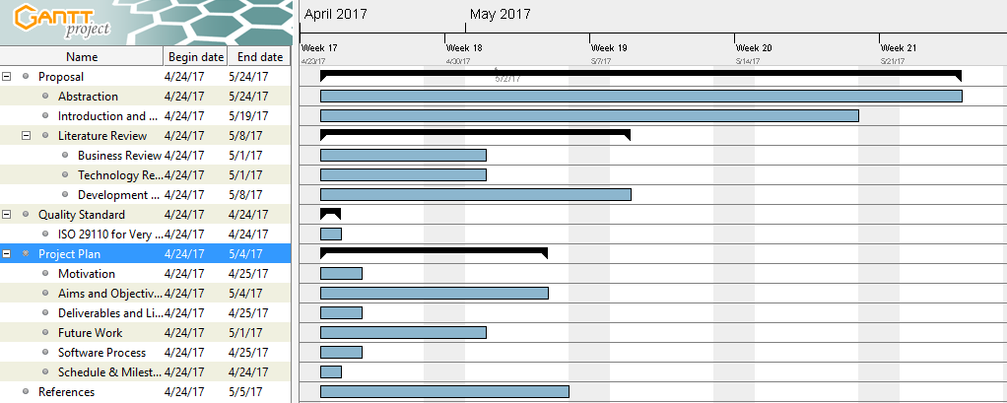

***Figure 16****: Proposal Milestone*

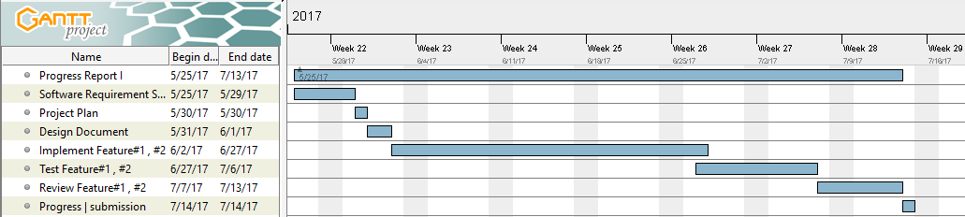

***Figure 17****: Progress I Milestone*

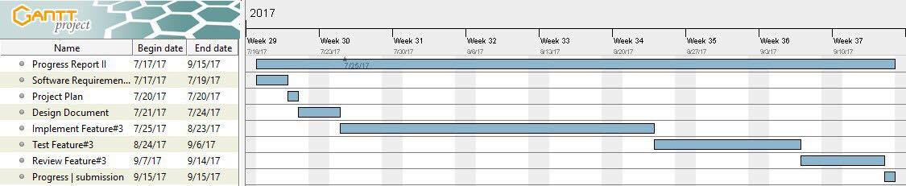

***Figure 18****: Progress II Milestone*

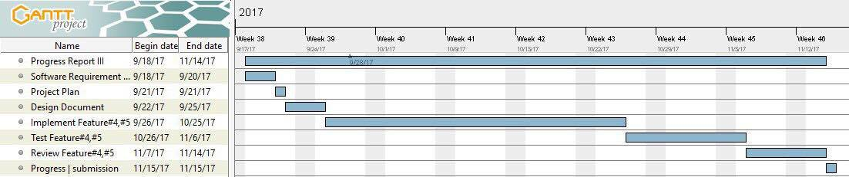

***Figure 19****: Final Progress Milestone*

# Chapter Five | References

[1] IoT Concept

https://www.particle.io/what-is-iot

[2] Angular2

http://blog.codeleak.pl/2016/03/quickstart-angular2-with-typescript-and.html

[3] Python

http://www.w3resource.com/python-exercises/string/python-data-type-string-exercise-27.php

[4] JSON

http://www.json.org/

[5] CSS

https://www.w3.org/standards/webdesign/htmlcss

[6] HTML

https://www.w3.org/standards/webdesign/htmlcss

[7] MySQL

https://www.mysql.com/about/

[8] QR code

http://en.wikipedia.org/wiki/QR_code

[9] Raspberry PI

<https://en.wikipedia.org/wiki/Raspberry_Pi>

[10] NETPIE

https://avatars3.githubusercontent.com/u/13195148?v=3&s=200

[11] USB Camera for the Raspberry Pi

https://www.pinterest.com/pin/362680576225032685/

[12] 3.5 Inch TFT Display for Raspberry Pi https://www.makerfabs.com/index.php?route=product/product&product_id=189

[13] Samsung Family Hub 2.0 Refrigerator

http://www.samsung.com/us/explore/family-hub-refrigerator/

[14] IntelliJ IDEA

https://twitter.com/intellijidea

[15] Nano Text Editor

https://en.wikipedia.org/wiki/GNU_nano

[17] Iterative Software Development Model

http://agilerules.blogspot.com/2014/07/software-development-methodologies.html