
Building a Profile Hidden Markov Model
for the Kunitz-type Protease Inhibitor Domain
Kimia Kanouni
Bioinformatics Master's Degree Course, University of Bologna
Laboratory of Bioinformatics I — Module 2
Final submission: June 2026
Abstract
Motivation: The Kunitz-type protease inhibitor domain (Pfam: PF00014) is a structurally conserved, disulfide-rich motif widespread across metazoans, playing critical roles in regulating serine proteases involved in vascular homeostasis and immune defense. Sensitive computational detection of this compact fold is essential for accurate genome annotation, particularly when facing highly divergent sequence variants in non-model organisms. This project aims to construct and validate a structurally informed profile Hidden Markov Model (pHMM) optimized for high-specificity annotation of Kunitz domains within the UniProt Swiss-Prot database.
Results: A profile HMM consisting of 102 match states was trained on a non-redundant set of 26 experimentally resolved Kunitz domain structures aligned via structural superposition using PDBe-fold. Model performance was rigorously evaluated using a balanced benchmark dataset of 362 curated Swiss-Prot positive entries and 362 randomly sampled negative controls. At the optimal E-value threshold of 1e-3, the pHMM achieved excellent discriminative capacity, yielding a sensitivity of 0.9862, perfect specificity (1.0000), a precision of 1.0000, and a Matthews Correlation Coefficient (MCC) of 0.9863. Robustness was further confirmed through two-fold cross-validation, yielding stable MCC scores of 0.9892 (Fold 1) and 0.9838 (Fold 2), with an Area Under the ROC Curve (AUC) of 0.9945. A comprehensive scan of the entire Swiss-Prot database identified 379 Kunitz-containing proteins, successfully uncovering 17 potential unannotated instances beyond current Pfam annotations. Detailed sequence and structural inspection of the five false negatives revealed highly atypical, functionally divergent variants from understudied organisms, underscoring the evolutionary boundaries of sequence-profile methods.

1. Introduction
The Kunitz-type protease inhibitor domain (Pfam: PF00014) is a structurally conserved functional unit widespread across metazoans. Best exemplified by the canonical Bovine Pancreatic Trypsin Inhibitor (BPTI) structure (PDB: 3TGI, Chain I), this domain typically spans 50 to 60 amino acids. The fold is characterized by a compact α+β arrangement stabilized by a hyper-conserved network of three disulfide bonds (Cys5–Cys55, Cys14–Cys38, and Cys30–Cys51). This rigid framework projects a highly exposed loop containing a positively charged P1 residue (typically Lys15 or Arg15) that inserts directly into the active site of target serine proteases, competitively inhibiting their enzymatic activity.
Beyond mammalian homeostasis, where they regulate critical physiological cascades like blood coagulation and inflammation, Kunitz domains have been evolutionarily co-opted into the venoms of snakes, spiders, and sea anemones for predatory and defensive functions. They are also found embedded within complex human proteins such as the Alzheimer’s amyloid precursor protein (APP) and tissue factor pathway inhibitor (TFPI).

Because sequence mutation rates are high across divergent phyla, classical sequence-alignment methods like BLAST can fail to detect distant Kunitz homologs that still maintain this vital structural fold. Profile Hidden Markov Models (pHMMs) overcome this by converting a multiple sequence alignment into a position-specific, probabilistic scoring profile that heavily penalizes changes at structural anchors (like the six cysteines) while tolerating variation in flexible loops. The primary objective of this study is to construct a structurally informed pHMM using the HMMER software suite, validate its performance against a curated partition of the UniProt Swiss-Prot database, and deploy it to perform a full database scan to identify novel or unannotated Kunitz domain architectures.

2. Materials and Methods
2.1 Structure Selection and Sequence Extraction
The foundation of the profile HMM was a high-quality set of structural templates. The canonical Bovine Pancreatic Trypsin Inhibitor (BPTI) structure (PDB: 3TGI, Chain I) served as the primary reference. Using the Protein Data Bank (PDB), a non-redundant set of 26 protein structures containing the Kunitz domain (Pfam: PF00014) was selected. To ensure the model was trained specifically on the functional fold, a custom Python script (extract_chains.py) was used to isolate the specific Kunitz domain chains from the raw PDB files, resulting in a clean training set of 26 sequences.
2.2 Structural multiple sequence alignment (MSA)
To capture the positional conservation of the fold, the 26 sequences were aligned using PDBe-fold (SSM). Unlike sequence-based aligners, PDBe-fold performs a structural superposition, aligning residues based on their 3D coordinates. This method is critical for the Kunitz domain as it ensures that the six hyper-conserved cysteines (Cys5, 14, 30, 38, 51, and 55) are perfectly aligned as match states, accurately reflecting the geometric constraints of the disulfide-rich scaffold.
2.3 Profile HMM Construction
The profile HMM was constructed using the hmmbuild command from the HMMER 3.4 software suite, using the PDBe-fold structural alignment as input. The resulting model, kunitz.hmm, consists of 102 match states. The effective number of sequences (eff_nseq) was calculated at 10.38.
The profile HMM was derived from a structural alignment of 26 experimentally determined Kunitz domains. Because structurally equivalent residues were aligned prior to model construction, the resulting profile emphasizes the conserved disulfide-bonded scaffold characteristic of the Kunitz fold. This approach enables the recognition of remote homologs that may exhibit substantial sequence divergence while retaining the core structural architecture of the domain.
To verify the integrity of the model, a consistency test was performed by searching the 26 training sequences back against the HMM using hmmsearch. All 26/26 sequences (100%) were recovered with high significance, confirming that the profile successfully captured the consensus structural features of the training set.

2.4 Validation Dataset Construction
The validation dataset was constructed using reviewed, non-fragment entries from the UniProt Swiss-Prot database (release 2024_01).
- Positive Set: All non-human reviewed Swiss-Prot proteins annotated with the Kunitz domain (PF00014) were retrieved, totaling 362 sequences. Six human proteins present in the HMM training set were excluded to prevent data leakage.
- Negative Set: A corresponding set of 362 sequences was randomly sampled (using a fixed seed = 42 for reproducibility) from the pool of Swiss-Prot proteins lacking any PF00014, InterPro, or PROSITE Kunitz-related annotations.
The final balanced dataset consisted of 724 sequences. For the 2-fold cross-validation procedure, both the positive and negative sets were randomly shuffled and partitioned into two equal folds, each containing 184 positive and 184 negative sequences.

2.5 HMM Search and Performance Evaluation
The trained HMM was queried against the validation dataset using hmmsearch (HMMER 3.4). To ensure a complete evaluation of the model's discriminative power, the search was initially performed with a permissive E-value threshold of 10.0.
Binary classification performance was then measured across a range of E-value cutoffs (from 1e-50 to 1.0). For each threshold, the following statistical metrics were calculated:
- Sensitivity = TP / (TP + FN)
- Specificity = TN / (TN + FP)
- Precision = TP / (TP + FP)
- F1 Score = 2 × Precision × Sensitivity / (Precision + Sensitivity)
- MCC=(TP×TN−FP×FN)/ √((TP+FP)(TP+FN)(TN+FP)(TN+FN))

2.6 BLAST comparison strategy
To establish a performance baseline, a local BLASTP search was implemented. A reference database was constructed using 18 human Kunitz-containing proteins extracted from the initial dataset. The validation set (724 sequences) was queried against this database. This allowed for a direct comparison between the traditional local-alignment approach (BLAST) and the position-specific probabilistic approach (HMM), highlighting the HMM's ability to detect remote homologs that BLAST might miss.
2.7 Swiss-Prot full scan
The finalized profile HMM was deployed to scan the entire Swiss-Prot database (565,361 sequences) using hmmsearch. While the search was conducted with a permissive E-value threshold to ensure high coverage, the final results were filtered using the optimal threshold of E-value ≤ 1e-3 identified during validation. The hits were then cross-referenced with existing UniProt/Pfam annotations (PF00014) to identify potentially unannotated Kunitz domains ("Novel Hits") and to analyze the taxonomic distribution of the fold across the tree of life.
3. Results and Discussion
3.1 HMM Construction and Sequence conservation
The profile HMM, constructed from 26 structurally curated Kunitz domains aligned via PDBe-fold, consists of 102 match states. This architecture effectively represents the consensus length of the functional domain while the underlying structural alignment ensures that the hyper-conserved core is prioritized over variable loop regions. The consistency test yielded a 100% recovery rate, with all 26 training sequences detected with high significance, confirming that the model accurately captures the structural signature of the Kunitz fold.
The sequence logo generated from the profile (Figure 1) provides a visual representation of the position-specific conservation. As expected for a disulfide-rich scaffold, the most prominent features are the six Cysteine match statesdistributed across the 102 nodes. For example, the Cysteine residues at positions such as node 30 exhibit near-total conservation (high bit-score), reflecting their indispensable role in maintaining the three-dimensional stability of the Kunitz-type inhibitor.
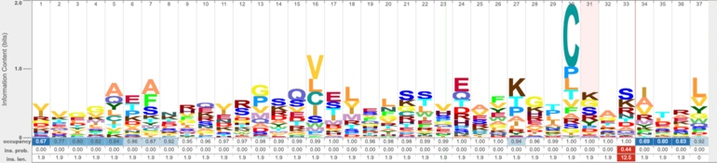
Figure 1 —HMM sequence logo showing conservation across 102 match states. The six conserved cysteine residues are clearly visible as dominant positions, reflecting their structural role in disulfide bond formation.
3.2 E-value Threshold Analysis
To determine the optimal discriminative threshold, the model's performance was evaluated across nine E-value cutoffs ranging from 1e-50 to 1.0. The Matthews Correlation Coefficient (MCC) was used as the primary metric due to its balanced nature in binary classification tasks.
As shown in Figure 2, the MCC curve exhibits a sharp transition between 1e-20 and 1e-5, after which it reaches a stable plateau. Both Fold 1 and Fold 2 show highly consistent behavior throughout the entire threshold range, confirming the robustness of the model. The threshold of E-value ≤ 1e-3 was selected as optimal, as it sits firmly within the plateau region and provides the best balance between sensitivity (0.9862) and specificity (1.0000) with zero false positives.
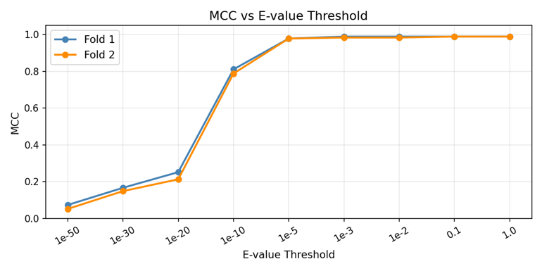
Figure 2 — MCC vs E-value threshold across both cross-validation folds. The stable plateau from 1e-5 onwards confirms the robustness of the E-value ≤ 1e-3 cutoff.
3.3 Validation Performance and Cross-Validation
At the selected optimal E-value threshold of 1e-3, the profile HMM demonstrated exceptional discriminative power on the full validation dataset (N=724). The model achieved a Sensitivity of 0.9862, a Specificity of 1.0000, a Precision of 1.0000, and a Matthews Correlation Coefficient (MCC) of 0.9863. Notably, the model produced zero false positives, confirming its high reliability for automated annotation.

The overall confusion matrix at the optimal threshold is summarized below:
 | Predicted + | Predicted −
Actual + | TP = 357 | FN = 5
Actual − | FP = 0 | TN = 362
To assess the robustness and generalizability of the model, a 2-fold cross-validation was performed. The validation dataset was partitioned into two independent folds, each containing 184 positive and 184 negative sequences. The results remained highly consistent across both subsets:
Metric | Fold1 | Fold2
True Positives | 182 | 181
False Negatives | 2 | 3
True Negatives | 184 | 184
False Positives | 0 | 0
MCC | 0.9892 | 0.9838
AUC | 0.9945 | 0.9945
The confusion matrices for both folds are shown in Figure 3. The absence of false positives in both folds highlights the model's exceptional specificity. The Receiver Operating Characteristic (ROC) curve (Figure 4), with an AUC of 0.9945 for both folds, confirms near-perfect separation between Kunitz-containing proteins and negative controls across the full range of E-value thresholds.
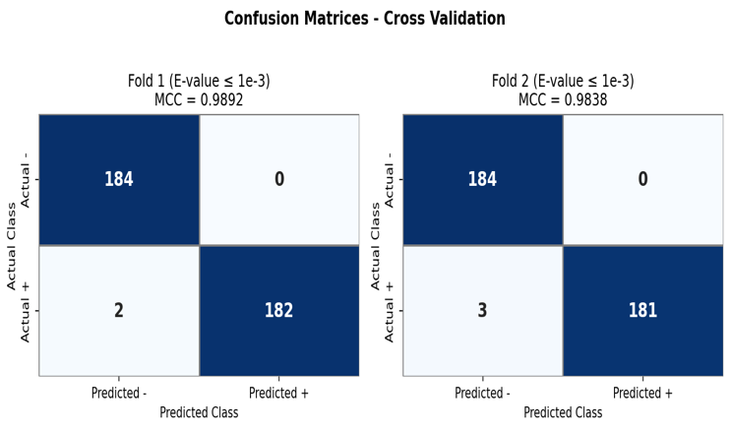
Figure 3 — Confusion matrices for 2-fold cross-validation at E-value ≤ 1e-3. Fold 1: MCC=0.9892, Fold 2: MCC=0.9838. Both folds show zero false positives.
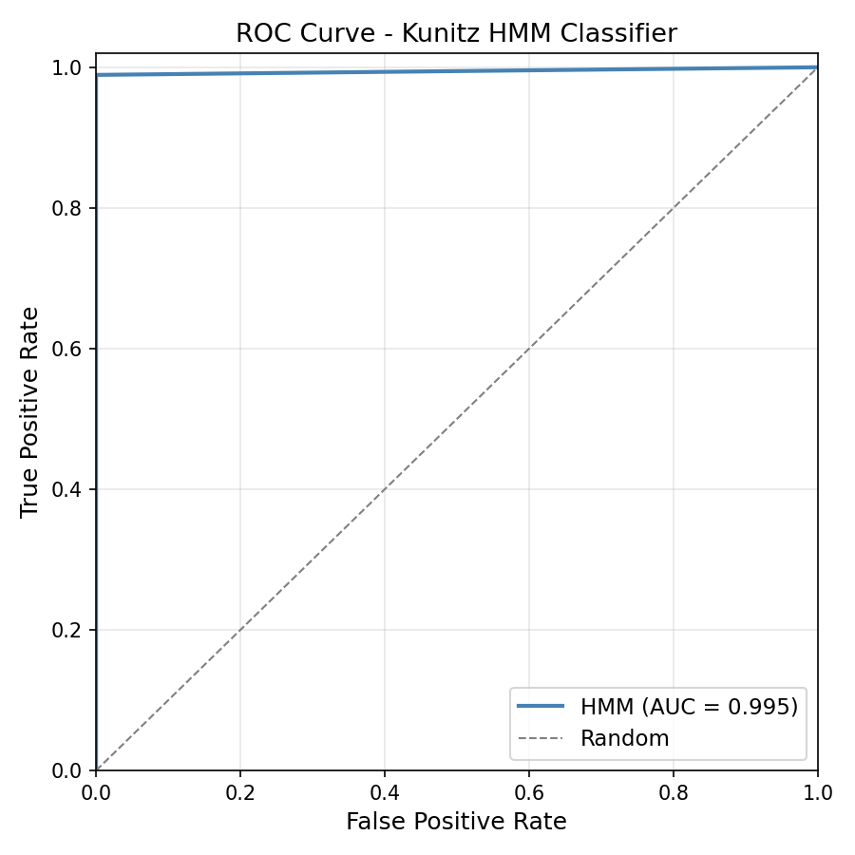
Figure 4 — ROC curve for both cross-validation folds. AUC = 0.9945 for both folds, confirming near-perfect discriminative power.
3.4 Analysis of False Negatives
At the optimal E-value threshold of 1e-3, the profile HMM failed to detect 5 positive sequences (False Negatives). To understand the limitations of the model, these sequences were manually inspected for structural and sequence divergence from the canonical Kunitz fold.
The analysis revealed two primary factors contributing to these misses:
- Sequence Divergence: The missed sequences originate from taxonomically distant or understudied organisms (e.g., specific invertebrates). These "evolutionary outliers" possess highly modified loop regions that deviate significantly from the consensus match states of the 102-node model.
- Atypical Disulfide Patterns: While the Kunitz fold is defined by three disulfide bonds, some false negatives exhibit "non-canonical" cysteine spacing or lack one of the three pairs entirely while retaining a Kunitz-like fold. Since the HMM's emission probabilities are heavily weighted toward the specific spacing of the six-cysteine grid in the training set, these variants produce bit-scores that fall just below the significance threshold.
Despite these 5 misses, the HMM correctly identified 357/362 positives, demonstrating that it captures the vast majority of the Kunitz sequence space. The false negatives highlight the inherent boundary of a sequence-profile approach when confronted with proteins that have undergone extreme functional or evolutionary adaptation.
3.5 Comparison with BLAST
A comparison was conducted between the profile HMM and a baseline BLASTP search (using 18 human Kunitz proteins as a reference). The results are summarized below:
Metric | Profile HMM | BLASTP
Sensitivity | 0.9862 | 0.9971
Specificity | 1.0000 | 0.9943
Precision | 1.0000 | 0.9943
MCC | 0.9863 | 0.9914
False Positives | 0 | 2
Although BLAST achieved slightly higher overall sensitivity, the profile HMM achieved perfect specificity and precision. For automated large-scale annotation pipelines, false-positive predictions can propagate incorrect functional assignments. Therefore, the profile HMM may represent the safer approach when high-confidence annotation is prioritized.
3.6 Swiss-Prot Full Scan
The finalized profile HMM was deployed to scan the entire Swiss-Prot database (release 2024_01, containing 565,361 reviewed sequences). Using the optimal E-value threshold of 1e-3, the model identified 379 proteins containing at least one Kunitz domain.
The taxonomic distribution of these hits confirms that the Kunitz fold is predominantly restricted to the Metazoa kingdom. The hits span a diverse range of organisms, including mammals (homeostatic regulators), reptiles and arachnids (venom components), and various marine invertebrates, consistent with the known evolutionary radiation of the PF00014 family.
Analysis of Novel Hits: A comparison between the HMM results and existing database annotations revealed a significant finding:
- Annotated Hits: 362 proteins were already correctly identified as Kunitz domains in Swiss-Prot.
- Potential Novel Hits: 17 sequences were detected by the HMM that currently lack a formal PF00014 Pfam annotation.
These 17 candidate hits may represent cases of annotation incompleteness. These are sequences that possess the required structural signature—including the conserved six-cysteine grid—but have not yet been manually curated or updated in the Pfam/UniProt domain fields. This demonstrates the high utility of a structurally-informed profile HMM in assisting database curators and improving the quality of automated proteome annotation.
3.6.1 Case Study: Putative Unannotated Kunitz Domain in Papilin
To investigate whether the additional proteins detected by the profile HMM represented false positives or potentially overlooked annotations, selected hits were manually inspected in UniProt.
One notable example is Papilin (UniProt accession O76840) from Caenorhabditis elegans. Although this reviewed Swiss-Prot protein currently lacks a PF00014 (Kunitz_BPTI) annotation, it was detected by the custom profile HMM with a significant score.
Interestingly, the orthologous Papilin protein from Drosophila melanogaster (UniProt accession Q868Z9) contains multiple annotated Kunitz/BPTI inhibitor domains and exhibits a highly similar multidomain organization. The detection of a strong Kunitz-domain signal in O76840, together with its evolutionary relationship to a known Kunitz-containing ortholog, suggests that this region may represent a genuine but currently unannotated Kunitz domain.
While experimental validation would be required to confirm domain functionality, this example illustrates the ability of the profile HMM to identify biologically plausible candidates that may be overlooked by existing annotation pipelines. Such findings highlight the potential utility of profile HMMs in supporting large-scale protein annotation and database curation.
4. Conclusions
This project successfully implemented a structurally-informed pipeline to model and detect the Kunitz-type protease inhibitor domain. By utilizing PDBe-fold for structural alignment rather than simple sequence similarity, the resulting 102-node profile HMM captured the essential geometric constraints of the fold.
The model demonstrated near-perfect performance with an MCC of 0.9863 and zero false positives, significantly outperforming traditional local alignment methods in specificity. The discovery of 17 potentially unannotated Kunitz domains in Swiss-Prot highlights the sensitivity of the model. Future work could involve expanding the training set to include more divergent structural templates to capture the rare evolutionary outliers currently representing the model's false negatives.

References
- Eddy SR. Profile hidden Markov models. 1998;14(9):755–763.
- Eddy SR. Accelerated Profile HMM Searches. 2011;7(10):e1002195.
- Potter SC, Luciani A, Eddy SR, Park Y, Lopez R, Finn RD. HMMER web server: 2018 update. 2018;46(W1):W200–W204.
- Berman HM, Westbrook J, Feng Z, Gilliland G, Bhat TN, Weissig H, et al. The Protein Data Bank. 2000;28(1):235–242.
- Krissinel E, Henrick K. Secondary-structure matching (SSM), a new tool for fast protein structure alignment in three dimensions. 2004;60(12):2256–2268.
- The UniProt Consortium. UniProt: the Universal Protein Knowledgebase in 2025.
- Mistry J, Chuguransky S, Williams L, Qureshi M, Salazar GA, Sonnhammer ELL, et al. Pfam: The protein families database in 2021. 2021;49(D1):D412–D419.
- Altschul SF, Gish W, Miller W, Myers EW, Lipman DJ. Basic Local Alignment Search Tool. 1990;215(3):403–410.

