**PCF**

**Integration with Spring Cloud Demo - Steps**

**(Service Discovery and Circuit Breaker Pattern Implementation)**

**Steps to Download the Source Code from Git Repo and built it**

1. Go to any folder where you want to download the code and run below command

git clone <https://github.com/kansal-mukul/PCF-SpringCloudIntegration.git>

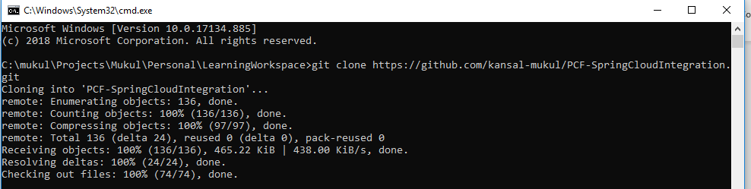

1. Run cd PCF-SpringCloudIntegration/PCF-SpringCloudIntegration



1. Run mvn clean install and wait until build success.

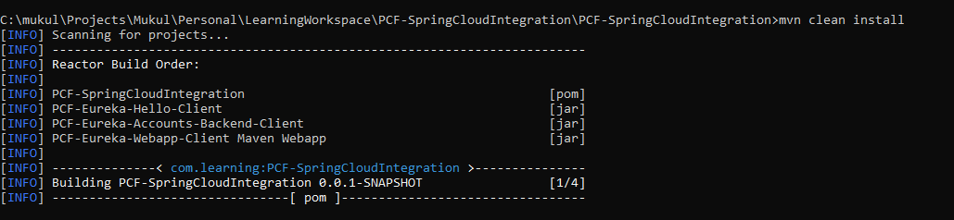

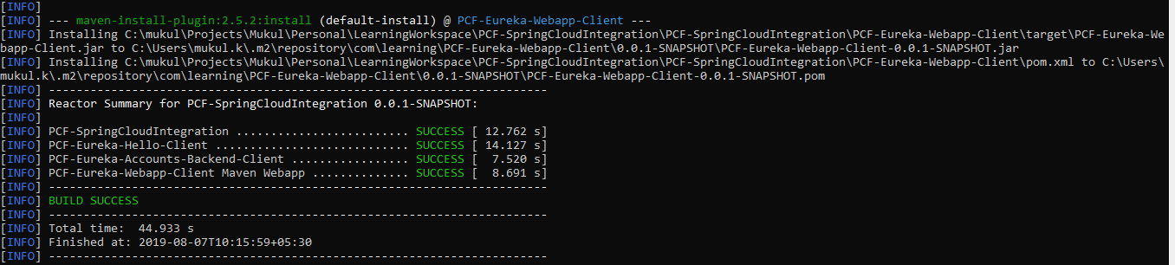

**Steps to login and Setup the PCF environment**

1. Login with this URL : <https://login.run.pivotal.io/login>

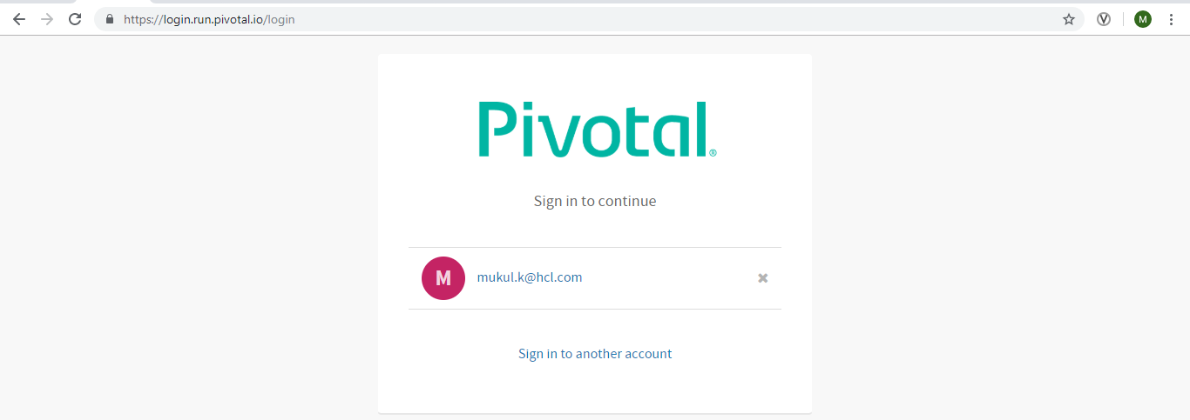

1. Login with your credentials as username/password.

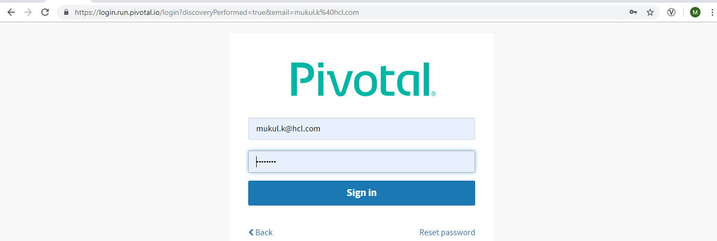

1. After successful login

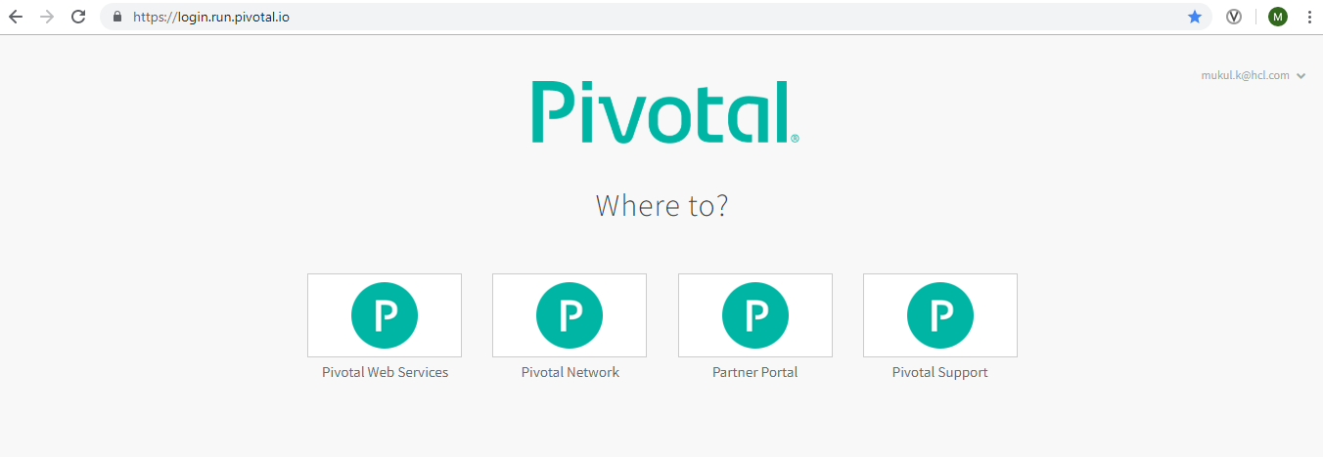

1. Then Click on Pivotal Web Services. Select the Org and Space on which you want to deploy your applications

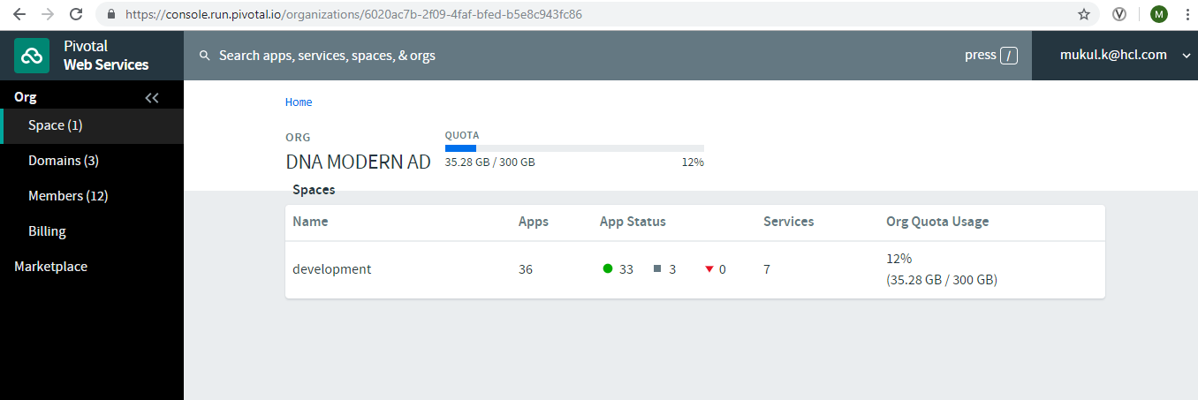

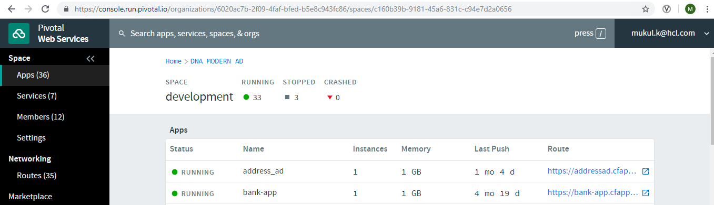

1. Go to Services -> Add a Service . Add 2 services Circuit Breaker and Service Registry with named mycircuitbreaker and mydemo-registry.

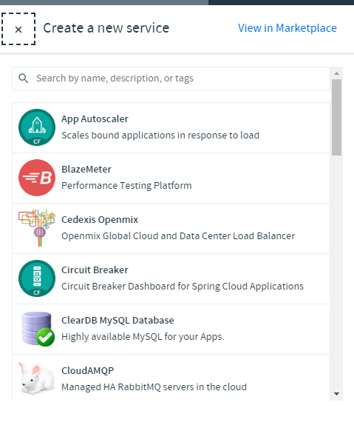

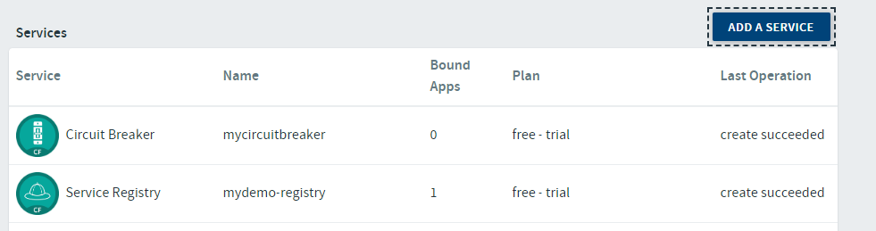

1. Click on mycircuitbreaker htperlink to view the circuit breaker dashboard

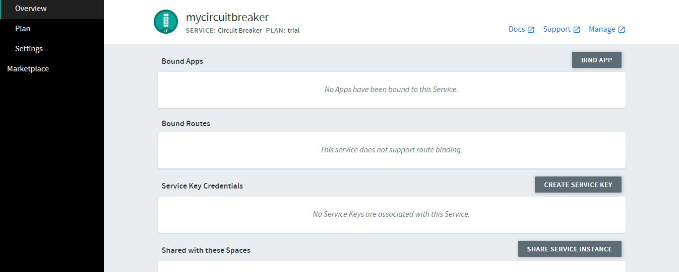

1. Click on Manage
2. Click on mydemo-registry to view the Service Registry dashboard

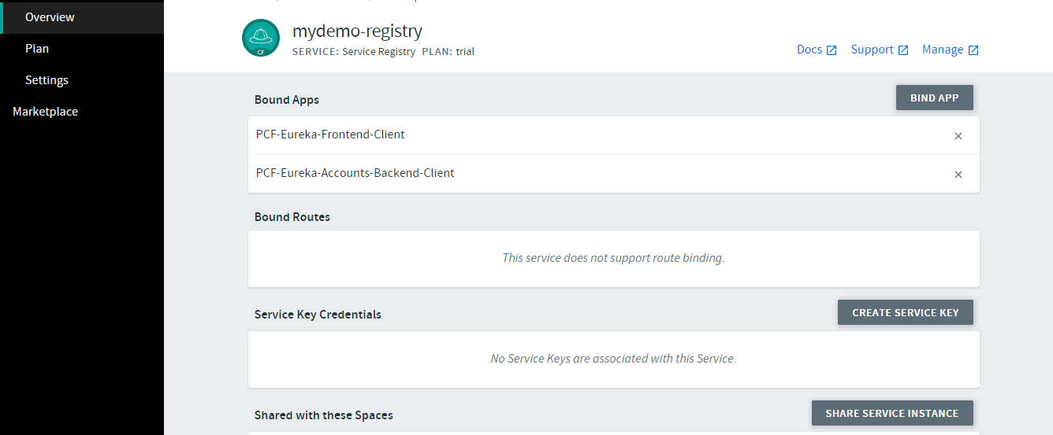

1. Click on Manage

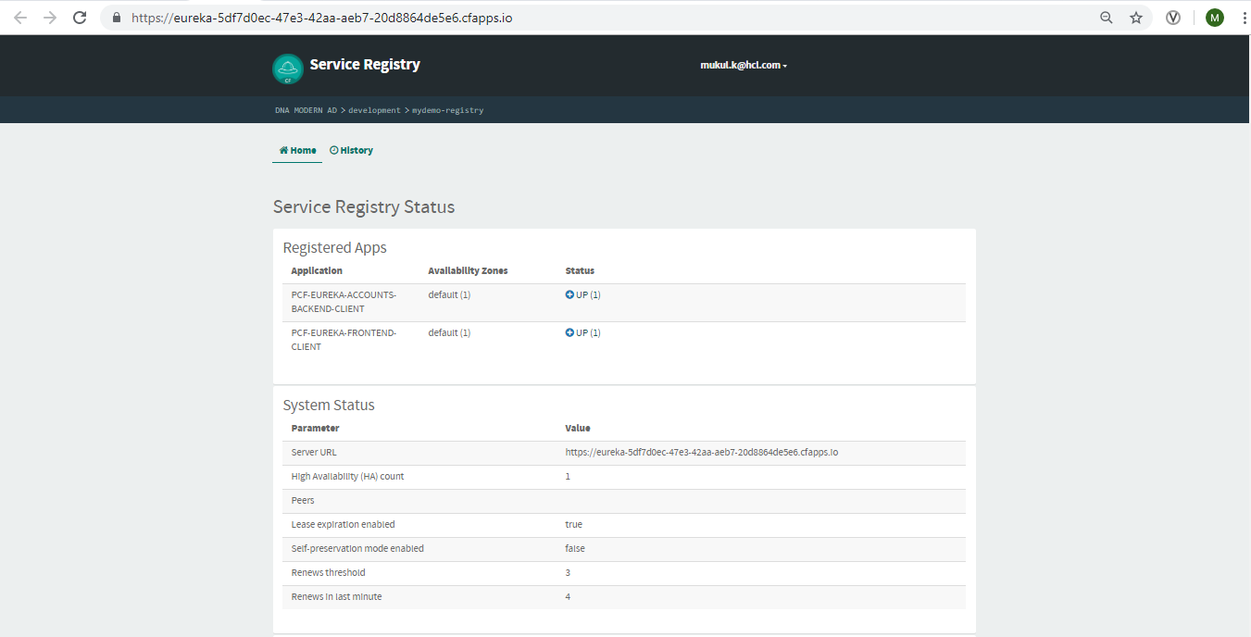

**Steps to Deploy the application in PCF thorough PCF CLI**

1. Install PCF CLI and run cf version



1. Open cmd and go to PCF-Eureka-Accounts-Backend-Client folder

cd PCF-Eureka-Accounts-Backend-Client



1. Run cf login and enter your credentials

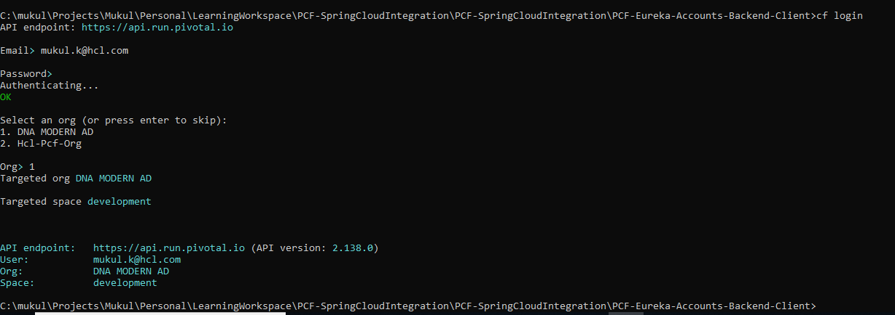

1. Run cf push

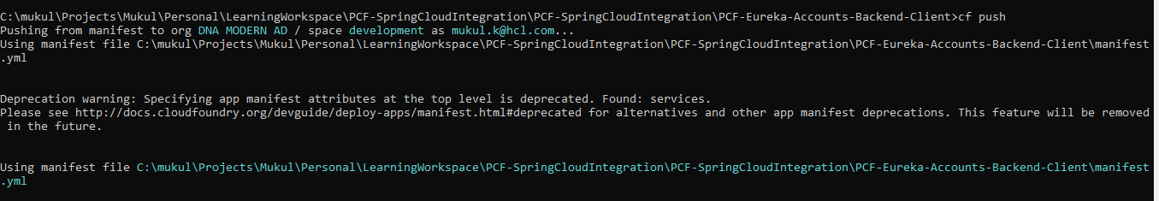

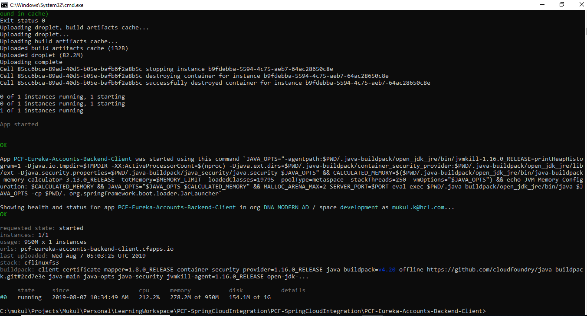

1. Application successfully deployed in PCF

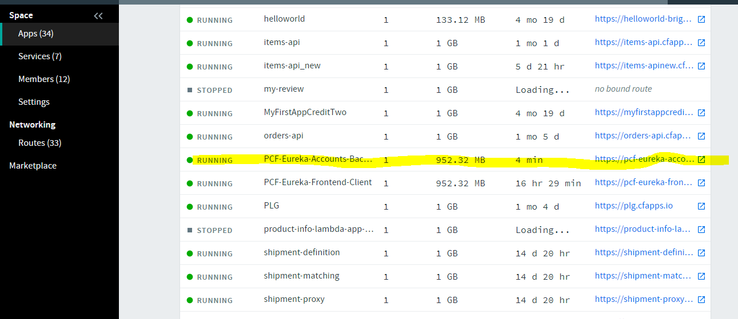

1. Click on this application

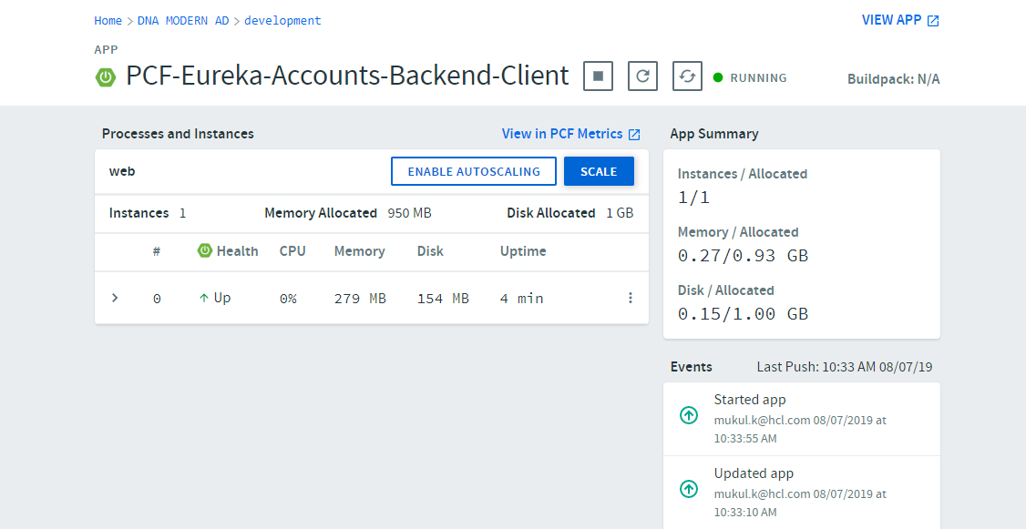

1. Click on View App link

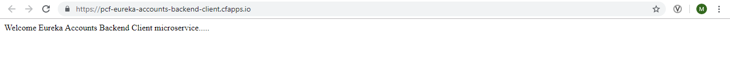

1. In the same way deploy another 2 microservices in PCF through cf push command

* PCF-Eureka-Hello-Client

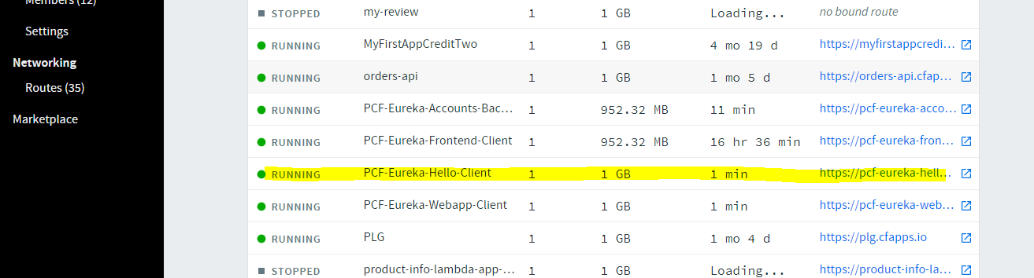

<https://pcf-eureka-hello-client.cfapps.io/hello>

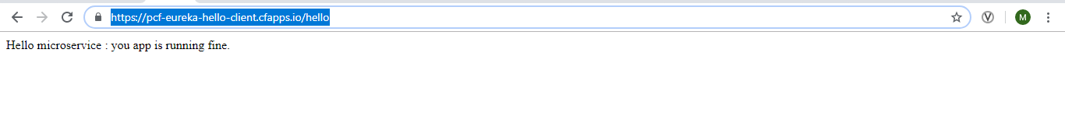

* PCF-Eureka-Webapp-Client

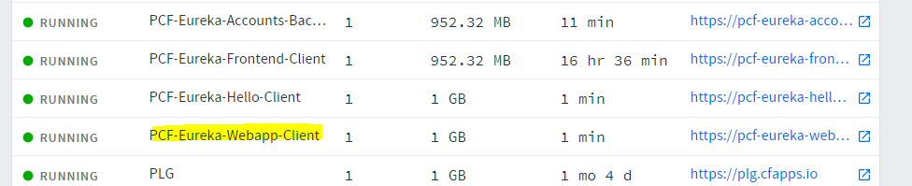



Click on Microservice A : Hello button

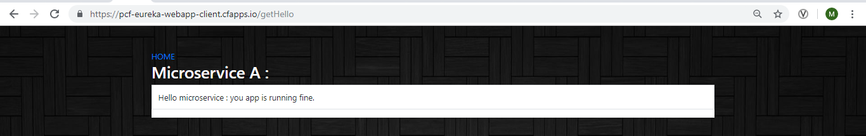

Click on Home : user will come back to main page

Then Click on Microservice B button

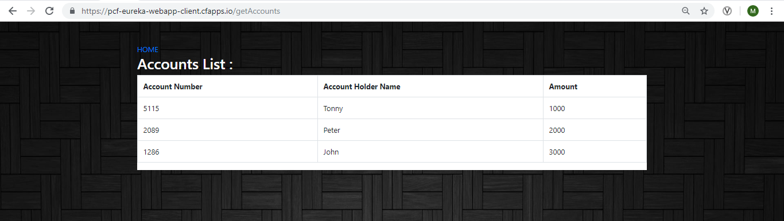

**Screenshot of running applications in PCF Eureka server**

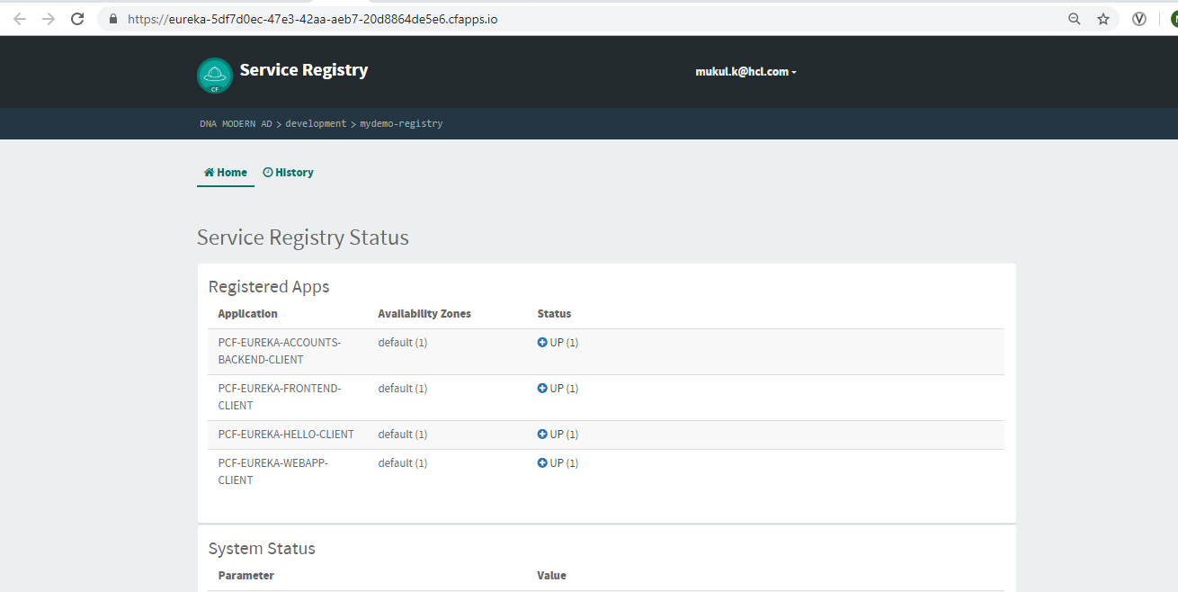

**Screenshot of running Circuit Breaker Dashboard**

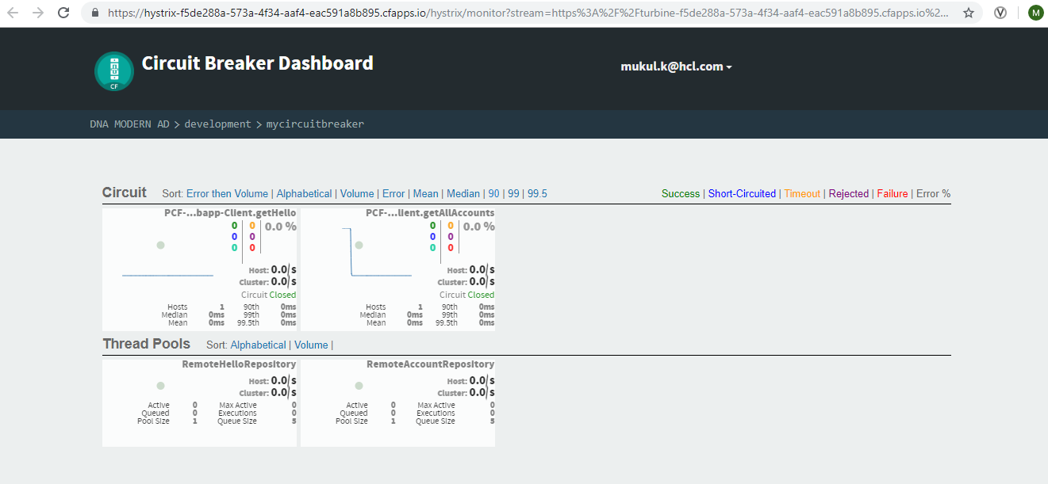

**Check how Circuit Breaker works**

Stop the Microservice Eureka Hello Client through PCF app console

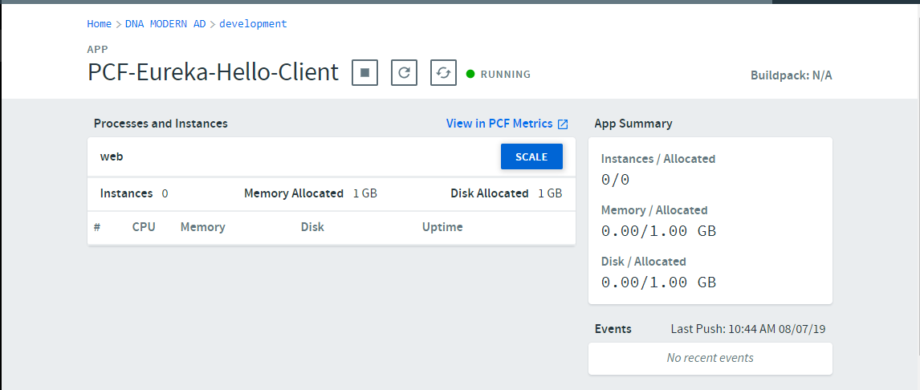 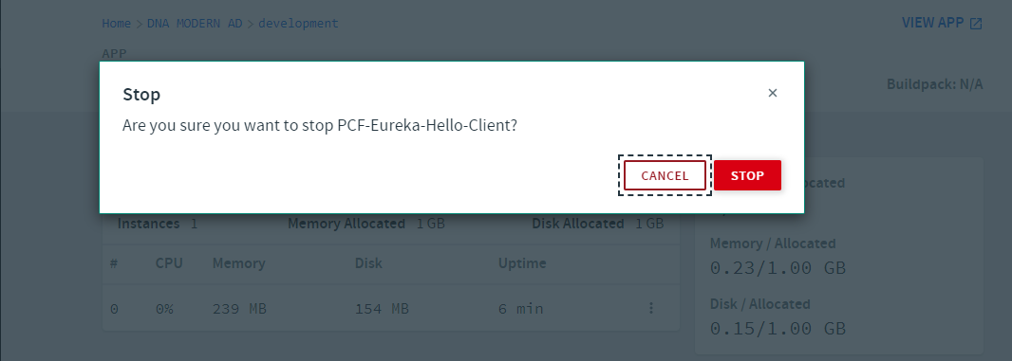

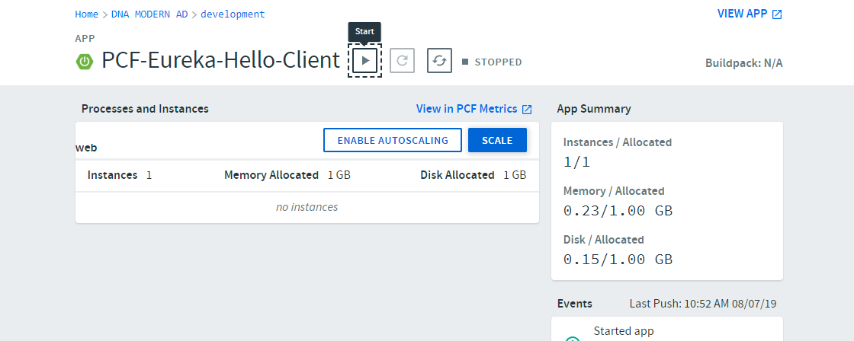

Go to

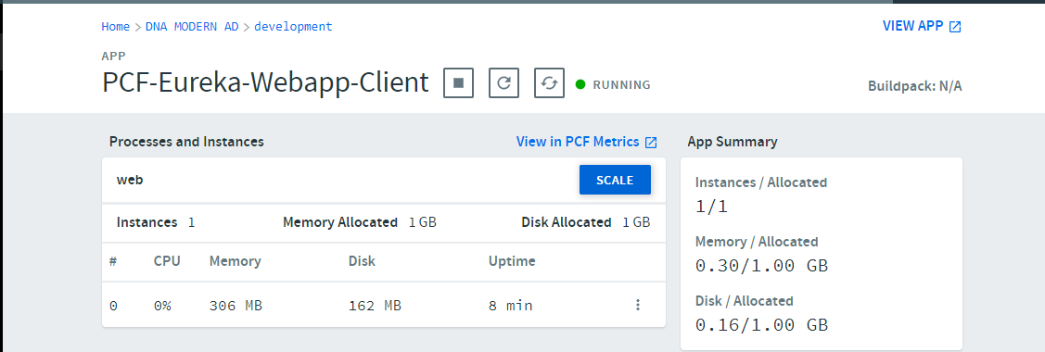

Click on View app

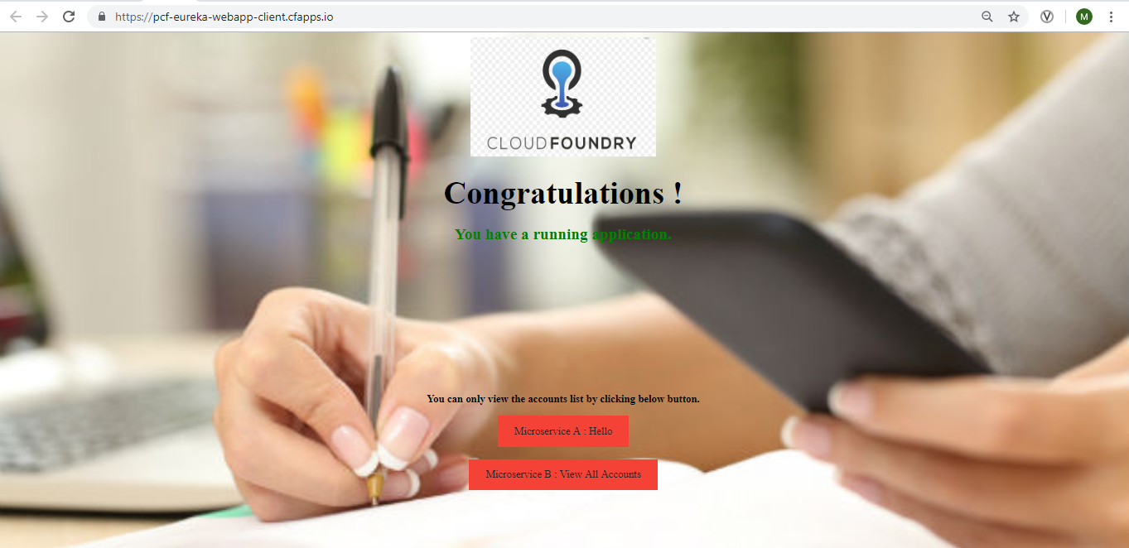

Then click on Microservice A button

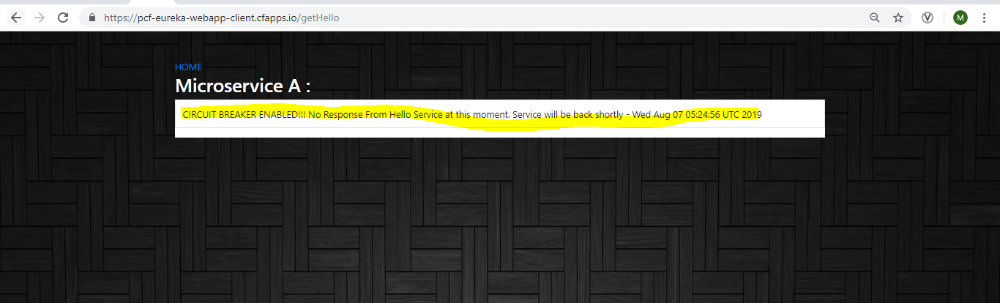

In the same way try to down Microservice B and then check

