**Installation of Nginx-operator through operator-sdk(0.16.0) in OCP 4.8.3**

**Operator-sdk installation**

wget <https://github.com/operator-framework/operator-sdk/releases/download/v0.16.0/operator-sdk-v0.16.0-x86_64-linux-gnu>  
mv operator-sdk-v0.16.0-x86_64-linux-gnu /usr/local/bin/operator-sdk  
chmod +x /usr/local/bin/operator-sdk

**oc installation**

wget --progress=dot:giga [https://mirror.openshift.com/pub/openshift-v4/x86_64/clients/ocp/stable-4.6/openshift-client-linux.tar.gz && \](https://mirror.openshift.com/pub/openshift-v4/x86_64/clients/ocp/stable-4.6/openshift-client-linux.tar.gz%20&&%20\)

tar xvf openshift-client-linux.tar.gz && \

chmod 755 oc && \

chmod 755 kubectl && \

mv oc /usr/local/bin && \

mv kubectl /usr/local/bin && \

rm openshift-client-linux.tar.gz

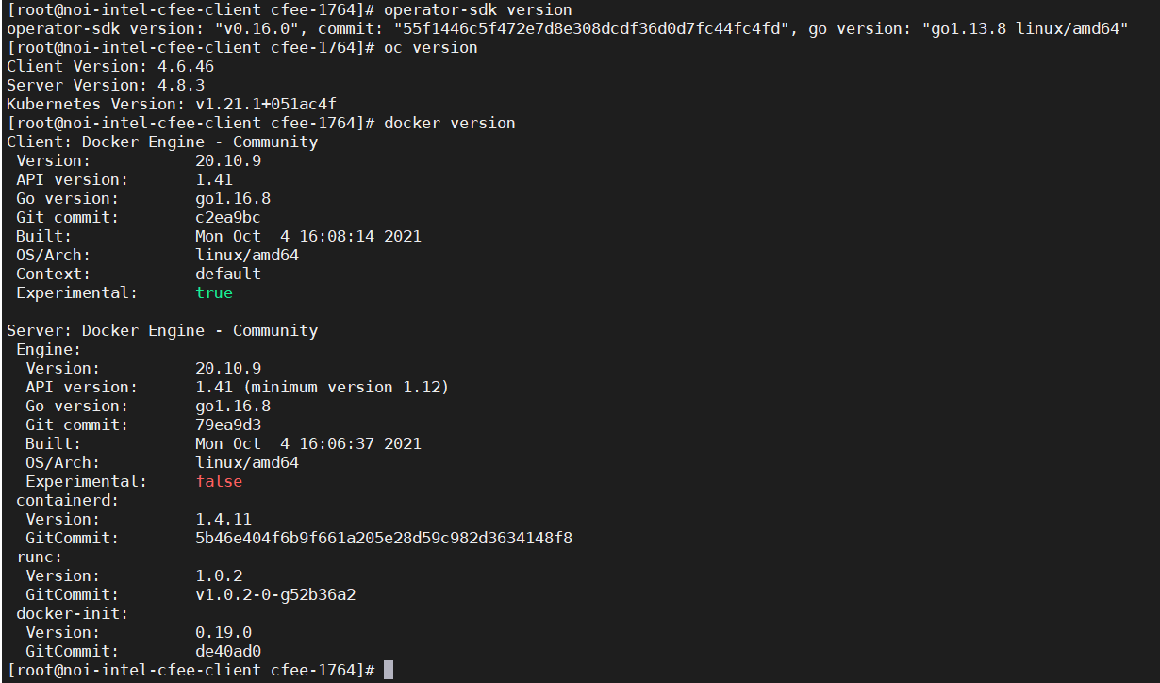

operator-sdk new nginx-operator --api-version=example.com/v1alpha1 --kind=Nginx --type=helm

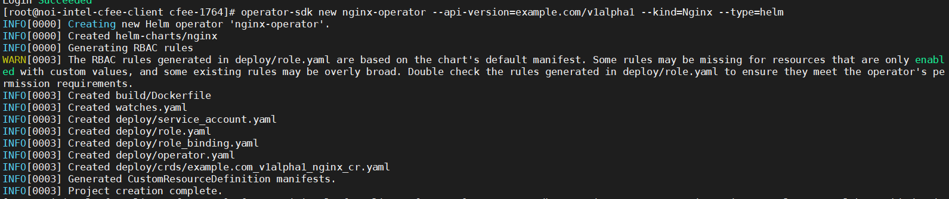

cd nginx-operator

operator-sdk build mukulk/nginx-operator:v0.0.1

docker push mukulk/nginx-operator:v0.0.1

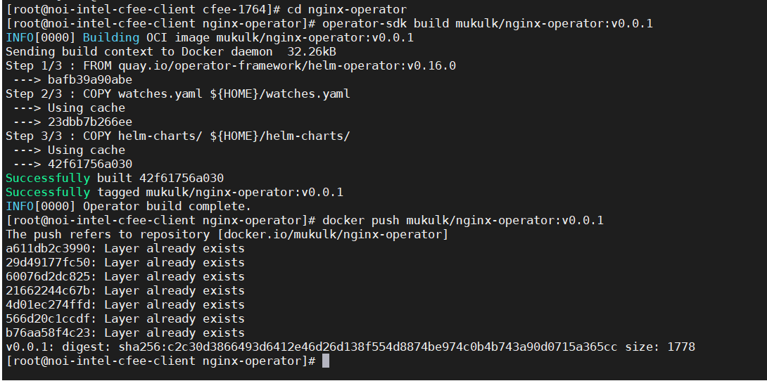

sed -i "s|REPLACE_IMAGE|mukulk/nginx-operator:v0.0.1|g" deploy/operator.yaml

kubectl create -f deploy/service_account.yaml

kubectl create -f deploy/role.yaml

kubectl create -f deploy/role_binding.yaml

kubectl create -f deploy/crds/example.com_nginxes_crd.yaml

kubectl create -f deploy/operator.yaml

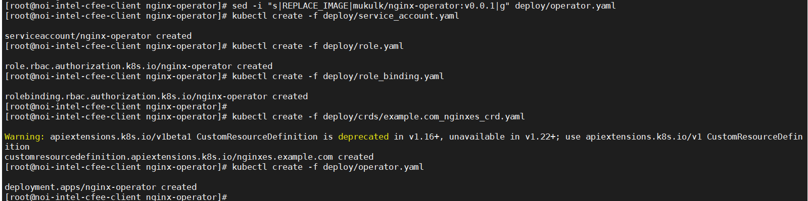

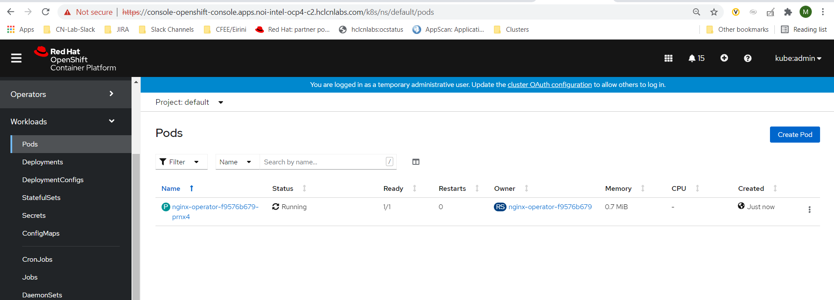

kubectl create -f deploy/crds/example.com_v1alpha1_nginx_cr.yaml

oc get Nginx

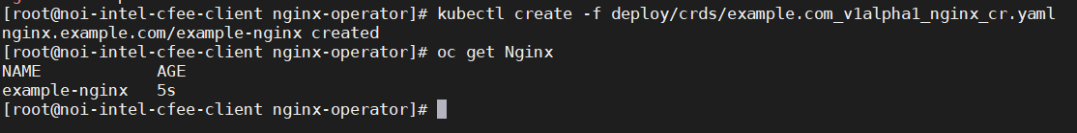

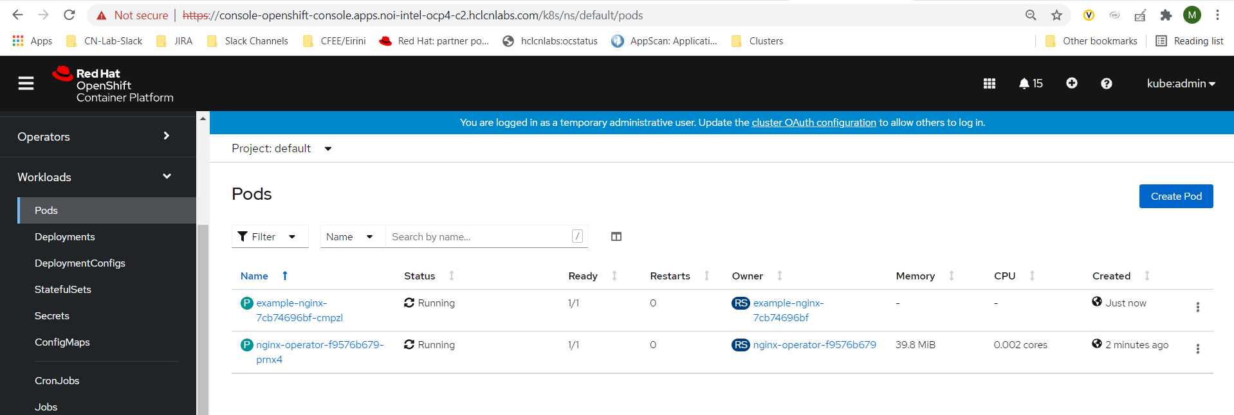

**Tree structure of Nginx-operator**

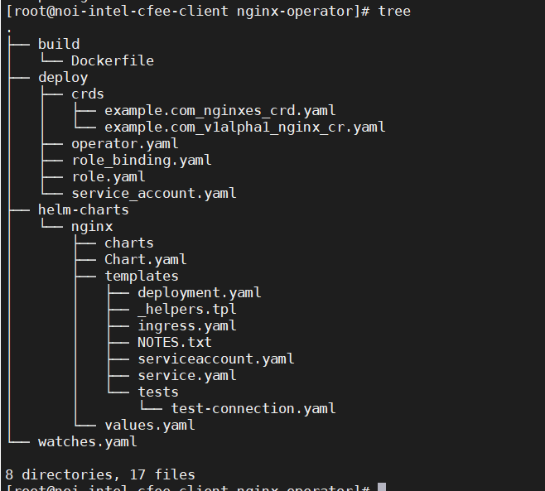

**Cleanup**

kubectl delete -f deploy/crds/example.com_v1alpha1_nginx_cr.yaml

kubectl delete -f deploy/operator.yaml

kubectl delete -f deploy/role_binding.yaml

kubectl delete -f deploy/role.yaml

kubectl delete -f deploy/service_account.yaml

kubectl delete -f deploy/crds/example.com_nginxes_crd.yaml