Fire Rescue Response Time Analysis
Fall Monsoon 2013
Kshitij Kansal
Lab For Spatial Informatics
IIIT-H
kshitij.kansal@students.iiit.ac.in

Anubhav Jaiswal E. Venkatesh
Lab For Spatial Informatics Lab For Spatial Informatics
IIIT-H IIIT-H
anubhav.jaiswal@students.iiit.ac.in earlapati.venkatesh@students.iiit.ac.in

Abstract: Our approach deals with the problem of calculating the fire response time of a place based on the four models. We calculate the fire response time of of a place using each model and then show the association of each model with the actual scenario.
Keywords: fire; response; analysis; London

Introduction
The City of London is served by the London Fire Department which has total of 113 fire stations serving the city. The purpose of the study was to evaluate options for improving response time, including the construction of a new fire station. The Fire Response Time is made up of several components. Response times are measured starting when the call is dispatched to when on-scene crews have established the resources for initial attack. All of the components must be performed in a safe and organized, as well as timely, manner. The components of response time include:
• The time for firefighters to reach the station and the apparatus
• The travel time for the apparatus to reach the scene
• Size-up and Scene Assessment
• Set-up and activities needed to safely proceed with initial attack
The significant factor in the travel time for the apparatus to reach the scene is the drive distance. Road conditions, driver training, equipment type and condition, and station access also affect this time. The time involved in Size-up, Assessment, and set-up for initial attack are significantly influenced by the effectiveness and efficiency of the Fire Department.
We have not considered each and every aspect here in our study. We have only taken into account drive distance, traffic and population of the city for calculating the fire response time.

Data
Geo Referenced Vector map of the city of London divided into boroughs was acquired. Location of Fire Stations in London was Obtained from London Fire Department site. Then Extraction of coordinates from the address and then combining them to form a layer of fire stations. Road network data of United Kingdom. Vector map showing major roads. Road Traffic data which included data giving the average annual daily flow of each road. Population data of London(Borough wise.)

Procedure and Results
The analysis was done by using four models which were developed for addressing the limitations of previous ones and bringing our final model as close to actual scenario as possible.

Euclidean Model
In this model we assumed that the road connectivity and the population of the city has no effect on the fire response time. Although this is in no way close to reality but this model forms a basis for development of other models.
To develop this model a buffer with specified radius was created for each fire station. Each buffer indicates the area a fire station can cover within a specified time. For our case we have assumed that the average speed be 40 km/h and fire response time be at max 5 minutes. Based on these calculations we got a buffer of radius 3.33 km for each fire station.
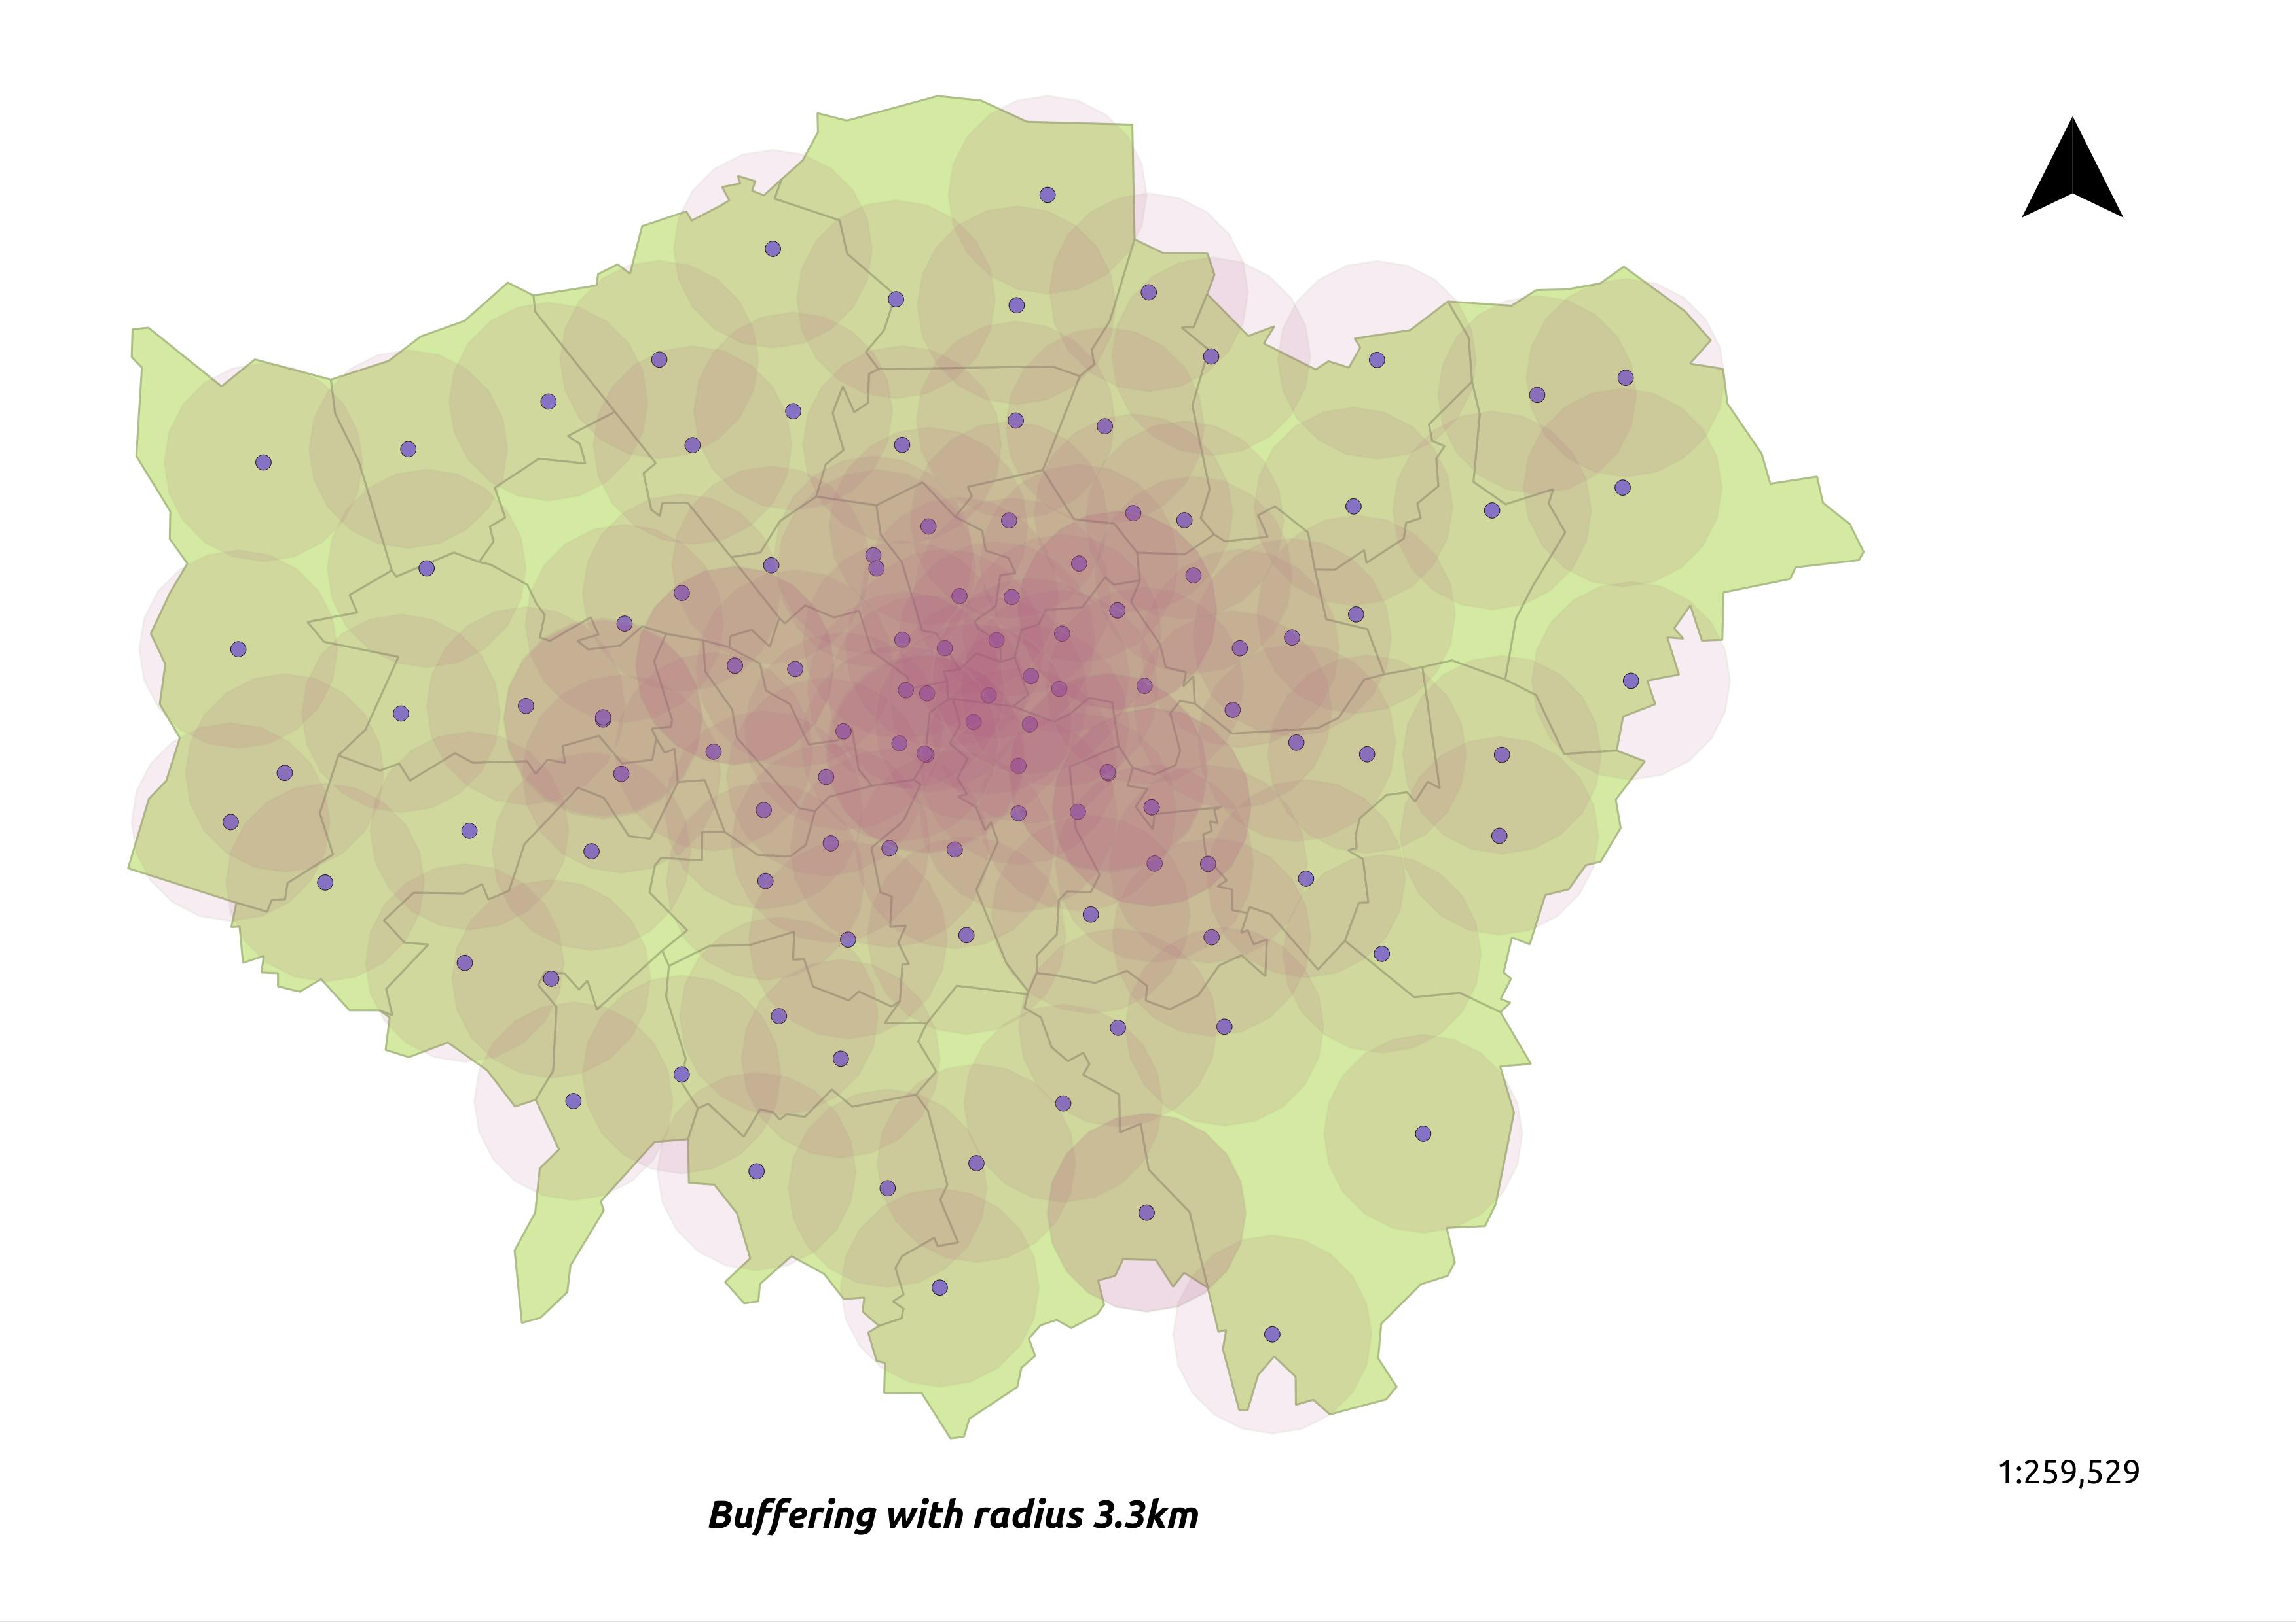
As seen from the above image, the whole city of London is well covered by existing fire stations. But not to forget our assumption, which make this model far off form reality. One major assumption we took was that each fire station is connected to a place by a “straight line shortest path” but in reality a path may not be a straight route.
So keeping this in mind we take into account the road connectivity which leads to our next model “Connectivity Based Model”.

Connectivity Model

To solve some of the limitations of “euclidean model”, we move on to the connectivity model. In this model, we have taken major road network of city of London and then calculated the response time for each place from the nearest fire station.

We have not taken into account the traffic and population while generating this model. With the uniform speed of 60km/h, we used GRASS GIS to mark each segment of road with different colors that indicate the time taken to reach there.

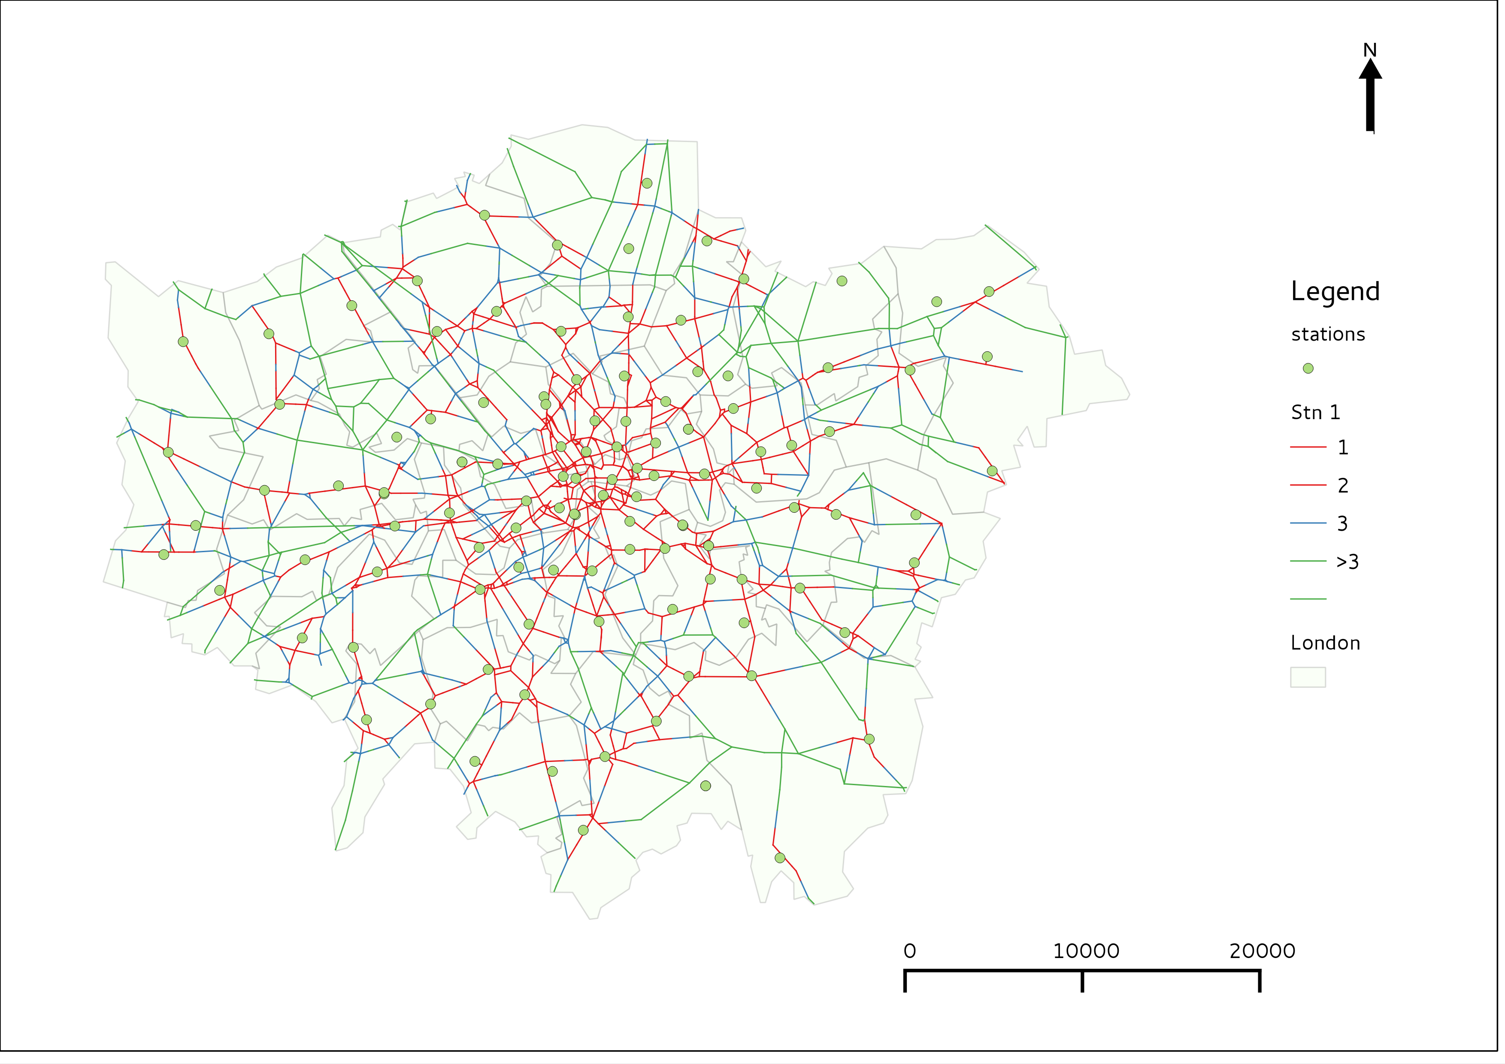
The above image shows the results of connectivity based analysis. Keeping in mind our assumption of speed, we have divided the response time in four categories: <1 minute, >1 and <2 minutes, >2 and <3 minutes and >3 minutes.
Most of the roads seem to be well within reach from the surrounding fire stations and very few areas have response time greater than 3 minutes. But again, we have not included road traffic data in our analysis and this makes our analysis faulty. This limitation demands for a better method of analysis, which we propose in our next model wherein we include traffic data.

Traffic Model
In our third model, we make an addition of the traffic data for each road in the previous analysis. For each road, we have the Average Annual Daily Flow (AADF), which is a measure of the traffic on that road for the year 2011. To calculate the response time, we allocate different speeds to each road depending upon their corresponding AADF values. Following are the speed assumptions taken to calculate time:
- AADF < 25000, speed = 75 km/h
- AADF > 25000 and < 100000, speed = 60 km/h
- AADF > 100000 and < 200000, speed = 50 km/h
- AADF > 200000, speed = 35 km/h

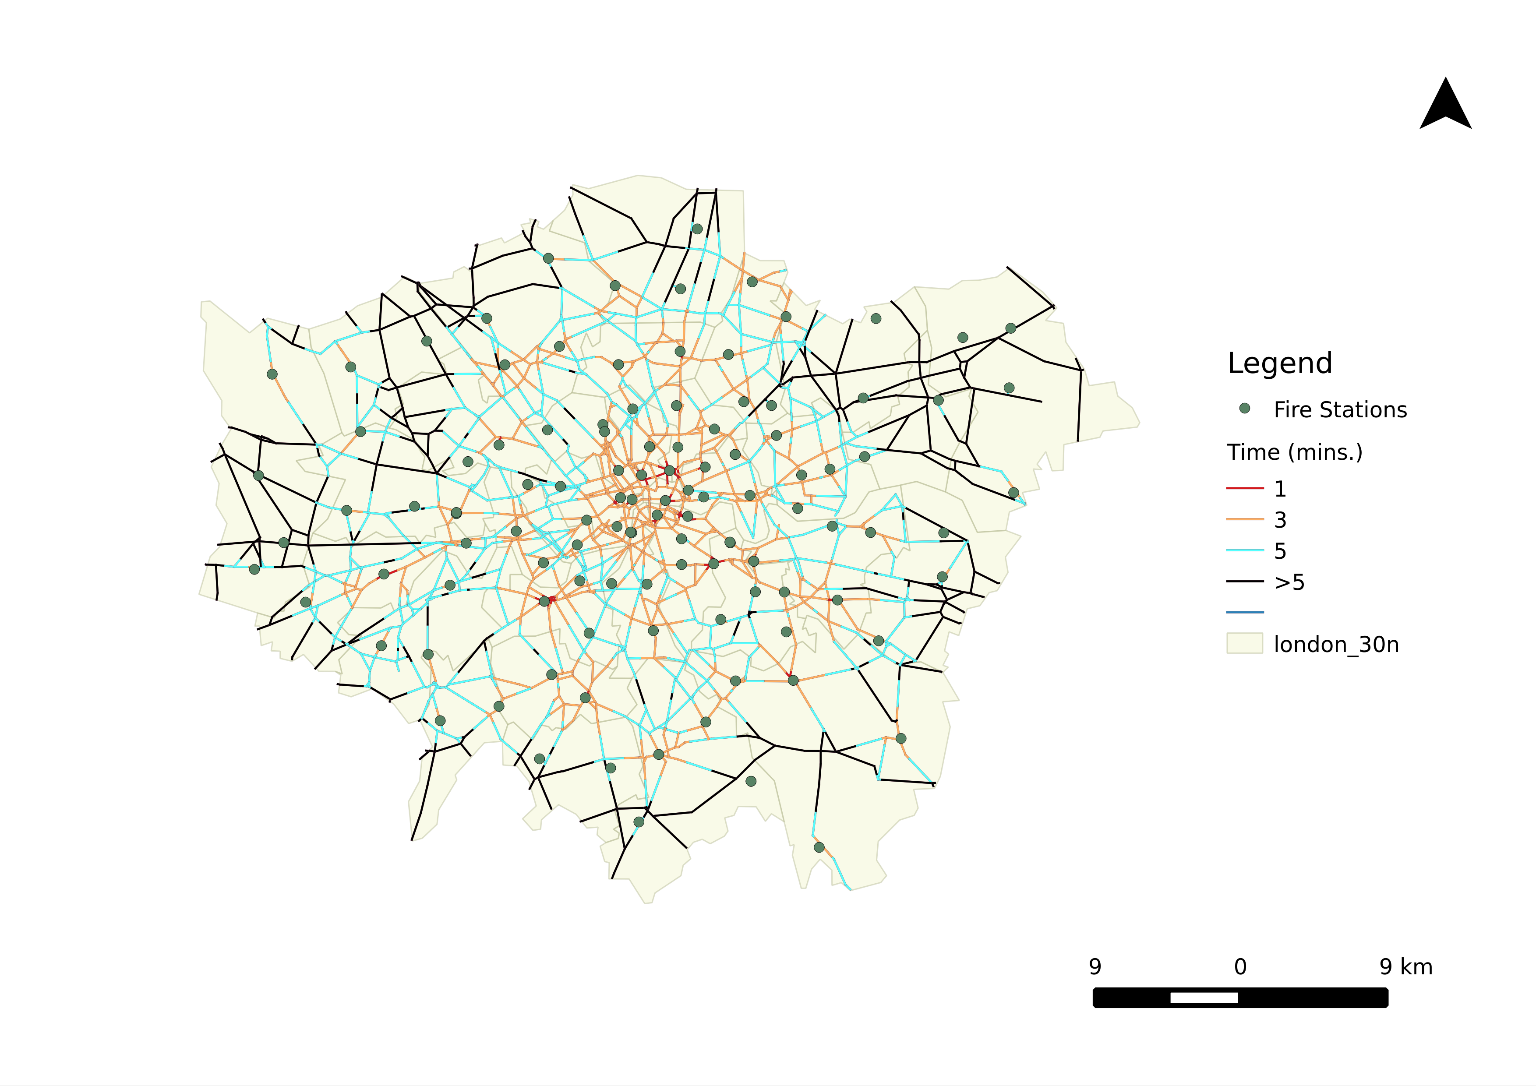
The above image shows the result obtained after addition of traffic data into our previous model. Again four time intervals were taken, <1 minute, >1 and <3 minutes, >3 and <5 minutes and >5 minutes. We can see that the reachability for each fire station has shrunk as compared to previous model and the response time has increased. The roads in the outer regions of London are mostly in 'Black', which indicates that these areas are sparsely covered by the fire stations owing to lesser density of fire stations in these areas and thus have response time on the higher side (greater than 5 minutes).
Now we will take into account population of the city which will lead us to our fourth and final model “Population Model”.

Population Model
In addition to connectivity, we can also take into account population of the city and do the analysis. This form the basis for the this model.
We generated thiessen polygon for each fire station and assumed that the population that each fire station is serving is equal to the population of that thiessen polygon. Then to calculate the population of each polygon, we assumed that the population is uniformly distributed and then found out the population density for each borough. Then based on this density and the percentage of area of each borough in polygon, we calculate the total population of polygon. This will serve as the total population served by a particular fire station.
So from previous step we know the area and the population each fire station is serving, and then based o some threshold (average value of population and area in our case) we found out the regions requiring the new fire stations. These areas are shown in yellow in the figure below.
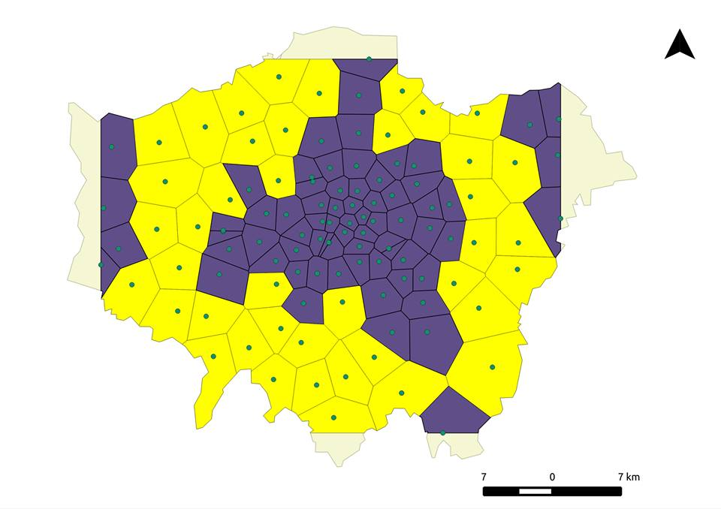
E. Visualizations
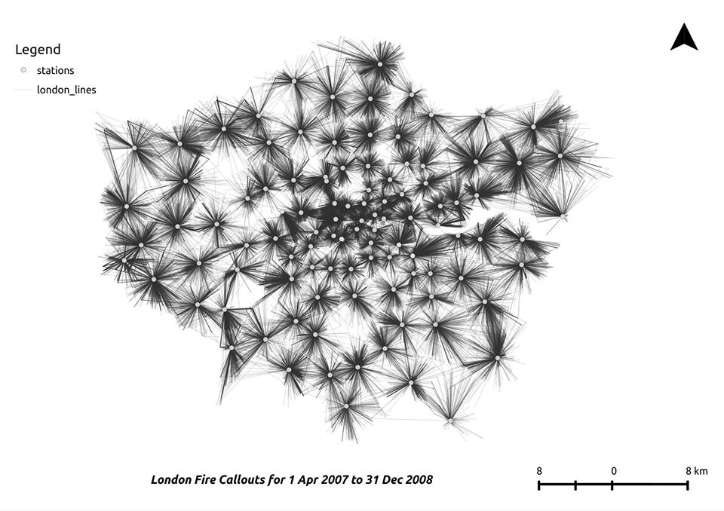
Using the actual Fire Response data for the year 2008, we created a visualization representing approximately 200000 fire callouts. Each fire station was connected to its callout site by straight lines, thus showing the coverage of fire stations.

The lines in the central portion of London are very dense, which implies that the average number of cases are more in the central area.
Thus we can say that the fire stations in the central portion are in need of more resources, such as number of fire trucks, to effectively serve the population.
- F. References
- http://www.geog.ubc.ca/courses/geob370/students/class12/ecbmclel/
- www.london-fire.gov.uk/
- www.ons.gov.uk/census
- http://data.gov.uk/dataset/gb-road-traffic-counts
- http://maps.london-fire.gov.uk/
- http://data.gov.uk/dataset/gb-road-traffic-counts

