# NG911 Topology Rules

By Kristen Jordan Koenig, December 2019, [kristen@kgs.ku.edu](mailto:kristen@kgs.ku.edu)

If you are editing data outside of the NG911 geodatabase template, the NG911 Topology rules can be duplicated in your geodatabase. See the following instructions on how to access NG911 Topology rules so they can be duplicated.

## Creating Topology

The following steps are necessary to create a topology in your own data editing location.

1. Make sure your data is stored in a feature dataset.
2. In the feature dataset, create a topology (right click on feature dataset > New > Topology) and name it whatever you like. Take the default tolerance and click next.
3. In the topology wizard, select AddressPoints, AuthoritativeBoundary, ESB layers, ESZ, and RoadCenterline to participate in the topology and click next.
4. Take the default for ranks and click next.

## Option 1- Importing .rul File

This step may or may not work with your data configuration, but it’s the easiest, so it’s worth trying out.

1. On the next screen, click the button for “Load Rules…” Navigate to the Doc folder the NG911 toolbox. If you have multiple ESB layers, choose NG911_Topology_MultiESB.rul. If you have a single ESB layer, choose NG911_Topology_OneESB.rul. Click OK to load the .rul file.
2. 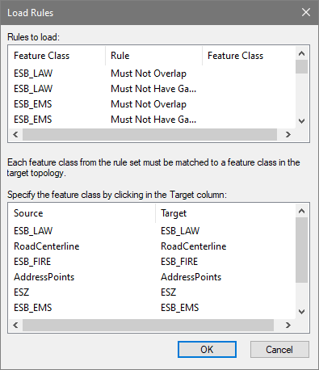On the next screen, examine Source and Target and change any Target layers to your data equivalencies.
3. Click through the next few screens to finish creating the Topology. You can validate the new topology if you so choose.

## Option 2- Manually Duplicate Topology Rules

If that method doesn’t work to import topology rules, you can manually duplicate NG911 Topology.

1. Locate an NG911 geodatabase.
2. If you want to guarantee that the topology is nice and clean before you use it as a template, run the geodatabase through the NG911 Toolbox > Enhancement Tools > Add/Verify NG911 Topology.
3. Right click on the topology in the NG911 geodatabase and open its Properties.
4. 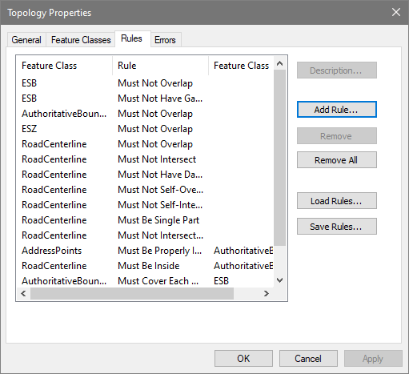From the Rules tab, you can see the topology rules that are present in NG911 Topology and these can be duplicated in your data’s topology.
5. In your own topology, click on the button “Add Rule…” to get started and to add rules. Work through each NG911 Topology rules until all are duplicated in your data’s topology then click OK.
6. Validate your new topology.