**ASSIGNMENT - 5**

**1.** Calculate the torque exerted on the square loop shown in Fig. , due to the

circular loop (assume r is much larger than a or b). If the square loop is free to rotate, what

will its equilibrium orientation be?

**2.** Starting from the Lorentz force law, in the form of Eq. 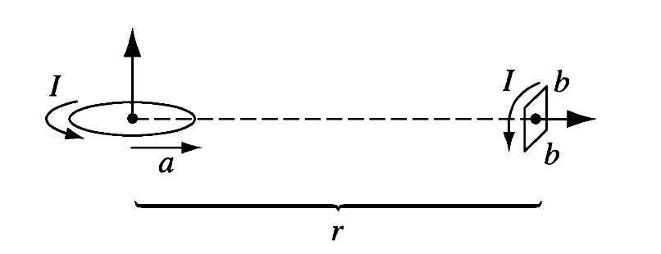

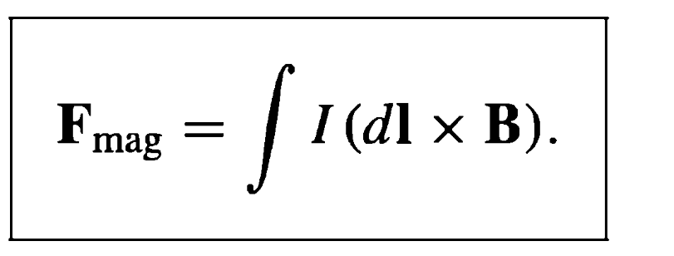

show that the torque on any steady current distribution (not just a square loop)

in a uniform field **B** is **m x B.**

**3.**  An infinitely long circular cylinder carries a uniform magnetization **M** parallel to its axis. Find the

magnetic field (due to **M**) inside and outside the cylinder.

**4**. An infinitely long cylinder, of radius R, carries a "frozen-in" magnetization, parallel to the axis,

**M** = ks **ẑ**

where k is a constant and s is the distance from the axis; there is no free current anywhere. Find the magnetic field inside and outside the cylinder by two different methods:

(a) Locate all the bound currents, and calculate the field they produce.

(b) Use Ampere's law



to find **H**, and then get **B** from $H≡\frac{1}{μo}B-M$ (Notice that the second method is much faster, and avoids any explicit reference to the bound currents.)

**5**. Suppose the field inside a large piece of magnetic material is **B0** so that $H=(\frac{1}{μo})B0-M$ **,** where **M** is a “ frozen –in” magnetization.

(a ) Now a small spherical cavity is hollowed out of the material (as shown in figure)

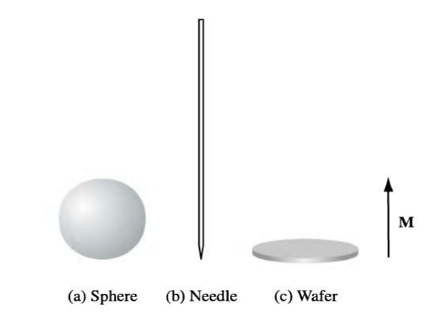

Find the field at the center of the cavity, in terms of **B0** and **M**. Also find **H** at the center of the cavity, in terms of **H**0 and **M**.

(b) Do the same for a long needle-shaped cavity running parallel to **M**.

(c) Do the same for a thin wafer-shaped cavity perpendicular to **M.**

**6**. A coaxial cable consists of two very long cylindrical tubes, separated by linear insulating material

of magnetic susceptibility **χ** m. A current ***I*** flows down the inner conductor and returns along the

outer one; in each case the current distributes itself uniformly over the surface (see the Figure).

Find the magnetic field in the region between the tubes. As a check, calculate the magnetization

and the bound currents, and confirm that (together, of course, with the free currents) they

generate the correct field.

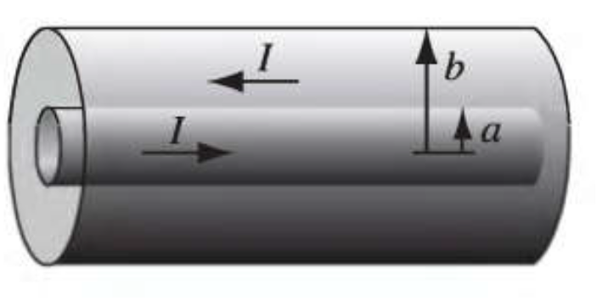

**7.** A sphere of linear magnetic material is placed in an otherwise uniform magnetic field **B0**. Find

the new field inside the sphere.

**8**. Two concentric metal spherical shells, of radius **a** and **b**, respectively, are separated by weakly

conducting material of conductivity $σ$ (Figure).

(a) If they are maintained at a potential difference V what current flows from one to the other?

(b) What is the resistance between the shells?

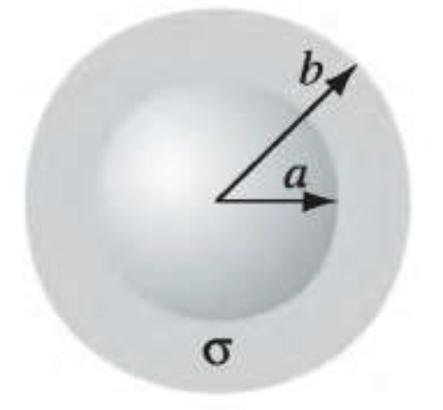

**9.** A capacitor **C** has been charged up to potential Vo ; at time t = 0 it is connected to a resistor R, and

begins to discharge (Fig. a).

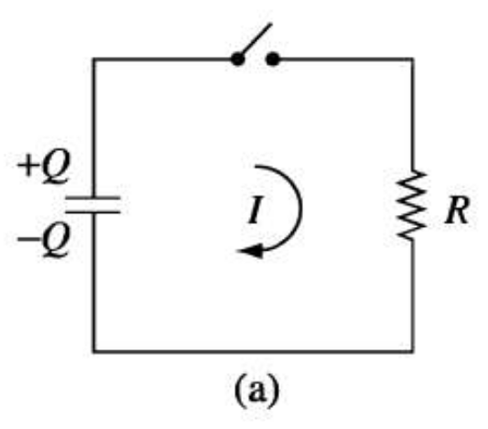 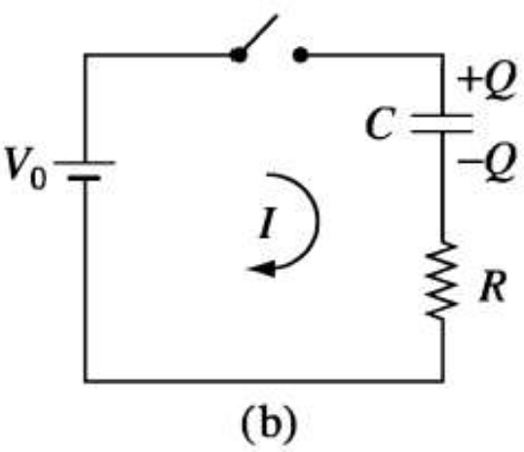

(a) Determine the charge on the capacitor as a function of time, **Q**(t). What is the current

through the resistor, I(t)?

(b) What was the original energy stored in the capacitor ($W=\frac{1}{2}Cv^{2}$)? By integrating Eq. $P=VI=I^{2}R$

confirm that the heat delivered to the resistor is equal to the energy lost by the capacitor.

Now imagine charging up the capacitor, by connecting it (and the resistor) to a battery of fixed

voltage Vo, at time t = 0 (Fig. b).

(c) Again, determine **Q**(t) and I(t).

(d) Find the total energy output of the battery ( ∫v0 I dt). Determine the heat delivered to the

resistor. What is the final energy stored in the capacitor? What fraction of the work done by

the battery shows up as energy in the capacitor? [Notice that the answer is independent of **R** !]

**10**. A battery of emf **Ɛ** and internal resistance **r** is hooked up to a variable "load" resistance, **R**. If you want to

deliver the maximum possible power to the load, what resistance **R** should you choose?

(You can't change **Ɛ** and **r**, of course.)

**11**. A square loop of wire, with sides of length **a**, lies in the first quadrant of the xy plane, with one corner at

the origin. In this region there is a nonuniform time-dependent magnetic field **B**(y, t) = ky3t2 **ẑ**

(where k is a constant). Find the emf induced in the loop.

**12.** A long solenoid of radius **a**, carrying **n** turns per unit length, is looped by a wire with resistance **R**, as

shown in Figure

(a) If the current in the solenoid is increasing at a constant rate (d**l**/dt = k), what current flows in the loop,

and which way (left or right) does it pass through the resistor?

(b) If the current I in the solenoid is constant but the solenoid is pulled out of the loop (toward the left,to a

place far from loop) what total charge passes through the resistor?

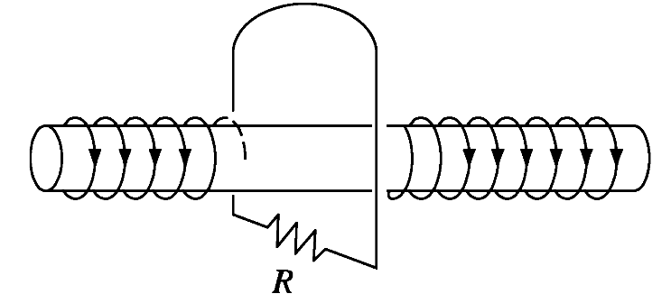

**13.** A small loop of wire (radius **a**) is held a distance z above the center of a large loop (radius **b**), as shown in

Figure The planes of the two loops are parallel, and perpendicular to the common axis.

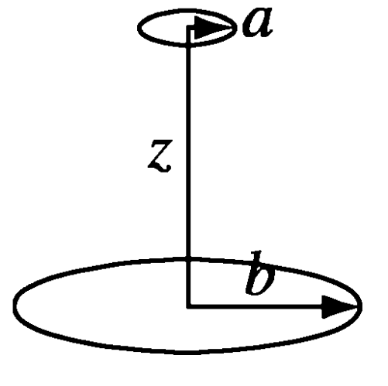

(a) Suppose current I flows in the big loop. Find the flux through the little loop. (The little loop is so small

that you may consider the field of the big loop to be essentially constant.)

(b) Suppose current I flows in the little loop. Find the flux through the big loop. (The little loop is so small

that you may treat it as a magnetic dipole.)

(c) Find the mutual inductances, and confirm that M12 = M21.

**14**. Suppose the circuit (in Figure) has been connected for a long time when suddenly, at time t = 0, switch **S**

is thrown from A to B, bypassing the battery.

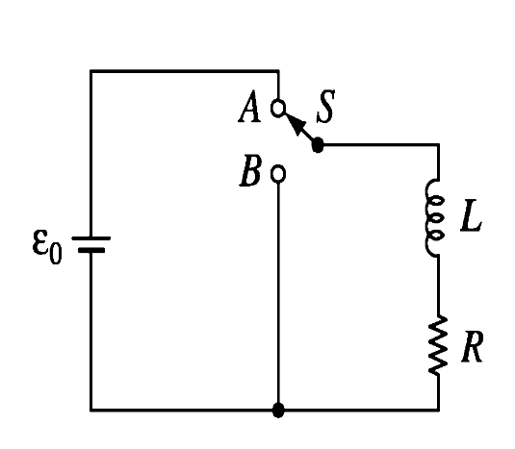

(a) What is the current at any subsequent time t?

(b) What is the total energy delivered to the resistor?

(c) Show that this is equal to the energy originally stored in the inductor.