How stationary are planetary waves in the Southern Hemisphere?

Abstract goes here

# Introduction

Zonal asymmetries of extratropical circulation in the Southern Hemisphere (hereafter called as “planetary waves”) strongly modulate weather systems and regional climate through latitudinal transport of heat, humidity, and momentum (REFS), and by contributing to the development of blocking events (e.g. Trenberth and Mo 1985).

In Rossby wave theory, stationary waves are those with zero frequency or phase velocity (Holton and Hakim 2012). In practice, however, most studies have assumed the “quasi-stationary” nature of southern hemisphere planetary waves based on Loon and Jenne (1972). In this foundational study, the authors analyzed data from 1957 and 1958 and found that while extratropical waves with wavenumber 1 to 6 had comparable amplitudes in daily fields, only wavenumbers 1 and 3 contributed significantly to the climatological field. From that, they concluded that only waves 1 and 3 recurr consistently in the same location and thus have a significant quasi-stationary component on top of a “moving” component. This was a qualitative conclusion and to our knowledge no study has quantified the level of stationarity of each wavenumber.

After more than four decades from the publication of Loon and Jenne (1972), and considering the current availability of different global reanalysis datasets, in this study we assess the stationarity features of planetary waves in the southern hemisphere, and extends Loon and Jenne (1972)’s methodology into a quantitative measure of planetary wave stationarity, which we apply to both hemispheres.

# Methods

## Planetary waves

We define *planetary waves* as waves that extend along a full latitude circle. *Zonal waves* (ZW) are planetary waves of the “instantaneous” fields and *quasi-stationary waves* (QS), planetary waves of the time-mean field such that:

where is wavenumber, longitude, and and , amplitude and phase, respectively. depends on time, but not .

These definitions depend on which are the “instantaneous fields” and the averaging time-scales. A dataset of 365 daily mean fields defines 365 daily zonal waves and one annual quasi-stationary wave but 12 monthly quasi-stationary waves (per level and latitude). A 30 year dataset of monthly mean fields define 360 monthly zonal waves and one 30-year quasi-stationary wave. Monthly planetary waves are quasi-stationary waves in one case and zonal waves in the other.

## Stationarity

From the properties of the superposition of waves we can deduce that, in general, the stationary phase does not equal and the stationary amplitude is less or equal (Pain 2005).

We use this latter property and use the quotient between and as a measure of quasi-stationary wave stationarity such as:

For a sample of completely random waves, the expected value of is because the average amplitude of the sum of waves with random phases and mean amplitude is (Pain 2005). For completely stationary waves irrespective of sample size.

is used –sometimes as (Singer 1967)– in the meteorological literature in the context of wind steadiness (e.g Hiscox, Miller, and Nappo 2010). To our knowledge this is the first time it has been applied to the study of atmospheric waves.

Equation is equivalent to

The numerator represents the sum of the zonal waves amplitudes projected onto the direction of the quasi-stationary wave. Waves that deviate from that direction decrease the overall stationarity in proportion to their amplitude.

We used Equation to compute a timeseries of quasi-stationary wave stationarity. We first calculated for each month and then, applied Equation with a 15-year rolling window approximated using loess regression with degree 0.

## Data

We use monthly geopotential fields from the NCEP/NCAR Reanalysis (Kalnay et al. 1996) for the period 1948 to 2017 and compute one quasi-stationary wave for the whole period for each month, level and wavenumber. Amplitude and phase for each wavenumber was estimated by fitting a fourier transform for each latitude circle, level and monthly record.

We analyzed the data using the statistical programming language R (R Core Team 2018), using data.table and metR packages (Dowle and Srinivasan 2018; Campitelli 2018) to read and transform it and ggplot2 package (Wickham 2016) to make the plots. The source code is available as Figshare repository (Campitelli, Díaz, and Vera 2019).

# Results

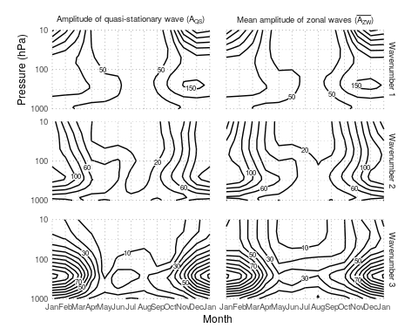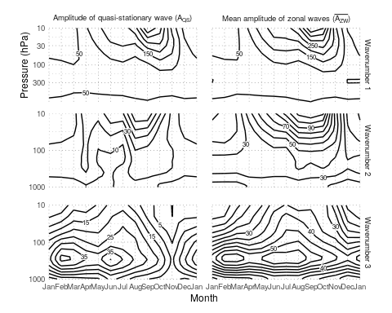

Figure shows the seasonal cycle of the amplitude of planetary waves at 50S and 50N using monthly fields from the NCEP/NCAR reanalysis (Kalnay et al. 1996) between 1948 and 2017. We computed the left column () as the amplitude of the average geopotential field for each month, level and wavenumber, and the right column () as the average amplitude of the 70 individual fields.

Figure shows that at 50N for the three wavenumbers and have a similar seasonal cycle with similar vertical extent. In the southern hemisphere, however, this is true only for wavenumber 1 (Figure ). is much smaller than and its seasonal cycle is less defined. has a smaller magnitude than end even though their overall structure is similar (one relative maximum in February-March in the middle troposphere and another in July-August that extends to the lower stratosphere), they differ in the details. has a local minimum in November that is absent in . The relative contribution of each wavenumber is also different. While dominates over in the stratosphere and is of similar magnitude in the troposphere, dominates over throughout the year and in every level except in the aforementioned November minimum.

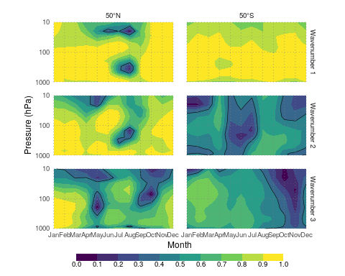

Seasonal cycle of stationarity at 50S and 50N computed using Equation

These observations are quantified in Figure , which shows for wavenumbers 1 to 3 computed using Equation at 50N and 50S. We separate between high and low stationarity with the ad-hoc threshold of 0.4 (black line in Figure ).

At 50N planetary waves 1, 2 and 3 are highly stationary in almost every month and level, and even more so planetary wave 1 at 50S.

In the southern hemisphere, planetary wave 2 stationarity has a semianual cycle. It reaches its maximum in April and in August-September, plummeting to a deep minimum in June. Planetary wave 3 stationarity peaks in February and slowly decreases towards a November deep minimum after witch increases sharply.

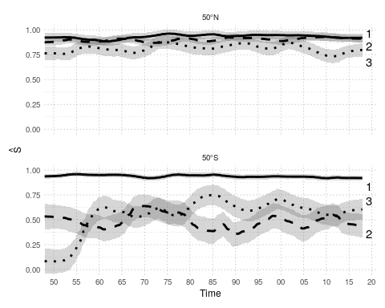

Quasi-stationary wave stationarity for wavenumbers 1 to 3

Because we computed using the whole period, it represents the mean stationarity between. Figure shows how planetary wave stationarity changed for each wavenumber at each latitude. Planetary wave stationarity remained high and constant for wavenumbers 1 to 3 at 50N and 1 at 50S but wavenumbers 2 and 3 at 50S show interdecadal variations.

Planetary wave 2 stationarity oscillated around 0.49 with maximums in the 50’s, 70’s and 00’s. Planetary wave 3 stationarity jumped from zero to more than 0.5 in less than five years in the 50’s and then oscillated around 0.62 with a strong maximum in the late 80’s. These could indicate inhomogeneities caused by changes in the observational network –routine satellite observations began in 1979– but the absense of similar breaks for wavenumbers 1 or 2 suggest they represent real changes in the atmospheric circulation with unknown cause.

# Conclusions

Using a quantitative measure of planetary wave stationarity we showed that, in the southern hemisphere, planetary wave 1 stationarity is high and constant throught the year and period, while waves 2 and 3 vary both in intraseasonal and interdecadal timescales. Planetary wave 3 stationarity, in particular, increased dramatically in the 50’s.

Plentary waves can be both forced by the surface and excited by internal variability. Assuming that the later process will not result in a phase preference, higher stationarity would be evidence of stronger forcing or, more strictly, stronger forcing response. In the northen hemisphere, topography and thermal contrast are the main forcings of plentary waves, which explains their highly and not variable stationary nature. In the southern hemisphere, only planetary wave 1 seems to be the result of mainly surface forcings. Planetary waves 2 and 3 seem to be composed of a comparable mix of internal variability and surface forcing.

Interanual and intradecadal variability in planetary wave stationarity may serve to study variability in surface forcing response cause either by the strengh of the forcing or the sensibility of mean state of the atmosphere.

xxx

(Silvestri and Vera (2009 )

xxxx The literature on the topic is dominated by two main methodologies that imply differnet definitions: some studies have defined planetary waves by removing zonal averages from time-mean fields (e.g. Loon and Jenne 1972, Quintanar and Mechoso (1995), Raphael (2004)) while others defined them by removing zonal averages from the instantaneous (e.g. daily, monthly or seasonal) fields (e.g. Rao, Fernandez, and Franchito 2004, Turner et al. (2017), Irving and Simmonds (2015)).

First, researchers should be aware of which phenomena they want to study and use the appropriate methods. The mean amplitude of zonal waves could be appropriate to study the vertical propagation of Rossby waves, for example. But zonal wave amplitude could lead to misleading results if used as the basis of local impacts studies because they are probably more influenced by phase effects.

Secondly, comparison between results should also be made having this issues in mind. For instance, Irving and Simmonds (2015) compare their planetary wave activity index with Raphael (2004)’s wave 3 index and conclude that the later cannot account for events with waves far removed from their climatological position. However, being an index of the zonal wave component in phase with the quasi-stationary wave, this is by design.

Although having a consistent nomenclature across papers is important, we believe this problem can be ameliorated by researchers detailing their definitions and methodology. This is also good for clarity and reproducibility. Since planetary waves are generally more stationary in the northern hemisphere, these issues are more critical for studies of the southern hemisphere.

Thirdly, the explorations of both ZW and QS can lead to novel levels of analysis. Here, we showed it can be used to define a metric of stationarity of quasi-stationary waves, but other applications are also possible. Smith and Kushner (2012) used the phase relationship between ZW1 and QS1 to show that linear interference between the QS1 and ZW1 was related to vertical wave activity transport at the tropopause.

We speculate that the level of stationarity responds to the nature of the forcings. Higly stationary planetary waves are explained mainly by stationary forcings while low stationary planetary waves respond mainly to the internal variation of the atmosphere. This suggests that in the southern midlatitudes, wave 2 and 3 consist of forced responses mixed with internat variability. Their annual cycle further suggests that the mean state of the atmosphere can modulate these responses.

*xx me falta un final acá xx*

Campitelli, Elio. 2018. *MetR: Tools for Easier Analysis of Meteorological Fields*. <https://github.com/eliocamp/metR>.

Campitelli, Elio, Leandro Díaz, and Carolina Vera. 2019. “How stationary are planetary waves in the Southern Hemisphere?: supplementary data.” doi:[10.6084/m9.figshare.7599890](https://doi.org/10.6084/m9.figshare.7599890).

Dowle, Matt, and Arun Srinivasan. 2018. *Data.table: Extension of ‘Data.frame‘*. <http://r-datatable.com>.

Hiscox, April L, David R Miller, and Carmen J Nappo. 2010. “Plume meander and dispersion in a stable boundary layer.” *Journal of Geophysical Research: Atmospheres* 115 (D21). doi:[10.1029/2010JD014102](https://doi.org/10.1029/2010JD014102).

Holton, James R., and Gregory J. Hakim. 2012. *An introduction to dynamic meteorology: Fifth edition*. doi:[10.1016/C2009-0-63394-8](https://doi.org/10.1016/C2009-0-63394-8).

Irving, Damien, and Ian Simmonds. 2015. “A novel approach to diagnosing Southern Hemisphere planetary wave activity and its influence on regional climate variability.” *Journal of Climate* 28 (23): 9041–57. doi:[10.1175/JCLI-D-15-0287.1](https://doi.org/10.1175/JCLI-D-15-0287.1).

Kalnay, E, M Kanamitsu, R Kistler, W Collins, D Deaven, L Gandin, M Iredell, et al. 1996. “The NCEP/NCAR 40-year reanalysis project.” *Bulletin of the American Meteorological Society* 77 (3): 437–71. doi:[10.1175/1520-0477(1996)077<0437:TNYRP>2.0.CO;2](https://doi.org/10.1175/1520-0477(1996)077<0437:TNYRP>2.0.CO;2).

Loon, Harry van, and Roy L Jenne. 1972. “The Zonal Harmonic Standing Waves in the Southern Hemisphe.” *Journal of Geophysical Research* 77 (6): 992–1003.

Pain, H.J. 2005. “Simple Harmonic Motion.” In *The Physics of Vibrations and Waves*, 570. doi:[10.1002/0470016957](https://doi.org/10.1002/0470016957).

Quintanar, Arturo I, and Carlos R Mechoso. 1995. “Quasi-stationary waves in the Southern Hemisphere. Part I: observational data.” *Journal of Climate* 8 (11): 2659–72. doi:[10.1175/1520-0442(1995)008<2659:QSWITS>2.0.CO;2](https://doi.org/10.1175/1520-0442(1995)008<2659:QSWITS>2.0.CO;2).

R Core Team. 2018. *R: A Language and Environment for Statistical Computing*. Vienna, Austria: R Foundation for Statistical Computing. <https://www.R-project.org/>.

Rao, V. Brahmananda, J. P. R. Fernandez, and S. H. Franchito. 2004. “Quasi-stationary waves in the southern hemisphere during El Nina and La Nina events.” *Annales Geophysicae* 22 (3): 789–806.

Raphael, Marilyn N. 2004. “A zonal wave 3 index for the Southern Hemisphere.” *Geophysical Research Letters* 31 (23): 1–4. doi:[10.1029/2004GL020365](https://doi.org/10.1029/2004GL020365).

Singer, Irving A. 1967. “Steadiness of the Wind.” *Journal of Applied Meteorology* 6 (6): 1033–8. doi:[10.1175/1520-0450(1967)006<1033:SOTW>2.0.CO;2](https://doi.org/10.1175/1520-0450(1967)006<1033:SOTW>2.0.CO;2).

Smith, Karen L., and Paul J. Kushner. 2012. “Linear interference and the initiation of extratropical stratosphere-troposphere interactions.” *Journal of Geophysical Research Atmospheres* 117 (13): 1–16. doi:[10.1029/2012JD017587,2012](https://doi.org/10.1029/2012JD017587,2012).

Trenberth, Kevin E., and Kingtse C. Mo. 1985. “Blocking in the Southern Hemisphere.” *Monthly Weather Review* 113 (1): 3–21. doi:[10.1175/1520-0493(1985)113<0003:BITSH>2.0.CO;2](https://doi.org/10.1175/1520-0493(1985)113<0003:BITSH>2.0.CO;2).

Turner, John, J. Scott Hosking, Thomas J. Bracegirdle, Tony Phillips, and Gareth J. Marshall. 2017. “Variability and trends in the Southern Hemisphere high latitude, quasi-stationary planetary waves.” *International Journal of Climatology* 37 (5): 2325–36. doi:[10.1002/joc.4848](https://doi.org/10.1002/joc.4848).

Wickham, Hadley. 2016. *Ggplot2: Elegant Graphics for Data Analysis*. Springer-Verlag New York. <http://ggplot2.org>.