**HOROP APPLICATION MANUAL**

Table of content

**Getting start……………………………………………………………………………..…...1**

Introduction……………………….………………………………………………………………………………………1

Team member……………………………………………………………………….…………………………………..2

**HOROP interface…………………………………………………………………………….3**

Navigating HOROP……………………………………………………..………………………….3

Function Description………………………………………….………..………………………..4

**Sharing content……………………………………………………………….………..………………7**

Share to Facebook………………………………………………………..………………………..7

**Execution…………………………………………………………………………………………8**

Execution steps……………………………………………………………………………..…………………………….8

Test case explanation……………………………………………………………………..………………………….11

Execute Test case……………………………………………………………………………………………………….12

**Getting Start**

1

**Introduction**

**This document is the user-mannual of HOROP application.** **The audience for thedocument includes both instructors and students. The assumption was that the users are notvery technically savvy, so both the application and the user manual had to be intuitive and easyto use.I have included the original Table of Contents to illustrate how much detail the manualprovided.**

**TEAM MEMBER**

2

Saurawit Sanguanphokai 56070503437

Naiprakarn Nakornkhet 56070503419

Chayuth Laoviwat 56070503452

Sarun Kiewkajee 56070503467

 Karn Sunthad  56070503448

**HOROP INTERFACE**

3

Welcome to HOROP! You are about to experience the excitement of live, Fortune in the application. HOROP Collect 5 main fortune function including God’s quote, Fortune Card, Zodiac fortune, Exorcise, Birthday fortune. This User Manual provides a detailed description of all the HOROP features. We are sure you will find HOROP easy to use.

**SYSTEM REQUIREMENT**

### iPhone, iPad, and iPod touch

* iOS 9.3

Mac

* OS X El Capitan

**Navigating HOROP**

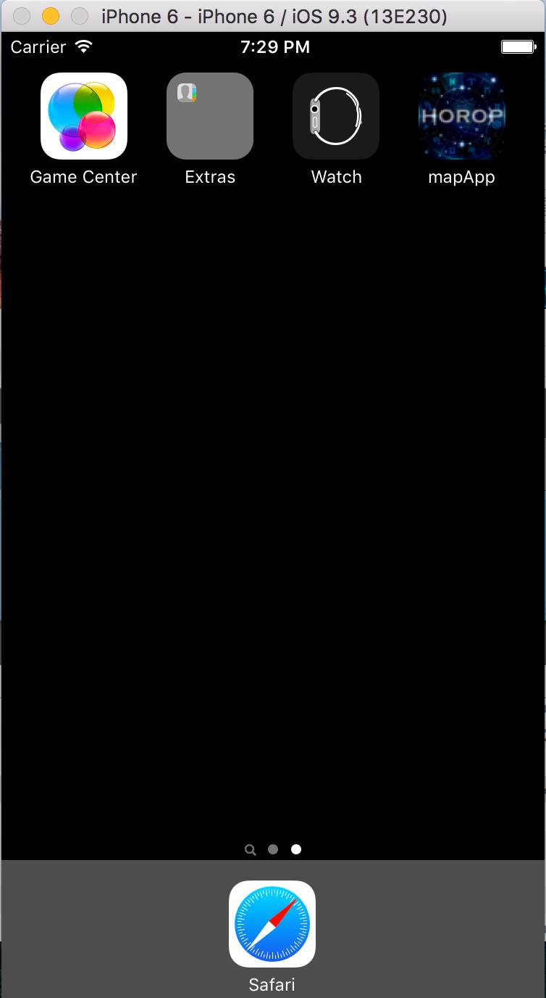The main areas of HOROP are labeled below and are described in detail on thefollowing pages.

HOROP application Icon

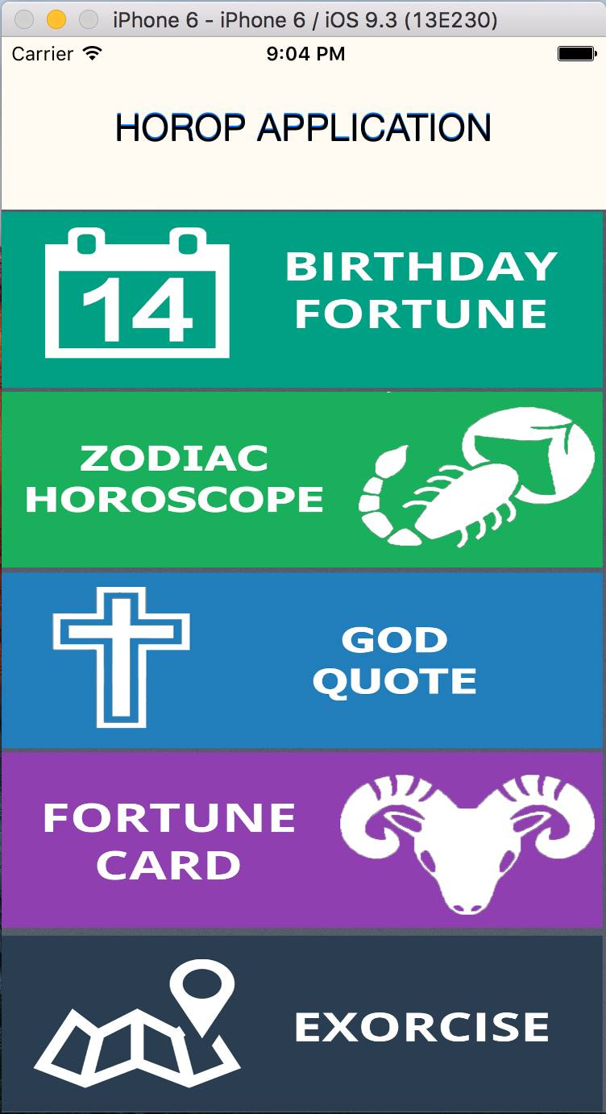

Exorcise Function

Fortune Card Function

Birthday Fortune Function

Zodiac horoscope Function

Birthday Fortune Function

**FUNCTION DESCRIPTION**

4

In this project we have create only 2 Functions which are Fortune Cards and Exorcise. This part of the document will explain about each function.(Exorcise is our main function)

**Fortune Card**

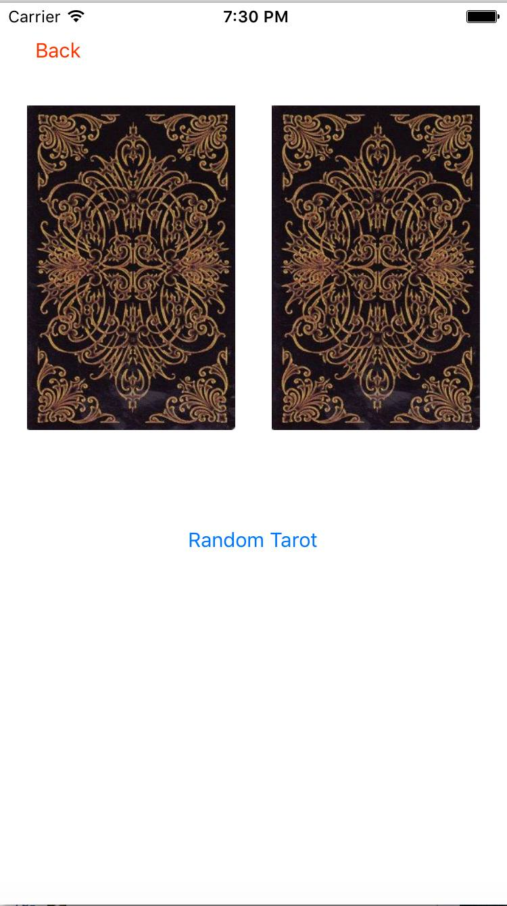This function will let user select 2 cards and fortune. This function is just the addition so it can only random the cards.

Press to random the card

Cards

**EXORCISE**

5

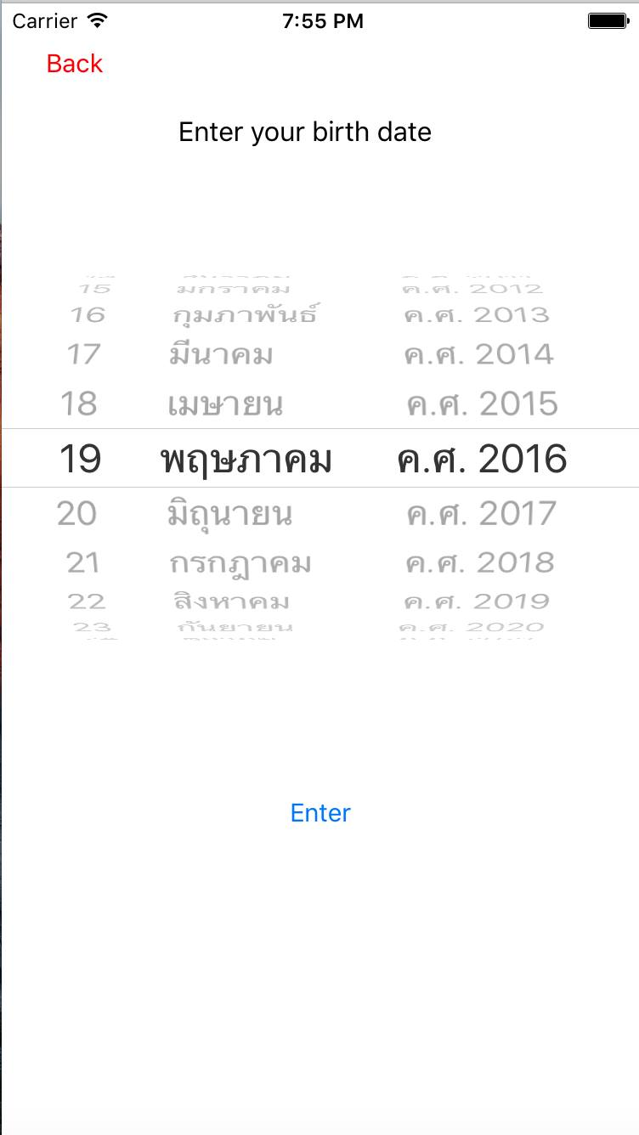 This is our main function for the project. This function will let the user enter their birthdate and generate the location for exorcise due to their zodiac. Which the application will compute the zodiac automatically.

Go to Exorcise location page

Birthdate input

6

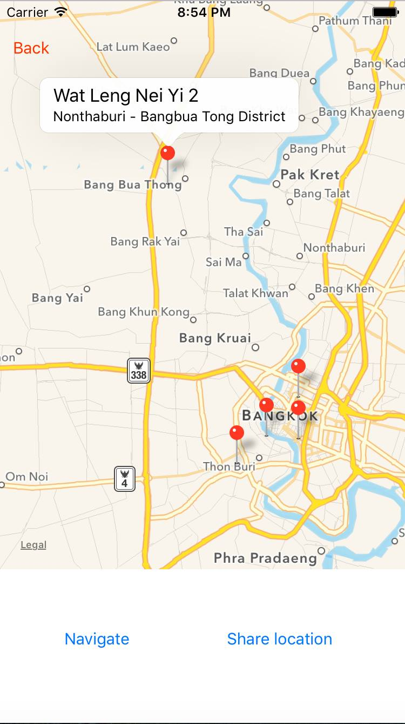

Share location on Facebook

Enable GPS

Go to Exorcise location page

Go to Exorcise location page

**GOD’s QUOTE**

 A quote from the god delivery directly into users hands  every single day. Which contain a warning message, fortune teller, encouraging  quotes all from the god.

**Birthday Fortune**

-​ This detailed astrological analysis of user day of  birth can reinforce​ user personality, true love, destiny, suitable jobs.

**ZODIAC HOROSCOPE**

- Fortuning user’s fate by their zodiac in each month.

**SHARING CONTENT**

7

Our application have an function to share Exorcise location or Fortune result on Facebook. This are some example.

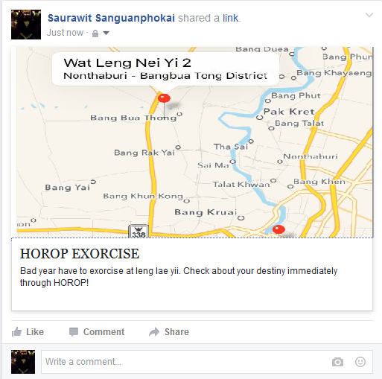

If user are not login with Facebook yet. This error message will show up.

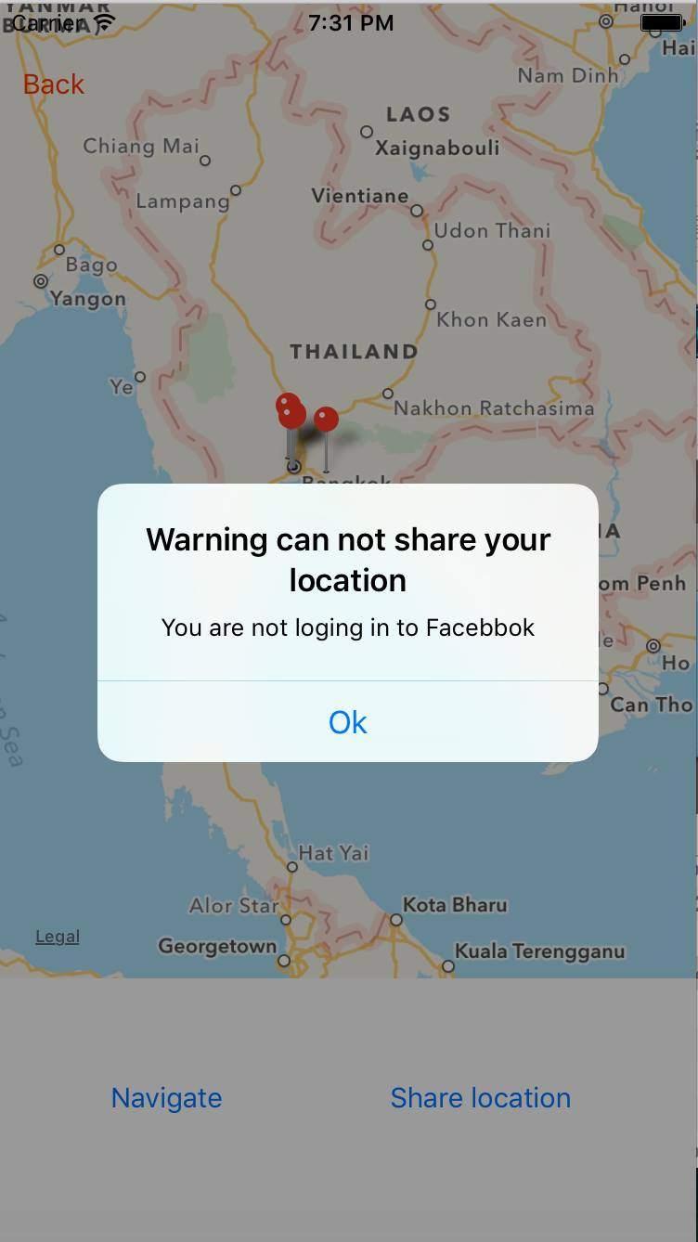

8

**EXECUTION**

**Execution steps**

* 1. 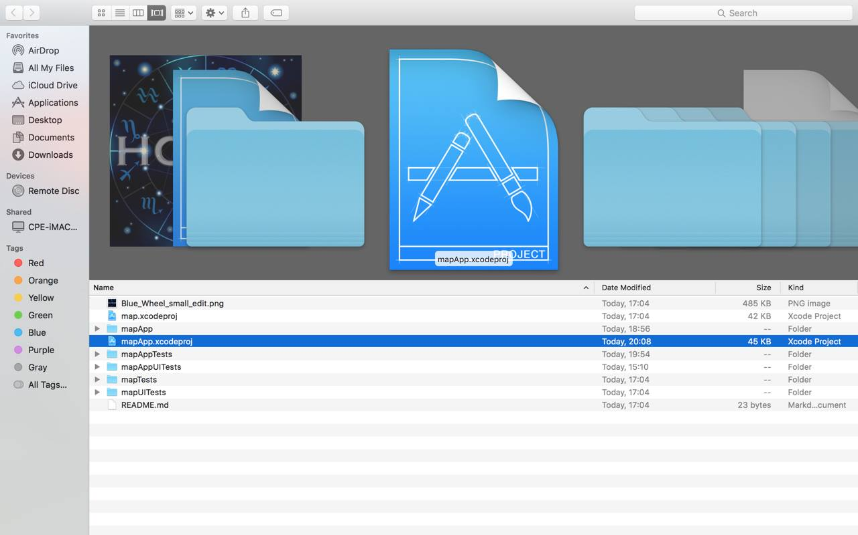Select mapApp.xcodeproj and execute with XCODE.

9

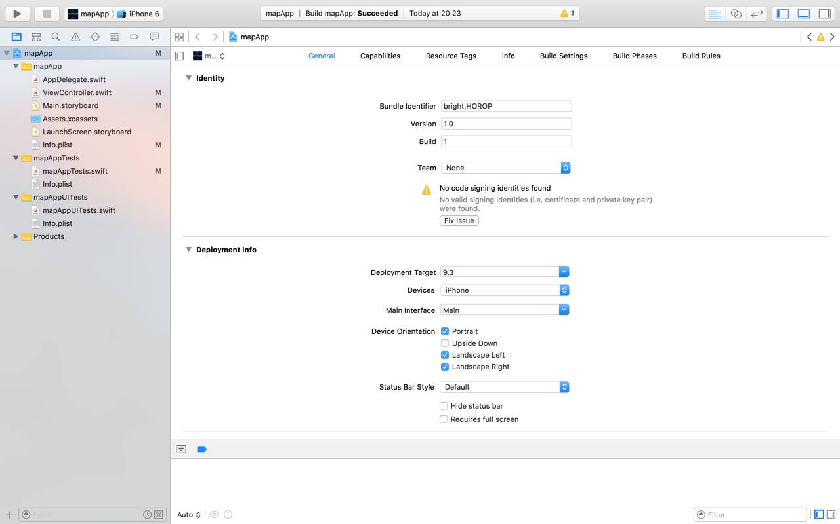2)Press play and program will automatically complie. Then, our application is ready to use

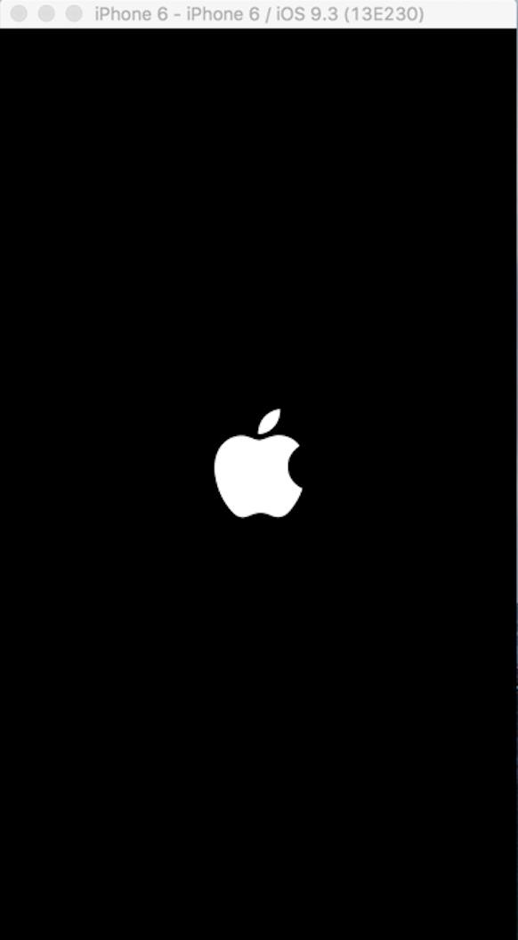3)Wait for program to complie.

10

6) This screen will come up. Select the application icon and welcome to HOROP.

**TEST CASE EXPLANATION**

11

1. Test the date that user have entered. To prevent the date after present day and test if the calendar is Gregorian or not.

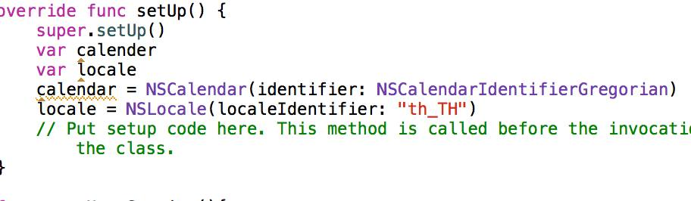

►NSCalendar use to identify if it Gregorian calendar else it will be error.

1. Test if our application have a location in the map for exorcise.

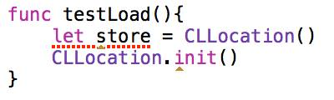

►Store is the variable that store the location if it null the program will crash.

1. 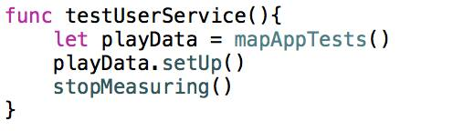Test if user have interact with HOROP application or not.

►playData is use for check if any user interact with our application.

**TESE CASE EXCUTATION**

12

**1)**Test the date if it beyond the present day.

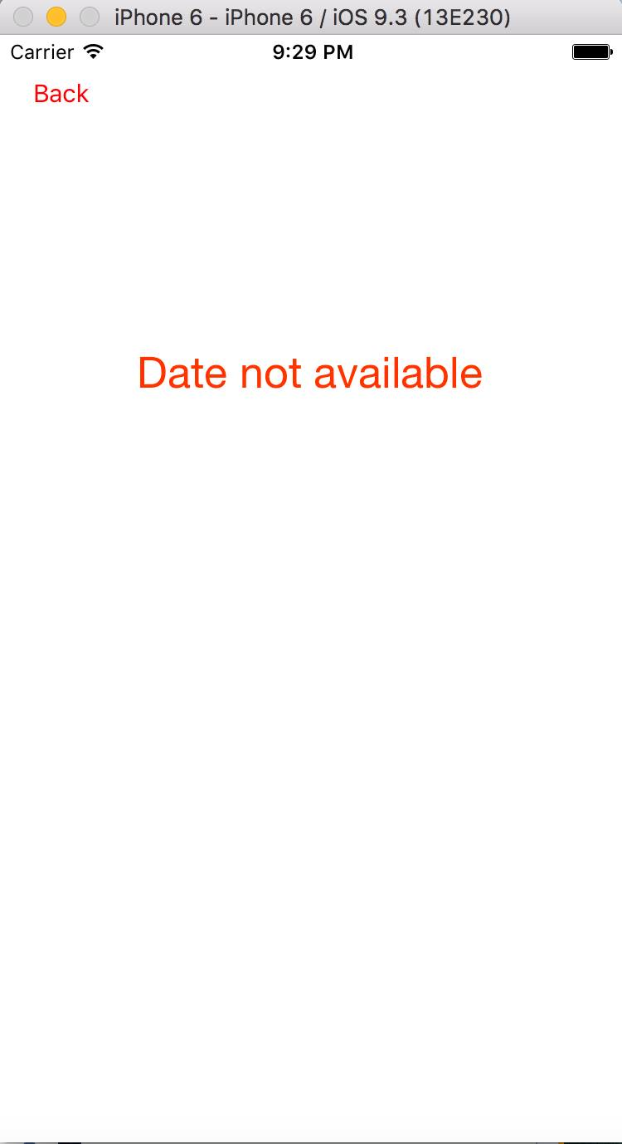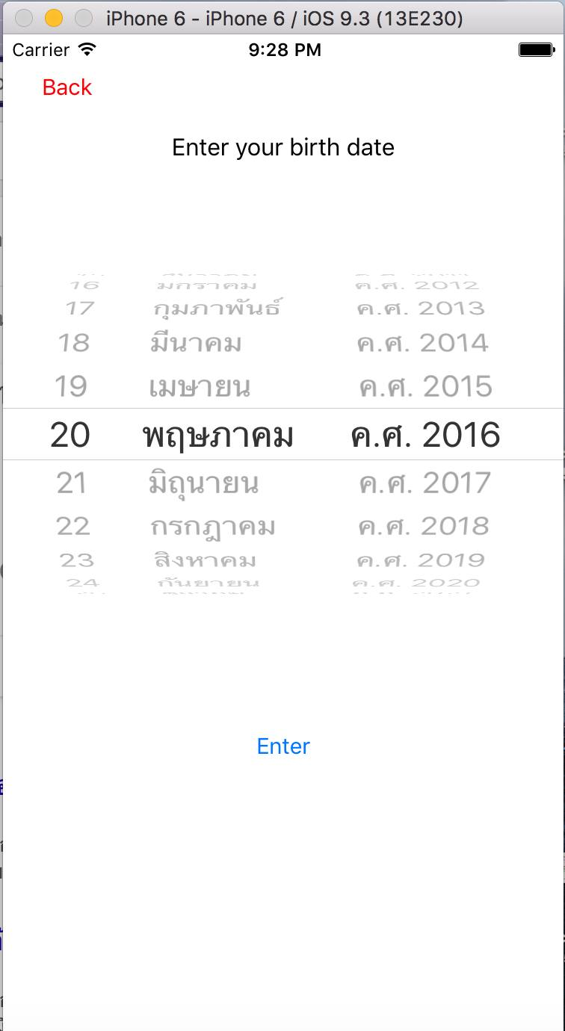

For Number 2) and 3) the application will crash and show the build fail message. (No interact from user and Location lost. This is in the condition that there are no location at all but in our code we have already add the location. If the user not interact with our application on the share result method the application will crash.

