

Database Management-Group Project

Comp1168



Submitted BY:

Karan Sharma

KANTA HUSARI

# Conceptual Data Model

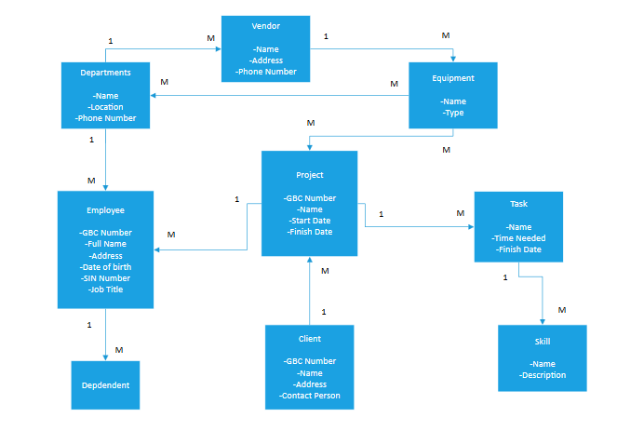

# Physical (Logical) Data Model

