**1.Add Employee Details**

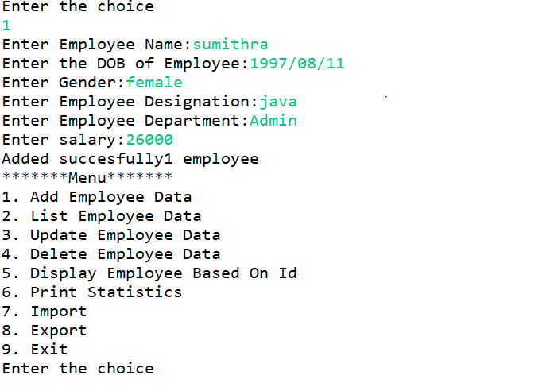

**2.List Employee Details**

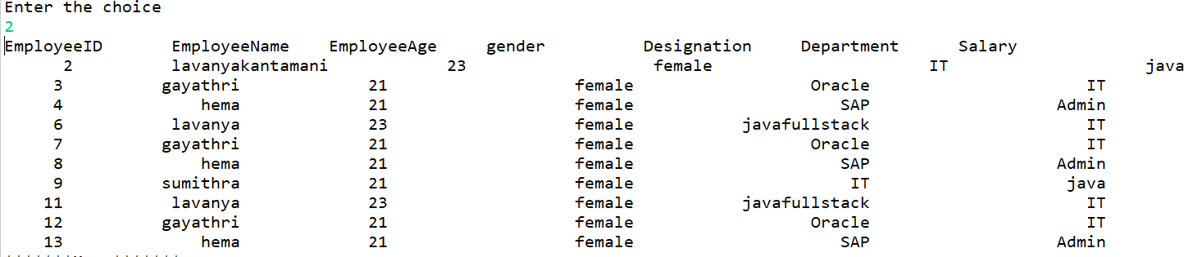

**3.Update Employee Details**

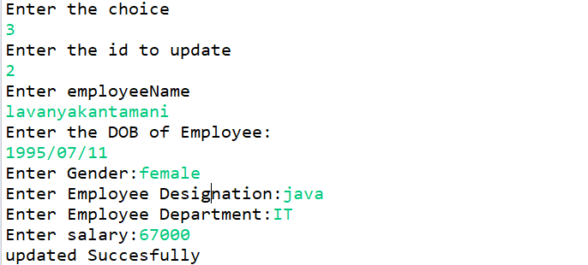

**4.Delete Employee Details**





**5.Display Employee Based On Id**



**6.Print Statistics**

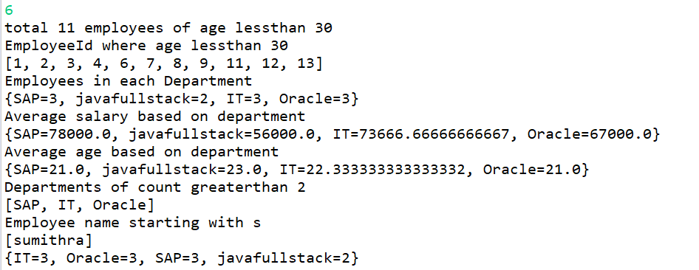

**7.Import Employee Details**

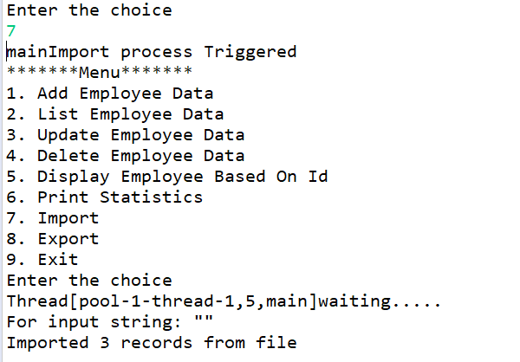

**8.Export Employee Details**

