**Amazon Elastic Block Store (EBS) Overview**

* **EBS** is a scalable block storage service designed for use with Amazon EC2 instances.
* Amazon Elastic Block Store (EBS) is called **block-level storage** because it manages and stores data in fixed-sized units called "blocks," similar to how data is stored on traditional hard drives or SSDs.
* It provides persistent storage that can be attached to EC2 instances, similar to how a physical hard drive is connected to a server.

**Key Features of EBS**

1. **Persistence**:
   * Data on EBS volumes persists independently of the lifecycle of the EC2 instance to which it is attached.
   * If an EC2 instance is stopped or terminated, the data on the attached EBS volume remains intact.
2. **Elasticity**:
   * EBS volumes can be resized and changed in type on the fly to accommodate changing workload requirements.
3. **Durability**:
   * EBS volumes are designed for 99.999% availability, replicating data within its Availability Zone to protect against hardware failures.
4. **Snapshot**:
   * EBS supports snapshots, which are incremental backups stored in Amazon S3.
   * Snapshots can be used to create new EBS volumes, restore existing volumes, or transfer data across regions.
5. **Encryption**:
   * EBS supports encryption at rest using AWS KMS (Key Management Service).
   * Data is automatically encrypted as it moves between EBS and the EC2 instance.
6. **Multi-Attach (io1/io2):**

• Allows multiple EC2 instances to attach to a single io1/io2 volume.

Useful for applications that require high availability.

**Volume Types:**

**1. General Purpose SSD (gp2, gp3):**

* Balanced price and performance.
* Suitable for a wide range of workloads.
* gp3 offers baseline performance of 3,000 IOPS and allows you to provision additional IOPS and throughput independently. The ratio of IOPS to volume size is 500 IOPS per GiB
* gp2 provides baseline performance of 3 IOPS/GB up to 16,000 IOPS.

**2. Provisioned IOPS SSD (io 1, io2):**

* Designed for latency-sensitive applications and workloads that require consistent high performance.
* io1 and io2 can provide up to 64,000 IOPS. 50 IOPS per GiB
* io2 offers higher durability (99.999%).

**3. Throughput Optimized HDD (st1):**

* Low-cost HDD volume designed for frequently accessed, throughput-intensive workloads.
* Network throughput is the rate at which data is transmitted over a network in a given time period. It's often measured in bits per second (bps), megabits per second (Mbps), or gigabits per second (Gbps). Throughput is different from bandwidth, which is the maximum amount of data a network can transmit.
* Suitable for big data, data warehouses, and log processing.

**4. Cold HDD (scl):**

* Lowest cost HDD volume designed for less frequently accessed workloads.
* Suitable for colder data requiring fewer scans per day.

**Use Cases**

* **Databases**: EBS volumes are commonly used to host databases, offering low-latency, high-performance storage.
* **File Systems**: EBS volumes can be attached to EC2 instances to host file systems that persist beyond the life of the instance.
* **Backup and Restore**: Snapshots provide a means of backing up data and restoring it in case of failure or disaster recovery.

**Managing EBS Volumes**

* **Attaching and Detaching**: Volumes can be dynamically attached and detached from EC2 instances.
* **Resizing**: Volumes can be resized (increased in size) without detaching from the instance, though some changes may require a reboot.
* **Monitoring**: AWS provides CloudWatch metrics for monitoring EBS volume performance and usage.

**Pricing**

* EBS pricing is based on the volume type, the amount of data provisioned, IOPS provisioned, and the amount of data transferred in and out of AWS.

**Best Practices**

1. **Use Snapshots Regularly**: Regular snapshots provide data redundancy and facilitate disaster recovery.
2. **Monitor Performance**: Use CloudWatch to monitor performance and adjust volume types or sizes as needed.
3. **Implement Encryption**: Always use encryption for sensitive data to enhance security.
4. **Plan for Redundancy**: Consider using multiple volumes and snapshots across different Availability Zones for critical applications.

**Important Points for the Exam:**

1. Understand the different EBS volume types and their use cases.
2. know how to create, attach, detach, and delete EBS volumes.
3. Be familiar with EBS snapshot creation and restoration.
4. Understand EBS performance characteristics and how to monitor them.
5. Know the cost implications of different EBS volumes and best practices for optimizing costs.
6. Understand the encryption options and how to enable them.
7. Be aware of the benefits and use cases for multi-attach volumes (io1/io2).
8. Understand how to use EBS with EC2 Auto Scaling and how EBS volumes behave with instance termination.

Creating and managing Amazon Elastic Block Store (EBS) volumes, snapshots, and copies involves a few steps within the AWS Management Console Here's a step-by-step guide:

* 1. **Creating an EBS Volume:**
* Create Volume: Click the "Create Volume" button at the top.
* Go to EC2 Dashboard: Under the “Services” menu, select “EC2”.
* Navigate to EBS: In the left sidebar, under "Elastic Block Store", click on “Volumes”.
* Create Volume: Click the "Create Volume" button at the top.

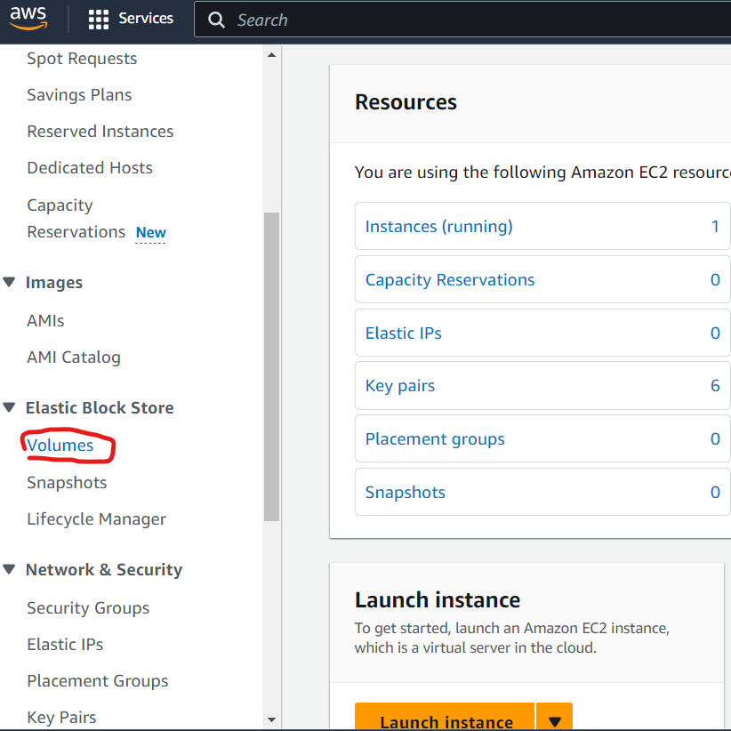

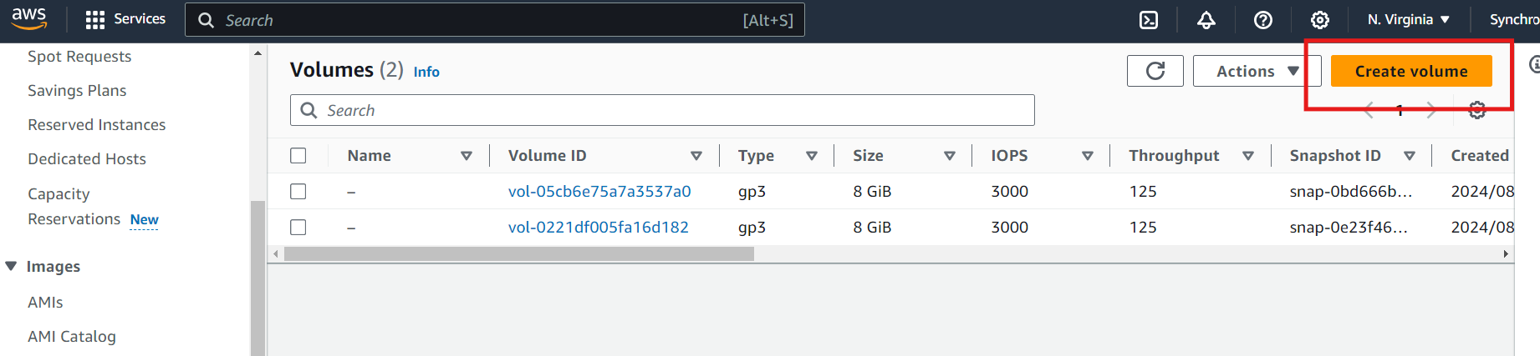

**Configure Volume**:

* **Volume Type**: Choose the type (e.g., General Purpose SSD, Provisioned IOPS SSD, Magnetic).
* **Size**: Specify the size of the volume in GiB.
* **Availability Zone**: Choose the availability zone where you want the volume to be created.
* **Other Settings**: Set any other desired parameters (e.g., encryption).

**Create**: Click “Create Volume” to finish.

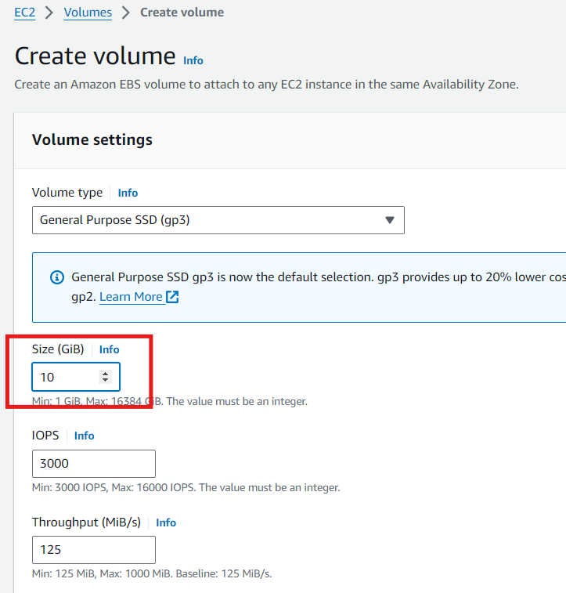

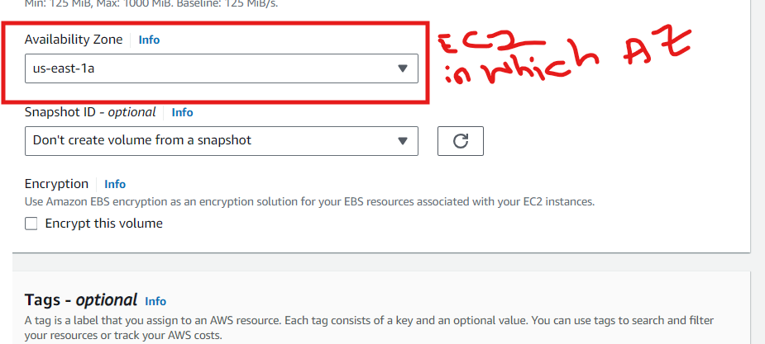

Now you can see new EBS volume in the volume feature and available to attach

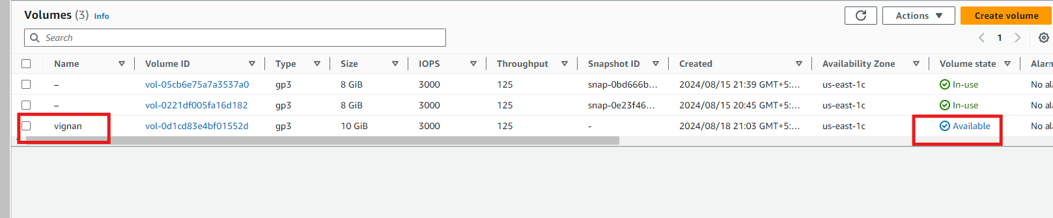

**Attach Volume Using the AWS Management Console:**

1. **Login to AWS Console**: Navigate to the [AWS Management Console](https://aws.amazon.com/console/).
2. **Go to EC2 Dashboard**: Under the “Services” menu, select “EC2”.
3. **Navigate to Volumes**: In the left sidebar under “Elastic Block Store”, click on “Volumes”.
4. **Select the Volume**: Find the volume you want to attach. Ensure the volume is in the same availability zone as your EC2 instance.
5. **Attach Volume**:
   * Select the checkbox next to the volume.
   * Click the “Actions” dropdown menu, and select “Attach Volume”.
6. **Configure Attachment**:
   * **Instance**: Choose the instance to which you want to attach the volume from the dropdown list.
   * **Device**: Specify the device name (e.g., /dev/sdf or /dev/xvdf). The naming convention may vary based on the operating system.
7. **Attach**: Click “Attach Volume” to complete the process.

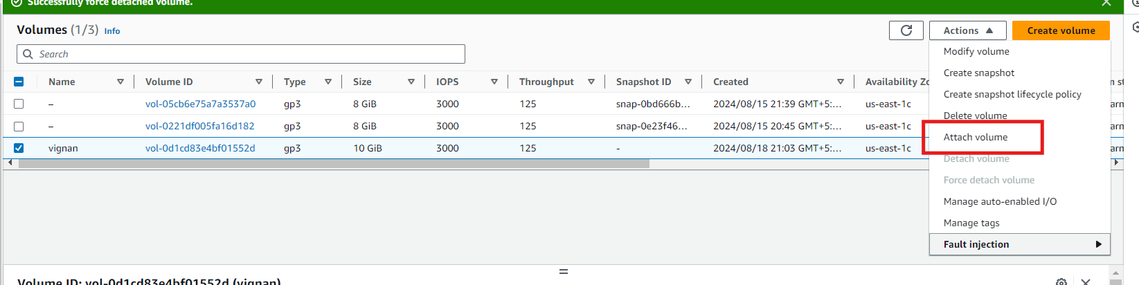

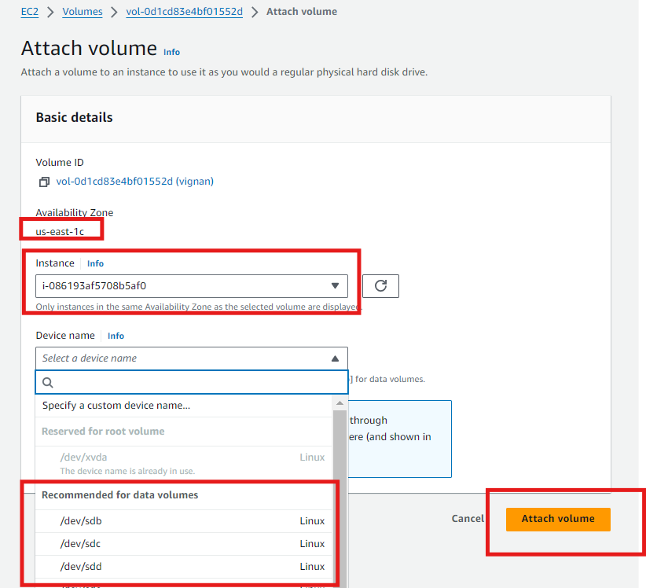

**1. Check if the Volume is Detected:**

Connect to EC2 instance

First, confirm that the OS detects the new volume using the **lsblk** or **fdisk -l** command.

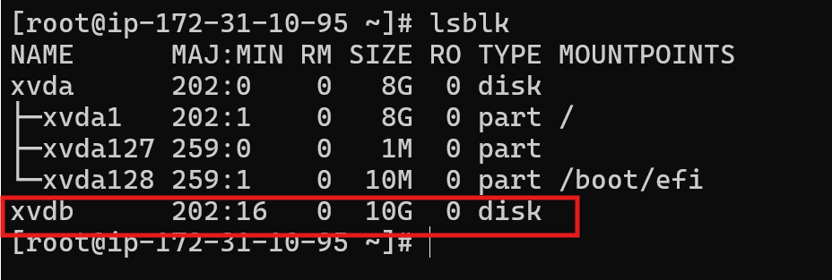

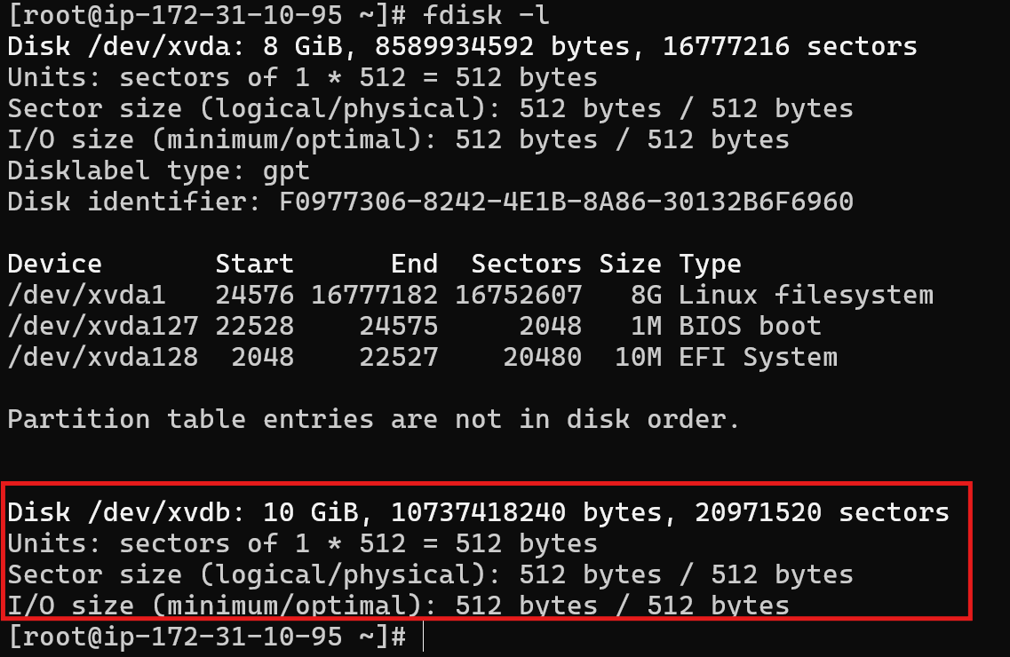

This command lists all block devices, and you should see /dev/sdb or similar in the output.

**2. Format the Volume (if needed):**

If the volume is new and unformatted, you'll need to format it before mounting. Be cautious as this will erase any existing data on the volume.

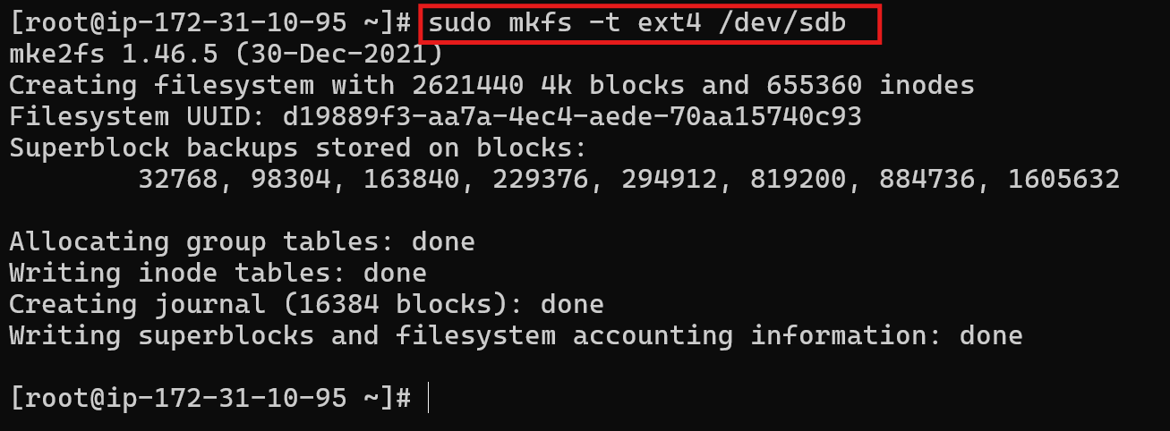

Replace ext4 with the filesystem type you prefer (e.g., xfs, ext3).

**3. Create a Mount Point:**

Create a directory where you want to mount the volume.

**sudo mkdir /mnt/data**

**4. Mount the Volume:**

**Mount the volume to the created directory.**

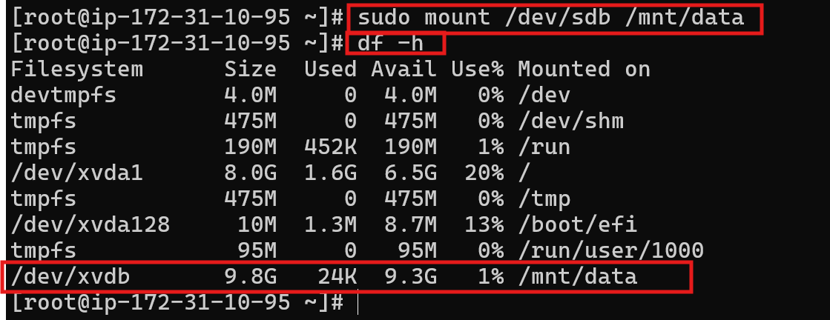

**Verify the Mount:**

Check if the volume is now available with the **df -h** command.

You should see the new volume listed with its available disk space

**Test the fstab Entry (optional but recommended):**

You can test the entry without rebooting by unmounting the volume and remounting using mount -a.

**sudo umount /mnt/data**

**sudo mount -a**

Check with **df -h** to confirm the volume is mounted correctly.

**Creating an EBS Snapshot:**

**AWS Management Console:**

1. **Go to Snapshots**: In the EC2 Dashboard, under “Elastic Block Store”, click on “Snapshots”.
2. **Create Snapshot**: Click the "Create Snapshot" button.
3. **Configure Snapshot**:
   * **Volume ID**: Select the volume from which to create the snapshot.
   * **Description**: Optionally add a description for the snapshot.
4. **Create**: Click “Create Snapshot” to start the snapshot process.

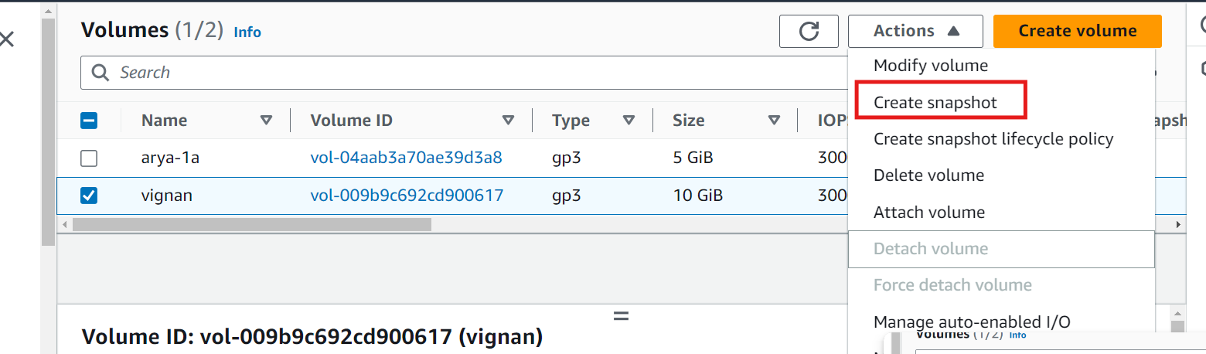

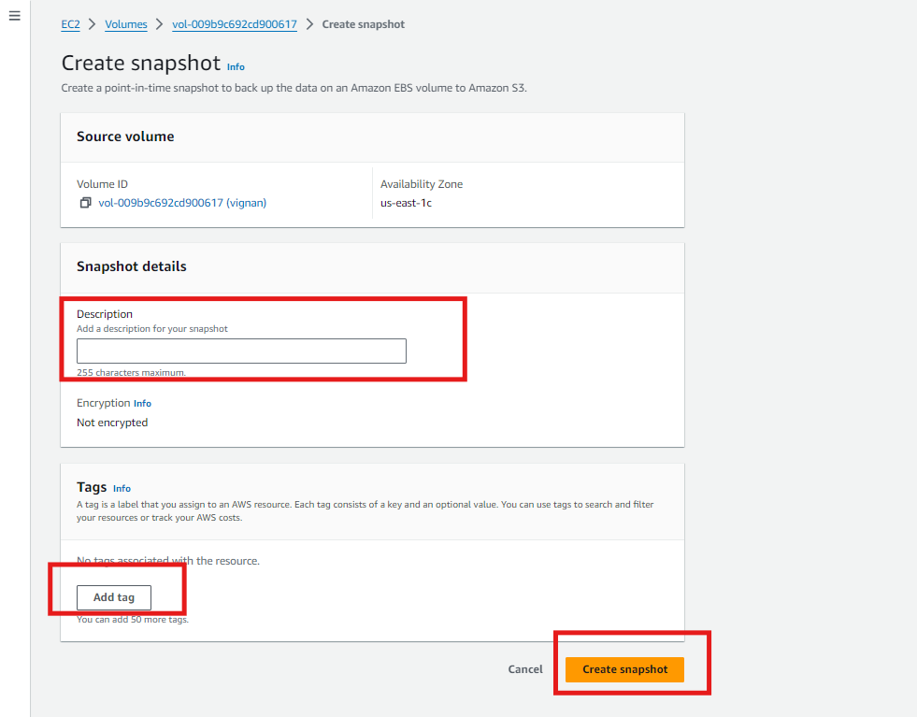

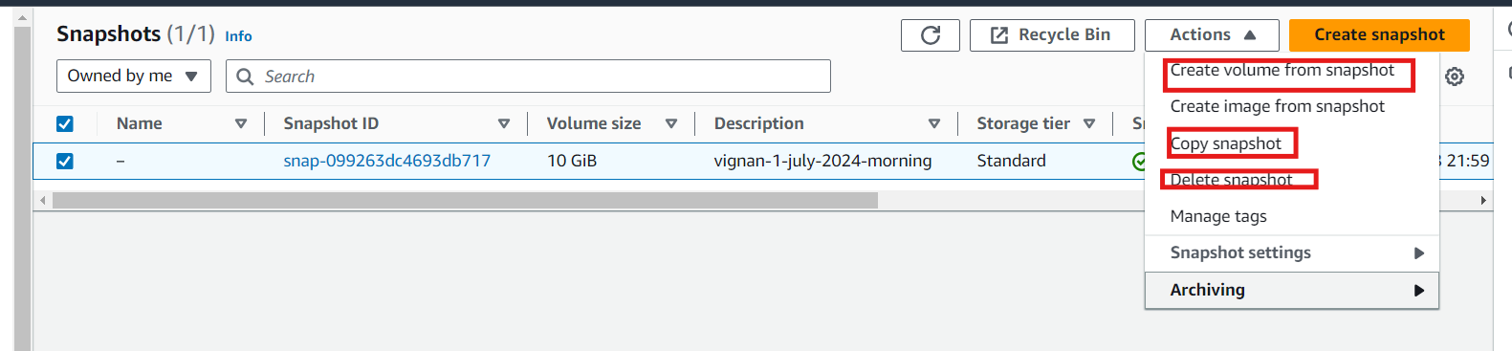

sudo growpart /dev/nvme0n1 1

sudo resize2fs /dev/nvme0n1p1

df -h