**CHEF**

- Instillation of Chef

- Logon to "www.chef.io"

- Click "MANAGEMENT CONSOLE" on the right to corner and click to "Click here to get started!" for new ID creation

- Now logon to Chef by using the credential created in the previous step.

- CHEF Architecture

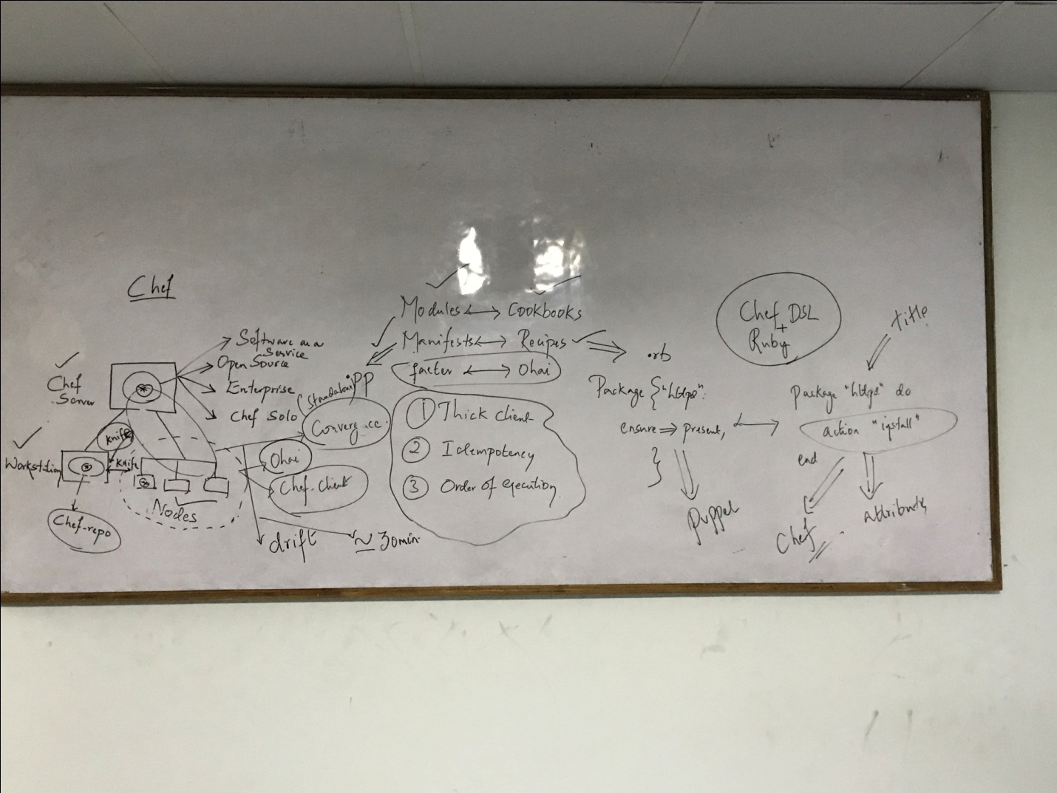

-Different **terminology** b/w Ansible, Puppet and CHEF

|  |  |  |
| --- | --- | --- |
| **Puppet (Version 3.3)** | **Ansible (Version 1.8)** | **CHEF (Version 12)** |
| Modules | Roles | Cookbook |
| Manifests | Playbook | Recipes |
| Facter | Setup | Ohai |

- Click create "new organization"

- Enter the info as given below

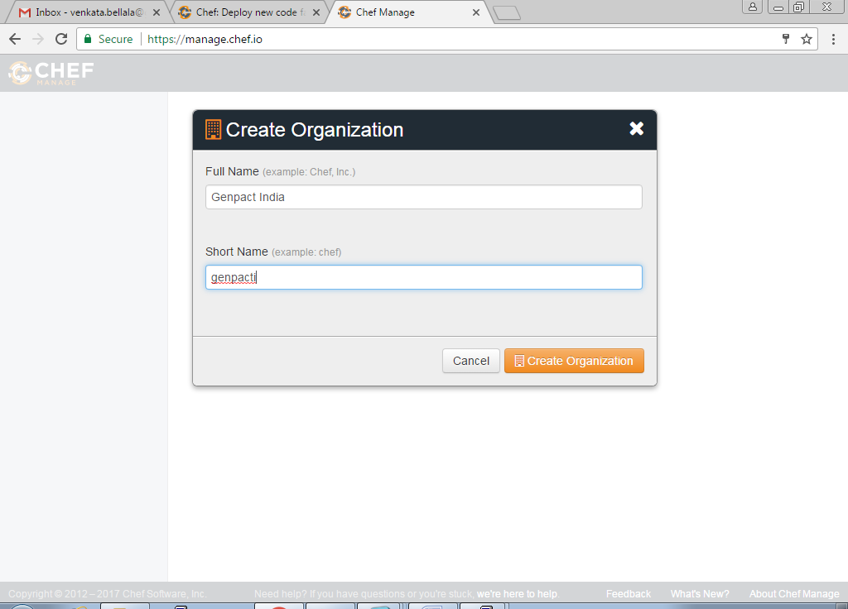

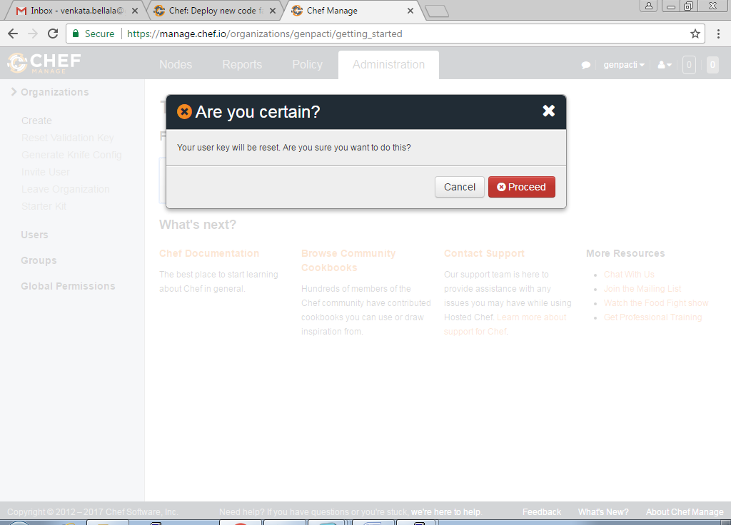

-Now download starter kit to your desk top

- Copy the starter kit (ZIP File) to root/server1 using "WinSCP" tool as show below

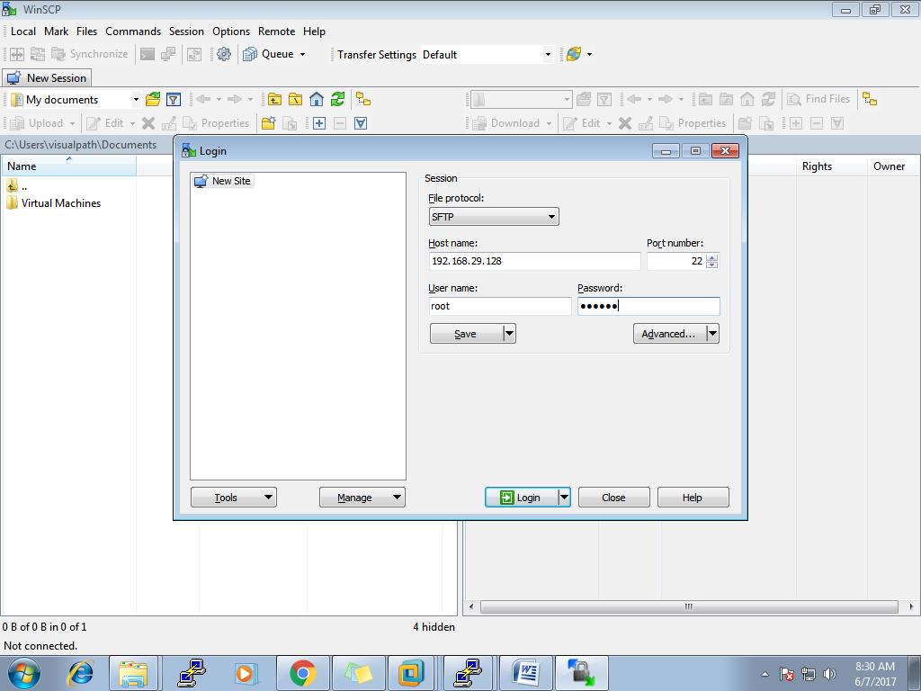

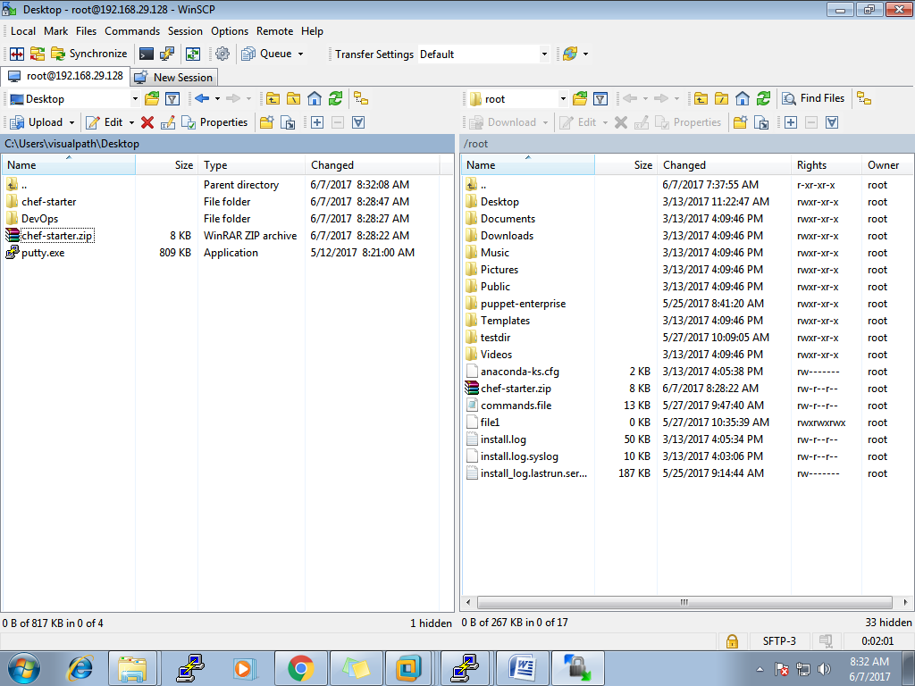

- Now verify whether ZIP file is copied to root/server1-

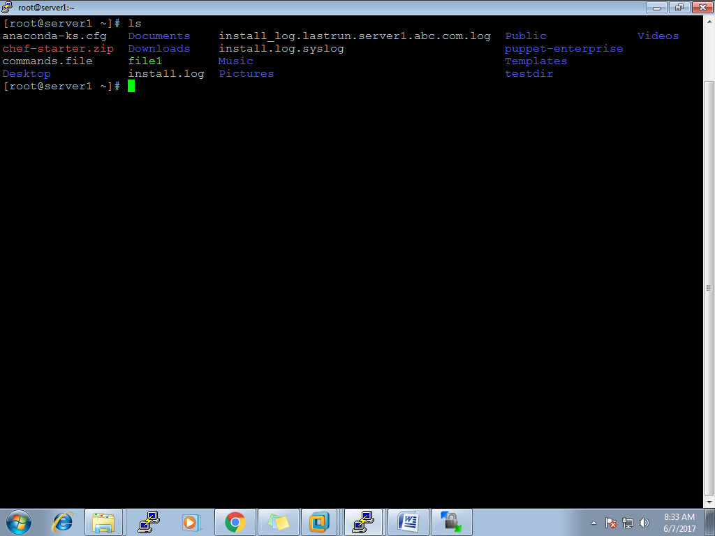

- Now we are going to unzip in linux environment

[root@server1 ~]# unzip chef-starter.zip

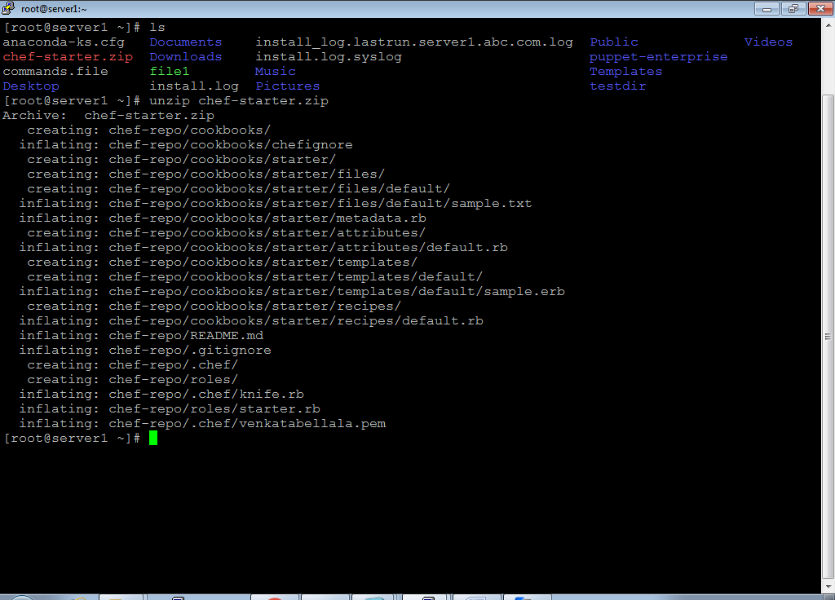

[root@server1 ~]# ls

[root@server1 ~]# cd chef-repo

[root@server1 chef-repo]# ls

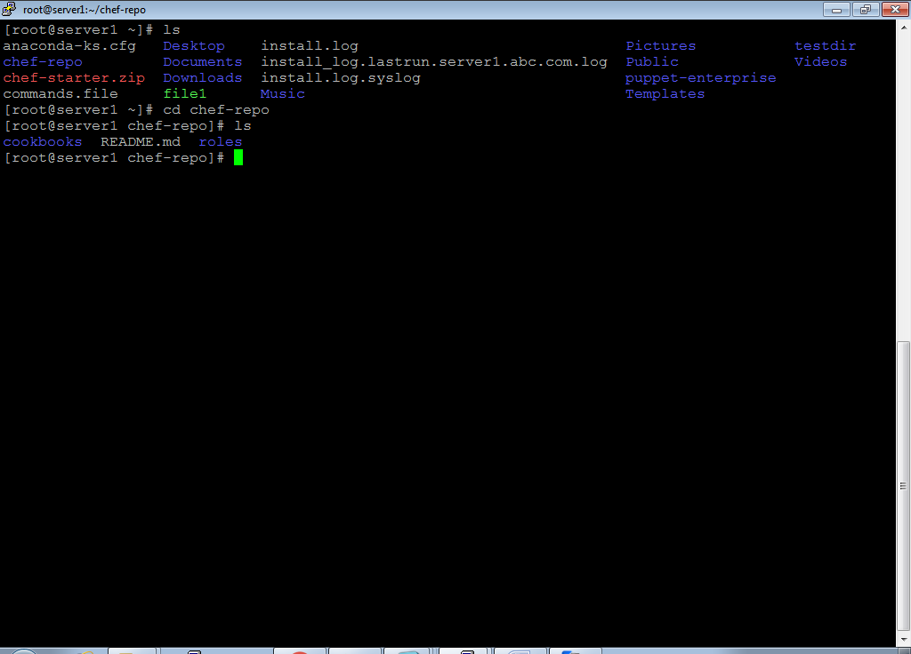

- The above steps is not the actual CHEF insatll, it's just a starter Kit

- Now we will install CHEF in "Work station" and in client

-Install CHEF in work station by using the below link

[root@server1 chef-repo]# curl -L https://**www.opscode.com**/chef/install.sh | bash

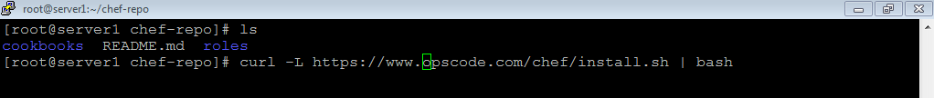

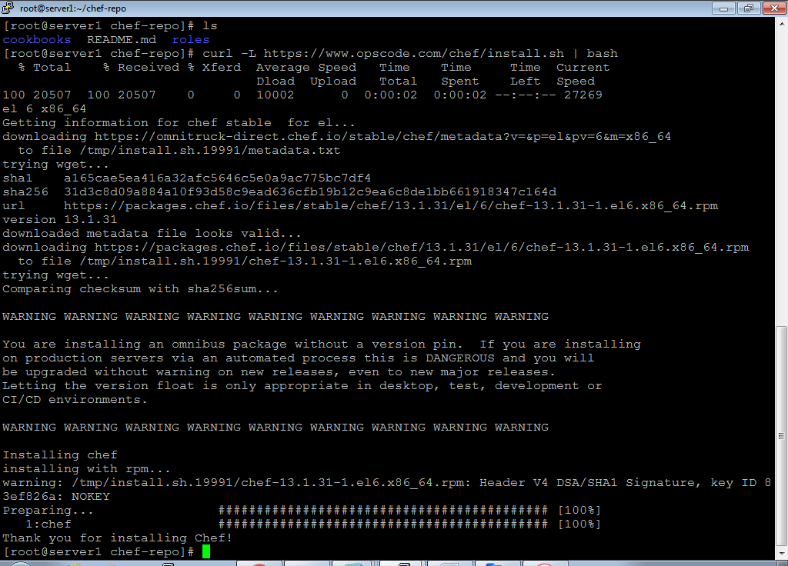

- Now we are going to install on "NODE" @ root/server2

[root@server1 chef-repo]# knife bootstrap server2.abc.com -x root -P redhat -N node1

