Visa Processing System Documentation

# Introduction

The Visa Processing System is designed to manage visa applications efficiently. It provides functionalities for adding, viewing, updating, and deleting visa applications along with status updates. This document provides a comprehensive overview of the application detailing its features, architecture, and technical specifications.

# System Requirements

Hardware Requirements:

- Standard PC or laptop

Software Requirements:

- Java Development Kit (JDK) 8 or higher

- Eclipse IDE

- MySQL Database

- Web Server (Apache)

# System Architecture

Overview:

The Visa Processing System follows a desktop application architecture with Swing for the user interface and JDBC for database connectivity.

Components:

- Frontend: Java Swing

- Backend: JDBC for database interaction

- Database: MySQL

Data Flow:

1. User interacts with the Swing frontend.

2. Requests are processed by the Java backend.

3. Backend communicates with MySQL database for CRUD operations.

4. The frontend updates the User Interface based on the response.

# Features

Application Management:

- Add, view, update, delete visa applications.

- Update visa application status.

# Technical Specifications

Frontend (Java Swing):

- Swing components for UI design.

- Event-driven programming model.

Backend (Java JDBC):

- JDBC API for database connectivity.

- Prepared statements for SQL queries.

Database (MySQL):

- Tables: applications (id, name, passport_number, visa_type, status).

# Database Design

Tables:

- applications:

- id (Primary Key)

- name

- passport_number

- visa_type

- status

# User Interface

Screens:

- Main Application Window:

- Fields for name, passport number, visa type, and status.

- Buttons for adding, removing, and updating applications.

- Login Dialog:

- Username and password fields.

# Installation and Setup

Java Version:

1. Download and install Eclipse IDE.

2. Clone the Java project repository.

3. Import the project into Eclipse.

4. Set up MySQL database and import schema.

5. Update database credentials in the Java code (VisaProcessingSystem.java).

6. Compile and run the VisaProcessingSystem.java file in Eclipse.

# Future Enhancements

- Implement encrypted storage for sensitive data.

- Add search functionality for visa applications.

.

# Execution Screenshots

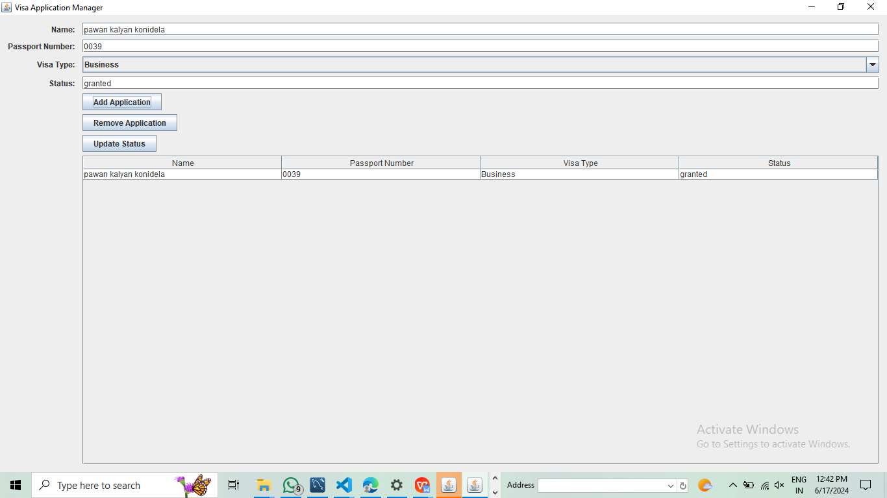

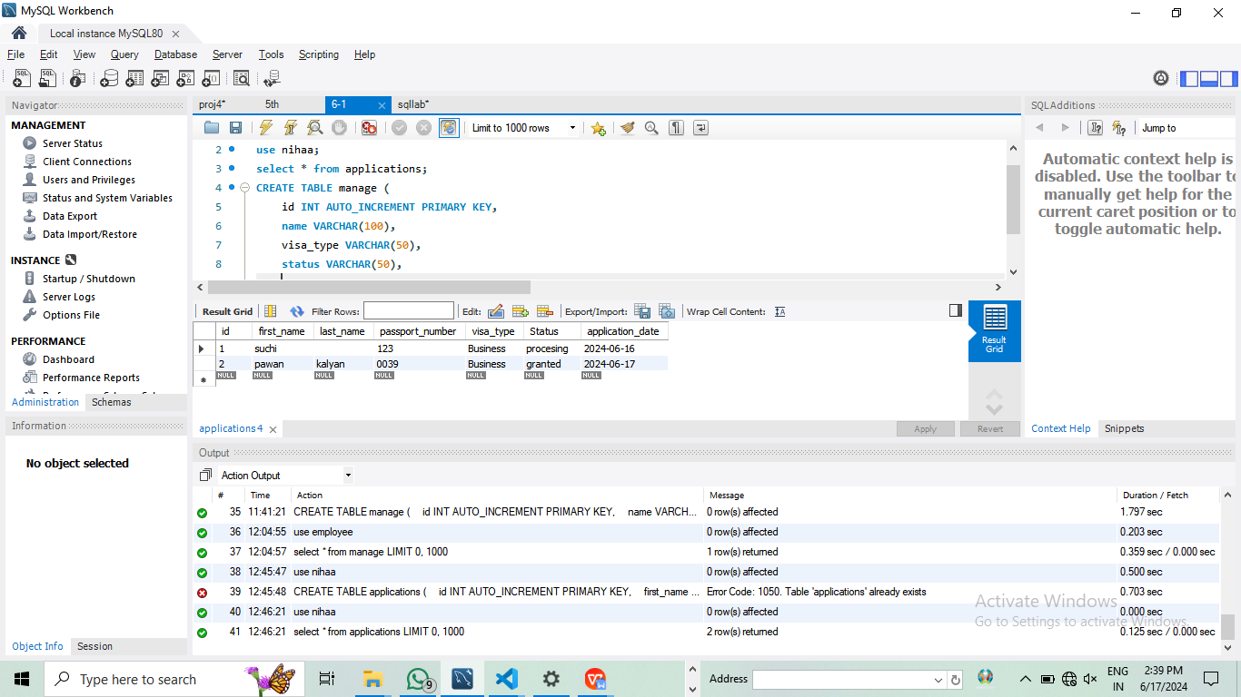

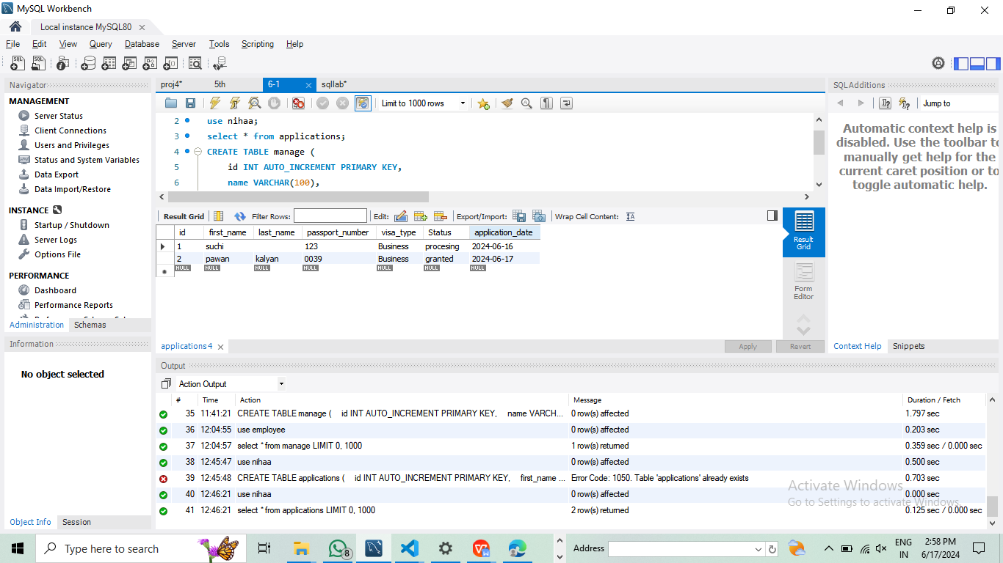

# Conclusion

The Visa Processing System provides a robust solution for managing visa applications securely using Java Swing with MySQL. It offers essential functionalities for application management and status updates. Future enhancements aim to further improve security and functionality.