Commands: minikube
docker - - version
minikube start - -driver=docker
minikube status
kubectl get pods -A
minikube dashboard
minikube version
minikube version –client
kubectl create deployment mynginx - -image=nginx
kubectl get deployments
kubectl get pods
kubectl describe pods
kubectl expose deployment mynginx - -type=NodePort - -port=80 - -target-port=80
kubectl scale deployment mynginx - -replicas=4
kubectl get service mynginx
kubectl port-forward svc/mynginx 8081:80
access via Access the app via http://localhost:8081.
minikube tunnel
Retrieve the service URL:
minikube service mynginx –url
kubectl delete deployment mynginx
kubectl delete service mynginx
minikube stop
minikube delete

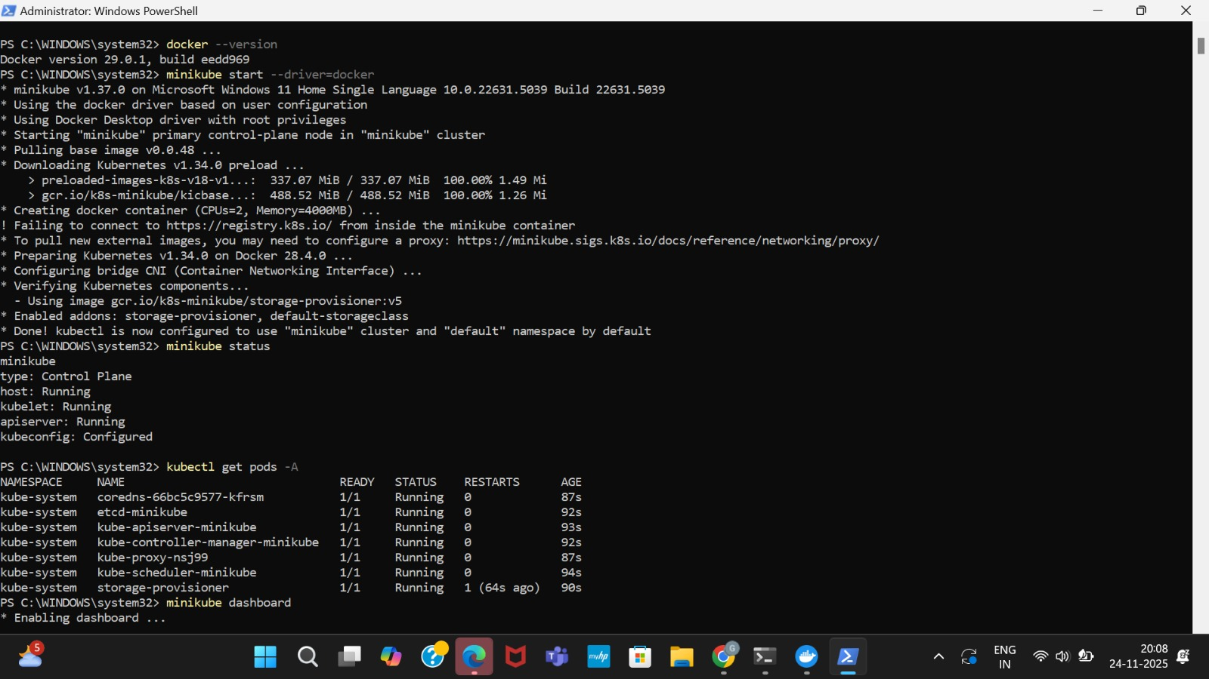
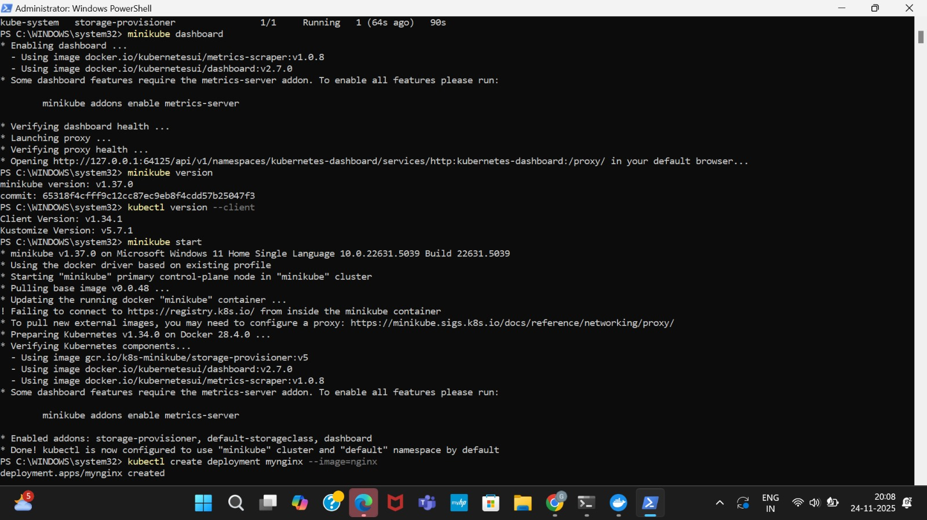
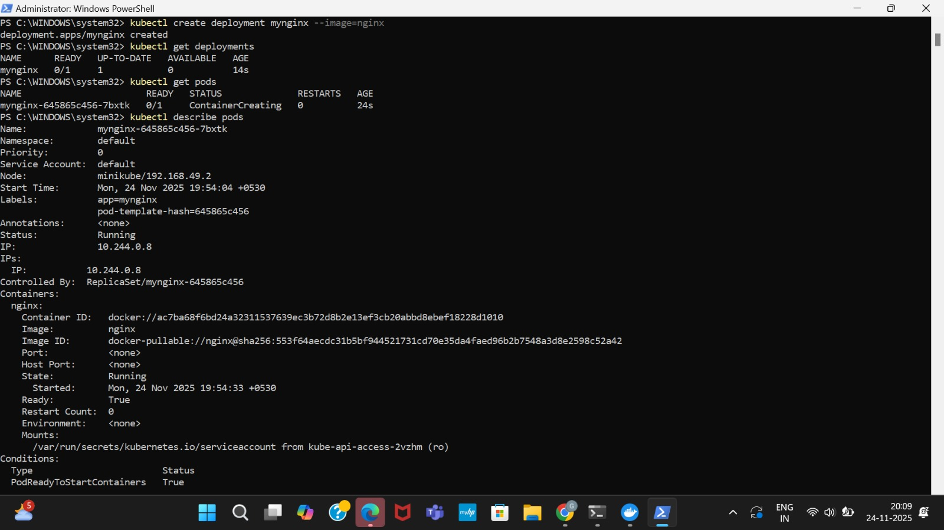
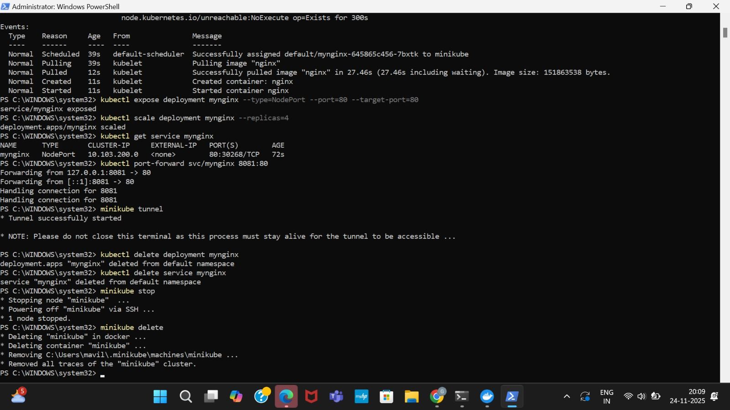
docker pull jasonrivers/nagios:latest
docker run --name nagiosdemo -p 8888:80 jasonrivers/nagios:latest
Open your browser and navigate to:
http://localhost:8888
docker stop nagiosdemo
docker rm nagiosdemo
docker images
docker rmijasonrivers/nagios:latest

