Dictionary
Bug – A bug is any kind of programming error that prevents the program from operating correctly
Vertices/Vertex(In graphs, noted with v or V (V means the totality of the vertices in the graph) – Sunt Varfuri/Noduri dintr-un graf (valorile propriu zise)
Edge – Muchii (drumurile care leaga varfurile)

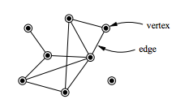
Argumente – ce trimiti(unei functii, etc…)
Parametrii – ce asteapta sa primeasca(functia, constructorul etc…)
Ternary operator – este asta: “? :”

[] – square brackets;
() – Parantheses;
{} – Curly Brackets,
<> - Angle Brackets

