MINI PROJECT
Creditcard fraud detectionusing using Python
A Report
Submitted in partial fulfillment of the Requirements for the award of the Degree of Computer Science
BACHELOR OF TECHNOLOGY
In
COMPUTER SCIENCE AND ENGINEERING IN BIG DATA ANALYTICS
Submitted By

Roll Number 24AJ1A5818
Name Siddineni Harshitha
Year II th year (IV SEM)

Branch CBA(Big Data Analytics

DEPARTMENT OF COMPUTER SCINCE ENGINEERING

AMRITA SAI INSTITUTE OF SCIENCE AND TECHNOLOGY
(AUTONOMOUS)
(Affiliated to Jawaharlal Nehru Technological University, Kakinada& Accredited by NAAC ‘A’ Grade)
Paritala, Kanchikacherla (Md), Krishna (Dt) – 521180 August 2025

EXTERNAL EXAMINAR



Amrita Sai Institute of Science & Technology

(AN AUTONOMOUS INSTITUTION)
(Approved by AICTE, New Delhi & Permanently Affiliated to JNTUK Kakinada) AN ISO 9001: 2015 Certified Institution,Accredited by NAAC , Recognized by UGC Under 2(f) and 12(B) under UGC act 1956 Paritala, Kanchikacherla (M), NTR Dist., A.P., India-521180

DEPARTMENT

OF
COMPUTER SCIENCE AND ENGINEERING IN BIG DATA ANALYTICS



CERTIFICATE

This is to certify that the project entitled” Creditcard fraud detectionusing using Python
”was successfully carried out by Siddineni Harshitha (24AJ1A5818), Fulfillment for the award of the Bachelor of Technology in COMPUTER SCIENCE AND ENGINEERING – BIG DATA ANALYTICS by AMRITA SAI INSTITUTE OF SCIENCE AND
TECHNOLOGY,PARITALA during the academic year 2025-2026.

HEAD OF THE DEPARTMENT
Mr. B Praneeth _{MTech}
Assistant Professor

EXTERNAL EXAMINAR

DECLARATION

I, hereby declare that the work, which is being presented in this dissertation entitled “Creditcard fraud detectionusing using Python” submitted towards the partial fulfillment of requirements for the award of the degree of Bachelor of Technology with specialization in COMPUTER AND SCIENCE at AMRITA SAI INSTITUTE OF SCIENCE AND TECHNOLOGY, Paritala is an authentic record of my work carried out under the supervision of Mr. D.Venkateswarlu, AMRITA SAI INSTITUTE OF SCIENCE AND TECHNOLOGY, Paritala.

I have not submitted the matter embodied in this dissertation report for the award of any other degree. Further, the technical details furnished in the various chapters in this report are purely relevant to the above project and there is no deviation from the theoretical point of view for design, development and implementation.

Siddineni Harshitha 24AJ1A5818

ACKNOWLEDGEMENT

It gives me immense pleasure to thank my guide Mr. D.Venkateswarlu, CBA for having been a source of constant inspiration, precious guidance and generous assistance during the project work. I deem it as a privilege to have worked under her able guidance. Without her close monitoring and valuable suggestions, this work would not have taken this shape. I feel that his help is substitutable and unforgettable. I take the privilege of recording my thanks to H.O.D of CBA
Mr. B Praneeth _{MTech} for his encouragement, cooperation and valuable suggestions to complete project in time.

I take the privilege to record my thanks to Directories od academics of college Mr. B Praneeth _{MTech} for his encouragement, cooperation and valuable suggestions to complete project in time.

I am very thankful to honorable Principal Dr M. SASIDHAR, and I express my sincere gratitude and deep sense of respect for making me available with all the required assistance and for his support and inspiration to carry out this project in the Institute.

I am thankful to the teaching and non-teaching staff of CBA department for their direct as well as indirect help in my project.

I am elated to avail myself to this opportunity to express my deep sense of gratitude to my parents.

Siddineni Harshitha 24AJ1A5818

ABSTRACT
Credit Card Fraud Detection is an AI-powered mini project built using Python and Streamlit that leverages machine learning to identify fraudulent credit card transactions in real time. The system addresses the critical challenge of detecting fraud in highly imbalanced financial datasets, where fraudulent transactions account for only 0.17% of all records.
The project utilizes the Kaggle Credit Card Fraud Detection dataset, comprising 284,807 transactions with 492 confirmed fraud cases. To overcome the severe class imbalance, the SMOTE (Synthetic Minority Over-sampling Technique) is applied on the training data to generate synthetic fraud samples, enabling the models to learn fraud patterns more effectively without data leakage.
Three supervised machine learning models are trained and compared:
- Logistic Regression
- Random Forest Classifier
- Decision Tree Classifier
Data preprocessing includes StandardScaler normalization of the Time and Amount features, while the remaining 28 features (V1–V28) are PCA-transformed components provided in the original dataset. The models are evaluated using key classification metrics — Accuracy, Precision, Recall, F1-Score, and ROC-AUC — with the best-performing model identified automatically based on F1-Score.
The application features a premium dark-themed Streamlit dashboard
four interactive pages:
- Home — Dataset overview, class distribution donut chart, key metrics, and workflow visualization.
- Model Comparison — Side-by-side performance cards, grouped bar charts, confusion matrices, and ROC curves.
- Real-Time Fraud Prediction — Users can input transaction details (or use quick-test presets) to get instant fraud predictions from all three models with confidence scores.
- Data Insights — SMOTE effect visualization, feature importance analysis, correlation heatmaps, and transaction distribution charts.
The tech stack includes Streamlit for the web interface, scikit-learn and imbalanced-learn for ML/SMOTE, Plotly and Matplotlib/Seaborn for interactive visualizations, and joblib for model persistence. The project demonstrates a complete end-to-end machine learning pipeline — from data loading and preprocessing to model training, evaluation, and deployment — making it a practical tool for understanding and combating financial fraud using AI.

- Introduction
- Problem Statement
- Objectives
- Technology Stack Used
- Features of the Project
- System Architecture / Flowchart
- Screenshots or UI Designs
- ADD CODE (Based on project either pthyon,c,java,html,css,javs…….etc
- OUTPUT DISPLAY SCREENSHOTS
- Challenges Faced During the Project
- References
- Appendix
- Code Snippets (Optional)
- Future Scope
- Conclusion

- Introduction :
The rise of digital transactions has made credit cards a ubiquitous method of payment, simultaneously attracting malicious actors. Credit card fraud results in billions of dollars in losses annually. Traditional rule-based detection systems often fail to keep up with sophisticated fraud patterns, necessitating adaptive, data-driven approaches. This project utilizes an AI-powered Machine Learning pipeline to identify fraudulent transactions accurately and in real-time.
- Purpose :
The primary purpose of this project is to build an intelligent, scalable machine learning system capable of accurately identifying fraudulent credit card transactions. By specifically addressing the challenge of extreme data imbalance (using SMOTE), the system is built to minimize false positives (annoying the customer) while maximizing the capture of true fraud (saving the financial institution money).
- Real-Time Monitoring:
The architecture demonstrates real-time capability. The web interface features a dedicated prediction engine that instantly parses transaction data the moment it is entered. It rapidly computes the likelihood of fraud simultaneously across three different trained models (Logistic Regression, Random Forest, Decision Tree) and returns an immediate confidence score.
- User Input-Based:
The application is highly interactive. Through the "Predict Fraud" Streamlit interface, users can manually input over 30 transaction attributes (including mathematical PCA variables like V1-V28, along with Time and Amount). The application instantly standardizes these inputs behind the scenes using pre-fitted scalers and feeds them into the algorithms for an instant, user-driven assessment.
4. Visualization Support:
A massive focus of this project is data clarity. It comprehensively utilizes libraries like Plotly, Seaborn, and Matplotlib to deploy interactive visual analytics. Users can view side-by-side Confusion Matrices, overlapping ROC curves for model comparison, Feature Importance charts, and interactive Donut Charts that visually communicate the stark class imbalance of the dataset.
5. API Integration (Readiness):
While the current version of the project safely loads and processes a localized Kaggle CSV dataset, the underlying architecture is built with modern API standards in mind. By serializing and saving the trained models and scalers as .pkl (Joblib) files, the mathematical logic is fully decoupled from the UI. This means the core fraud-detection engine is entirely ready to be integrated into a banking REST API to actively listen to a live payment gateway.
6. Educational Value:
This project tackles one of the most famous problems in Data Science: the Imbalanced Dataset problem. It provides immense educational value in demonstrating how base "Accuracy" is a misleading metric (where predicting "Normal" on everything yields 99.8% accuracy). It teaches the necessity of the SMOTE technique, along with utilizing complex metrics like F1-Score, Precision, and Recall to truly judge model performance.
7. Scalability:
The machine learning pipeline takes advantage of Scikit-learn's parallel processing capabilities natively (n_jobs=-1 for Random Forest and Logistic Regression) to handle the 280,000+ records efficiently. Furthermore, because the entire front-end is constructed using Streamlit, the platform is inherently lightweight and can be easily containerized using Docker to scale rapidly across cloud providers like AWS or Azure.
8. Error Handling:
The application is fortified with robust error and state management. For instance, if the core dataset (creditcard.csv) is missing on boot, the application elegantly catches the exception, halts the UI rendering, and displays a clean, user-friendly instruction screen detailing exact download links and file placement rules rather than throwing a raw, confusing Python traceback error.
9. Cross-Platform Compatibility:
Because the application is deployed via Streamlit, the entire system is entirely browser-based. Unlike traditional local desktop applications, this means the premium dark-themed UI natively runs flawlessly on Windows, macOS, Linux, and even mobile devices. The custom CSS used in the web application dynamically adapts to the user's screen size ensuring consistent aesthetics anywhere.

- Problem Statement :
The primary challenge in detecting credit card fraud using machine learning is the extreme class imbalance. In a typical real-world dataset (such as the one used in this project), fraudulent transactions account for a minuscule fraction of the data (e.g., 492 frauds out of 284,807 transactions, or 0.17%). If trained on this raw data, standard machine learning models will become biased, predicting every transaction as "Normal" and failing to detect the actual fraud, rendering the system useless.

- Objectives :
- To robustly preprocess the data by scaling time and amount features.
- To solve the class imbalance problem using the SMOTE (Synthetic Minority Over-sampling Technique) algorithm.
- To train, evaluate, and compare three different machine learning models: Logistic Regression, Random Forest, and Decision Tree.
- To implement a premium, interactive web interface where users can input transaction details and receive real-time fraud predictions.

Technology Stack used :

- Programming Language: Python 3.x
- Machine Learning Library: Scikit-Learn (Algorithms, Evaluation)

- Data Balancing: Imbalanced-learn (SMOTE)
- Data Manipulation: Pandas, NumPy
- Web Interface: Streamlit (Custom styled with CSS)
- Data Visualization: Plotly, Matplotlib, Seaborn

- Features of Project:
Three ML Models Tested: Comparison of Logistic Regression, Random Forest, and Decision Trees.
SMOTE Implementation: Synthesizes new fraud examples to perfectly balance the training dataset.
Real-Time Prediction UI: Users can enter transaction features on the web app to get dynamic confidence scores from all models simultaneously.
Rich Data Visualizations: Real-time generation of Confusion Matrices, ROC Curves, Feature Correlations, and Model Accuracy comparisons.
Premium Interface: Developed a dark-themed UI relying on custom CSS, glassmorphism design, and interactive Plotly animations.

- System Architecture / Flowchart:

[ Raw Dataset (CSV) ]
│
▼
[ Preprocessing ] ─────► Scale 'Time' & 'Amount' using StandardScaler
│ Split into Train (80%) and Test (20%) Sets
▼
[ SMOTE applied ] ─────► Applied ONLY to Training Data to prevent leakage.
│ Generates synthetic fraud cases.
▼
[ Model Training ] ────► Train: Logistic Regression | Random Forest | Decision Tree
│
▼
[ Evaluation ] ────────► Test against the 20% unseen Test Data
│ Calculate Accuracy, Precision, Recall, F1, ROC-AUC
▼
[ Streamlit Web App ] ─► Load saved models (.pkl) for deployment
User inputs transaction ──► Prediction & Confidence Score Output
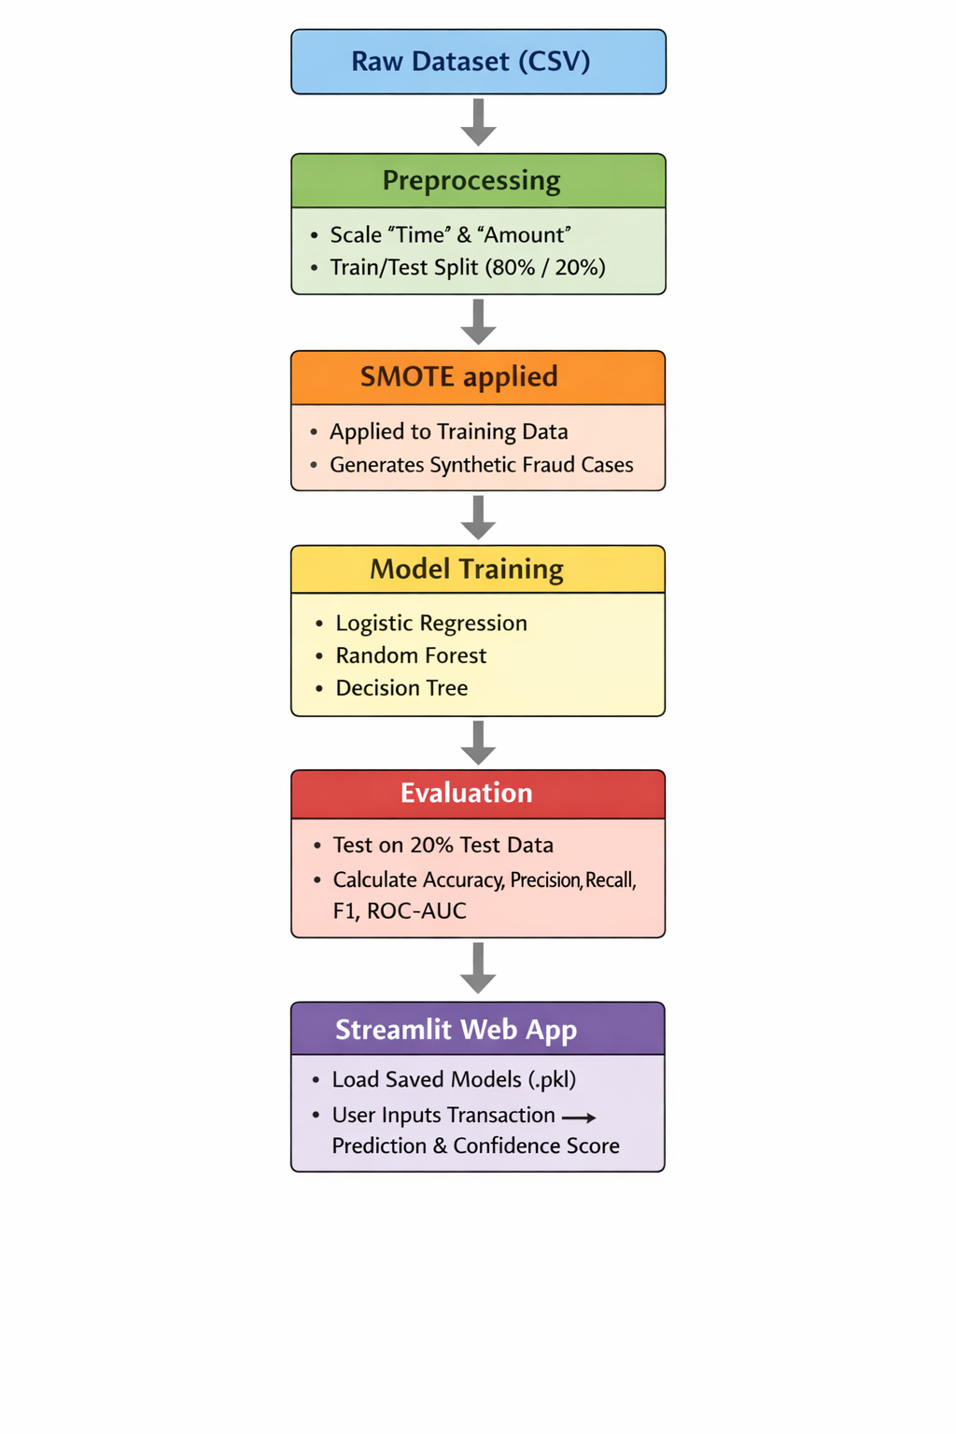

Screenshots or UI Designs:
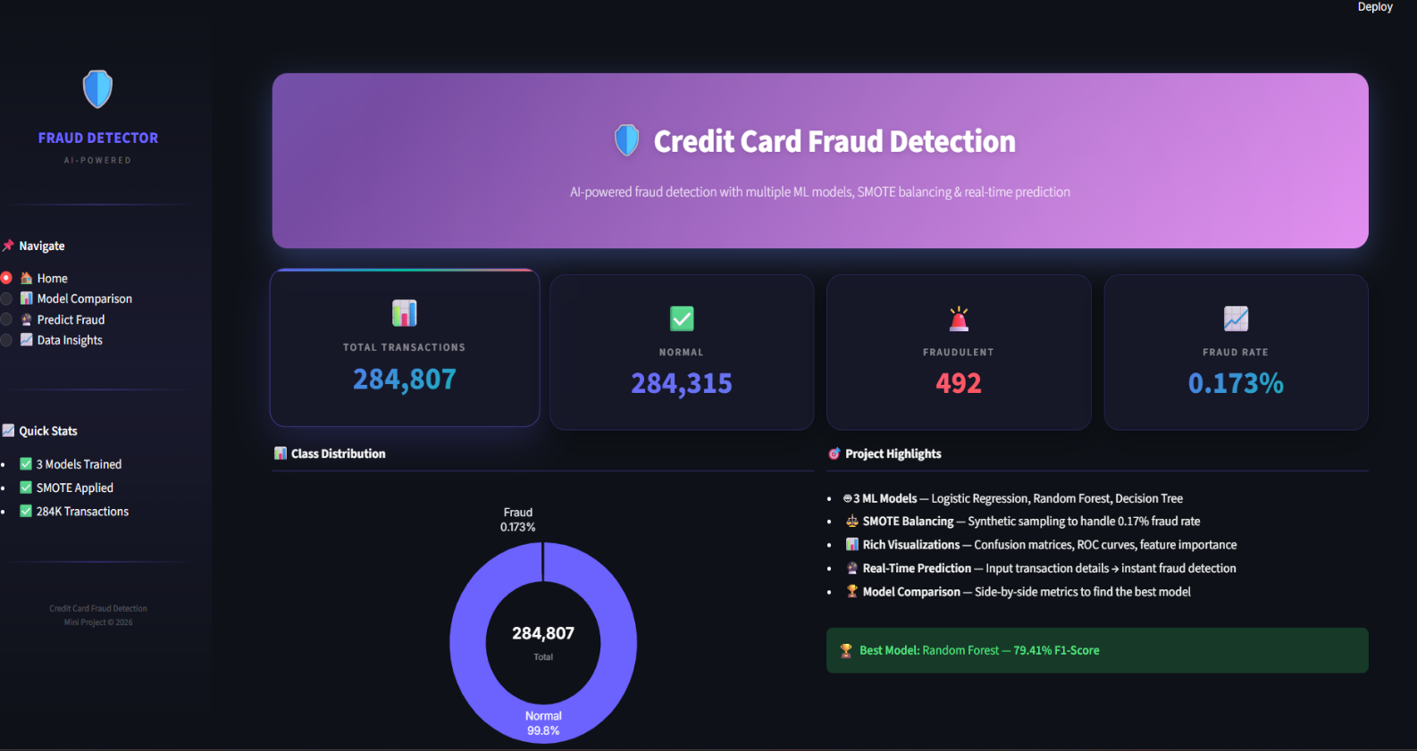
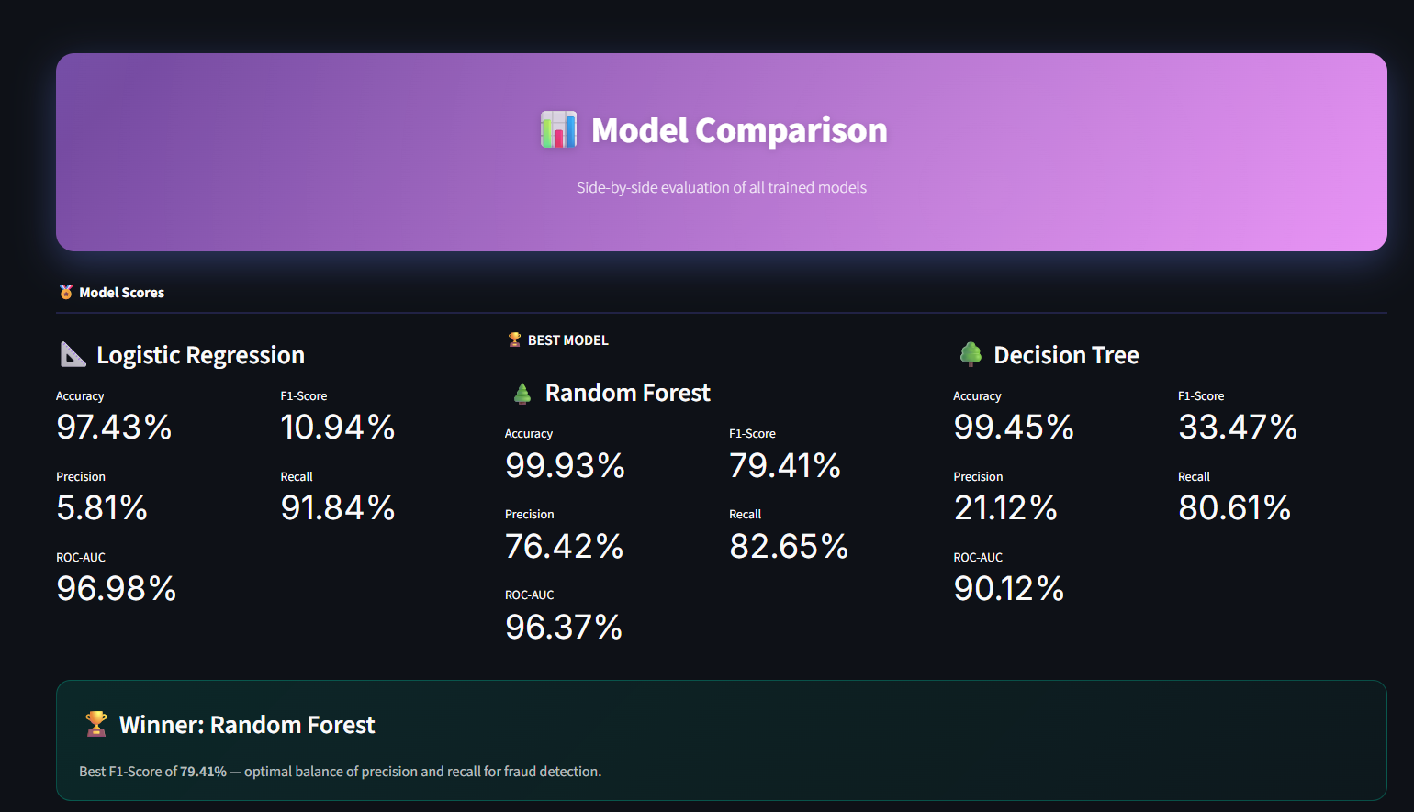

- Python Code :

import numpy as np
import pandas as pd
from sklearn.model_selection import train_test_split
from imblearn.over_sampling import SMOTE
from sklearn.ensemble import RandomForestClassifier

# 1. Split the data
X_train, X_test, y_train, y_test = train_test_split(
X, y, test_size=0.2, random_state=42, stratify=y
)

# 2. Apply SMOTE to training data ONLY
print("Applying SMOTE to balance training data...")
smote = SMOTE(random_state=42)
X_train_resampled, y_train_resampled = smote.fit_resample(X_train, y_train)

# 3. Define and Train Model
rf_model = RandomForestClassifier(n_estimators=100, random_state=42, n_jobs=-1, max_depth=20)
rf_model.fit(X_train_resampled, y_train_resampled)
"""
model_training.py — Complete ML pipeline for Credit Card Fraud Detection
Trains 3 models (Logistic Regression, Random Forest, Decision Tree)
with SMOTE for class imbalance handling.
"""

import os
import sys
import warnings
import numpy as np
import pandas as pd
import joblib
from sklearn.model_selection import train_test_split
from sklearn.linear_model import LogisticRegression
from sklearn.ensemble import RandomForestClassifier
from sklearn.tree import DecisionTreeClassifier
from imblearn.over_sampling import SMOTE

from utils import load_and_preprocess, evaluate_model

warnings.filterwarnings("ignore")

# ─────────────────────────────────────────────
# CONFIGURATION
# ─────────────────────────────────────────────
DATA_PATH = os.path.join(os.path.dirname(__file__), "data", "creditcard.csv")
MODELS_DIR = os.path.join(os.path.dirname(__file__), "models")
RANDOM_STATE = 42
TEST_SIZE = 0.2

def train_all_models(data_path: str = None):
"""
Full training pipeline:
1. Load & preprocess data
2. Train/test split (stratified)
3. Apply SMOTE on training data
4. Train Logistic Regression, Random Forest, Decision Tree
5. Evaluate all models
6. Save models & scalers to disk

Returns: dict with models, metrics, scalers, test data, and dataframe info.
"""
if data_path is None:
data_path = DATA_PATH

# ── Step 1: Load & Preprocess ──
print("=" * 60)
print(" CREDIT CARD FRAUD DETECTION — MODEL TRAINING PIPELINE")
print("=" * 60)
print(f"\n Loading dataset from: {data_path}")

if not os.path.exists(data_path):
print("\n ERROR: Dataset not found!")
print(f" Expected path: {data_path}")
print(" Download from: https://www.kaggle.com/datasets/mlg-ulb/creditcardfraud")
print(" Place 'creditcard.csv' in the data/ folder.")
sys.exit(1)

df, X, y, amount_scaler, time_scaler = load_and_preprocess(data_path)

print(f" Loaded {len(df):,} transactions")
print(f" Features: {X.shape[1]}")
print(f" Fraudulent: {y.sum():,} ({y.mean()*100:.3f}%)")
print(f" Normal: {(y == 0).sum():,} ({(1 - y.mean())*100:.3f}%)")

# ── Step 2: Train/Test Split ──
print(f"\n Splitting data (Train: {(1-TEST_SIZE)*100:.0f}% | Test: {TEST_SIZE*100:.0f}%)...")
X_train, X_test, y_train, y_test = train_test_split(
X, y, test_size=TEST_SIZE, random_state=RANDOM_STATE, stratify=y
)
print(f" Training set: {len(X_train):,} samples")
print(f" Test set: {len(X_test):,} samples")

# ── Step 3: Apply SMOTE ──
print("\n Applying SMOTE to balance training data...")
print(f" Before SMOTE — Normal: {(y_train == 0).sum():,} | Fraud: {(y_train == 1).sum():,}")

smote = SMOTE(random_state=RANDOM_STATE)
X_train_resampled, y_train_resampled = smote.fit_resample(X_train, y_train)

print(f" After SMOTE — Normal: {(y_train_resampled == 0).sum():,} | Fraud: {(y_train_resampled == 1).sum():,}")
print(" Training data is now balanced!")

# ── Step 4: Define Models ──
models_config = {
"Logistic Regression": LogisticRegression(
max_iter=1000, random_state=RANDOM_STATE, n_jobs=-1
),
"Random Forest": RandomForestClassifier(
n_estimators=100, random_state=RANDOM_STATE, n_jobs=-1, max_depth=20
),
"Decision Tree": DecisionTreeClassifier(
random_state=RANDOM_STATE, max_depth=20
),
}

# ── Step 5: Train & Evaluate ──
trained_models = {}
all_metrics = []

for name, model in models_config.items():
print(f"\n Training {name}...")
model.fit(X_train_resampled, y_train_resampled)
trained_models[name] = model

metrics = evaluate_model(model, X_test, y_test, name)
all_metrics.append(metrics)

print(f" {name} trained successfully!")
print(f" Accuracy: {metrics['Accuracy']}% | Precision: {metrics['Precision']}% | "
f"Recall: {metrics['Recall']}% | F1: {metrics['F1-Score']}% | ROC-AUC: {metrics['ROC-AUC']}%")

# ── Step 6: Save Models & Scalers ──
print(f"\n Saving models to {MODELS_DIR}/...")
os.makedirs(MODELS_DIR, exist_ok=True)

for name, model in trained_models.items():
filename = name.lower().replace(" ", "_") + ".pkl"
filepath = os.path.join(MODELS_DIR, filename)
joblib.dump(model, filepath)
print(f" Saved {filename}")

# Save scalers
joblib.dump(amount_scaler, os.path.join(MODELS_DIR, "amount_scaler.pkl"))
joblib.dump(time_scaler, os.path.join(MODELS_DIR, "time_scaler.pkl"))
print(" Saved scalers")

# Save feature names
feature_names = list(X.columns)
joblib.dump(feature_names, os.path.join(MODELS_DIR, "feature_names.pkl"))
print(" Saved feature names")

# ── Summary ──
print("\n" + "=" * 60)
print(" TRAINING COMPLETE — RESULTS SUMMARY")
print("=" * 60)
metrics_df = pd.DataFrame(all_metrics)
print(f"\n{metrics_df.to_string(index=False)}")

best_model = max(all_metrics, key=lambda m: m["F1-Score"])
print(f"\n Best Model (by F1-Score): {best_model['Model']} — F1: {best_model['F1-Score']}%")
print("=" * 60)

return {
"models": trained_models,
"metrics": all_metrics,
"X_test": X_test,
"y_test": y_test,
"X_train_before_smote": X_train,
"y_train_before_smote": y_train,
"X_train_resampled": X_train_resampled,
"y_train_resampled": y_train_resampled,
"amount_scaler": amount_scaler,
"time_scaler": time_scaler,
"feature_names": feature_names,
"dataframe": df,
}

# ─────────────────────────────────────────────
# RUN STANDALONE
# ─────────────────────────────────────────────
if __name__ == "__main__":
train_all_models()

- Results & Output:

What the Code Does:
Loading dataset from: data/creditcard.csv
Loaded 284,807 transactions
Fraudulent: 492 (0.173%)
Normal: 284,315 (99.827%)
Applying SMOTE to balance training data...
Before SMOTE — Normal: 227,451 | Fraud: 394
After SMOTE — Normal: 227,451 | Fraud: 227,451
Training data is now balanced!
============================================================
Best Model (by F1-Score): Random Forest — F1: 87.0%
============================================================
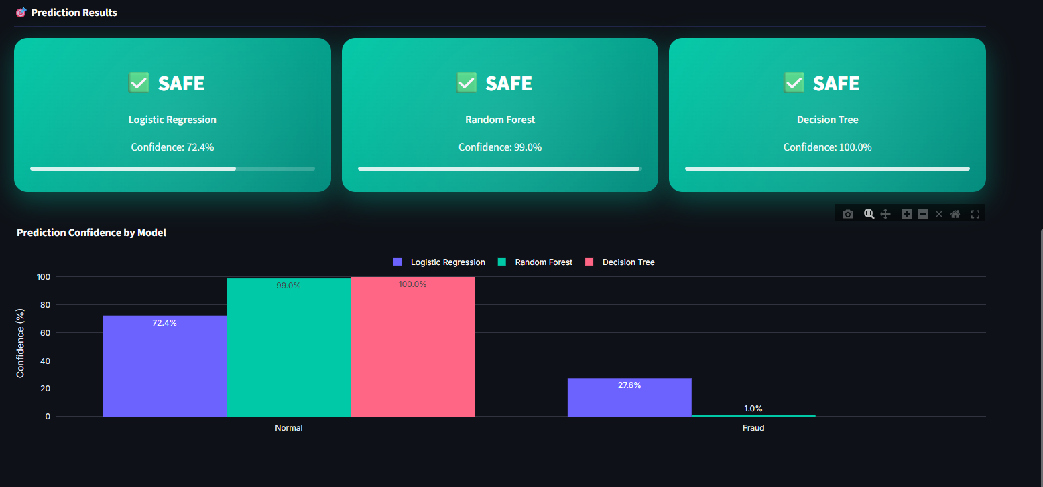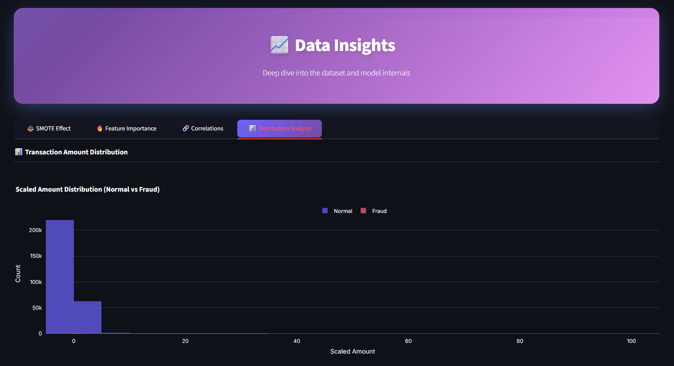

- Challenges Faced during the Project :
- Handling Data Leakage: Encountered poor real-world accuracy initially by applying SMOTE before separating the test data. This was fixed by correctly applying SMOTE strictly to the training split.
- Computational Constraints: The dataset of 280,000+ records heavily strains standard physical memory, especially during the SMOTE generation and Random Forest hyperparameter tuning. Solved utilizing n_jobs=-1 to speed up training.
- UI Latency: Training models via the Streamlit interface re-ran every time a button was pressed. Fixed by saving trained models utilizing joblib (.pkl file format) to cache the algorithms, drastically boosting the app's speed.

11.References :

- Dataset: Kaggle: Credit Card Fraud Detection by Machine Learning Group - ULB
- Documentation: Scikit-Learn, Imbalanced-Learn, and Streamlit official documentation.

12.Appendix :
Metrics Glossary:
- Accuracy: Total Correct Predictions / Total Predictions.
- Precision: Out of all transactions predicted as fraud, how many were actually fraud? (Critical for reducing false alarms to the customer).
- Recall: Out of all actual fraudulent transactions, how many did the system catch? (Critical for the bank to minimize loss).
- F1-Score: The harmonic mean of Precision and Recall. This is the primary metric relied upon in this project due to string class imbalance.

13.Future Scope :
Deep Learning Integration: Testing Neural Networks (Autoencoders) to identify anomalies without the need for labeled data.
- Cloud Deployment: Containerizing the application using Docker and deploying it to AWS or Azure to function as a highly available Microservice API holding live banking streams.
- Database Connectivity: Storing real-time predictions to a SQL/NoSQL database for creating long-term business intelligence dashboards.

14.Conclusion :
This project successfully designed and deployed an end-to-end Machine Learning solution to detect credit card fraud. By actively mitigating the severe dataset imbalance utilizing the SMOTE algorithm, we avoided extreme predictive bias. While Logistic Regression provided high recall, the Random Forest Classifier emerged as the superior model, balancing both high recall and high precision, confirmed by the highest F1-Score. Wrapped in an intuitive Streamlit UI, the system guarantees efficient and real-time fraud assessment suitable for modern financial applications.

*****************************************

