

***Hey 👋👋, Thanks for the purchase***

***FIRST UNZIP FOLDER THAT YOU GOT !!!!!***

***\*\*\*\*WEB folder\*\*\*\****

***Configuration Firebase Database***

Go to firebase.com and follow this instructions below

<https://firebase.google.com/>

1. go to console
2. add project
3. set name example and waiting

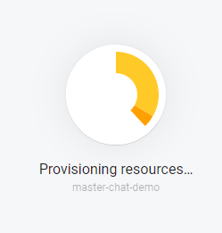

1. click here choose “web”

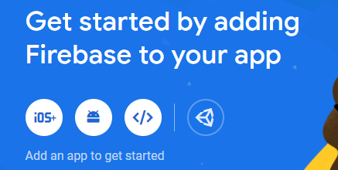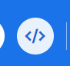here click

1. register app - set any name

6. and you get this and from this

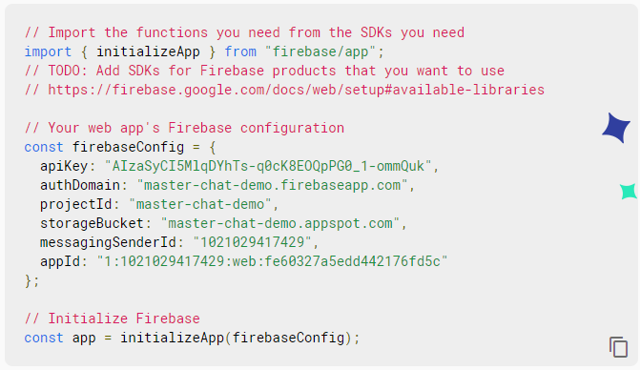

this copy

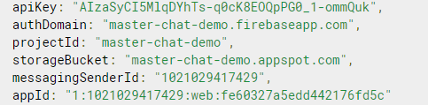

1. put copy firebase config to code in

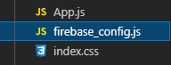

here put config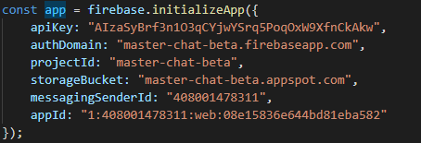

9. and go back to firebase.com

1. go to authentication and click “get started” click to ***email/password*** and then enable email and password



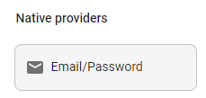

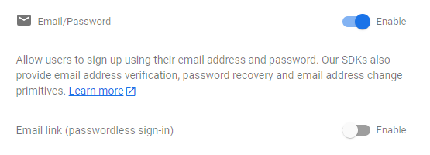

1. go to “firebase database” and click create database (click all things) and go to rules and change it like in image



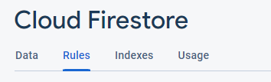

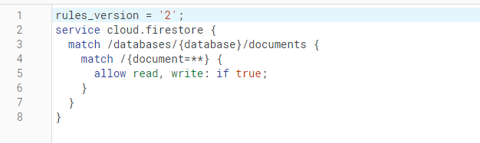

1. go to real time database and click create database and go to rules and change it like in image

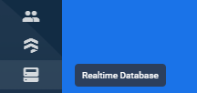

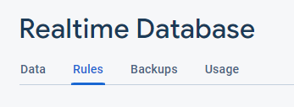

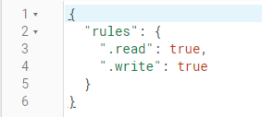

1. go to firebase storage and go to rules and change it like in image



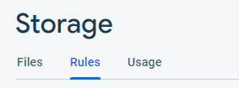

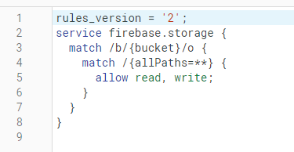

***Start/Open Code***

* you must have all instructions done before starting run code.
* open folder in code editor (best is with terminal - VS code)
* open terminal
* and write: ***npm install*** - install all node module packages
* after installing write: ***npm start*** - start web app on localhost in browser
* ***npm run build*** - create build folder to apply to your domain
* and you can do what you want

***In Folder***

***change favicon:***

* create new favicon and save it like *“favicon.ico”*

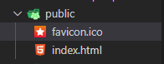

***change title:***

* in index.html change title
* <title>Master CHat</title>

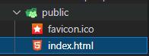

***src:***

in src folder you can see:

* assets (there is images and others)
* components (all components use in the web)
* context:

- AuthContext - auth things

- UserContext - current user info context

* pages (all pages in the web)

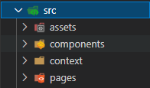

***If you want help, write me email on*** [***fistrba@gmail.com***](mailto:fistrba@gmail.com) ***or*** [***team.masterchat@gmail.com***](mailto:%20team.masterchat@gmail.com)

***\*\*\*\*APP folder\*\*\*\****

***in App.js you must to change link to your new chat web domain***

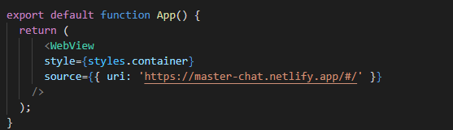

***Start/Open Code***

* open terminal
* write ***npm install***
* than ***npm start***
* first of all download expo go on your mobile phone
* than log in or sign up on expo go
* login in localhost expo
* after that use expo go on mobile app to open app or scan QR code to open app

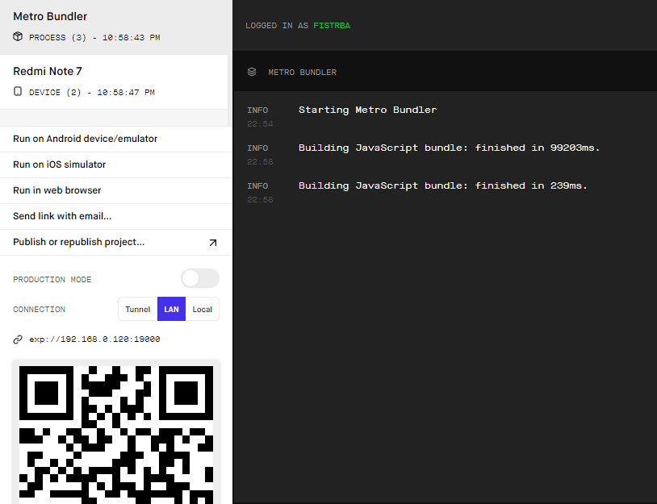

***Building Standalone Apps***

here is all documentation about build app: <https://docs.expo.dev/classic/building-standalone-apps/>

***Change***

change name of app here - in app.json:

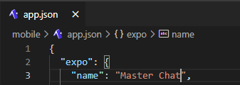

change icon of app here - in app.json

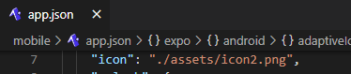

change splash of app here - in app.json

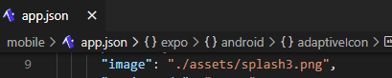

***Any Help ????, write me email on*** [***fistrba@gmail.com***](mailto:fistrba@gmail.com) ***or*** [***team.masterchat@gmail.com***](mailto:%20team.masterchat@gmail.com)

***FISTRBA TEAM***