Quiz Game Documentation

# Team Banana :

1. Asia Todorova – [atodorova](http://telerikacademy.com/Users/atodorova)
2. Ventsislav Staykov – [v.staykov](http://telerikacademy.com/Users/v.staykov)
3. Ivailo Ivanov – [Jarolim](http://telerikacademy.com/Users/Jarolim)
4. Ivan Ivanov – [ivivanov](http://telerikacademy.com/Users/ivivanov)
5. Ivan Petrov – [Ivanski1024](http://telerikacademy.com/Users/Ivanski1024)

# Project information:

The project purpose is creating a simple online quiz game. The player will compete with specially implemented AI bot on a variety of topics. The idea of the game flow is:

1. The player enters the game’s website where an initial welcome message shows up. Here the player should enter his/her name and press the “play” button. If the player do not enter his/her initials – a default value is send to the game engine – “John Doe”;
2. When the “play” button is pressed the main interface of the game is rendered on the page. It includes:
   1. A game field that contains the main menu buttons and the flags with all questions;
   2. A hidden field where the score board will be printed on demand;
   3. A message field which contains the main instructions and information for the player;
   4. A question field where each question will be printed;
   5. Two fields which keep the information for the two players – their names and points. The name of the player’s opponent is chosen from an array of cartoon characters’ names.
3. After rendering the initial game “skeleton” the player starts a new game with pressing the „start game” button”. Then 10 flags are loaded in the game field. When clicked each flag loads a question in the question field;
4. When a question is loaded the player has 10 sec to answer it or a random answer is selected. After that the opponent gives his answer two and they are both checked with the questions real answer;
5. If only the player or only the opponent answers correct – 10 points are added to their current points amount. If the two players give correct answer – another question of type “short answer question” is asked. Who is closer to the correct answer of the question gets the points;
6. When all of the 10 questions are answered – the winners name and points are saved in the score list using local storage.

Menu buttons:

* START GAME – starts a new game;
* END GAME – ends the current game; clears the players’ scores;
* HELP – shows some useful information about the game and how to play;
* TOP SCORES – shows/hides the score board;

There is also an implemented functionality for sharing the game using the most popular social networks.

# Additional functionality ideas:

* Pausing and resuming the game;
* Changing flags images and when question answer is correct – the clicked flags goes to the player’s field;

# Class diagram

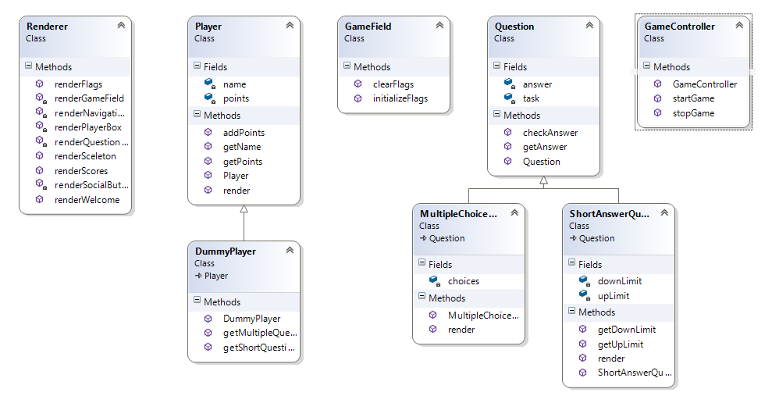

# Project repository

[Team Banana Quiz Game Repository](https://code.google.com/p/conqquiztador/)