센티넬원 월간 리포트

## 1.기간별 전체 탐지 내역

|  |  |  |  |  |
| --- | --- | --- | --- | --- |
| agent 명 | IP 주소 | 구분 | 처리 여부 | account>site>group |
| DESKTOP-8HIMT5R | 192.168.0.81 | Malware | marked_as_benign | Comsys>Default site>Default Group |
| DESKTOP-8HIMT5R | 192.168.0.81 | Malware | marked_as_benign | Comsys>Default site>Default Group |
| DESKTOP-8HIMT5R | 192.168.0.81 | Malware | marked_as_benign | Comsys>Default site>Default Group |
| DESKTOP-8HIMT5R | 192.168.0.81 | Malware | marked_as_benign | Comsys>Default site>Default Group |
| DESKTOP-8HIMT5R | 192.168.0.81 | Malware | marked_as_benign | Comsys>Default site>Default Group |
| DESKTOP-8HIMT5R | 192.168.0.81 | Malware | marked_as_benign | Comsys>Default site>Default Group |

## 2. 위협별 탐지

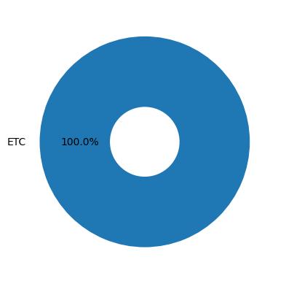

|  |  |
| --- | --- |
| 탐지내역 | 탐지수 |
| etc(Malware, ) | 6 |