') MINGW64:/c/project_dir x

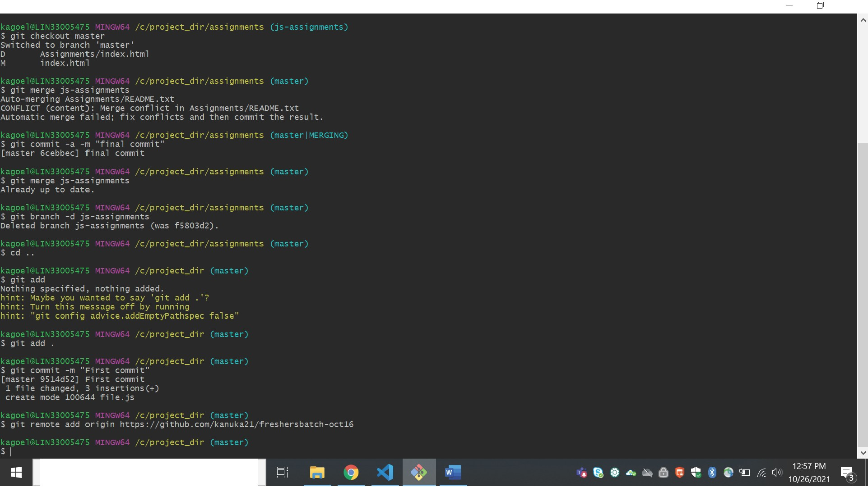

*P* Type here to search