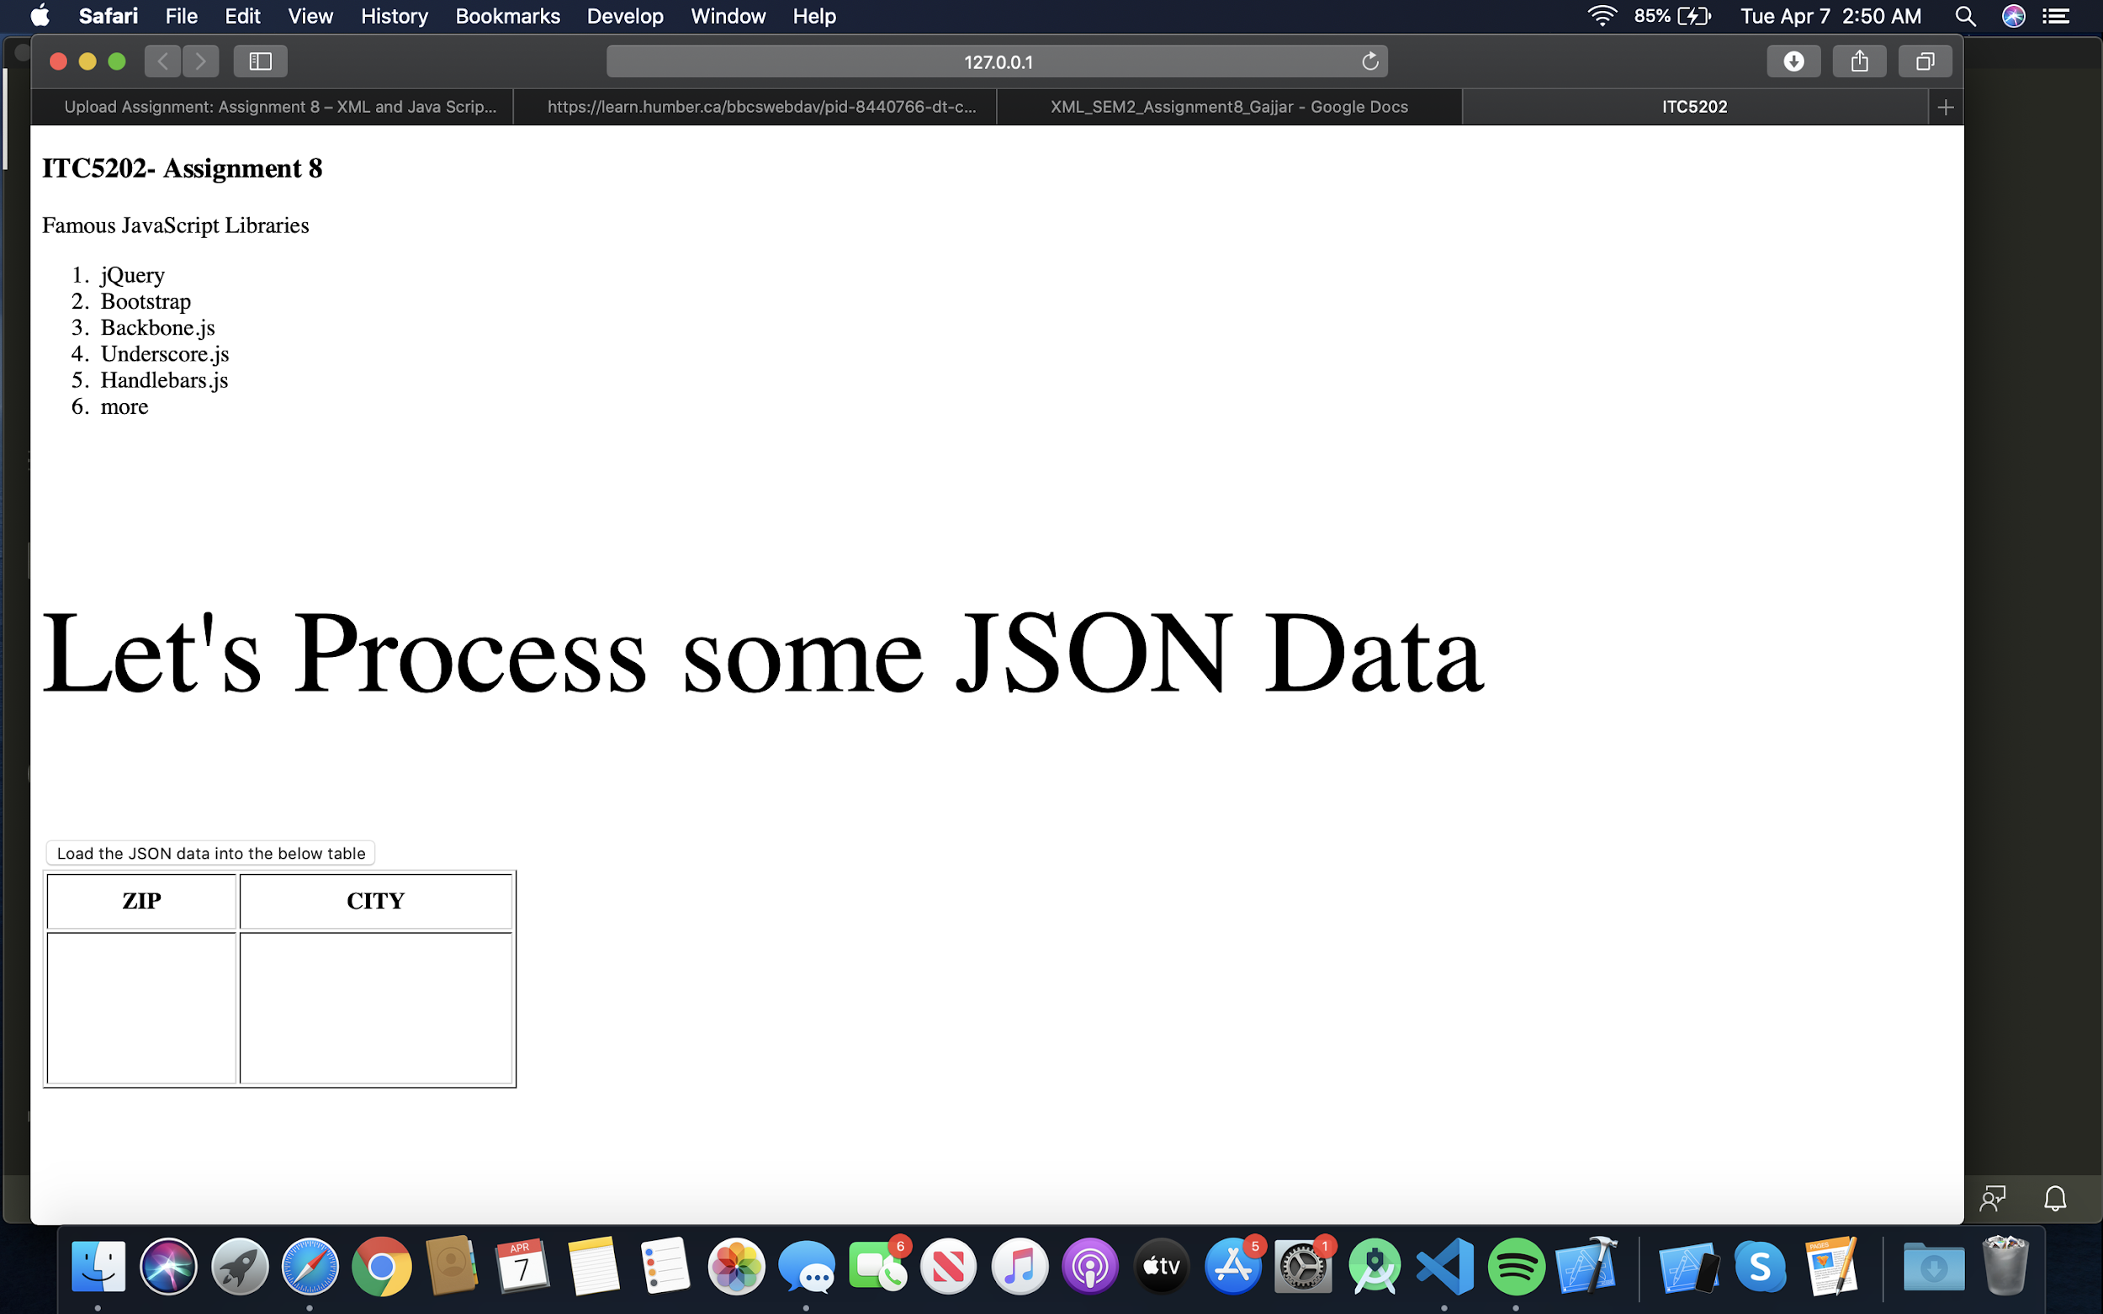

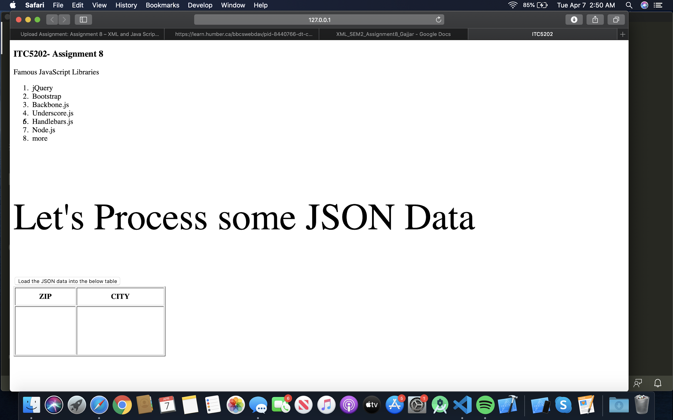

Step 3 :

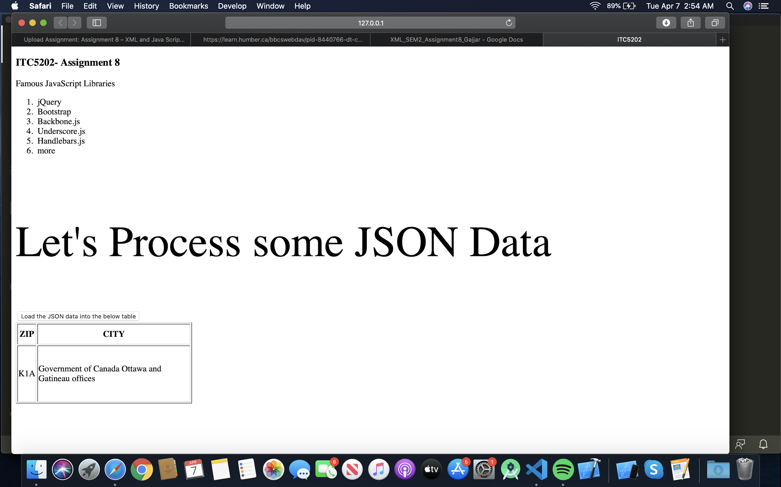

A-2

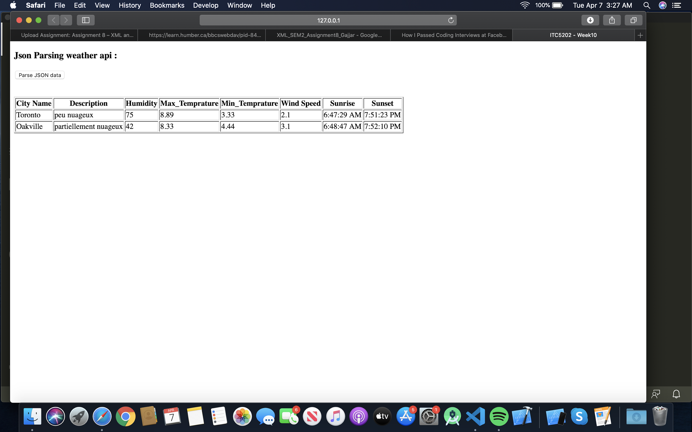

A-3

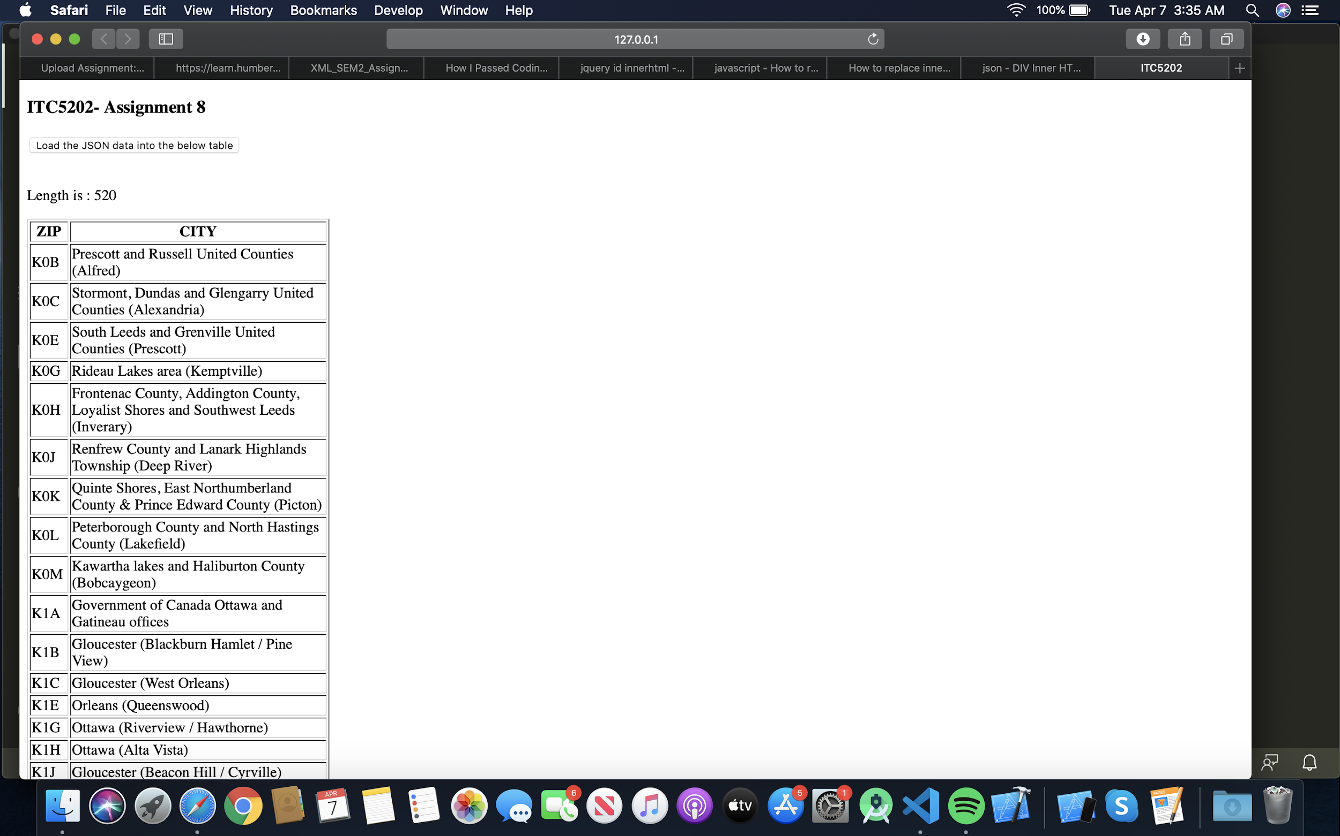

**Using your own word, explain what the main purpose of using it is?**

**Answer:-**

$.each() iterates over the DOM element. It replaces the general for loop while executing in the same way with minimized hardcode manipulation. We can efficiently use $.each to read multi level Json data with ease as compared to other iterating loops.

Syntax –

$(selector).each(function(index,element));

• index - The position index of the selector

• element - The current element