<?xml version="1.0" encoding="UTF-8" ?>

<?xml-stylesheet type="text/xsl" href="cust.xsl"?>

<customers>

<customer>

<customerID>1002</customerID>

<fname>John</fname>

<lname>Smith</lname>

<product>Laptop</product>

<invoiceNo>200</invoiceNo>

</customer>

<customer>

<customerID>1002</customerID>

<fname>John</fname>

<lname>Smith</lname>

<product>Printer</product>

<invoiceNo>200</invoiceNo>

</customer>

<customer>

<customerID>1005</customerID>

<fname>Sara</fname>

<lname>Coner</lname>

<product>Mouse</product>

<invoiceNo>300</invoiceNo>

</customer>

<customer>

<customerID>1005</customerID>

<fname>Sara</fname>

<lname>Coner</lname>

<product>Keyboard</product>

<invoiceNo>310</invoiceNo>

</customer>

<customer>

<customerID>1005</customerID>

<fname>Sara</fname>

<lname>Coner</lname>

<product>Printer</product>

<invoiceNo>310</invoiceNo>

</customer>

</customers>

Ans1 xsl

<?xml version="1.0" encoding="UTF-8" ?>

<xsl:stylesheet version="1.0"

xmlns:xsl="http://www.w3.org/1999/XSL/Transform">

<xsl:template match="/">

<html>

<head>

<title>Title of the page</title>

</head>

<style>

table, th, td {

border: 1px solid black;

border-collapse: collapse;

}

th{

color : yellow;

background-color : blue;

}

td, th {

border: 1px solid #ddd;

padding: 8px;

}

tr:nth-child(even){background-color: #f2f2f2;}

</style>

<body>

<h1>XSLT Answer 1</h1>

<table border="1">

<tr>

<th> Customer ID </th>

<th> FName </th>

<th> LName </th>

<th> Product </th>

<th> Invoice No </th>

</tr>

<xsl:for-each select="customers/customer">

<tr>

<td>

<xsl:value-of select="customerID"/>

</td>

<td>

<xsl:value-of select="fname"/>

</td>

<td>

<xsl:value-of select="lname"/>

</td>

<td>

<xsl:value-of select="product"/>

</td>

<td>

<xsl:value-of select="invoiceNo"/>

</td>

</tr>

</xsl:for-each>

</table>

</body>

</html>

</xsl:template>

</xsl:stylesheet>

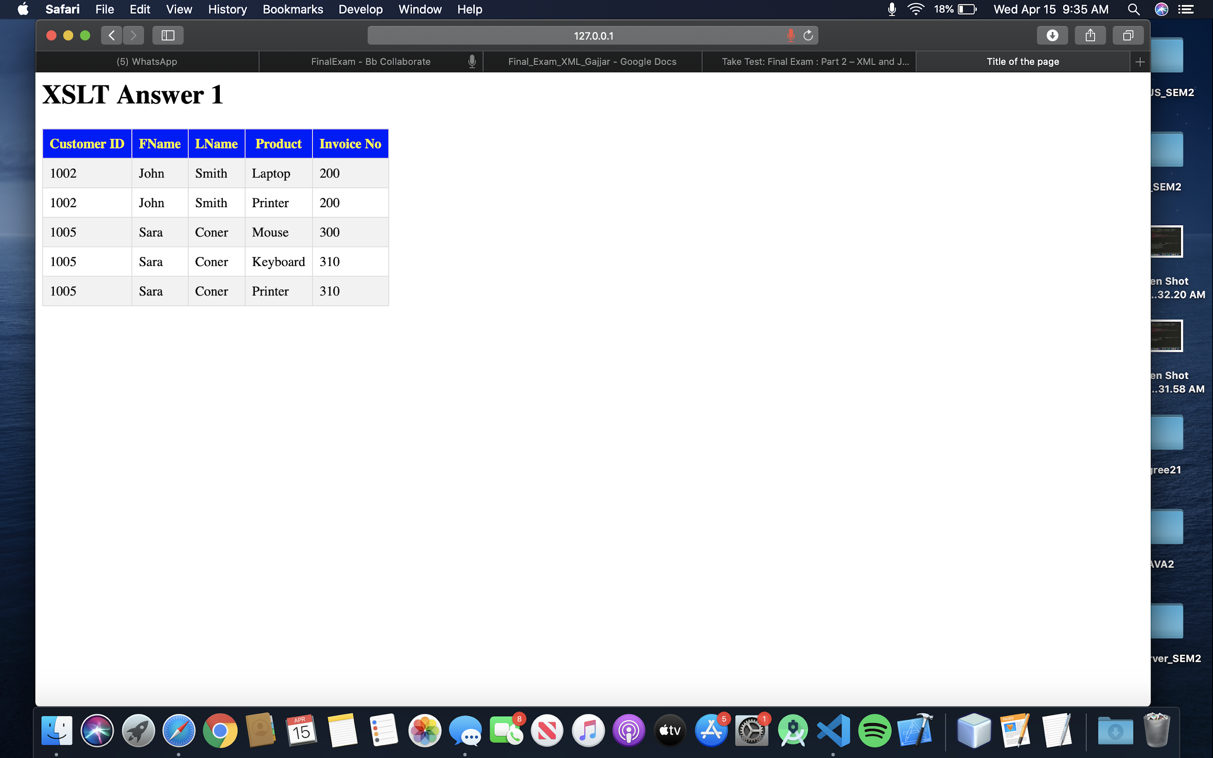

Ans 2 :

<!DOCTYPE html>

<html lang="en">

<head>

<title>Answer 2</title>

<style>

table,

th,

td {

*border*: 1px solid black;

*border-collapse*: collapse;

}

th {

*color*: yellow;

*background-color*: blue;

}

td,

th {

*border*: 1px solid #ddd;

*padding*: 8px;

}

tr:nth-child(even) {

*background-color*: #f2f2f2;

}

</style>

<script src="https://code.jquery.com/jquery-3.4.1.min.js"></script>

<script>

$(document).ready(*function*() {

$("#btn").click(*function*() {

*var* str = $("#inputId").val();

$.getJSON("customer.json", *function*(*result*) {

*var* list = *result*;

output = "<table border='1' >";

output += "<tr>";

output += "<th> First Name </th>";

output += "<th> Last Name </th>";

output += "<th> Product </th>";

output += "<th> Invoice No </th>";

output += "</tr>";

for (i in list) {

if (list[i].customerID === str) {

output += "<tr>";

output += "<td>" + list[i].fname + "</td>";

output += "<td>" + list[i].lname + "</td>";

output += "<td>" + list[i].product + "</td>";

output += "<td>" + list[i].invoiceNo + "</td>";

output += "</tr>";

}

}

output += "</table>";

$("#demo").html(output);

});

});

});

</script>

</head>

<body>

Enter Id : <input type="text" id="inputId">

<br/> <button type="button" id="btn">Submit</button>

<br/>

<p id="demo"></p>

</body>

</html>

.json

[{

*"customerID"*: "1002",

*"fname"*: "John",

*"lname"*: "Smith",

*"product"*: "Laptop",

*"invoiceNo"*: "200"

},

{

*"customerID"*: "1002",

*"fname"*: "John",

*"lname"*: "Smith",

*"product"*: "Printer",

*"invoiceNo"*: "200"

},

{

*"customerID"*: "1005",

*"fname"*: "Sara",

*"lname"*: "Coner",

*"product"*: "Mouse",

*"invoiceNo"*: "300"

},

{

*"customerID"*: "1005",

*"fname"*: "Sara",

*"lname"*: "Coner",

*"product"*: "Keyboard",

*"invoiceNo"*: "310"

},

{

*"customerID"*: "1005",

*"fname"*: "Sara",

*"lname"*: "Coner",

*"product"*: "Printer",

*"invoiceNo"*: "310"

}

]

