Kanupriya Sharma C074

Experiment 1: Implementation of stack using menu driven approach.

Code:

#include<stdio.h>

int arr[10];

int top = -1;

int n = 10;

void push(int val) {

    if(top == n - 1) {

        printf("Stack is Full\n");

    } else {

        top = top + 1;

        arr[top] = val;

    }}

void peek() {

    if(top == -1)

        printf("\nStack is empty\n");

    else

        printf("\nTop element is %d\n", arr[top]);

  }

void pop() {

    int temp;

    if(top == -1)

        printf("Stack is empty\n");

    else {

        temp = arr[top];

        top = top - 1;

        printf("Deleted item is %d\n", temp);}}

void display() {

    if(top == -1) {

        printf("Stack is empty\n");    }

else {

        for(int i = top; i >= 0; i--) {

            printf("Element: %d\n", arr[i]);        }}}

int main() {

    int choice, e, val;

    do {

        printf("Enter your choice:\n1. Push\n2. Pop\n3. Display\n4. Peek\n");

        scanf("%d", &choice);

switch(choice) {

            case 1:

                printf("Enter the value to be pushed: ");

                scanf("%d", &val);

                push(val);

                break;

            case 2:

                pop();

                break;

            case 3:

                display();

                break;

            case 4:

                peek();

                break;

            default:

                printf("Invalid choice\n");

        }

        printf("Enter 5 to continue: ");

        scanf("%d", &e);

    } while(e == 5);

    return 0;

}

Output:

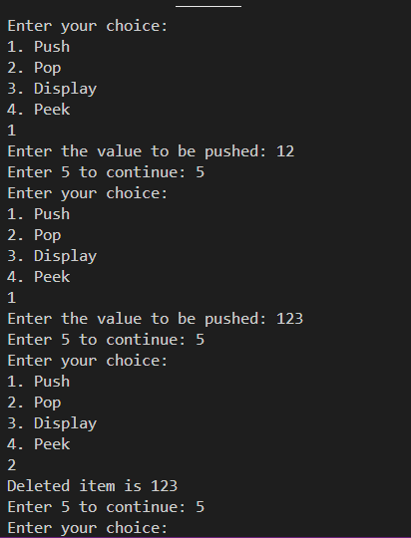

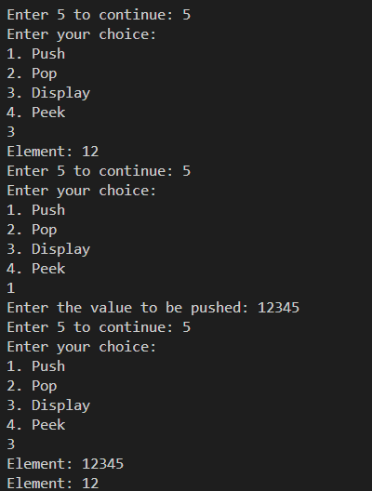

Experiment 2: Implementation of Infix to Postfix conversion

Code:

#include <stdio.h>

#include <ctype.h>

#define MAX 30

char stack[MAX];

int top = -1;

void push(char val) {

    if (top < MAX - 1) {

        stack[++top] = val;

    }}

char pop() {

    if (top == -1)

        return -1;

    else

        return stack[top--];}

int priority(char ch) {

    switch (ch) {

        case '^':

            return 3;

        case '*':

        case '/':

            return 2;

        case '+':

        case '-':

            return 1;

        default:

            return 0;

    }}

void infix_to_postfix(char infix[], char postfix[]) {

    char temp, x;

    int i = 0, j = 0;

    while (infix[i] != '\0') {

        temp = infix[i];

        if (isalnum(temp)) {

            postfix[j++] = temp;

        } else if (temp == '(') {

            push(temp);

        } else if (temp == ')') {

            while ((x = pop()) != '(') {

                postfix[j++] = x;

            }

        } else {

            while (top != -1 && priority(stack[top]) > priority(temp) ||

                   (priority(stack[top]) == priority(temp))) {

                x = pop();

                postfix[j++] = x;

            }

            push(temp);

        }

        i++; }

    while (top != -1) {

        postfix[j++] = pop();

    }

    postfix[j] = '\0';

}

int main() {

    char infix[MAX];

    char postfix[MAX];

    printf("Enter the infix expression: ");

    scanf("%s", infix);

    infix_to_postfix(infix, postfix);

    printf("Postfix is: %s\n", postfix);

    return 0;

}

Output:





Experiment 3: Implementation of Linked List using menu driven approach.

Code:

#include <stdio.h>

#include <stdlib.h>

typedef struct node {

    int data;

    struct node* next;

} node;

node* head = NULL;

node* temp = NULL;node* newnode = NULL;

void insertBeg(){

    node* newnode = (node*)malloc(sizeof(node));

    if (newnode == NULL) {

        printf("Memory allocation failed\n");

        return;

    }

    printf("Enter data: ");

    scanf("%d", &newnode->data);

    newnode->next = head;

    head = newnode;

}

void inserEnd(){

    node* newnode = (node*)malloc(sizeof(node));

    if (newnode == NULL) {

        printf("Memory allocation failed\n");

        return;

    }

    printf("Enter data: ");

    scanf("%d", &newnode->data);

    newnode->next = 0;

    if (head == NULL) {

        head = newnode;

    } else {

        temp = head;

        while(temp->next != 0) {

            temp = temp->next;

        }

        temp->next = newnode;

    }

}

    void insertAny(){

    int i=1,pos;

    printf("Enter pos: ");

    scanf("%d", &pos);

    if (pos == 1) {

        node* newnode = (node*)malloc(sizeof(node));

        if (newnode == NULL) {

            printf("Memory allocation failed\n");

            return;

        }

        printf("Enter data: ");

        scanf("%d", &newnode->data);

        newnode->next = head;

        head = newnode;

    } else {

        node* newnode = (node*)malloc(sizeof(node));

        if (newnode == NULL) {

            printf("Memory allocation failed\n");

            return;

        }

        printf("Enter data: ");

        scanf("%d", &newnode->data);

        temp = head;

        while (i < pos ) {

            if(temp->next == NULL) {

                printf("Position out of range\n");

                return;

            }

            temp = temp->next;

            i++;

        }

        newnode->next = temp->next;

        temp->next = newnode;

    }

}

    void deleteBeg(){

    temp=head;

    head=head->next;

    free(temp);

}

    void deleteEnd(){node*prev;

    temp=head;

    while(temp->next!=0){

        prev=temp;

        temp=temp->next;    }

        if(temp==head){head==0;}

        else{prev->next=0;}

        free(temp);

}

    void deleteAny(){

     int i=1,pos;node* nextnode;

    printf("Enter pos: ");

    scanf("%d", &pos);

    temp=head;

    while(i<pos-1){

        temp=temp->next;

        i++;

    }

    if (temp == NULL || temp->next == NULL) {

        printf("Invalid position. Position exceeds list length.\n");

        return;

    }

    nextnode=temp->next;

    temp->next=nextnode->next;

    free(nextnode);

}

    void display() {

    temp = head;

    while (temp != NULL) {

        printf("%d\n", temp->data);

        temp = temp->next;

    }

}

    void search(){ int i=1,key;node* temp;

    printf("Enter data to be searched: ");

    scanf("%d", &key);

    temp=head;

    if(temp==NULL)

    {

        printf("\nThe list is empty");

    }

    int found=0;

    while((temp!=NULL)&&(found==0))

    {

        if(temp->data!=key)

        temp=temp->next;

        else

        found=1;  }

    if(found==1)

    printf("\nThe element is present\n");

    else

    printf("\nThe element is not present\n"); }

    int main(){

    int choice,e;

    printf("Choices: \n1.Insert beg\n2.Insert end\n3.Insert any\n4.Display\n5.Delete beg\n6.Delet end\n7.Delete Any\n8.Search\n");

    do {

        printf("Enter the choice:");

        scanf("%d", &choice);

        switch (choice) {

            case 1: insertBeg(); break;

            case 2: inserEnd(); break;

            case 3: insertAny(); break;

            case 4: display(); break;

            case 5: deleteBeg(); break;

            case 6: deleteEnd();break;

            case 7: deleteAny();break;

            case 8: search();break; }

        printf("Enter 9 to continue: ");

        scanf("%d", &e);

    } while (e == 9);

    return 0;

}

Output:

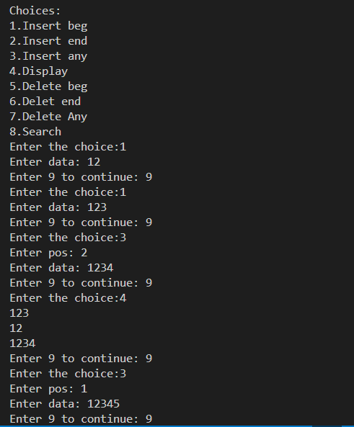

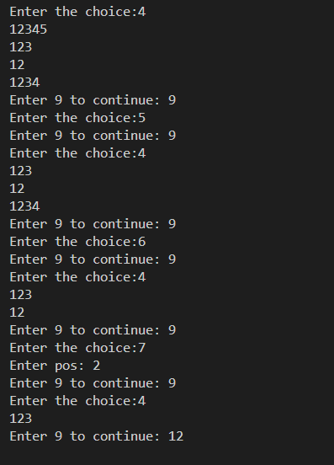

Experiment 4: Implementation of stack and queue using Linked List.

Code: QUEUE

#include <stdio.h>

#include <stdlib.h>

typedef struct node

{

    int data;

    struct node*next;

    }node;

node * front=0;node*rear=0;

void enqueue(int val){node *newnode;

newnode=(node *)malloc(sizeof (node));

newnode->data=val;

newnode->next=0;

    if(front==0&&rear==0){

        front=rear=newnode;

}else{

rear->next=newnode;

rear=newnode;

}

}

void dequeue(){node * temp;

    temp==front;

if(front==0&&rear==0){

        printf("empty");

}else{

  front=  front->next;

    free(temp);

}

}

void display(){

    node*temp;

    temp=front;

    if(front==0)printf("empty");

    else{

        while(temp!=0){

            printf("%d ",temp->data);

            temp=temp->next;

        }}}

void peek(){

    if(front==0)printf("empty");

    else

    printf(" top is %d\n",front->data);

}

int main() {

    int choice, e, val;

 printf("Enter your choice:\n1. Push\n2. Pop\n3. Display\n4. Peek\n");

    do {

        printf("Enter your choice:");

        scanf("%d", &choice);

        switch(choice) {

            case 1:

                printf("Enter the value to be pushed: ");

                scanf("%d", &val);

                enqueue(val);

                break;

            case 2:

                dequeue();

                break;

            case 3:

                display();

                break;

            case 4:

                peek();

                break;

            default:

                printf("Invalid choice\n");}

        printf("\nEnter 5 to continue: ");

        scanf("%d", &e);

    } while(e == 5);

    return 0;

}

Output:

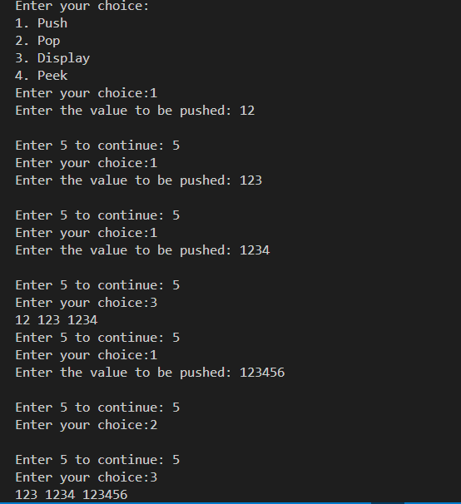

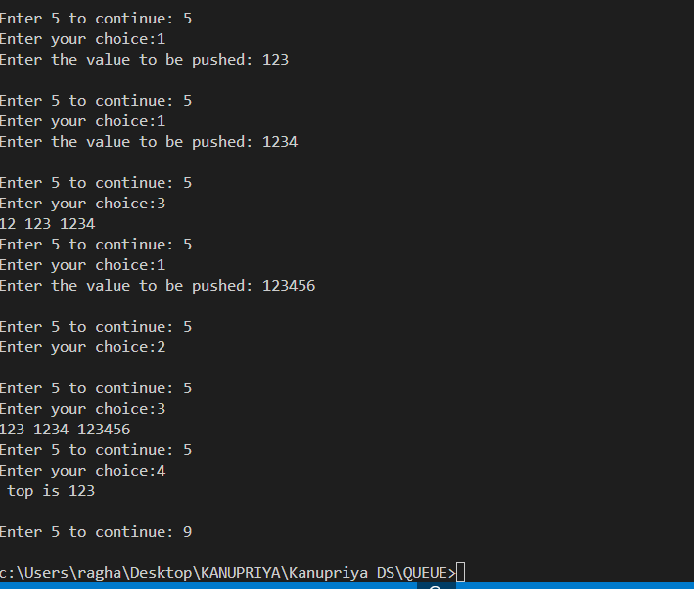

Code: STACK

#include <stdio.h>

#include <stdlib.h>

typedef struct node

{

    int data;

    struct node*next;

}node;

node*top=0;

void push(int val){

    node*newnode;

    newnode=(node*)malloc(sizeof(node));

    newnode->data=val;

    newnode->next=top;

    top=newnode;

}

void display(){

    node*temp;

    temp=top;

    if(top==0)printf("empty");

    else{

        while(temp!=0){

            printf("%d ",temp->data);

            temp=temp->next;

        }

    }

}

void peek(){

    if(top==0)printf("empty");

    else

    printf(" top is %d",top->data);

}

void pop(){

    node*temp;

    temp=top;

    if(top==0){

        printf("empty");

    }else{

        printf("%d",top->data);

        top=top->next;

        free(temp);

    }}

int main() {

    int choice, e, val;

printf("Enter your choice:\n1. Push\n2. Pop\n3. Display\n4. Peek\n");

    do {

        printf("Enter your choice: ");

        scanf("%d", &choice);

        switch(choice) {

            case 1:

                printf("Enter the value to be pushed: ");

                scanf("%d", &val);

                push(val);

                break;

            case 2:

                pop();

                break;

            case 3:

                display();

                break;

            case 4:

                peek();

                break;

            default:

                printf("Invalid choice\n");

        }

        printf("\nEnter 5 to continue: ");

        scanf("%d", &e);

    } while(e == 5);

    return 0;

}

Output:

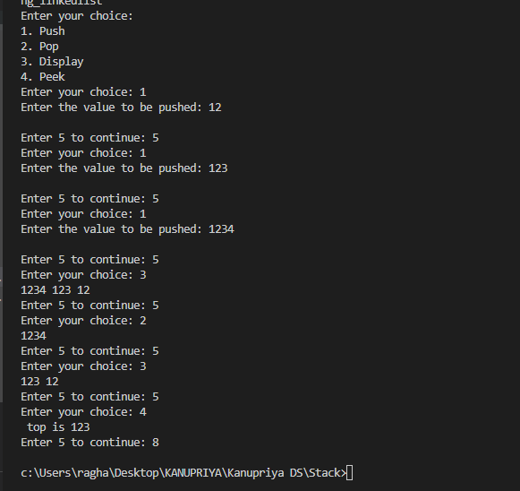

Experiment 5: Implementation of polynomials operations (addition, subtraction) using Linked List.

CODE:

#include <stdio.h>

#include <stdlib.h>

struct node {

    int num;

    int coeff;

    struct node* next;

};

struct node* add_node(struct node* start, int n, int c);

struct node* display_poly(struct node* start);

struct node* add_poly(struct node* start1, struct node* start2, struct node* start3);

struct node* sub_poly(struct node* start1, struct node* start2, struct node* start4);

int main() {

    struct node *start1 = NULL, *start2 = NULL, *start3 = NULL, *start4 = NULL;

    int option, n, c;

    do {

        printf("\n******* MAIN MENU *******");

        printf("\n 1. Enter the first polynomial");

        printf("\n 2. Display the first polynomial");

        printf("\n 3. Enter the second polynomial");

        printf("\n 4. Display the second polynomial");

        printf("\n 5. Add the polynomials");

        printf("\n 6. Display the addition result");

        printf("\n 7. Subtract the polynomials");

        printf("\n 8. Display the subtraction result");

        printf("\n 9. EXIT");

        printf("\n\n Enter your option : ");

        scanf("%d", &option);

        switch(option) {

            case 1:

                do {

                    printf("\n Enter the number: ");

                    scanf("%d", &n);

                    if(n == -1)

                        break;

                    printf("\t Enter its coefficient: ");

                    scanf("%d", &c);

                    start1 = add_node(start1, n, c);

                } while(n != -1);

                break;

            case 2:

                display_poly(start1);

                break;

            case 3:

                do {

                    printf("\n Enter the number: ");

                    scanf("%d", &n);

                    if(n == -1)

                        break;

                    printf("\t Enter its coefficient: ");

                    scanf("%d", &c);

                    start2 = add_node(start2, n, c);

                } while(n != -1);

                break;

            case 4:

                display_poly(start2);

                break;

            case 5:

                start3 = add_poly(start1, start2, start3);

                printf("\nAddition Completed.");

                break;

            case 6:

                display_poly(start3);

                break;

            case 7:

                start4 = sub_poly(start1, start2, start4);

                printf("\nSubtraction Completed.");

                break;

            case 8:

                display_poly(start4);

                break;

        }

    } while(option != 9);

    return 0;

}

struct node* display_poly(struct node* start) {

    struct node* ptr = start;

    if(ptr == NULL) {

        printf("Polynomial is empty.\n");

        return start;

    }

    while(ptr != NULL) {

        printf("%d x^%d", ptr->num, ptr->coeff);

        if (ptr->next != NULL)

            printf(" + ");

        ptr = ptr->next;

    }

    printf("\n");

    return start;

}

struct node* add_poly(struct node* start1, struct node* start2, struct node* start3) {

    struct node *ptr1 = start1, *ptr2 = start2;

    int sum_num;

    while(ptr1 != NULL && ptr2 != NULL) {

        if(ptr1->coeff == ptr2->coeff) {

            sum_num = ptr1->num + ptr2->num;

            start3 = add_node(start3, sum_num, ptr1->coeff);

            ptr1 = ptr1->next;

            ptr2 = ptr2->next;

        } else if(ptr1->coeff > ptr2->coeff) {

            start3 = add_node(start3, ptr1->num, ptr1->coeff);

            ptr1 = ptr1->next;

        } else {

            start3 = add_node(start3, ptr2->num, ptr2->coeff);

            ptr2 = ptr2->next;

        }

    }

    while(ptr1 != NULL) {

        start3 = add_node(start3, ptr1->num, ptr1->coeff);

        ptr1 = ptr1->next;

    }

    while(ptr2 != NULL) {

        start3 = add_node(start3, ptr2->num, ptr2->coeff);

        ptr2 = ptr2->next;

    }

    return start3;

}

struct node* sub_poly(struct node* start1, struct node* start2, struct node* start4) {

    struct node *ptr1 = start1, *ptr2 = start2;

    int sub_num;

    while(ptr1 != NULL && ptr2 != NULL) {

        if(ptr1->coeff == ptr2->coeff) {

            sub_num = ptr1->num - ptr2->num;

            start4 = add_node(start4, sub_num, ptr1->coeff);

            ptr1 = ptr1->next;

            ptr2 = ptr2->next;

        } else if(ptr1->coeff > ptr2->coeff) {

            start4 = add_node(start4, ptr1->num, ptr1->coeff);

            ptr1 = ptr1->next;

        } else {

            start4 = add_node(start4, -ptr2->num, ptr2->coeff);

            ptr2 = ptr2->next;

        }

    }

    while(ptr1 != NULL) {

        start4 = add_node(start4, ptr1->num, ptr1->coeff);

        ptr1 = ptr1->next;

    }

    while(ptr2 != NULL) {

        start4 = add_node(start4, -ptr2->num, ptr2->coeff);

        ptr2 = ptr2->next;

    }

    return start4;

}

struct node* add_node(struct node* start, int n, int c) {

    struct node* new_node = (struct node*)malloc(sizeof(struct node));

    new_node->num = n;

    new_node->coeff = c;

    new_node->next = NULL;

    if(start == NULL) {

        start = new_node;

    } else {

        struct node* ptr = start;

        while(ptr->next != NULL)

            ptr = ptr->next;

        ptr->next = new_node;

    }

    return start;

}

Output:

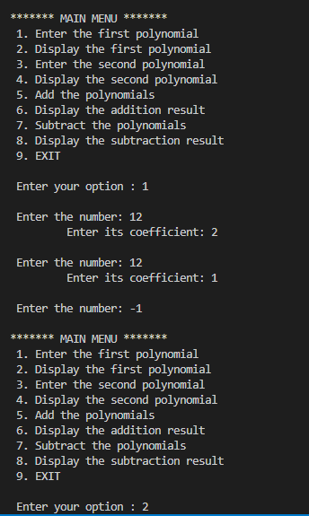

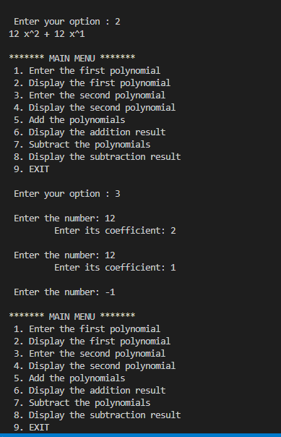

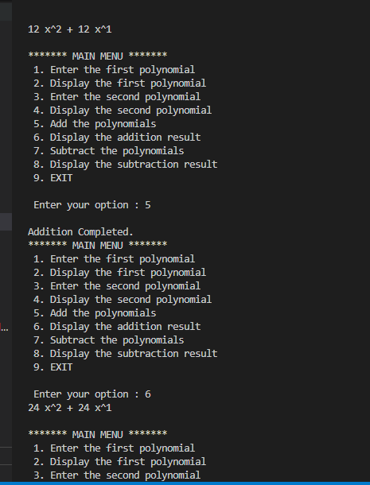

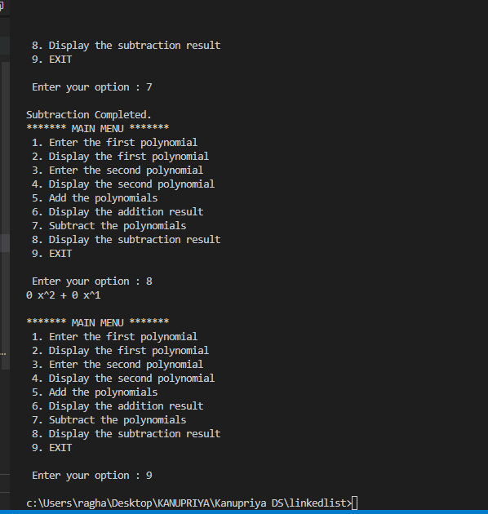

EXPERIMENT 6:

AIM: Implementation of double ended queue using menu driven approach

CODE:

#include <stdio.h>

#define MAX 20

int queue[MAX];

int rear = -1, front = -1;

void frontenqueue(int val) {

    if ((rear + 1) % MAX == front) {

        printf("Queue is full\n");

    } else if (front == -1) {

        front = rear = 0;

        queue[front] = val;

    } else if (front == 0) {

        front = MAX - 1;

        queue[front] = val;

    } else {

        front--;

        queue[front] = val;

    }

}

void rearenqueue(int val) {

    if ((rear + 1) % MAX == front) {

        printf("Queue is full\n");

    } else if (front == -1) {

        front = rear = 0;

        queue[rear] = val;

    } else if (rear == MAX - 1) {

        rear = 0;

        queue[rear] = val;

    } else {

        rear++;

        queue[rear] = val;

    }

}

void display(){int i=front;

    if(front==-1||rear==-1)

    printf("empty");    else{

        printf("queue is ");

        while(i!=rear){

            printf("%d ",queue[i]);

            i=(i+1)%MAX;

        }

        printf("%d",queue[rear]);

    }

}

int frontdelete() {

    if (front == -1) {

        printf("Queue is empty\n");

        return -1;

    } else {

        int temp = queue[front];

        if (front == rear) {

            front = rear = -1;

        } else {

            front = (front + 1) % MAX;

        }

        return temp;

    }

}

int reardelete() {

    if (front == -1) {

        printf("Queue is empty\n");

        return -1;

    } else {

        int temp = queue[rear];

        if (front == rear) {

            front = rear = -1;

        } else if (rear == 0) {

            rear = MAX - 1;

        } else {

            rear--;

        }

        return temp;

    }

}

void peek() {

    if (front == -1) {

        printf("Queue is empty\n");

    } else {

        printf("The first element is %d\n", queue[front]);

    }

}

int main() {

    int choice, e;

    printf("Choices: \n1. Enqueue the element from front\n2. Enqueue the element from back\n3. Peek operation\n4. Front delete\n5. Rear delete\n6. Display the queue\n");

    do {

        printf("Enter the choice: ");

        scanf("%d", &choice);

        switch (choice) {

            case 1:

                printf("Enter the value to enqueue from front: ");

                int val;

                scanf("%d", &val);

                frontenqueue(val);

                break;

            case 2:

                printf("Enter the value to enqueue from back: ");

                int v;

                scanf("%d", &v);

                rearenqueue(v);

                break;

            case 3:

                peek();

                break;

            case 4:

                printf("Deleted element from front: %d\n", frontdelete());

                break;

            case 5:

                printf("Deleted element from rear: %d\n", reardelete());

                break;

            case 6:

                display();

                break;

            default:

                printf("Invalid choice. Please try again.\n");

                break;

        }

        printf("\n Enter 7 to continue: ");

        scanf("%d", &e);

    } while (e == 7);

    return 0;

}

Output:

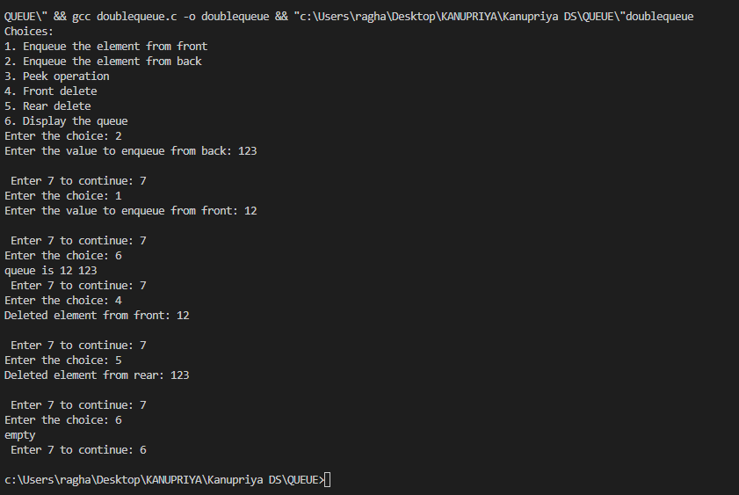

EXPERIMENT 7:

AIM: Implementation of BST using following operations – create, delete, display.

CODE:

#include <stdio.h>

#include <stdlib.h>

struct node {

    int data;

    struct node *left;

    struct node *right;

};

struct node *tree = NULL;

void create_tree(struct node *);

struct node *insertElement(struct node *, int);

void preorderTraversal(struct node *);

void inorderTraversal(struct node *);

void postorderTraversal(struct node *);

struct node *deleteElement(struct node *, int);

int main() {

    int option, val;

    struct node *ptr;

    create_tree(tree);

 printf("\n ******MAIN MENU******* \n");

        printf("\n 1. Insert Element");

        printf("\n 2. Preorder Traversal");

        printf("\n 3. Inorder Traversal");

        printf("\n 4. Postorder Traversal");

        printf("\n 5. Delete an element");

        printf("\n 6. Exit");

    do {

        printf("\nEnter your option: ");

        scanf("%d", &option);

        switch (option) {

            case 1:

                printf("Enter the value of the new node: ");

                scanf("%d", &val);

                tree = insertElement(tree, val);

                break;

            case 2:

                printf("The preorderTraversal of the tree are: \n");

                preorderTraversal(tree);

                break;

            case 3:

                printf("The inorderTraversal elements of the tree are: \n");

                inorderTraversal(tree);

                break;

            case 4:

                printf("The postorderTraversal elements of the tree are: \n");

                postorderTraversal(tree);

                break;

            case 5:

                printf("Enter the element to be deleted: ");

                scanf("%d", &val);

                tree = deleteElement(tree, val);

                break;

        }

    } while (option != 6);

    return 0;

}

void create_tree(struct node *tree) {

    tree = NULL;

}

struct node *insertElement(struct node *tree, int val) {

    struct node *ptr, *nodeptr, *parentptr;

    ptr = (struct node*)malloc(sizeof(struct node));

    ptr->data = val;

    ptr->left = NULL;

    ptr->right = NULL;

    if (tree == NULL) {

        tree = ptr;

    } else {

        parentptr = NULL;

        nodeptr = tree;

        while (nodeptr != NULL) {

            parentptr = nodeptr;

            if (val < nodeptr->data)

                nodeptr = nodeptr->left;

            else if(val >nodeptr->data)

                nodeptr = nodeptr->right;

                else {printf("Already data exists %d",val);

                return tree;}

        }

        if (val < parentptr->data)

            parentptr->left = ptr;

        else

            parentptr->right = ptr;

    }

    return tree;

}

void preorderTraversal(struct node *tree) {

    if (tree != NULL) {

        printf("%d\t", tree->data);

        preorderTraversal(tree->left);

        preorderTraversal(tree->right);  }}

void inorderTraversal(struct node *tree) {

    if (tree != NULL) {

        inorderTraversal(tree->left);

        printf("%d\t", tree->data);

        inorderTraversal(tree->right);}}

void postorderTraversal(struct node *tree) {

    if (tree != NULL) {

        postorderTraversal(tree->left);

        postorderTraversal(tree->right);

        printf("%d\t", tree->data);

    }

}

struct node *inOrderPredecessor(struct node* tree){

    tree = tree->left;

    while (tree->right!=NULL)

        tree = tree->right;

    return tree;

}

struct node *deleteElement(struct node *tree, int value){

    struct node* iPre;

    if (tree == NULL){

        return NULL;

    }

    if (tree->left==NULL&&tree->right==NULL){

        free(tree);

        return NULL;

    }

    if (value < tree->data){

        tree-> left = deleteElement(tree->left,value);

    }

    else if (value > tree->data){

        tree-> right = deleteElement(tree->right,value);

    }else{

 if (tree->left == NULL) {

            struct node* temp = tree->right;

            free(tree);

            return temp;

        } else if (tree->right == NULL) {

            struct node* temp = tree->left;

            free(tree);

            return temp; }

        iPre = inOrderPredecessor(tree);

        tree->data = iPre->data;

        tree->left = deleteElement(tree->left, iPre->data);}

    return tree;}

Output:

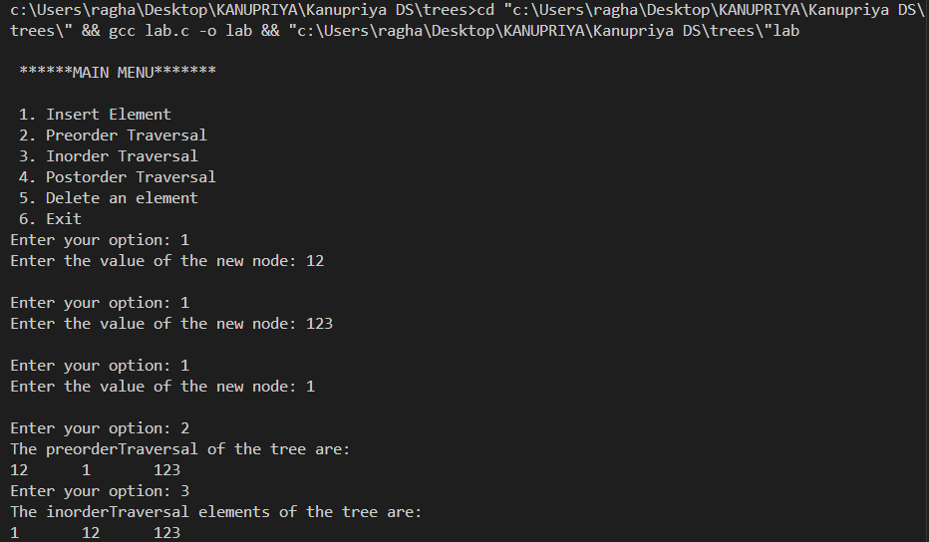

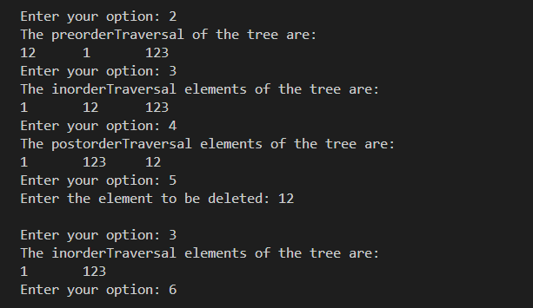

Experiment 8:

AIM: Implementation of Graph traversal using menu driven program (DFS & BFS).

CODE:

#include <stdio.h>

int q[20], front = -1, rear = -1, a[20][20], vis[20], stack[20];

int delete();

void add(int item);

void bfs(int s, int n);

void dfs(int s, int n);

int main()

{

    int n, i, s, ch, j;

    int c, dummy;

    printf("Enter the number of vertices: ");

    scanf("%d", &n);

    for (i = 1; i <= n; i++)

    {

        for (j = 1; j <= n; j++)

        {

            printf("Enter 1 if %d has a node with %d else 0: ", i, j);

            scanf("%d", &a[i][j]);

        }

    }

    printf("The Adjacency Matrix is: \n");

    for (i = 1; i <= n; i++)

    {

        for (j = 1; j <= n; j++)

        {

            printf(" %d", a[i][j]);

        }

        printf("\n");

    }

  do

{

    for (i = 1; i <= n; i++)

        vis[i] = 0;

    printf("\nMenu");

    printf("\n1. B.F.S");

    printf("\n2. D.F.S");

    printf("\nEnter the choice: ");

    scanf("%d", &ch);

    printf("Enter the source vertex: ");

    scanf("%d", &s);

    if (s < 1 || s > n)

    {

        printf("Invalid source vertex.\n");

        continue;

    }

    switch (ch)

    {

    case 1:

        bfs(s, n);

        break;

    case 2:

        dfs(s, n);

        break;

    default:

        printf("Invalid choice.\n");

    }

    printf("\nDo you want to continue? Press 3 for Yes: ");

    scanf("%d", &c);

} while (c == 3);

    return 0;

}

void bfs(int s, int n)

{

    int p, i;

    add(s);

    vis[s] = 1;

    p = delete();

    if (p != 0)

        printf(" %d", p);

    while (p != 0)

    {

        for (i = 1; i <= n; i++)

        {

            if ((a[p][i] != 0) && (vis[i] == 0))

            {

                add(i);

                vis[i] = 1;

            }

        }

        p = delete();

        if (p != 0)

            printf(" %d", p);

    }

    for (i = 1; i <= n; i++)

        if (vis[i] == 0)

            bfs(i, n);

}

void add(int item)

{

    if (rear == 19)

        printf("Queue full..");

    else

    {

        if (rear == -1)

        {

            q[++rear] = item;

            front++;

        }

        else

            q[++rear] = item;

    }

}

int delete()

{

    int k;

    if ((front > rear) || (front == -1))

        return (0);

    else

    {

        k = q[front++];

        return (k);

    }

}

void dfs(int s, int n)

{int i;

        printf(" %d ", s);

   vis[s] = 1;

        for (i = 1; i <= n; i++)

        {

            if (a[s][i]==1&&(vis[i] == 0))

            {

              dfs(i,n);

            }

        }

}

OUTPUT:

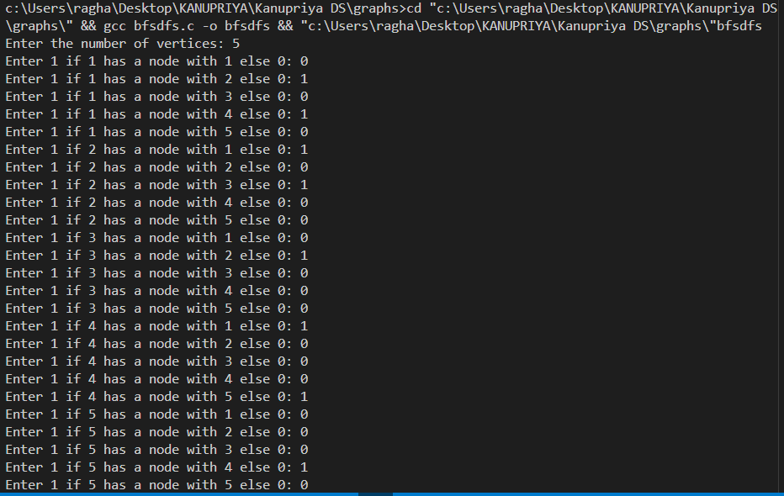

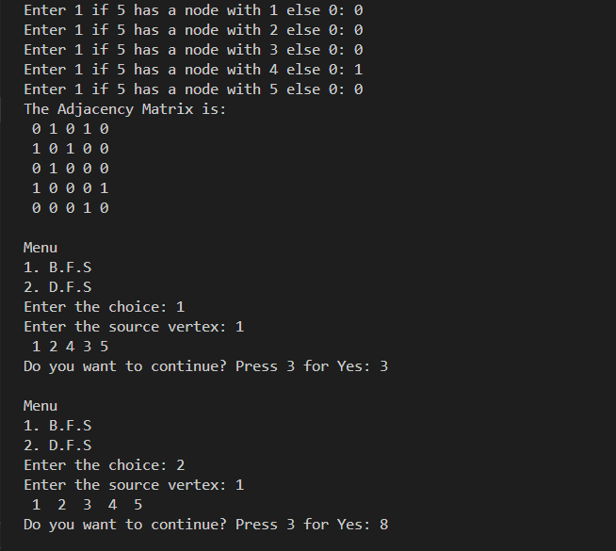

Experiement 9: WAP to implement Selection Sort, Insertion Sort, Quick Sort

Code: Insertion Sort

#include <stdio.h>

#define size 50

void insertion_sort(int arr[], int n);

void main()

{

int arr[size], i, n;

printf("\n Enter the number of elements in the array: ");

scanf("%d", &n);

printf("\n Enter the elements of the array:\n ");

for(i=0;i<n;i++)

scanf("%d", &arr[i]);

insertion_sort(arr, n);

printf("\n The sorted array is: \n");

for(i=0;i<n;i++)

printf(" %d\t", arr[i]);

}

void insertion_sort(int arr[], int n)

{int i, j, temp;

for(i=1;i<n;i++){

temp = arr[i];

j = i-1;

while((temp < arr[j]) && (j>=0)){

arr[j+1] = arr[j];

j--;}

arr[j+1] = temp;

}}

Output:

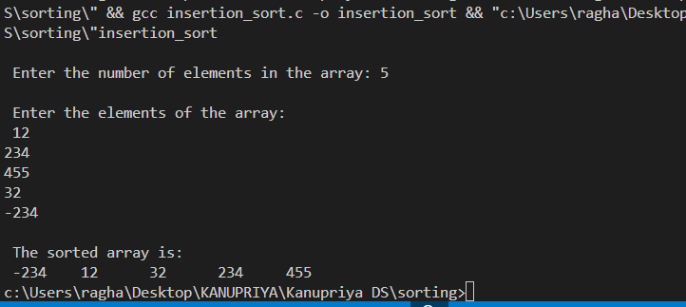

Quick Sort:

#include <stdio.h>

#define size 100

int partition(int a[], int beg, int end);

void quick_sort(int a[], int beg, int end);

void main()

{

int arr[size], i, n;

printf("\n Enter the number of elements in the array: ");

scanf("%d", &n);

printf("\n Enter the elements of the array: \n");

for(i=0;i<n;i++)

scanf("%d", &arr[i]);

quick_sort(arr, 0, n-1);

printf("\n The sorted array by quick sort is: \n");

for(i=0;i<n;i++)

printf(" %d\t", arr[i]);}

int partition(int a[], int beg, int end){

int left, right, temp, loc, flag;

loc = left = beg;

right = end;

flag = 0;

while(flag != 1){

while((a[loc] <= a[right]) && (loc!=right))

right--;

if(loc==right)

flag =1;

else if(a[loc]>a[right])

{

temp = a[loc];

a[loc] = a[right];

a[right] = temp;

loc = right;

}

if(flag!=1)

{

while((a[loc] >= a[left]) && (loc!=left))

left++;

if(loc==left)

flag =1;

else if(a[loc] <a[left])

{

temp = a[loc];

a[loc] = a[left];

a[left] = temp;

loc = left;}}

}

return loc;

}

void quick_sort(int a[], int beg, int end){

int loc;

if(beg<end)

{

loc = partition(a, beg, end);

quick_sort(a, beg, loc-1);

quick_sort(a, loc+1, end);

}}

Output:

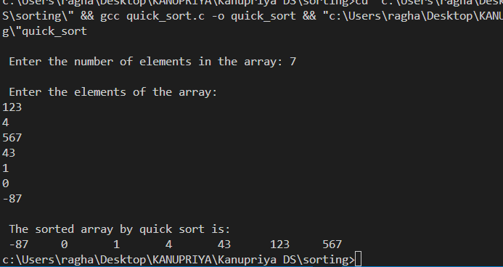

Selection Sort:

#include <stdio.h>

#include <stdlib.h>

int smallest(int arr[], int k, int n);

void selection_sort(int arr[], int n);

void main(int argc, char *argv[]) {

int arr[10], i, n;

printf("\n Enter the number of elements in the array: ");

scanf("%d", &n);

printf("Enter the elements of the array:\n ");

for(i=0;i<n;i++)

scanf("%d", &arr[i]);

selection_sort(arr, n);

printf("\n The sorted array by selection sort is: \n");

for(i=0;i<n;i++)

printf(" %d\t", arr[i]);

}

int smallest(int arr[], int k, int n){

int pos = k, small=arr[k], i;

for(i=k+1;i<n;i++){

if(arr[i]< small){

small = arr[i];

pos = i;}}

return pos;}

void selection_sort(int arr[],int n){

int k, pos, temp;

for(k=0;k<n;k++){

pos = smallest(arr, k, n);

temp = arr[k];

arr[k] = arr[pos];

arr[pos] = temp;}

}

Output: Selection Sort:

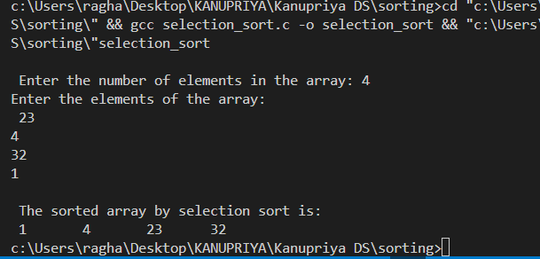

Experiment 10: Write a menu driven program in C to implement hashing techniques.

Code:

#include <stdio.h>

#include<stdlib.h>

#define TABLE_SIZE 5

int h[TABLE_SIZE] = {NULL};

void insert() {

 int key, index, i, hashingKey;

 printf("\nEnter data:\n");

 scanf("%d", &key);

 hashingKey = key % TABLE_SIZE;

 for(i = 0; i < TABLE_SIZE; i++){  index = (hashingKey + i) % TABLE_SIZE;

     if(h[index] == NULL){

        h[index] = key;

         break;}  }

    if(i == TABLE_SIZE){

     printf("\nelement cannot be inserted\n");}}

void search() {

 int key, index, i, hashingKey;

 printf("\nEnter element to be searched:\n");

 scanf("%d", &key);

 hashingKey = key % TABLE_SIZE;

 for(i = 0; i< TABLE_SIZE; i++) {

    index=(hashingKey + i) % TABLE_SIZE;

    if(h[index] == key) {

      printf("Value at index %d", index);

      break;}}

  if(i == TABLE_SIZE)

    printf("\n Value Not Found\n");}

void display() { int i;

  printf("\nElements are \n");

  for(i = 0; i < TABLE_SIZE; i++)

    printf("\nIndex %d value =  %d", i, h[i]);}

int main(){   int opt;

     printf("\nMenu:\n1.Insert\n2.Display\n3.Search\n4.Exit \n");

    while(1)

    {   printf("\nEnter the choice: ");

        scanf("%d", &opt);

        switch(opt)   {

            case 1:

                insert();

                break;

            case 2:

                display();

                break;

            case 3:

                search();

                break;

            case 4:exit(0);

            default:

            printf("Invalid");    } }

    return 0;}

Output:

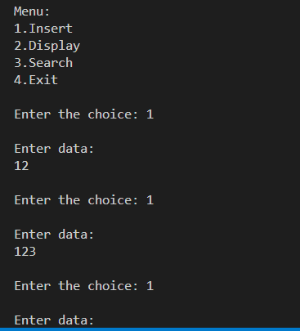

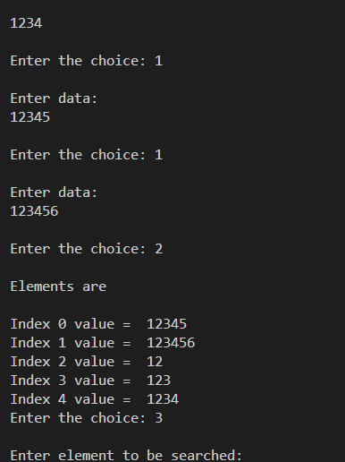

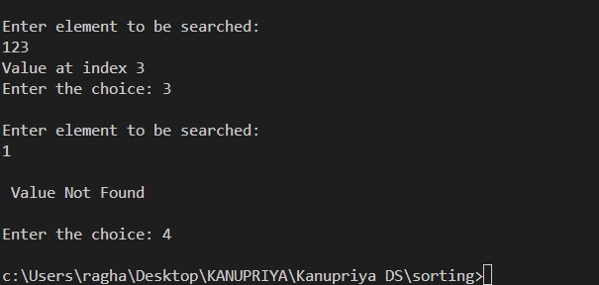

Linear Search:

Code:

include<stdio.h>

#include<conio.h>

void main(){

    int n,i,temp,num;

printf("Enter the number elements in an array\n");

scanf("%d",&n);

printf("Enter the elements in an array\n");

int arr[n];

for(i=0;i<n;i++){

    scanf("%d",&arr[i]);

}

printf("Enter the element to be searched \n");

scanf("%d",&num);

for(i=0;i<n;i++){

        if(arr[i]==num){

 printf("The element is found at index %d ",i+1);break;}

  if(i==n-1){

 printf("The element is not found ");}

        }

}

Output:

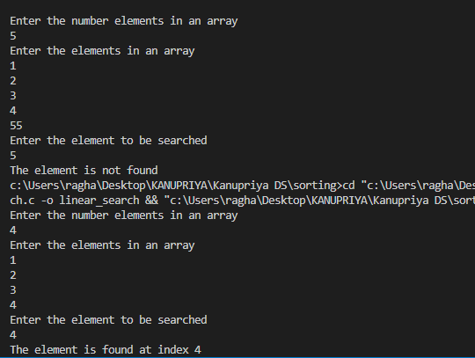

Binary Search:

Code:

#include <stdio.h>

void executeAtMid(int mid, int arr[], int size) {

    printf("Checking middle element at index %d: %d\n", mid, arr[mid]);

}

int binarySearch(int arr[], int size, int target) {

    int left = 0;

    int right = size - 1;

    while (left <= right) {

        int mid = left + (right - left) / 2;

        executeAtMid(mid, arr, size);

        if (arr[mid] == target) {

            return mid;

        }

        if (arr[mid] < target) {

            left = mid + 1;

        } else {

            right = mid - 1;

        }

    }

    return -1;

}

int main() {

    int n, i;

    printf("\nEnter the number of elements in the array: ");

    scanf("%d", &n);

    int arr[n];  // This works in C99 or later, but the size must be determined at runtime.

    printf("Enter the elements of the array:\n");

    for(i = 0; i < n; i++) {

        scanf("%d", &arr[i]);

    }

    int target;

    printf("Enter the target value to search for: ");

    scanf("%d", &target);

    int result = binarySearch(arr, n, target);

    if (result != -1) {

        printf("Target %d found at index %d\n", target, result);

    } else {

        printf("Target %d not found in the array\n", target);

    }    return 0;

}

Output:

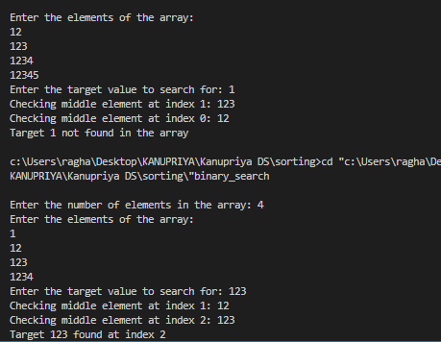

Fibonacci Search:

Code:

#include <stdio.h>

int min(int, int);

int fibonacci_search(int[], int, int);

int min(int a, int b){

    return (a > b) ? b : a;}

int fibonacci_search(int arr[], int n, int key){

    int offset = -1;

    int Fm2 = 0;

    int Fm1 = 1;

    int Fm = Fm2 + Fm1;

    while (Fm < n) {

        Fm2 = Fm1;

        Fm1 = Fm;

        Fm = Fm2 + Fm1; }

    while (Fm > 1) {

        int i = min(offset + Fm2, n - 1);

        if (arr[i] < key) {

            Fm = Fm1;

            Fm1 = Fm2;

            Fm2 = Fm - Fm1;

            offset = i;

        } else if (arr[i] > key) {

            Fm = Fm2;

            Fm1 = Fm1 - Fm2;

            Fm2 = Fm - Fm1;

        } else

            return i;   }

    if (Fm1 && arr[offset + 1] == key)

        return offset + 1;

    return -1;

}

int main(){

   int i, n, key, pos;

   int arr[10] = {6, 11, 19, 24, 33, 54, 67, 81, 94, 99};

   printf("Array elements are: ");

   int len = sizeof(arr) / sizeof(arr[0]);

   for(int j = 0; j<len; j++){

      printf("%d ", arr[j]);

   } n = 10;

   key = 67;

   printf("\nThe element to be searched: %d", key);

   pos = fibonacci_search(arr, n, key);

    if(pos >= 0)

        printf("\nThe element is found at index %d", pos);

    else

        printf("\nUnsuccessful Search");}

Output:

